BigData Frameworks CSE3120
Lab – 1
Naveen Nidadavolu
22MIA1049

1. Display odd numbers between 1 -100

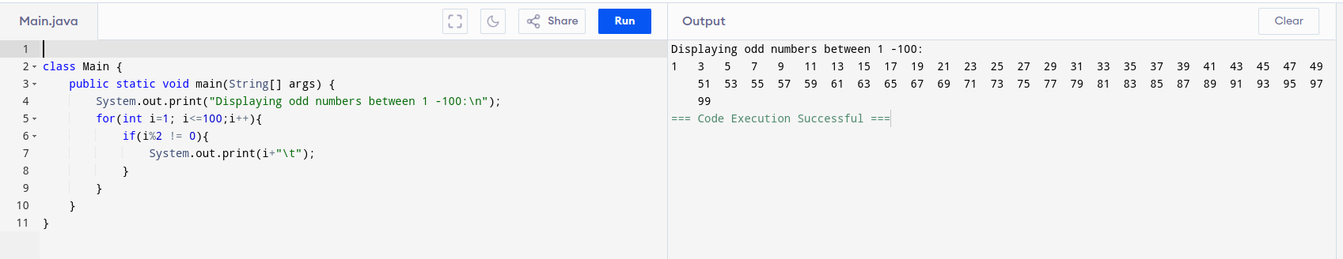

2. Sum of odd numbers between 1 -100

3. Program to check the given number is Palindrome or not

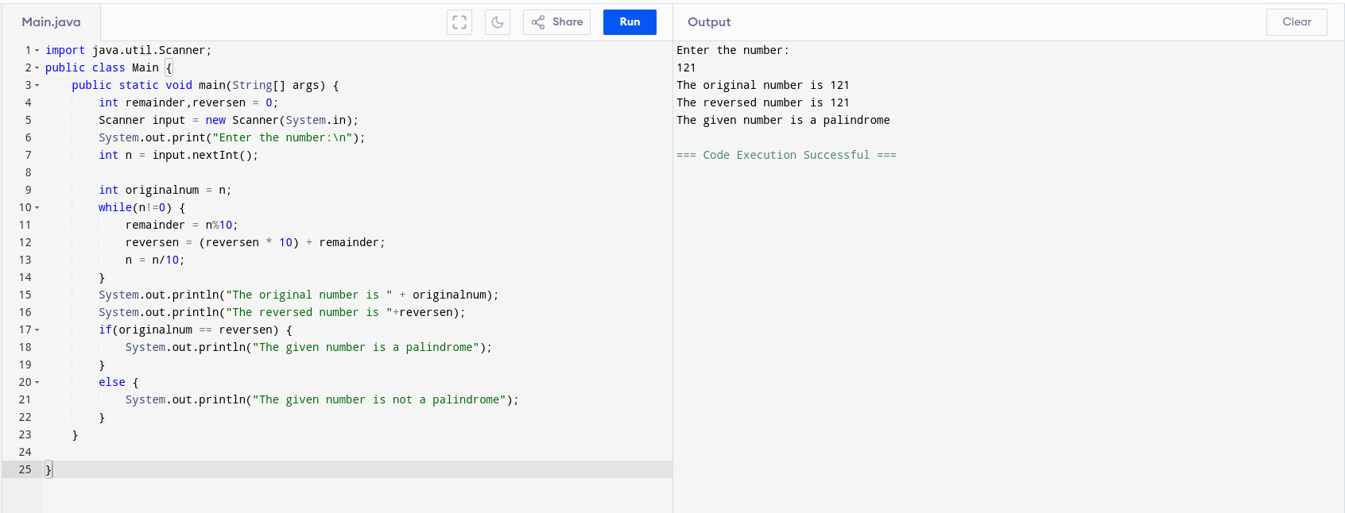

Q4. Program to print patterns of numbers and stars
*
* *
* * *
* * * *

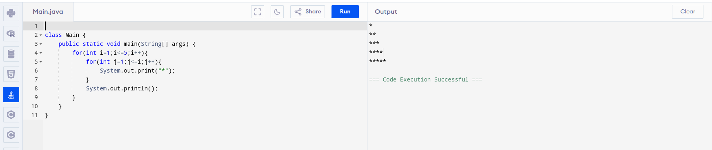
5. Print numbers in triangle and pyramid vice
1
121
12321
1234321
123454321
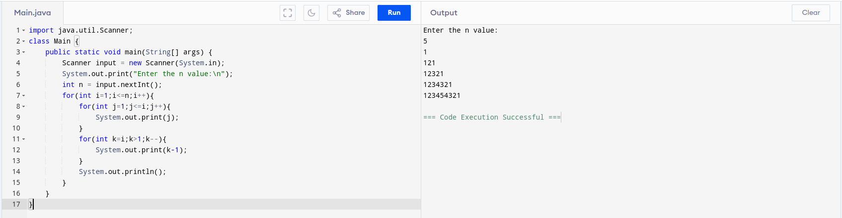
6. Find largest and smallest number in an array in java
