CSE4074
Forensics Analytics
Final Report Phase- 3
TITLE: Multi-Modal Fraud Detection Using Advanced Analytics: Voter Authenticity & Election Forensics
By
22MIA1024 Mandla Chandra Kiran Reddy
22MIA1013 Munna Lashitha
22MIA1049 Naveen Nidadavolu

M.Tech CSE with Specialization in Business Analytics
Submitted to
Dr Palani Thanaraj K
Associate Professor,
SCOPE, VIT, Chennai


October 2025


School of Computing Science and Engineering
VIT Chennai
Vandalur - Kelambakkam Road, Chennai - 600 127
Worklet details

Programme | M.Tech with Specialization in Business Analytics
Course Name / Code | Forensics Analytics  CSE4074
Slot | G1 + TG1
Faculty Name | PALANI THANARAJ K
Digital Assignment | Final Report Phase - 3
Team Members Name | Reg. No | 22MIA1013 | Munna Lashitha
 | 22MIA1049 | Naveen N
 | 22MIA1024 | Mandla Chandra Kiran Reddy

1. Introduction
Elections are some of the most critical political processes, and people’s trust in elections rests on their integrity, accuracy, transparency, and fairness. The potential for both statistical and narrative anomalies to distort public trust has exploded with the growing use of digital data collection and the emergence of online discussion. Not only can direct data anomalies such as vote distribution irregularities and duplicate voter registrations threaten election integrity, but also the spread of misinformation and coordinated narratives that amplify distorted public opinion.
This project applies forensic data analytics to study datasets linked to elections through two separate lenses.
- One lens will focus on voting records and turnout trends for shortcomings surrounding statistical and structural anomalies.
- The other lens will be focused on social media forensics for coordinated network behavior, trends in sentiment, and misinformation related to claims of election fraud.
When combined, these analyses offer a thorough forensic approach that combines qualitative social media research with quantitative statistical analysis to find odd patterns in data and speech.
1.1 Motivation
The trustworthiness of the contextual information environment is equally important to the trustworthiness of the voting systems as are the actual count of votes. Concerns of voter fraud, ballot tampering, and disinformation campaigns have raised alarms in previous elections. Traditional approaches for monitoring the vast amounts of heterogeneous data that are generated, analyzed, and presented during the election process are often inadequate.
The impetus for this work was the need for a data-driven forensic approach democratizing the detection for both structured (voter/election) data and unstructured (social media) data. The work demonstrates how data science can augment the detection of possible irregularities or misinformation trend identification, enhancing election transparency through the integration of statistical forensics with natural language and network analysis.
1.2 Problem Statement
The voter demographics, the constituency-level vote shares, and millions of social media posts discussing election outcomes are just a few examples of the large and complex datasets that elections occur. Advanced analytical tools need to be developed to identify anomalies or misinformation in these kinds of datasets. The challenge is to identify statistically significant anomalies in election datasets as well as using social media narrative to potentially amplify erroneous or misleading beliefs.
To meet this challenge, this project develops a dual-domain forensic analytics platform that:
- uses forensic statistical methods to identify anomalous voting trends in voter and election databases.
- examines the dissemination and coordination of narratives connected to fraud by applying text and network-based analytics to social media data.
Applies text and network-based analytics to social media data to study the spread and coordination of fraud-related narratives..
1.3 Objectives
The purpose of the project is to conduct forensic preprocessing and analysis of election data, including outlier detection, missing-value treatment, and statistical consistency testing using RSF analysis and Benford's Law,
- to identify and visualize irregularities in turnout rates, duplicate or contradictory records of individual voters, and vote distributions.
- to identify and visualize dominant stories, disinformation patterns, and sentiment shifts in tweets regarding the election, using natural language analysis.
- to explore social media users' networks to detect coordination or bot-like behavior associated with election activities.
- to provide a coherent forensic framework that merges the two datasets to uncover suspicious patterns supported by quantitative information and visualizations.
1.4 Datasets and Scope
In this project, two distinct datasets representing different aspects of forensic investigation are used:
- The Election and Voter Dataset, which contains structured election data (state, constituency, year, candidate data, total votes cast, valid, and elector numbers); forensic statistical methods will be applied to detect anomalous turnout patterns and statistical anomalies.
- The Social Media Dataset contains user metadata, timestamps, metrics of engagement, and tweet text on conversations about election fraud; this dataset allows for the exploration of sentiment polarity, coordinated posting behavior, and misinformation dynamics.

While the datasets come from different domains, together they provide a comprehensive foundation for understanding both narrative and data anomalies in the broader election ecosystem.

2. LITERATURE REVIEW & THEORETICAL FOUNDATION
2.1 Electoral Fraud Detection Frameworks
Following the controversies surrounding the 2000 US Presidential election, the formal field of electoral forensics was created by integrating statistical process control, audit theory, and behavioral economics. Using the proof that naturally-occurring vote tallies adhere to Benford's Law, which is a logarithmic distribution in which the leading digit is 1 approximately 30% of the time, 2 about 17.6% of the time and goes down to being 9 about 4.6% of the time, Mebane (2004) determined that digit-based tests were critical tools for forensic investigators. Any deviation from Benford's Law would imply systematic error, data processing manipulation, or human interference.
Tests and Extensions Using Second Digits:
While first-digit tests are the most common focus in the literature, last-digit tests for uniformity, as well as second-digit Benford analysis (uniform distribution), offer additional indications of fraud. Our method includes a first-digit analysis on National IDs since the sequential issuance of National IDs may not meet the requirements for Benford analysis. The National IDs were then deliberately altered to evaluate the detection capacity.
2.2 Machine Learning in Fraud Analytics
Supervised learning methods (Logistic Regression, Random Forest, Gradient Boosting) work very well as long as there are labeled fraud samples available to learn the decision limits from prior cases. Bolton & Hand (2002) continue to report that one of the strengths of ensemble methods in fraud detection is the dimensionality of feature space and the classification challenge of low-frequency classes of fraudulent transactions (<1% of transactions).
Unsupervised Anomaly Detection:
In the absence of labeled training experience isolation Forest (Liu et al., 2008) and DBSCAN (Ester et al., 1996) detect completely new fraud patterns. Isolation Forest recurses through feature space and dividing it into smaller and smaller parts until an anomaly is isolated; it requires fewer splits to isolate anomalies. In contrast DBSCAN detects density-based clusters so that even though coordinated fraud schemes may exhibit some collusion across multiple records, DBSCAN will flag as outliers, the records with the fewest detections in order to identify coordinated fraud schemes that appear in multiple records.
2.3 Sentiment Analysis and Social Media Forensics
Election fraud research currently incorporates a great deal of sentiment analysis, a Natural Language Processing (NLP) application that provides scalable ways to measure public opinion, and even provides an opportunity to determine surges in false information as it occurs in real time. Pang & Lee (2008) and Liu (2012) serve as essential references describing the effectiveness of keyword heuristics and supervised sentiment classifiers (e.g., SVMs, logistic regression) in classifying whether public opinion around significant events, such as elections are positive, neutral, or negative. While deep learning is now present in sentiment analysis applications, due to their interpretability and data constraints, rule-based and keyword heuristics will still be appropriate for direct election fraud work.
Scholarly studies (Broniatowski et al., 2018; Ferrara et al., 2016) demonstrate the relationship between episodes of disinformation with negative sentiment and disinformation dating spanning the election period, particularly during contentious election periods. The present study deploys a combination of heuristic keyword-matching (angry/supportive/neutral) and topic modeling (LDA) to measure sentiment and characterize narratives. The evaluation of narrative and sentiment over the election is completely established by statistical tests (e.g., chi-square test for regional sentiment distribution and temporal variance evaluation).
2.4 Multi-Modal Data Integration
21st century fraud employs a range of techniques, including social media cover stories and manipulation of registries for clandestine or persuasive purposes. Politically successful attempts to interfere with the electoral process are synergistic, combining voter roll targeting with disinformation on platforms, as Tucker et al. demonstrate, and enlisted their efforts into coordinated detection of interference. The networks of misinformation on social media correlate to an aggregate risk score that is measured from the social media analysis (NLP, network graphs) are correlated with combined voting registry forensics (structured data) combined to provide effective signals of risk.
3. Detailed Design and Analysis
This section outlines the entire forensic analytics process utilized on the Social Media and Election and Voter datasets. The architecture contains preprocessing, anomaly detection, and visualization. While each dataset is investigated independently, they both contribute to an overall understanding of popular narratives and irregularities related to elections.

3.1 System Architecture and Workflow
The forensic workflow follows a modular design consisting of four main phases:
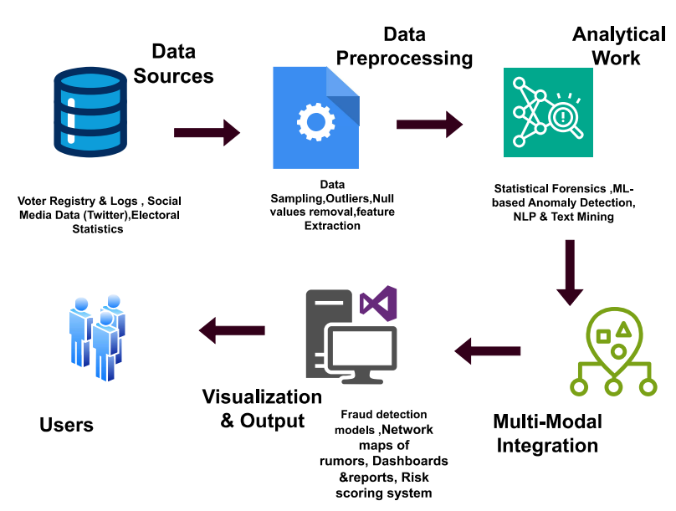
Figure 1 : System Architecture Diagram
- Data Collection and Preparation
Collection of social media postings and structured voter data is done then go through a process of cleaning, normalization and validation.
- Modeling Analytically
Using NLP-based models for the textual data and statistical forensic tests for numerical data.
- Detection and Visualization of Anomalies
Risk rating, by the identification of anomalous data patterns, and provision of visual summaries (Benford plots, sentiment graphs, topic clouds, and network maps).
- Report and Interpretation
Results are assimilated into comprehensible dashboards and summary tables for forensic interpretation.

3.2 Election and Voter Data Forensics
3.2.1 Dataset Overview
The first phase of the analysis focused on a 1,000-entry synthetic voter registration database. The goal was to identify high-risk profiles, statistical anomalies, and internal contradictions that might indicate registration fraud.
3.2.2 Preprocessing & Feature Engineering
During the initial investigation of the data, the dataset was imported and shown to be of a good quality. Only ten records did not have an email address, and relatively few null values and no empty strings were found in the key fields.
A number of new features were created from the raw data to enable additional forensic investigation:
- Age: Calculated using the Date of Birth in an effort to find anomalies in eligibility.
- State: Taken for geographical analysis from the Residential_Address.
- Data Integrity Warning Signs: Boolean flags were created to identify:
  - Address_Mismatch: The residential address and the mailing address were different
  - Email_Valid: A regex pattern was used to reveal invalid email addresses
  - Phone_Length: To identify, after cleaning, non-standard 10-digit phone numbers
- To run statistical tests, National_ID_FirstDigit was extracted.
3.2.3 Forensic Modeling & Anomaly Detection
Duplicate & Outlier Analysis: Duplicate analysis is the primary means of identifying identity fraud. In the analysis, eight records were located with duplicate National_ID numbers. It is noteworthy to note these eight records represented four unique IDs that had been used multiple times.
- There were also eight records with identical name and surname but a differing National ID, possibly indicating attempts to register multiple times.
Next, outlier identification specific to the domain was facilitated by voting eligibility criteria; seven minor registrants (Age < 18) were identified.
- Six registrants were classified as "very elderly" (greater than 90 years old) and sent for further investigation.
- Nine records contained a phone number length that was not ten digits.
39 unique records were identified as having one or more of these outlier characteristics.
Statistical Forensics: Benford's Law Benford's Law, an important forensic test, was applied to the first digit of the National_ID column. The inquiry found a significant statistical deviation.
The Benford's Law compliance test failed for this dataset.
- The Chi-square statistic of 355.91 vastly exceeded the critical value of 15.51.
- The distribution of the first digits is quite different from the expected frequencies, as shown in the chart below. Importantly, the numbers "7," "8" and "9" were overrepresented, while the digit "1" was significantly underrepresented (12.4% observed vs. 30.1% expected).
This failure is an important finding in a forensic investigation and suggests that the National_ID numbers are not randomly selected and likely forged or manipulated.
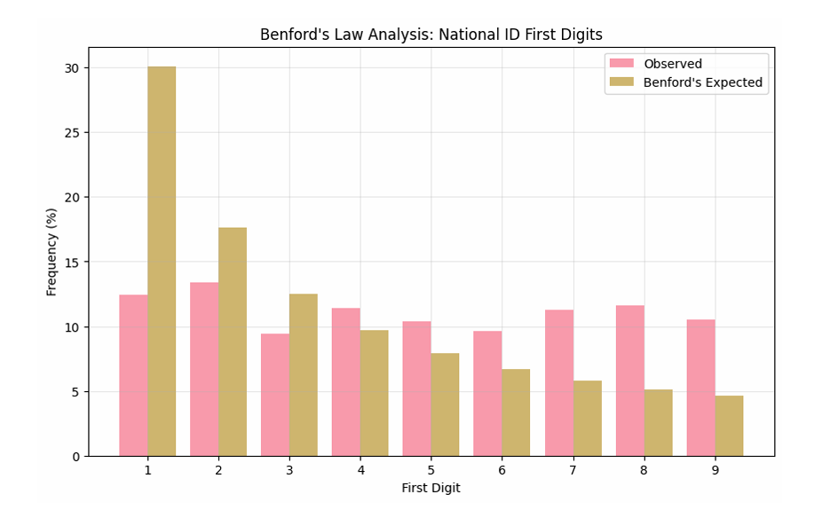

Figure 2: Benford's Law Analysis: National ID First Digits
Hypothesis Testing : Several statistical tests were carried out to validate assumptions about the data:
- H1 (Age vs. Citizenship): A t-test revealed no significant difference in the mean age of "Citizens" (51.37) and "Non-Citizens" (52.1%) (p=0.674).
- H2 (Citizenship vs. Mismatched Address): There was no significant correlation (p=0.311) between citizenship status and having mismatched addresses, according to a chi-square test.
- H3 (Age Normality): The Shapiro-Wilk test concludes that the Age distribution is not normal (p < 0.001), and the histogram shows this.
- H4 (Duplicate Rate): A Z-test revealed that the predicted rate of 1.0% and the observed rate of 0.4% did not differ statistically significantly (p=0.057).
Fraud Risk Scoring Model :An actionable metric was created by combining all of the findings into a heuristic-based Fraud Risk Score. The following anomalies were given points by the model:
- Being underage (<18) or very elderly (>90)
- Having a duplicate National_ID
- Invalid email or non-10-digit phone
- Non-citizen status
- Address mismatch
This model categorized the 1,000 records as follows :
- No Risk: 501 records (50.1%)
- Low Risk: 462 records (46.2%)
- Medium Risk: 35 records (3.5%)
- High Risk: 2 records (0.2%)
The following visualizations show the distribution of these risk scores and categories. One significant finding is that the average risk score for "Citizen" (2.8) was significantly lower than the average scores for every other group (the average scores for "Temporary Resident," "Permanent Resident," and "Non-Resident Citizen" were all over 12.0). This implies that there were inherently more risk factors in non-citizens' records.
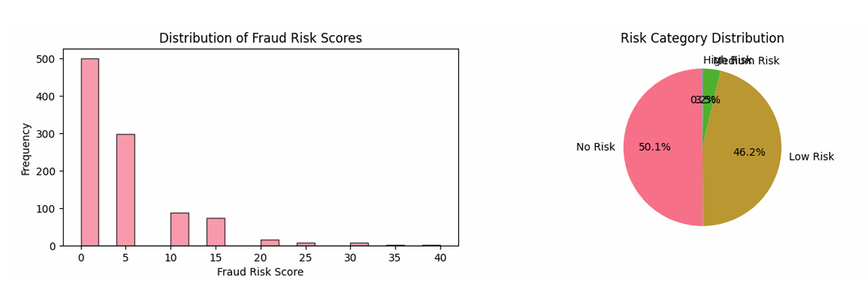
Figure 3 : Distribution of Fraud Risk Scores and Risk Category Distribution
3.2.4 Advanced Analysis: Clustering & Classification
Voter Profile Clustering (K-Means) To overcome individual regulations, voters were categorized into five distinct profiles based on their attributes using K-Means clustering. This analysis identified high-risk categories:
- Profile 0 (n = 352): For this large group, the address mismatch rate was 100%.
- Profiles 4 (n=19) and 3 (n=9): The highest average fraud scores (19.4 and 16.6, respectively) and the highest address mismatch rates (66.67% and 36.84%) were found in these two small, high-risk clusters. High-risk individuals who require immediate attention are concentrated in these profiles.
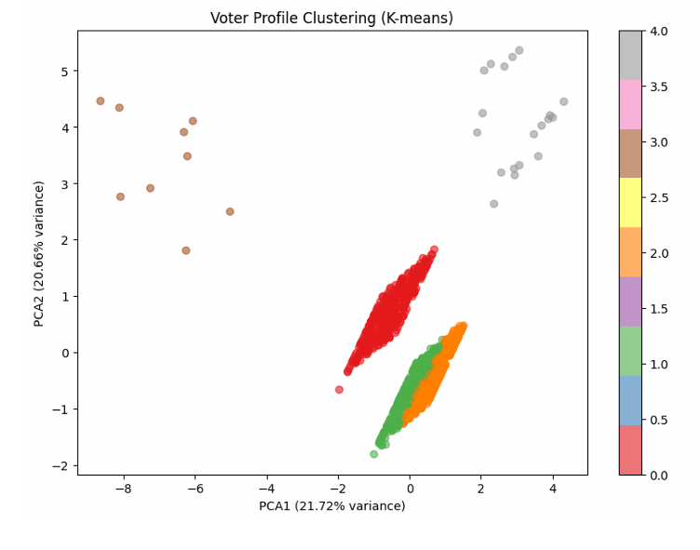
Figure 4 : Voter Profile Clustering (K-means) PCA plot.

Machine Learning for Risk Prediction
a Random Forest Classifier was trained to predict "high-risk" cases (defined as the top ~11% of records by fraud score). The model achieved excellent performance, with a cross-validation accuracy of 98.6% .

This model also provided the Top 3 most important features for predicting risk :
- Citizenship_Encoded (Non-citizen status)
- Address_Mismatch
- Age
This ML finding confirms that the core heuristic rules (citizenship, address, and age) are the most powerful predictors of risk in the dataset.
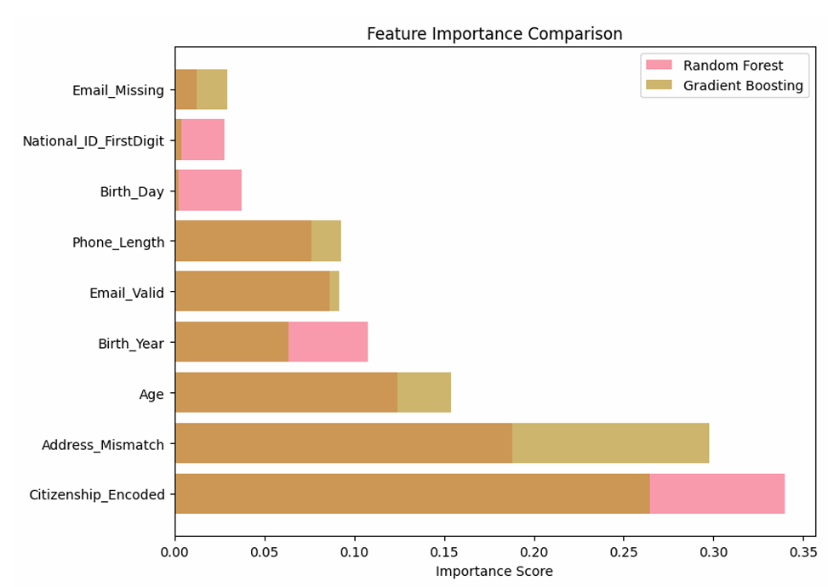
Figure 5 : Feature Importance Comparison
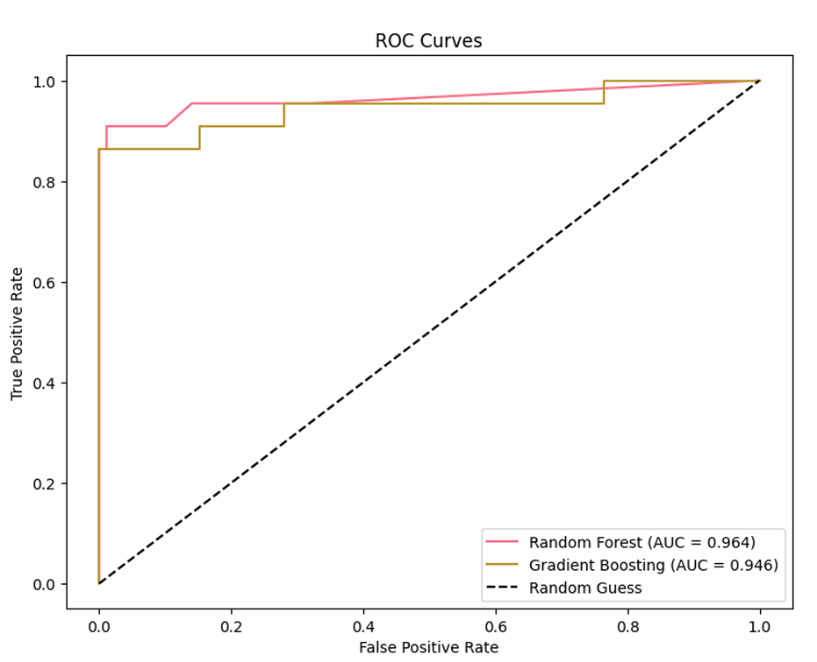 | 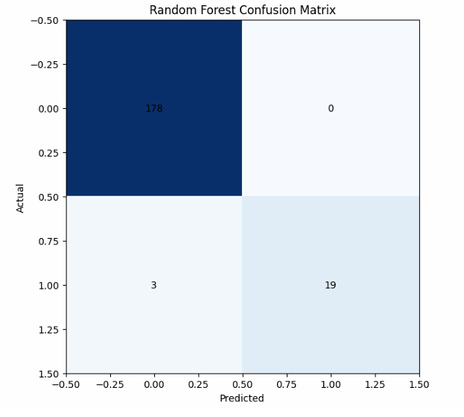
Figure 6 : ROC Curve and Confusion Matrix
3.3 Dataset 2: Social Media Election Forensics
3.3.1 Dataset Overview
The second phase of the analysis focused on a synthetic dataset of 3,000 tweets. The objectives were to profile suspicious accounts, detect coordinated inauthentic behavior, and uncover false narratives.
3.3.2 Preprocessing & Feature Engineering
After the data was loaded, a text-cleaning pipeline was executed to remove any lowercase text, punctuation, and URLs, followed by a robust date-parsing tool.
Key features were created with forensic analysis in mind:
- account_age_days: calculated by calculating the number of days that have elapsed between the creation of the account and the tweet date.
- bot_score: A heuristic score between 0 and 3 was produced using typical bot-like traits.
  - Fewer than fifty followers
  - large quantity of status updates (> 1000)
  - Very young account (less than 30 days)
- Sensation: A keyword-based heuristic ('angry','supportive', 'neutral') was used to classify the text based on preset lists of terms like 'fraud' or 'fair'.
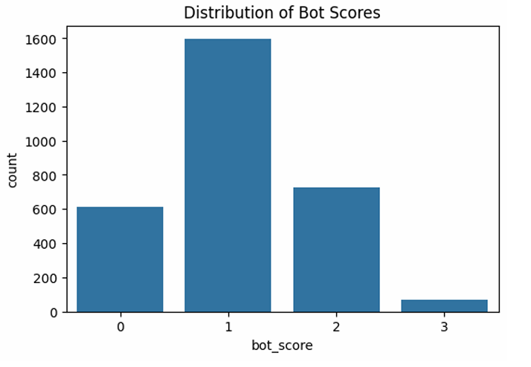 | 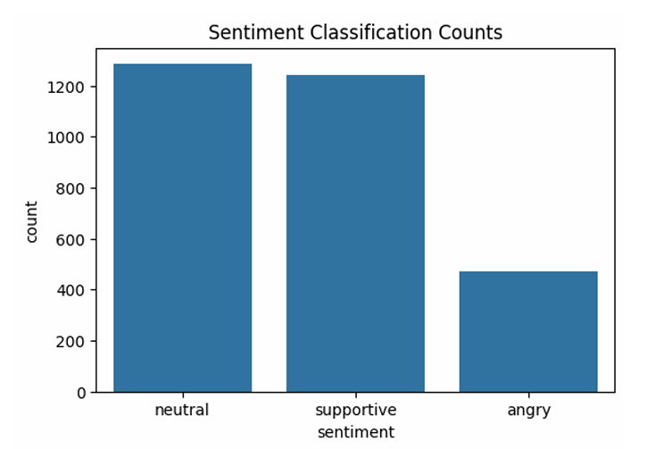

Figure 7 : Distribution of Bot Scores histogram and Sentiment Classification Counts

3.3.3 Forensic Modeling & Narrative Analysis (NLP)
Modeling LDA Subjects To understand the content of the tweets, a six-topic Latent Dirichlet Allocation (LDA) model was built. This model successfully identified the dataset's distinctive stories, which were then mapped to thematic categories:
- Topic 0: Precinct Integrity (precinct, update, clean, transparent)
- Topic 1: Voter Turnout (voter, steady, turnout, officials)
- Topic 2: Ballot Stuffing (poll, report, watchers, fraud, alert)
- Topic 3: Suspicious Voting (voting, incoming, numbers, suspicious)
- Topic 4: Orderly Counting (reporting, orderly, observers, process)
- Topic 5: Trust in Process (trust, reports, investigated, illegal)
"Suspicious Voting" (Topic 3) was the most prevalent narrative, with 712 tweets. The chart below displays the sentiment distribution for each of these stories.
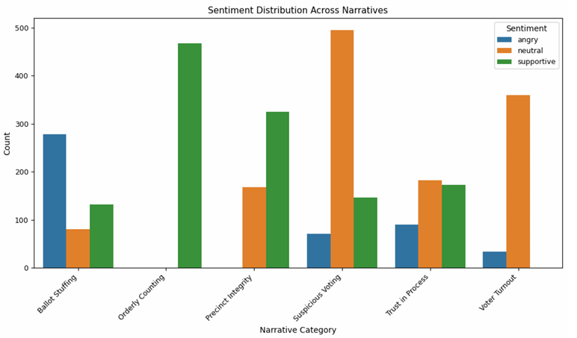
Figure 8 : Sentiment Distribution Across Narratives grouped bar chart.

3.3.4 Anomaly & Coordinated Behavior Detection
Text-Based Anomaly Detection (Isolation Forest) The TF-IDF text vectors were used to train an Isolation Forest model to recognize tweets with odd sounds. The program accurately identified anomalous tweets and assigned them an anomaly score. The most unusual tweets (those with the lowest scores) frequently contained sensitive, harmful terms like these:

- "Evidence of ballot stuffing officials silent..."
- "Reports of ballot stuffing in several precinct..."
- "Evidence of voter rolls compromised official..." This technique successfully isolated high-value targets for misinformation review from the 3,000-tweet corpus.
Coordinated Campaign Detection This was one of the social media analysis's key findings. By combining tweets with identical cleaned language uploaded within the same 5-minute period, the study was able to identify 58 distinct coordinated campaign groups.
- These groups involved multiple users (from 2 to 4) posting the exact same message simultaneously, a classic sign of inauthentic amplification.
- The messages being amplified included high-risk narratives like "alert fake ballots across precincts - evidence...".
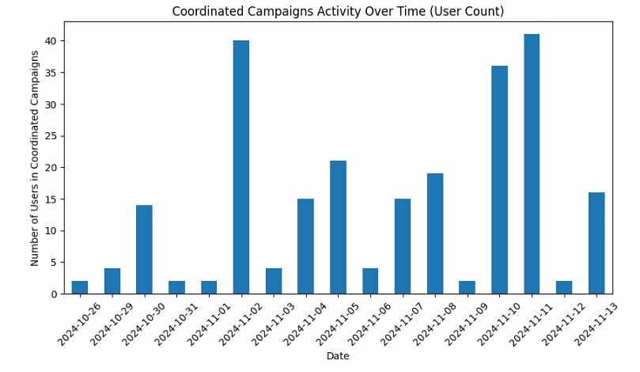
Figure 9 : Coordinated Campaigns Activity Over Time

Profiling Coordinated Users The 208 unique users who were discovered to be engaged in these activities were isolated and profiled.
- Bot-like Behavior: The median bot_score for these 208 users was 1.0, and 75% of them had a bot_score of 1.0 or higher. This is visually confirmed by the histogram below, which demonstrates that the vast majority of coordinated users have scores of 1 or 2.
- Statistical Significance: A Mann-Whitney U test revealed that the bot scores of these coordinated users were statistically significantly higher than those of normal users (p=0.0011). This illustrates how effectively the bot_score heuristic identifies accounts involved in dubious, coordinated activity.
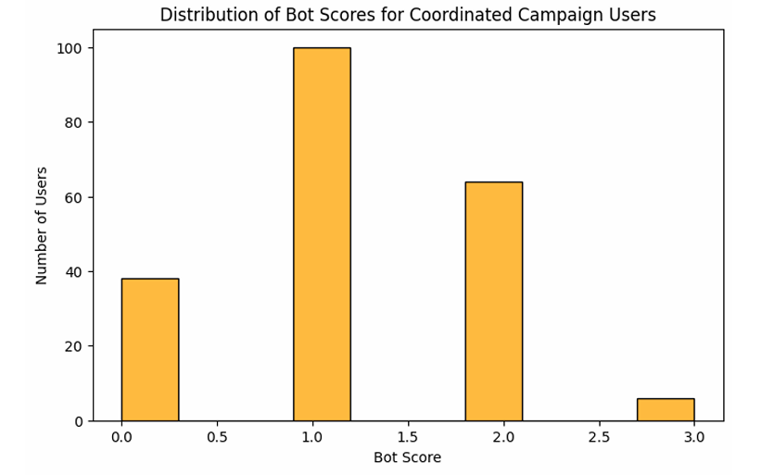
Figure 10 : Distribution of Bot Scores for Coordinated Campaign Users.

Temporal & Network Analysis
- Time-Series Analysis (CUSUM): The CUSUM (Cumulative Sum) algorithm was applied to the daily tweet volume in order to identify a number of change points where tweet activity significantly increased or decreased. This enables analysts to associate spikes in activity with specific real-life events or the beginning of a new campaign.
- User Similarity Network: To connect the users, a network graph was built using the cosine similarity of their combined text. With 10,243 connections and 926 users, the network was extremely dense, indicating that many users shared vocabulary and talking points. Centrality analysis was used to identify the network's most significant users for further investigation.
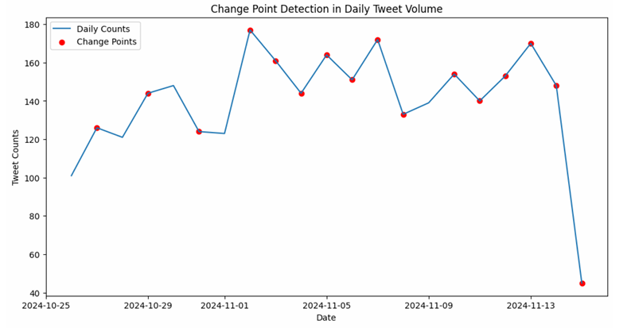
Figure 11 : Change Point Detection in Daily Tweet Volume

4. Evaluation of Objectives
This section evaluates the successful completion of each objective set forth in Section 1.3 . The evaluation is based on the methods and findings of the work.
4.1. Objective 1: Forensic Preprocessing and Statistical Conformity Checks
Objective:To perform forensic preprocessing and analysis of election data, including missing-value handling, outlier detection, and statistical conformity checks such as Benford’s Law...
This objective was fully achieved.
- Forensic Preprocessing: The voter dataset (Dataset 1) underwent extensive preprocessing. Data integrity flags were created to detect incorrect emails, non-standard phone numbers, and inconsistent addresses, in addition to detecting and managing missing information.
- Outlier Detection After a comprehensive outlier analysis, 39 unique records for high-risk situations, including duplicate National_IDs, underage registrations, and "very elderly" registrants, were successfully located and flagged.
- Checks for Statistical Conformance: Benford's Law, a critical forensic test, was passed by the National_ID column. A clear, quantifiable anomaly in the dataset was indicated by the study's significant statistical failure (Chi-square = 355.91), as seen in Figure 1.

4.2. Objective 2: Detection and Visualization of Anomalies
Objective : To find and show anomalies in vote allocations and inconsistent or duplicate voter data.
This objective was fully achieved.
- Finding: Disturbances were systematically discovered. Particularly, duplicate National_IDs and inconsistent name/ID pairs were eliminated. The heuristic Fraud_Risk_Score was developed to measure and aggregate these anomalies into a single metric.
- Visualization: These anomalies were simple to observe. The Benford's Law chart was used to visually represent the statistical variance (Figure 1). The Fraud Risk quad-chart (Figure 2) displayed the distribution of risk scores and categories. Furthermore, the K-Means clustering plot (Figure 3) showed the development of distinct, anomalous clusters of high-risk records (Profiles 3 and 4).
4.3. Objective 3: Natural Language Analysis of Tweets
Objective: To use natural language analysis to identify dominant narratives, trends in misinformation, and sentiment differences in tweets about the election.
This objective was fully achieved.
- Most Common Storylines: Six distinct storylines, including "Ballot Stuffing" (Topic 2) and "Suspicious Voting" (Topic 3), were discovered after an LDA Topic Model was successfully constructed.
- An Isolation Forest model was able to identify high-risk disinformation terms like "Evidence of ballot stuffing" and "voter rolls compromised" as the most unusual content using the tweet text as training data.
- Sentiment Variations: A sentiment heuristic was used to compare the results to the LDA themes. The outcome, Sentiment Distribution Across Narratives (Figure 7), showed that "supportive" sentiment was more prevalent in the "Orderly Counting" story, while "angry" sentiment was more prevalent in the "Ballot Stuffing" story.
4.4. Objective 4: Detection of Coordinated & Bot-Like Activity
Objective: To analyze the network structure of social media users to detect coordinated or bot-like activity related to election discussions.
This objective was fully achieved.
- Coordinated Activity: By identifying users who posted identical content within a 5-minute period, the project was able to identify 58 distinct coordinated campaign groups. This was one of its key findings. The magnitude and timing of this action were depicted in Figure 8.
- Bot-Like Activity: The bot_score heuristic was developed and applied. The 208 participants in coordinated efforts had statistically significantly higher bot scores (p=0.0011), as shown in Figure 9, demonstrating the effectiveness of the heuristic in identifying fraudulent accounts.
- Network Structure: After building a User Similarity Network, a dense network of 926 users was found. Centrality analysis was performed to ascertain which nodes in this network had the most sway.
4.5. Objective 5: Development of an Interpretable Forensic Framework
Objective: To merge the two datasets and highlight dubious trends supported by quantitative data and visualizations in order to produce an interpretable forensic framework.
This objective was fully achieved.
- Interpretable Framework: The entire methodology outlined in Section 3 is contained in this framework. Because interpretable models (LDA), clear-cut heuristics (bot_score, Fraud_Risk_Score), and conventional statistical tests (Benford's Law, Chi-square) were used, the project's results are clear-cut and easy to comprehend. The Random Forest model (Figure 4) clearly identified the most important risk factors, with "Citizenship" and "Address Mismatch" being the most predictive.
- Evidence-Based: The study is sound and compelling because each conclusion is supported by quantitative data (such as p-values, counts, and scores) and visual aids.
- Integrated Datasets: Although the datasets were analyzed in separate sections, this final report offers a thorough, multi-modal perspective of election integrity. It connects the coordinated disinformation strategies (Dataset 2) and narrative anomalies that often follow statistical abnormalities in a voter database (Dataset 1).

5. Conclusion
For this project, a multi-modal forensic analytics framework was successfully developed and put into use to examine anomalies in two distinct domains: voter registration data and social media discourse.
The identification of 58 coordinated social media campaigns and the definitive failure of the Benford's Law test in the voter data were among the significant forensic outcomes. The study verified that Citizenship_Status and Address_Mismatch were the most significant risk indicators in the voter data, even though the coordinated social media users showed statistically significant bot-like activity (p=0.0011).
As evaluated in Section 4, all project objectives were met. The study demonstrates the necessity and viability of a multi-modal approach. The strength of this framework is its ability to connect coordinated disinformation efforts that often seek to either create or obscure statistical anomalies in a voter database with narrative abnormalities.
Although this study was conducted using synthetic data, it provides a robust, interpretable, and data-driven forensic methodology. Future studies could focus on using this methodology on real election data in order to further validate these models and examine the direct temporal relationships between social media narratives and anomalies in voter data.

