

**Basic Linux Commands Assignments**

Assignment-1

Connect and disconnect with login Access

* What happens when you login a non-existent users or username?
  + Provide Screenshot and What you understand, explain in short brief?  
      
    It gives an prompt error that user does not exist.   
    This explains that Linux has very high security and no one without user data can rwx.  
      
    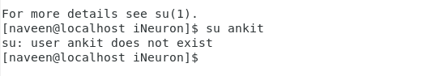

Assignment-2

Password changing

* Login into your account and then change password?
  + Change your password into **IneuR0n#42** and hit the **Enter** key
    - Explain what happen and give screenshot?

Password changed successfully.  
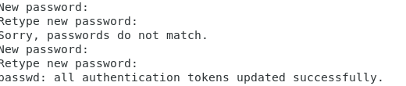

* + Try again to change password but use like password ***1234*** or ***abcd***
    - Explain what happen and give screenshot?  
      Gives an error that password cannot be shorter than 8 digits.  
      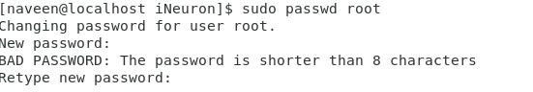
  + Try again to change password but now don’t use any password just hit **Enter** key
    - Explain what happen and give screenshot?  
      It gives an error that no password has been supplied.  
      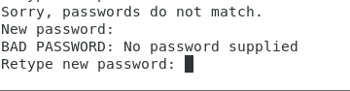

Assignment-3

Working with Directories

* Enter the command **cd /** and then **ls** and then hit **Enter** key
  + Take screenshot and explain what output we got?  
    With this command we can change from working directory to system’s root directory.  
    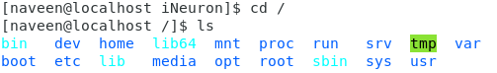

* Enter the command now **cd /home** and then hit **Enter** key
  + Do **ls,** provide screenshot and explain what is **/home** directory used for?  
    This commands take to users homepage.  
    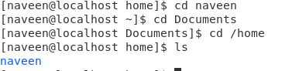
* Enter **cd ..** and hit **Enter** key [ *Note: here we have space after cd then use double dot*]
  + Check what happen and give screenshot?

Takes from working directory to parent directory.  
 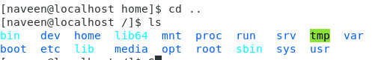

* Now enter **cd /var/www/html** and then type **cd** and hit **Enter** key
  + Explain what happen and give screenshot?  
    www folder was not found so took help from internet and came to know that it is the folder which comes with apache.  
    So installed apache server and then it was available.
  + Screenshot attached in next question.
* Now type **cd /root** and then hit **Enter** key
  + Do **ls,** check any output we have on screen if yes then take screenshot?  
      
    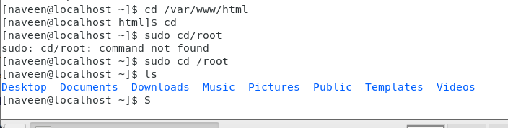

Assignment-4

Working with File Listing

* Go to **cd /etc** and type **ls**
  + Take screenshot and explain what files you have seeing?
  + Take screenshot and explain what different output you found compare to previous command you used?
* I can see that these are system configuration files of linux. Previous commands were showing folders and this command helped us to see hidden files in etc folder.

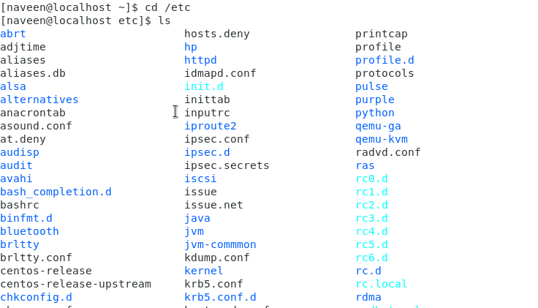

* Then type **ls -al** and hit **Enter** key
  + Take screenshot and explain what new file or directory you found?

Was able to see Hidden files.  
  
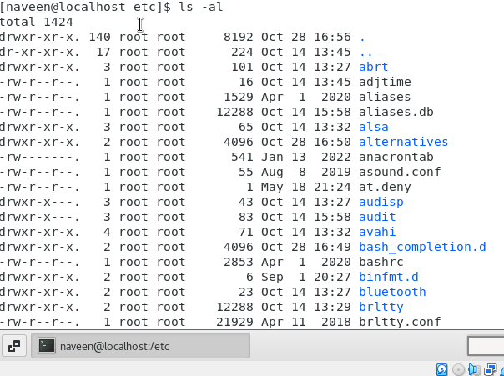

* Then use **ls -i** and hit **Enter** key
  + Now see what different output its shows and take screenshot?

This will show files in list format

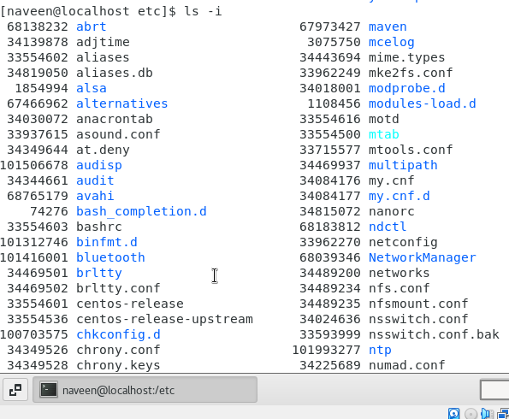

* Then use **ls –help** and see other options about **ls** command
  + Explore it and try with other attribute we can use with **ls** command
* Ls -help shows the usage of ls command and its variation.

Assignment-5

Know where you are and where you working

*Here we use* ***pwd, cd and ls*** *as combine task to understand where you working on terminal and how you can switch from one directory to another one.*

* Open terminal after restart the linux
  + Check which location you working, type **pwd** and take screenshot

Naveen - parent directory

* Now use **cd /var** and hit **Enter** key
  + Do **ls,** and see what output comes, give screenshot?

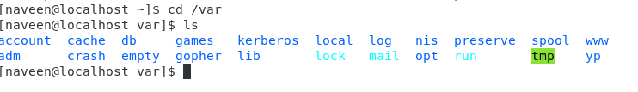

* Do explore other help options of each command to learn more other things we can do with these commands