**Software Project**

**Implementation Report**

**PUP-INSTITUTE OF TECHNOLOGY**

**INVENTORY SYSTEM**

**CHIN, GILBERTO R.**

**CONSTANTINO, JOHN SOVEREIGN U.**

**SORRA, IVAN CHRISTIAN S.**

**VICTORINO, KEVIN**

**Table of Contents**

1. **PROJECT OVERVIEW** **3**
2. **SYSTEM FUNCTIONAL REQUIREMENTS 4**

**2.1 USE CASE DIAGRAM 4**

**2.2 ACTIVITY DIAGRAM (Per Use Case) 4**

1. **DESIGN CONSTRAINTS AND NON-FUNCTIONAL REQUIREMENTS 5**
2. **ACRCHITECTURAL DESIGN 5**

**4.1 COMPONENT DIAGRAM 5**

**4.2 DEPLOYMENT DIAGRAM 5**

**4.3 CLASS DIAGRAM 5**

1. **USER INTERFACE DESIGN 6**
2. **BUSINESS PROCESSES SUPPORTED 6**
3. **INTERNAL TEST REPORT 7**
4. **USER ASSESSMENT 7**
5. **RECOMMENDATIONS 8**

**10.0 RECOMMENDATIONS 8**

**10.1 LETTER & APPROVAL 8**

**10.2 IMPLEMENTATION PICTURE 8**

**10.3 SURVERY INSTRUMENT AND SURVEY RESULTS 8**

**10.4 OTHER FORMS, LETTERS, DOCUMENTS 8**

**10.5 MOA/MOU 8**

**1.0 PROJECT OVERVIEW**

With rapidly-changing technology and increasing emphasis in managing information properly, PUP-Institute of Technology Inventory System has been developed as a solution to improve the efficiency of retrieving the documents online at any time and tracking the movement of documents in and out.

PUP-Institute of Technology Inventory System is a system that will help the inventory keeper in keeping track and monitoring the everyday inventory. The system will become a lifetime support for the Institute itself. It will consistently keep the inventory secured and unharmed. The system is uniquely designed by the developers to have a secured database. The developers sought to be responsible when the system goes down and when it becomes outdated.

This inventory system will allow the institute to archive or store information of certain list of items and at the same time, the system will store item’s full information. The system will not allow a normal user to edit and item’s information, only the admin has access to this feature.

**2.0 SYSTEM FUNCTIONAL REQUIREMENTS**

**2.1 USE CASE DIAGRAM**

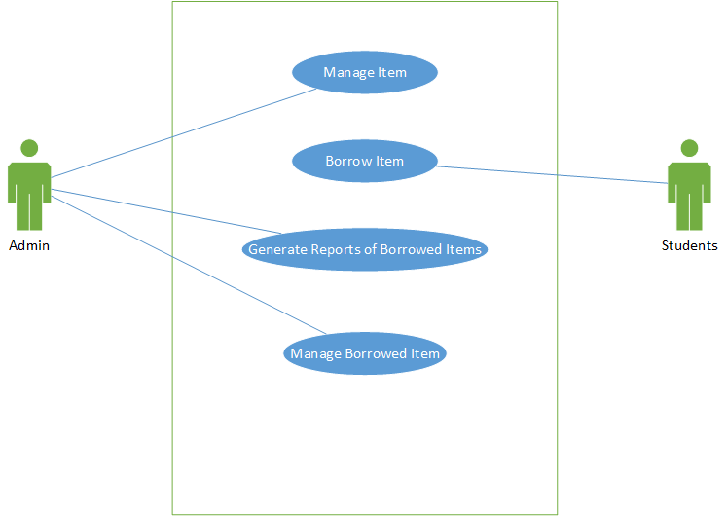

**2.2 ACTIVITY DIAGRAM**

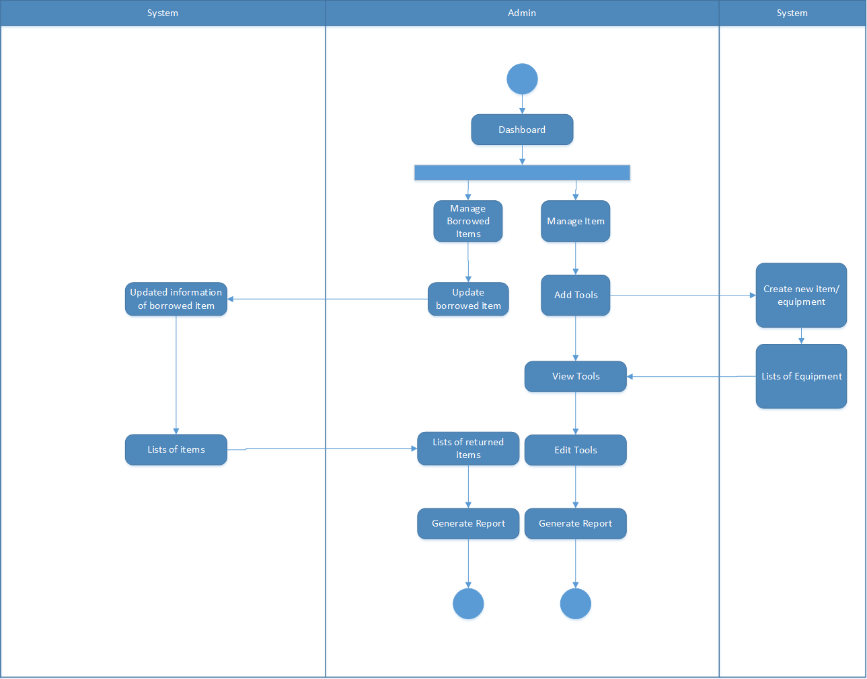

**3.0 DESIGN CONSTRAINTS AND NON-FUNCTIONAL REQUIREMENTS**

|  |  |  |  |  |  |  |  |
| --- | --- | --- | --- | --- | --- | --- | --- |
| **System Features** | **Requirements** | **RQ1:** Make the process less time consuming but still accurate. | **RQ2:** Maintain every requests **RQ2:** records from everyday transactions. | **RQ3:** Track every users borrowed item. | **RQ4:** Provide every transaction safe and secured. | **RQ5**: Create database management system for admin and students' information. | **RQ6:** Provide system generated reports that are usually manually created by the admin. |
| Web-based system for tracking of documents in and out. |  |  |  | * | * | * | * |
| Provide a database wherein all the documents are being stored and secured. |  |  | * | * | * | * |  |
| Provide an admin to manage the requests from students. |  | * | * | * |  |  | * |
| Generate reports for borrowed items. |  | * | * | * | * |  | * |
| Provide a limit that students can borrow. |  |  |  | * | * |  |  |

Table 1

**Requirements – Features Matrix**

**4.0 ARCHITECTURAL DESIGN**

**4.1 COMPONENTS DIAGRAM**

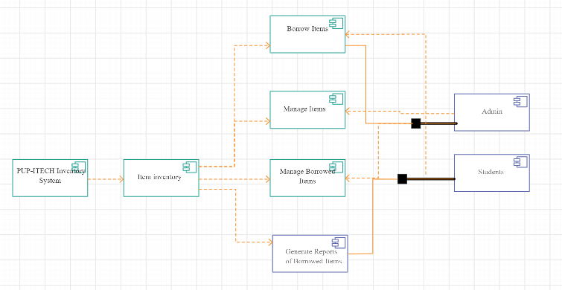

**4.2 DEPLOYMENT DIAGRAM**

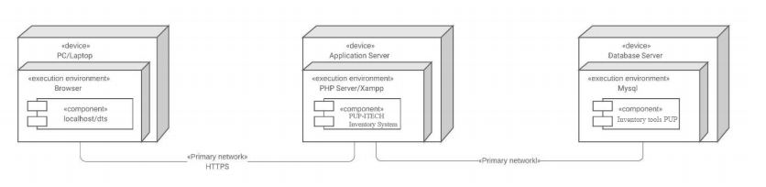

**4.3 CLASS DIAGRAM**

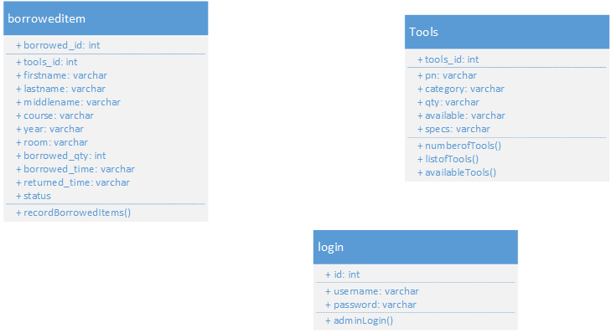

**5.0 USER INTERFACE DESIGN**

**6.0 BUSINESS PROCESSES SUPPORTED**

**Student Module Process**

|  |  |
| --- | --- |
| **Description:** | Consist of a feature allowing the student(s) to borrow an item through the system providing the necessary information that the admin will require before the completion of the process. |
| **Purpose:** | Can only submit information about the item that will be borrowed and the information about the borrower/student. |
| **Actor:** | Students |
| **Process Flow:** | Student will view the dashboard |
|  | In the dashboard, the student will provide the required information (name of the student, year and section, quantity of the item that he will borrow and add more item (if multiple items will be borrowed)). |
|  | After submitting the information, the student will surrender his I.D card and can be obtain only when all the borrowed items are returned properly. |
|  | Then the student will sign a paper for the completion of the process. |
| **Process Output:** | The student can make a request to borrow an item. |

Table 2

**Student Module Process**

**Admin Maintenance Module Process**

|  |  |
| --- | --- |
| **Description:** | Add item, manage item, and return items to the system. |
| **Purpose:** | Can be used in adding items, managing requests by the students and return items to the system |
| **Actor:** | Admin |
| **Process Flow:** | Dashboard has add item that can be managed by the admin |
|  | The admin will add an item and the information about it then the students will be able to borrow that item. |
|  | In addition, the admin can also view the list of the items and can also update the existing items. |
| **Process Output:** | The output of this process is adding an item, managing borrowed item in the system and update it. |

Table 3

**Admin Maintenance Module Process**

**7.0 INTERNAL TEST REPORT**

|  |  |  |  |  |  |
| --- | --- | --- | --- | --- | --- |
| Test Case # | Description | Intended Result | Actual Result | Action Taken  Recommendation | Date |
| 1. Admin Module: Manage Item | The system can view, edit, delete the item | Passed | Passed | None | 10/14/2019 |
| 2. Admin Module: Borrow Item | The system can store the information of the student (borrower) and the item borrowed | Passed | Passed | None | 10/14/2019 |
| 3. Admin Module: Manage Borrowed Item | The system can view, edit, delete borrowed items | Passed | Passed | None | 10/14/2019 |
| 4 Admin Module: Generate Reports | The system can generate lists of borrowed items, items, and returned items | Passed | Passed | None | 10/14/2019 |

Table 4

**Internal Test Report**

**8.0 USER ASSESSMENT**

The data shows the summary and the verbal interpretation of the result of the User Assessment Test divided in nine (9) categories: Security, Productivity, Reliability, Availability, Efficiency, Maintainability, and Effectiveness. Illustrations are presented in tabular and textual presentation, to easily differentiate of each evaluation.

**Weighted Arithmetic Mean**

Weighted Arithmetic Mean was used to determine the average responses of the five choices named: very satisfactory, satisfactory, fair, and poor. This enabled the proponents to arrive at a specific interpretation of results.

WM = Σ𝑤𝑓

𝑁

**Where:**

**WM** – weighted mean

**Wf** – number of scores multiplied by the corresponding scales

**N** – total population

Presented below are the tabular representation of the data gather from the User Acceptance Test and is computed using the *Weighted Arithmetic Mean* to define its corresponding make in verbal interpretation using the opinion index.

**Table 5 – Opinion Index**

|  |  |  |
| --- | --- | --- |
| **Scale** | **Range** | **Verbal Interpretation** |
| 5 | 4.01 – 5.0 | Excellent |
| 4 | 3.01 – 4.0 | Very Satisfactory |
| 3 | 2.01 – 3.0 | Satisfactory |
| 2 | 1.01 – 2.0 | Fair |
| 1 | 0.01 – 1.0 | Poor |

**Table 6 – Security and the Productivity of the System**

|  |  |  |
| --- | --- | --- |
| **Questions** | **Weighted Mean** | **Verbal Interpretation** |
| 1. The Inventory System has all the functions required for its execution |  |  |
| 2.The Inventory System does what was specified correctly |  |  |
| 3.The Inventory System is precise in its results |  |  |
| 4.The Inventory System has secure access through passwords |  |  |
| 5.The Inventory System interacts with the specified modules |  |  |

**Table 7 – Reliability of the System**

|  |  |  |
| --- | --- | --- |
| **Questions** | **Weighted Mean** | **Verbal Interpretation** |
| 1. The Inventory System informs users concerning invalid data entry |  |  |
| 2. The Inventory System reacts appropriately when failure occurs |  |  |
| 3. The Inventory System has no frequent failures |  |  |
| 4. The Inventory System is capable of recovering data in the event of failure |  |  |
| 5. The Inventory System can provide correct output all the time in all requested information without service interrupts |  |  |

**Table 8 – Availability of the System**

|  |  |  |
| --- | --- | --- |
| **Questions** | **Weighted Mean** | **Verbal Interpretation** |
| 1. The Inventory System is easy to operate and control |  |  |
| 2. The Inventory System facilitates the users’ data entry |  |  |
| 3. The Inventory System is easy to learn how to use. |  |  |
| 4. The Inventory System provides help in a clear manner. |  |  |
| 5. The Inventory System is easy to perform its functions |  |  |

**Table 9 – Efficiency of the System**

|  |  |  |
| --- | --- | --- |
| **Questions** | **Weighted Mean** | **Verbal Interpretation** |
| 1. The Inventory System’s execution time is appropriate |  |  |
| 2. The resources used by the Inventory System are appropriate. |  |  |
| 3. The Inventory System’s response time is appropriate |  |  |

**Table 10 – Maintainability of the System**

|  |  |  |
| --- | --- | --- |
| **Questions** | **Weighted Mean** | **Verbal Interpretation** |
| 1. The Inventory system is easy to modify and adapt. |  |  |
| 2. There is no great risk when changes are made |  |  |
| 3. The Inventory system is easy to find a failure, when it occurs |  |  |
| 4. Changes are easy to test. |  |  |

**Table 11 – Effectiveness of the System**

|  |  |  |
| --- | --- | --- |
| **Questions** | **Weighted Mean** | **Verbal Interpretation** |
| 1. The Inventory system is pleasant to use |  |  |
| 2. I think I need to have the Inventory system |  |  |
| 3. The Inventory system works the way I want it. |  |  |
| 4. The Information system is pleasant to use. |  |  |
| 5. I would recommend the Information system. |  |  |

**9.0 RECOMMENDATIONS**

The system may provide basic help to the client but we encourage the future developers to explore more and do further upgrades when making a similar system. Our system is a basic inventory system that mostly needed only when students are borrowing an item, for this we encourage the future developers to also provide features that might be useful for the system and for the client .

**10.0 APPENDICES**

**10.1 LETTER APPROVAL**

**10.2 IMPLEMENTATION PICTURE**

**10.3 SURVEY INSTRUMENT AND SURVEY RESULTS**

**10.4 OTHER FORMS, LETTERS, DOCUMENTS**

**10.5 MOA/MOU** (gains additional point in final grade)