Contents

001 Introduction 2

002 Walkthrough 2

003 Requirement 2

004 Setup a previous project 3

克隆基础项目 3

安装request组件 3

更新django到1.8版本 3

更新安装组件 3

删除老的数据库 3

数据库迁移 3

创建超级用户 3

005 Trydjano18 to ecommerce 3

006 Project Roadmap 3

007 Product App 4

008 Product Detail View 5

参考 5

009 url with django app 6

参考 7

010 Add html templates 7

011 ListView 7

参考 8

012 Using Links for Model Instance 8

013 Model Manager 8

014 Product Variation 8

015 Post Save Signal for Variation 9

016 Project Detail Layout 9

017 Image Uploads 10

018 Search Query 11

访问url 11

在view添加get_queryset 11

添加navbar 11

019 Formset for Inventory 11

访问url 11

添加Variation Inventory ModelForm 11

添加Variation Model 12

参考 13

020 Login Required Mixins 13

定义Staff Required Mixin类 13

定义Login Required Mixin类 13

添加为基类 13

021 Django Message 13

参考Djangoproject 13

参考Bootstrap 14

Template – display message 14

Settings – configure message application 14

View – add message 15

022 Social Share 15

参考 16

023 Dynamic Update Price with jQuery 16

Base模板添加JavaScript入口ready函数 16

产品模板继承block并更新价格更新函数 16

添加css 17

024 Single Variation Price 17

025 Product Categories 17

添加Category Model并在Product添加对应项 17

Admin中减价Category 17

026 Category Detail View 18

添加url 18

在Model里添加get_absolute_url 18

添加Category Detail View 18

添加Template 18

027 Related Products 19

028 Distinct Radom QuerySets 19

029 Improve UI 20

030 Django Template Include with Variable 20

031 Featured Product on Homepage 21

添加ProductFeatured model 21

在Admin添加ProductFeatured 22

将Featured image添加到context 22

在Template中增加Featured Image的显示 22

效果图 22

032 Login as Dropdown Menu 23

参考 23

033 Shopping cart icon 23

034 Product Lists on Homepage 24

在context添加产品集 24

新建专门显示产品列表的模板 24

更新产品列表模板 24

更新主页模板，添加推荐产品和特色产品 24

035 Product Editing with django Inline 24

学习参考 – inlinemodeladmin 24

036 Carts App 25

创建cart application 25

定义Cart和CartItem model 25

037 ManyToMany through 25

学习参考 – m2m through 25

Migration Issue 27

通过CartItem将Cart和Variation关联 27

在Admin中添加Cart相关model 28

038 ManyToMany Through using the Python Shell 28

039 Add, Update, Remove Carts in CBV 29

学习参考 – class-based-view 29

添加url 29

添加类CartView 29

040 Django sessions 29

学习参考 – session 30

CartView中添加cart_id session处理 30

041 Render Cart View 30

参考学习 – SingleObjectMixin 30

为CartView添加基本SingleObjectMixin 30

042 Add to cart from product view 31

043 Format Cart Remove Items 32

044 Update Cart Item quantity in Cart 33

045 Cart Item Line Total 33

学习参考– pre-save 33

添加line_item_total到model CartItem，并为CartItem绑定pre-save函数 33

更新Template，line_total->line_item_total 34

046 Cart Subtotal 34

047 Ajax Part1 35

048 Ajax Part2 36

049 Jquery Flash Message 37

050 Display Message from Server 38

087 Empty Cart 39

088 Cart Count in Navbar 40

089 Cart Total Taxes 41

090 Checkout View 42

091 Orders App 43

092 Checkout from FromMixin 44

093 Save Guest Info 45

094 User Address Model 46

095 User Address View 47

096 Model Choice Field 47

097 Order Model 48

098 Crafting the Order Part 1 49

099 Crafting the Order Part 2 50

100 Crafting the Order Part 3 50

101 Crafting the Order Part 4 52

102 Custom Mixin for Cart Order 53

103 Checkout Finalize View 55

104 Order Status 55

105 Order List 55

106 Login Required Mixin 56

107 Order Detail 56

111 UI Updates 58

113 Add On Advanced Filter for Product List 59

校错 60

# 001 Introduction

026 Category Detail View

027 Related Products

028 Distinct Radom QuerySets

029 Improve UI

030 Django Template Include with Variable

031 Featured Product on Homepage

033 Shopping cart icon

034 Product Lists on Homepage

035 Product Editing with django Inline

036 Carts App

037 ManyToMany through

038 ManyToMany Through using the Python Shell

039 Add, Update, Remove Carts in CBV

040 Django sessions

041 Render Cart View

042 Add to cart from product view

043 Format Cart Remove Items

044 Update Cart Item quantity in Cart

045 Cart Item Line Total

046 Cart Subtotal

047 Ajax Part1

048 Ajax Part2

049 Jquery Flash Message

050 Display Message from Server

087 Empty Cart

088 Cart Count in Navbar

089 Cart Total Taxes

090 Checkout View

091 Orders App

092 Checkout from FromMixin

093 Save Guest Info

094 User Address Model

095 User Address View

096 Model Choice Field

097 Order Model

098 Crafting the Order Part 1

099 Crafting the Order Part 2

100 Crafting the Order Part 3

101 Crafting the Order Part 4

102 Custom Mixin for Cart Order

103 Checkout Finalize View

104 Order Status

105 Order List

106 Login Required Mixin

107 Order Detail

111 UI Updates

113 Add On Advanced Filter for Product List

# 002 Walkthrough

# 003 Requirement

Tool

Braintree : 支付

Sublime

# 004 Setup a previous project

从github repository拿到trydjango的git地址<git@github.com:navicester/trydjango18course.git>

或者<https://github.com/codingforentrepreneurs/ecommerce-2>

## 克隆基础项目

>**git clone git@github.com:navicester/trydjango18course.git**

**virtualenv .** 试了一下不工作，还是回到父目录执行

## 安装request组件

>**pip install requests[security]** 有时安装不成功

**>pip freeze**

cffi==1.8.3

cryptography==1.5.1

enum34==1.1.6

idna==2.1

ipaddress==1.0.17

ndg-httpsclient==0.4.2

pyasn1==0.1.9

pycparser==2.14

pyOpenSSL==16.1.0

requests==2.11.1

six==1.10.0

>**pip install -r** **requirements.txt**

## 更新django到1.8版本

**>pip install django==1.8.4**

**>pip install django-registration-redux --upgrade**

## 更新安装组件

**>pip freeze > requirements.txt**

## 删除老的数据库

**>rm db.sqlite3**

## 数据库迁移

**>python manage.py migrate**

## 创建超级用户

**>python manage.py createsuperuser**

# 005 Trydjano18 to ecommerce

将文件里的trydjango18全部替换成ecommerce2，并添加新的git repository

Trydjango18目录改成ecommerce2

>rm -rf .git 切记

git init

git remote add origin git@github.com:navicester/ecommerce2course.git

git add .

git push -u origin master

# 006 Project Roadmap

1. **Product** (Physical)

Single Product (Detail View)

Social Sharing Buttons

List Product (Product View)

Inventory Contorl + Viewable

Search Products

2. **Checkout**

**Cart** (Shopping Cart)

Auth User & Guest User (non auth)

Shopping & Billing Address

3. **Payment**

Integration with Braintree (steps on other integrations)

* 007 Product App
* DetaiView
* 008 定义ProductDetailView (**View**)
* 009 添加ProductDetailView入口 (**URL**)
* 010 实现模板 (**template**)
* ListView
* 011 添加ProductListView (**View**), 模板(**template**), 入口 (**URL**)
* 012 模板里添加直接访问Model实例的链接 (**get_absolute_url**)
* 013 定制Model queryset (**Model Manager**)
* Variation
* 014 定义Variation (**model**)，添加admin，更新Product模板添加Variation选项(**template**)
* 015 Product保存时，如果没有型号，则添加一个默认型号 (**Post Save**)
* Product View Layout
* 016 分为两列，左边(col-sm-8)显示title，description，右边显示Variation
* 017 图片上传功能 (**image, PIL, slug**)
* 018 搜索功能 (**queryset, distinct**)
* 019 库存显示功能，应用(**ModelFormset**)功能
* 020 库存登录才能访问，(**LoginRequiredMixin**)
* 021 消息 (**Message**)
* 022 分享
* 023 动态更新价格 (**Jquery**)
* 024 仅一个型号时的价格显示 (**_Set.first**)
* 029 Improve UI (**thumbnail** **Cycle**)
* 030 Django Template Incude with Variabl (**include**/**with**)
* Category

025 定义Category，并为Product定义元素Categories (**m2m**)和Default Category

026 Detail View，

* 相关产品
* 027 显示相关产品 (同种**Category**) (**Distinct**)
* 028 图片显示 (**Queryset**, **sorted**, **random**, **lambda**)
* 特色产品
* 031 将特色产品显示到主页 (**ImageField**)
* Checkout

# 007 Product App

添加Product application

* 创建app python manage.py startapp *app_name*
* 定义Product类 (**Model**)
* 在settings里的INSTALLED_APPS添加这个新加的APP
* 添加Admin接口

创建一个新的app我们需要执行以下步骤

(1) 创建app，使用startapp命令。

(2) 在setting里面” INSTALLED_APPS”添加这个app名字

(3) 为改app添加model

(4) 执行migration为该app创建数据库

(5) 修改admin，为该app在admin增加入口显示

(6) 添加view处理

>python manage.py startapp product

在products.models添加product类

**from** django**.**db **import** models

# Create your models here.

**class** **Product(**models**.**Model**):**

title **=** models**.**CharField**(**max_length**=**120**)**

description **=** models**.**TextField**(**blank**=True,** null**=True)**

price **=** models**.**DecimalField**(**decimal_places**=**2**,** max_digits**=**20**)**

active **=** models**.**BooleanField**(**default**=True)**

**def** __unicode__**(**self**):** #def __str__(self):

**return** self**.**title

settings里添加products

INSTALLED_APPS **=** **(**

'django.contrib.admin'**,**

'django.contrib.auth'**,**

'django.contrib.contenttypes'**,**

'django.contrib.sessions'**,**

'django.contrib.messages'**,**

'django.contrib.sites'**,**

'django.contrib.staticfiles'**,**

'newsletter'**,**

'products'**,**

'crispy_forms'**,**

'registration'**,**

**)**

**>python manage.py makemigrations**

**>python manage.py migrate**

添加admin接口. products.admin.py

**from** **.**models **import** Product

# Register your models here.

admin**.**site**.**register**(**Product**)**

# 008 Product Detail View

## 学习参考 - class-based-views/generic-display/#detailview

<https://docs.djangoproject.com/en/1.8/ref/class-based-views/generic-display/#detailview>

**get_object(queryset=None)**[**¶**](https://docs.djangoproject.com/en/1.8/ref/class-based-views/mixins-single-object/#django.views.generic.detail.SingleObjectMixin.get_object)

Returns the single object that this view will display. If **queryset** is provided, that queryset will be used as the source of objects; otherwise, [**get_queryset()**](https://docs.djangoproject.com/en/1.8/ref/class-based-views/mixins-single-object/#django.views.generic.detail.SingleObjectMixin.get_queryset) will be used. **get_object()** looks for a [**pk_url_kwar g**](https://docs.djangoproject.com/en/1.8/ref/class-based-views/mixins-single-object/#django.views.generic.detail.SingleObjectMixin.pk_url_kwarg)argument in the arguments to the view; if this argument is found, this method performs a primary-key based lookup using that value. If this argument is not found, it looks for a [**slug_url_kwarg**](https://docs.djangoproject.com/en/1.8/ref/class-based-views/mixins-single-object/#django.views.generic.detail.SingleObjectMixin.slug_url_kwarg) argument, and performs a slug lookup using the [**slug_field**](https://docs.djangoproject.com/en/1.8/ref/class-based-views/mixins-single-object/#django.views.generic.detail.SingleObjectMixin.slug_field).

**get_context_data(**kwargs)**[**¶**](https://docs.djangoproject.com/en/1.8/ref/class-based-views/mixins-single-object/#django.views.generic.detail.SingleObjectMixin.get_context_data)

Returns context data for displaying the list of objects.

The base implementation of this method requires that the **self.object** attribute be set by the view (even if**None**). Be sure to do this if you are using this mixin without one of the built-in views that does so.

It returns a dictionary with these contents:

* **object**: The object that this view is displaying (**self.object**).
* **context_object_name**: **self.object** will also be stored under the name returned by[**get_context_object_name()**](https://docs.djangoproject.com/en/1.8/ref/class-based-views/mixins-single-object/#django.views.generic.detail.SingleObjectMixin.get_context_object_name), which defaults to the lowercased version of the model name.

**Using SingleObjectMixin with View**[**¶**](https://docs.djangoproject.com/en/1.8/topics/class-based-views/mixins/#using-singleobjectmixin-with-view)

If we want to write a simple class-based view that responds only to **POST**, we’ll subclass [**View**](https://docs.djangoproject.com/en/1.8/ref/class-based-views/base/#django.views.generic.base.View) and write a **post()**method in the subclass. However if we want our processing to work on a particular object, identified from the URL, we’ll want the functionality provided by **[SingleObjectMixin](https://docs.djangoproject.com/en/1.8/ref/class-based-views/mixins-single-object/" \l "django.views.generic.detail.SingleObjectMixin" \o "django.views.generic.detail.SingleObjectMixin)**.

We’ll demonstrate this with the **Author** model we used in the [generic class-based views introduction](https://docs.djangoproject.com/en/1.8/topics/class-based-views/generic-display/).

要更好的理解这些函数可以参考class SingleObjectMixin(ContextMixin):

类变量

model：view显示的数据。设置model=Foo的效果和指定queryset = Foo.objects.all()是一样的。Objects代表Foo的默认manager。

queryset：代表objects。 如果指定该值，那么它会取代model提供的值。

template_name：指定模板的名字

## 功能：创建Product Detail View

* 从DetailView继承，设置model元素为该app的model名字
* 指定template/context, 并渲染render

更新products.views，创建ProductDetailView，并指定template和context （测试用）

**from** django**.**views**.**generic**.**detail **import** DetailView

**from** **.**models **import** Product

# Create your views here.

**class** **ProductDetailView(**DetailView**):**

model **=** Product

下面先用非DetailView的方式显示产品，需要指定模板和context(object)，最后通过render函数渲染。

**def** product_detail_view_func**(**request**,** id**):**

product_instance **=** Product**.**objects**.**get**(**id**=**id**)**

template **=** "products/product_detail.html"

context **=** **{**

"object"**:** product_instance

**}**

**return** render**(**request**,** template**,** context**)**

urlpatterns **=** **[**

url**(**r'^(?P<id>\d+)'**,** 'products.views.product_detail_view_func'**,** name**=**'product_detail_function'**),**

**]**

<http://127.0.0.1:8000/products/1/>

# 009 url with django app

## 功能：实现DetailView的显示

## Tag : as_view, regex

在ecommerce2.url添加入口

url**(**r'^products/'**,** include**(**'products.urls'**)),**

新建文件products.url

注释掉之前的function based view的方式。添加ProductDetailView的URL。

其中, as_view将class based view转换为function based view

P<id>这个跟view里面的参数是一致的，对于CBV，这个参数会在get_absolute_url里被调用，根据name和kward reverse到对应URL。

**from** django**.**conf **import** settings

**from** django**.**conf**.**urls **import** include**,** url

**from** django**.**conf**.**urls**.**static **import** static

**from** django**.**contrib **import** admin

**from** **.**views **import** ProductDetailView

urlpatterns **=** **[**

url**(**r'^(?P<pk>\d+)/$'**,** ProductDetailView**.**as_view**(),** name**=**'product_detail'**),**

#url(r'^(?P<id>\d+)', 'products.views.product_detail_view_func', name='product_detail_function'),

**]**

<https://github.com/codingforentrepreneurs/Guides/blob/master/all/common_url_regex.md>

# 010 Add html templates

## 功能：创建template

创建products/templates/products/product_detail.htnl

DetailView的默认名字是template_name = "<appname>/<modelname>_detail.html"

可以通过更新这个名字来修改template位置

<http://127.0.0.1:8000/products/1/>

可以访问刚刚创建的product

如果访问的数据越界了，需要做一些处理，下面还是以function based view为例来讲一下这个用法

**from** django**.**shortcuts **import** render**,** get_object_or_404

**from** django**.**http **import** Http404

**def** product_detail_view_func**(**request**,** id**):**

#product_instance = Product.objects.get(id=id)

product_instance **=** get_object_or_404**(**Product**,** id**=**id**)**

**try:**

product_instance **=** Product**.**objects**.**get**(**id**=**id**)**

**except** Product**.**DoesNotExist**:**

**raise** Http404

**except:**

**raise** Http404

template **=** "products/product_detail.html"

context **=** **{**

"object"**:** product_instance

**}**

**return** render**(**request**,** template**,** context**)**

# 011 ListView

## 学习参考 - class-based-views/generic-display/#listview

<https://docs.djangoproject.com/en/1.8/ref/class-based-views/generic-display/#listview>

## 功能：ProductListView实现

* 添加入口 (url), **ListView.as_view()
* 添加ProductListView，从ListView继承
* 添加模板

更新products.urls

**from** **.**views **import** ProductDetailView**,** ProductListView

urlpatterns **=** **[**

url**(**r'^$'**,** ProductListView**.**as_view**(),** name**=**'products'**),**

**]**

<http://127.0.0.1:8000/products/>

更新products.views，添加listview的处理

和DetailView一样，我们首先指定model。

可以通过更新get_context_data函数来更新context，比如下面函数就将now信息加入到了context

**from** django**.**views**.**generic**.**list **import** ListView

**from** django**.**utils **import** timezone

**class** **ProductListView(**ListView**):**

model **=** Product

**def** get_context_data**(**self**,** **\***args**,** **\*\***kwargs**):**

context **=** super**(**ProductListView**,** self**).**get_context_data**(\***args**,** **\*\***kwargs**)**

context**[**"now"**]** **=** timezone**.**now**()**

**return** context

添加products/templates/products/product_list.html

{% extends "base.html" %}

{% block content %}

<table>

{% for object in object_list %}

<tr>

<td>{{object.title}}</td>

</tr>

{% endfor %}

</table>

{% endblock %}

# 012 Using Links for Model Instance

## 功能：Model添加直接访问Instance URL的方法

## Tag : get_absolute_url, reverse

reverse翻译就是“反转”的意思，反解析url以直接访问其它视图方法。它一般以下面的形式出现：

def reverse(self, lookup_view, *args, **kwargs):  
    return self._reverse_with_prefix(lookup_view, '', *args, **kwargs)

更新models，添加get_absolute_url() 函数，这样在模板里访问model对象时，可以直接调用该函数，避免显式地使用网址或object.pk。这样即使URL变了，对模板和view也没有影响。

**from** django**.**core**.**urlresolvers **import** reverse

**class** **Product(**models**.**Model**):**

**def** get_absolute_url**(**self**):**

**return** reverse**(**"product_detail"**,** kwargs**={**"pk"**:** self**.**pk**})**

Products/templates/products/product_list.html

<td><a href="/products/{{object.pk}}/">{{object.title}}</a></td>

<td><a href="{% url 'product_detail' pk=object.pk %}">{{object.title}}</a></td>

可以用下面的方式

<td><a href="{{ object.get_absolute_url }}">{{object.title}}</a></td>

# 013 Model Manager

<https://docs.djangoproject.com/en/1.8/topics/db/managers/>

<https://docs.djangoproject.com/en/1.8/ref/models/querysets/>

## 功能：定制化model queryset, 过滤model里面的一些objects

## Tag : QuerySet, filter

[Django ORM之QuerySet](http://www.cnblogs.com/ajianbeyourself/p/3604332.html)

Django ORM用到三个类：Manager、QuerySet、Model。Manager定义表级方法（表级方法就是影响一条或多条记录的方法），我们可以以models.Manager为父类，定义自己的manager，增加表级方法；QuerySet：Manager类的一些方法会返回QuerySet实例，QuerySet是一个可遍历结构，包含一个或多个元素，每个元素都是一个Model 实例，它里面的方法也是表级方法，前面说了，Django给我们提供了增加表级方法的途径，那就是自定义manager类，而不是自定义QuerySet类，一般的我们没有自定义QuerySet类的必要；django.db.models模块中的Model类，我们定义表的model时，就是继承它，它的功能很强大，通过自定义model的instance可以获取外键实体等，它的方法都是记录级方法（都是实例方法，貌似无类方法），不要在里面定义类方法，比如计算记录的总数，查看所有记录，这些应该放在自定义的manager类中。

By default, Django adds a Manager with the name **objects** to every Django model class.

如果想定制化返回queryset，需要子类化models.Manager，并在Model类里面将objects指向这个Manager

objects就是一个默认的modelManager

Model里添加Model Manager，更新all()函数，使这个queryset过滤active为True的这些对象。

通过下面实现，objects.all()变成了只包含active状态的products。

class ProductQuerySet(models.query.QuerySet):

def active(self):

return self.filter(active=True)

class ProductManager(models.Manager):

def get_queryset(self):

return ProductQuerySet(self.model, using=self._db)

def all(self, *args, **kwargs):

return self.get_queryset().active()

**class** **Product(**models**.**Model**):**

title **=** models**.**CharField**(**max_length**=**120**)**

description **=** models**.**TextField**(**blank**=True,** null**=True)**

price **=** models**.**DecimalField**(**decimal_places**=**2**,** max_digits**=**20**)**

active **=** models**.**BooleanField**(**default**=True)**

objects **=** ProductManager**()**

view里更新queryset，这个Product**.**objects**.**all**()**函数已经在Manager里面定制化过，只返回active=True的对象。

**class** **ProductListView(**ListView**):**

model **=** Product

queryset **=** Product**.**objects**.**all**()**

# 014 Product Variation

## 功能：添加产品型号Model

* 定义Variation (model)
* 添加admin接口
* 更新模板，添加Variation选项

## JQuery ：select/option

## 添加类variation

文件products.models

|  |  |
| --- | --- |
| product | Variation和Product的关系是n.1，一个product可以有多个型号 |
| title | 型号的标题 |
| price | 各个型号对应的价格，十进制的，默认两位小数点，最多20个数字 |
| sale_price | 销售价格，这个可以为空。获取商品价格时，默认取销售价格，如果没有，则读取成本价格 |
| active | 上架或下架状态 |
| inventory | 库存量 |

class Variation(models.Model):

product = models.ForeignKey(Product)

title = models.CharField(max_length=120)

price = models.DecimalField(decimal_places=2, max_digits=20)

sale_price = models.DecimalField(decimal_places=2, max_digits=20, null=True, blank=True)

active = models.BooleanField(default=True)

inventory = models.IntegerField(null=True, blank=True) #refer none == unlimited amount

def __unicode__(self):

return self.title

def get_price(self):

if self.sale_price is not None:

return self.sale_price

else:

return self.price

def get_absolute_url(self):

return self.product.get_absolute_url()

## 更新ProductDetail模板

这儿object指的是product对象，遍历product的所有型号。

option标签可选的属性

|  |  |  |
| --- | --- | --- |
| 属性 | 值 | 描述 |
| [disabled](http://www.w3school.com.cn/tags/att_option_disabled.asp) | disabled | 规定此选项应在首次加载时被禁用。 |
| [label](http://www.w3school.com.cn/tags/att_option_label.asp) | text | 定义当使用 <optgroup> 时所使用的标注。 |
| [selected](http://www.w3school.com.cn/tags/att_option_selected.asp) | selected | 规定选项（在首次显示在列表中时）表现为选中状态。 |
| [value](http://www.w3school.com.cn/tags/att_option_value.asp) | text | 定义送往服务器的选项值。 |

<select class='form-control'>

{% for vari_obj in object.variation_set.all %}

<option value = "{{vari_obj.id}}">

{{vari_obj}}

</option>

{% endfor %}

</select>

## 添加admin接口

**from** **.**models **import** Variation

admin**.**site**.**register**(**Variation**)**

更新一些css符合commerce的风格

# 015 Post Save Signal for Variation

<https://docs.djangoproject.com/en/1.8/ref/signals/#post-save>

## 功能：Variation模型的Post Save，新建一个product时，如果没有variation，那么创建一个default的variation

型号往往是产品创建之后才会创建型号，为避免型号忘记创建导致后面处理的问题，每次产品创建之后，直接创建一个默认的型号。

在model添加post save处理

新建一个product时，如果没有variation，那么创建一个default的variation

首先，要定义一个post save的处理函数，然后通过post_save.connect将函数和对应的model绑定起来。

**def** product_post_saved_receiver**(**sender**,** instance**,** created**,** **\***args**,** **\*\***kwargs**):**

product **=** instance

variations **=** product**.**variation_set**.**all**()**

**if** variations**.**count**()** **==** 0**:**

new_var **=** Variation**()**

new_var**.**product **=** product

new_var**.**title **=** "Default"

new_var**.**price **=** product**.**price

new_var**.**save**()**

post_save**.**connect**(**product_post_saved_receiver**,** sender**=**Product**)**

在template product_detail.html过滤掉默认创建的variation

**{% if object.variation_set.count > 0 %}**

<select class=**'form-control'**>

**{% for vari_obj in object.variation_set.all %}**

<option value = **"{{vari_obj.id}}"**>

**{{vari_obj}}**

</option>

**{% endfor %}**

</select>

**{% endif %}**

<br/>

<a href=**"#"**>**Add to Cart**</a>

# 016 Project Detail Layout

## 功能：分为两栏，左边是描述，右边是Variation

## Tag : row, col-sm-x

<div class=**"row"**>

<div class=**"****col-sm-8"**>

<h2>**{{object.title}}**</h2>

<p class=**"lead"**>

**{{object.description}}**

</p>

</div>

<div class=**"col-sm-4"**>

<h3>**{{object.price}}**</h3>

**{% if object.variation_set.count > 1 %}**

<select class=**'form-control'**>

**{% for vari_obj in object.variation_set.all %}**

<option value = **"{{vari_obj.id}}"**>

**{{vari_obj}}**

</option>

**{% endfor %}**

</select>

**{% endif %}**

<br/>

<hr/>

<h4>**Related Products**</h4>

<a href=**"#"**>**Add to Cart**</a>

</div>

**{% endblock %}**

# 017 Image Uploads

## 功能：图片上传功能 (admin)

## Tag : PIL, slug

## 学习参考

<https://github.com/codingforentrepreneurs/Guides/blob/master/all/imagefield_and_pillow.md>

## pillow

pillow是python image库

>**pip install pillow**

## slug

slug：用于生成一个有意义（valid, meaninful）URL　　参考（http://stackoverflow.com/questions/427102/what-is-a-slug-in-django）

比如：<http://stackoverflow.com/questions/427102/what-is-a-slug-in-django>　　后面的“what-is-a-slug-in-django”就是经过slug后的产物

如何使用：

需要使用slugify功能：from django.utils.text import slugify

例子：slugify(value)　　If value is "Joel is a slug", the output will be "joel-is-a-slug".

It's a way of generating a valid URL, generally using data already obtained. For instance, using the title of an article to generate a URL. I'd advise to generate the slug, using a function, given a title (or other piece of data), rather than setting it manually.

An example:

<title> The 46 Year Old Virgin </title>

<content> A silly comedy movie </content>

<slug> the-46-year-old-virgin </slug>

Now let's pretend that we have a Django model such as:

class Article(models.Model):

title = models.CharField(max_length=100)

content = models.TextField(max_length=1000)

slug = models.SlugField(max_length=40)

How would you reference this object with a URL, with a meaningful name? You could use Article.id so the URL would look like this:

www.example.com/article/23

Or, you could reference the title like so:

www.example.com/article/The 46 Year Old Virgin

Problem is, spaces aren't valid in URLs, they need to be replaced by %20 which is ugly, making it the following:

www.example.com/article/The%2046%20Year%20Old%20Virgin

That's not solving our meaningful URL. Wouldn't this be better:

www.example.com/article/the-46-year-old-virgin

That's a slug. the-46-year-old-virgin. All letters are downcased and spaces are replaced by hyphens -. See the URL of this very webpage for an example!

**SlugField**

也是起到类似作用，只不过这个一般是后台直接添加时使用，比如：slug = models.SlugField(unique=True)

这样在后台就有个slug框，填写后，URL中就包含slug中的内容。

## 创建ProductImage类 (product.models)

其中，存放路径在MEDIA_ROOT = os.path.join(os.path.dirname(BASE_DIR), "static_in_env", "media_root")

子目录可以自定义

这儿有2个文件iphone_cover.jpg，mp3_player.jpg分别传给Product里面的iPhone Cover和MP3 Player

**from** django**.**utils**.**text **import** slugify

**def** image_upload_to**(**instance**,** filename**):**

title **=** instance**.**product**.**title

slug **=** slugify**(**title**)**

basename**,** file_extension **=** filename**.**split**(**"."**)**

new_filename **=** "%s-%s.%s" **%(**slug**,** instance**.**id**,** file_extension**)**

**return** "products/%s/%s" **%(**slug**,** new_filename**)**

比如上传的文件名名为iphone_cover.jpg，为iPhone Cover model添加ProductImage

则title, slug, basename, file_extension, new_filename的值分别如下：

iPhone Cover iphone-cover iphone_cover jpg iphone-cover-2.jpg

如果是第一次创建ProductImage，instance**.**id为None

MP3 Player mp3-player mp3_player jpg mp3-player-None.jpg

MP3 Player mp3_player.jpg

同样的名字，如果做第二次修改

MP3 Player mp3-player mp3_player jpg mp3-player-3.jpg

MP3 Player mp3_player.jpg

**Currently:**[products/mp3-player/mp3-player-3.jpg](http://127.0.0.1:8001/media/products/mp3-player/mp3-player-3_7KveE47.jpg)

同样的名字，如果继续覆盖，文件不会被覆盖，而是增加随机数重新拷贝一个

MP3 Player mp3-player mp3_player jpg mp3-player-3.jpg

MP3 Player mp3_player.jpg

**Currently:**[products/mp3-player/mp3-player-3_7KveE47.jpg](http://127.0.0.1:8001/media/products/mp3-player/mp3-player-3_7KveE47.jpg)

入参instance和filename分别为

iPhone Cover iphone_cover.jpg

filename为上传文件的文件名

class ProductImage(models.Model):

product = models.ForeignKey(Product)

image = models.ImageField(upload_to=image_upload_to)

def __unicode__(self):

return self.product.title

**>python manage.py makemigrations**

**>python manage.py migrate**

创建admin接口

**from** **.**models **import** Product**,**Variation**,**ProductImage

admin**.**site**.**register**(**ProductImage**)**

在product_detail_view添加图片显示

下面这两个的显示分别如下

{{ img.image.file }}

{{ img.image.url }}

D:\virtualenv\ecommerce-ws\src\static_in_env\media_root\products\mp3-player\mp3-player-None.jpg

/media/products/mp3-player/mp3-player-None.jpg

MEDIA_URL = '/media/'

MEDIA_ROOT = os.path.join(os.path.dirname(BASE_DIR), "static_in_env", "media_root")

# 018 Search Query

## 功能：实现搜索功能

## Tag : distinct, queryset, Q, icontains

## 访问url

如果想要搜索的话，一般我们会用

127.0.0.1:8000/products/?q=

## 在view添加get_queryset

**distinct**符合两个q的object不会重复显示

products/views.py

**from** django**.**db**.**models **import** Q

**class** **ProductListView(**FilterMixin**,** ListView**):**

model **=** Product

queryset **=** Product**.**objects**.**all**()**

**def** get_context_data**(**self**,** **\***args**,** **\*\***kwargs**):**

context **=** super**(**ProductListView**,** self**).**get_context_data**(\***args**,** **\*\***kwargs**)**

context**[**"now"**]** **=** timezone**.**now**()**

context**[**"query"**]** **=** self**.**request**.**GET**.**get**(**"q"**)** #None

**return** context

**def** get_queryset**(**self**,** **\***args**,** **\*\***kwargs**):**

qs **=** super**(**ProductListView**,** self**).**get_queryset**(\***args**,** **\*\***kwargs**)**

query **=** self**.**request**.**GET**.**get**(**"q"**)**

**if** query**:**

qs **=** self**.**model**.**objects**.**filter**(**

Q**(**title__icontains**=**query**)** **|**

Q**(**description__icontains**=**query**)**

**)**

**try:**

qs2 **=** self**.**model**.**objects**.**filter**(**

Q**(**price**=**query**)**

**)**

qs **=** **(**qs **|** qs2**).**distinct**()**

**except:**

**pass**

**return** qs

## 添加navbar

修改navbar.html来增加搜索

注释掉about和contact不再使用

去掉默认的submit按钮，功能跟回车一样

添加method为get，action指向product url

<!-- <li><a href="{% url 'about' %}">About</a></li>

<li><a href="{% url 'contact' %}">Contact</a></li> -->

<form class=**"navbar-form navbar-left"** method=**"GET"** role=**"search"** action=**'{% url "products" %}'**>

<div class=**"form-group"**>

<input type=**"text"** class=**"form-control"** placeholder=**"Search"** name=**"q"'**>

</div>

<!-- <button type="submit" class="btn btn-default">Submit</button> -->

</form>

# 019 Formset for Inventory

## 功能：库存视图

* 定义Variation库存ModelForm
* 定义Variation Model
* 定义VariationListView视图（从ListView继承），使用到Formset
* 添加variation入口

## 访问url

127.0.0.1:8000/products/1/inventory/

## 添加Variation Inventory ModelForm

添加forms.py，定义VariationInventoryForm

**from** django **import** forms

**from** django**.**forms**.**models **import** modelformset_factory

**from** **.**models **import** Variation

**class** **VariationInventoryForm(**forms**.**ModelForm**):**

**class** **Meta:**

model **=** Variation

fields **=** **[**

"price"**,**

"sale_price"**,**

"inventory"**,**

"active"**,**

**]**

VariationInventoryFormSet **=** modelformset_factory**(**Variation**,** form**=**VariationInventoryForm**,** extra**=**0**)**

form.instance是自带的参数

**class** **BaseModelForm(**BaseForm**):**

**def** __init__**(**self**,** data**=None,** files**=None,** auto_id**=**'id_%s'**,** prefix**=None,**

initial**=None,** error_class**=**ErrorList**,** label_suffix**=None,**

empty_permitted**=False,** instance**=None):**

## 添加Variation Model

在model中增加variation定义

**添加Varation List View**

在views.py增加VariationList object

**from** django**.**contrib **import** messages

**from** django**.**shortcuts **import** render**,** get_object_or_404**,** redirect

**class** **VariationListView(**ListView**):**

model **=** Variation

queryset **=** Variation**.**objects**.**all**()**

**def** get_context_data**(**self**,** **\***args**,** **\*\***kwargs**):**

context **=** super**(**VariationListView**,** self**).**get_context_data**(\***args**,** **\*\***kwargs**)**

context**[**"formset"**]** **=** VariationInventoryFormSet**(**queryset**=**self**.**get_queryset**())** #增加formset context

**return** context

**def** get_queryset**(**self**,** **\***args**,** **\*\***kwargs**):**

product_pk **=** self**.**kwargs**.**get**(**"pk"**)**

**if** product_pk**:**

product **=** get_object_or_404**(**Product**,** pk**=**product_pk**)**

queryset **=** Variation**.**objects**.**filter**(**product**=**product**)** #过滤variation为对应与该product的

**return** queryset

**def** post**(**self**,** request**,** **\***args**,** **\*\***kwargs**):**

formset **=** VariationInventoryFormSet**(**request**.**POST**,** request**.**FILES**)**

**if** formset**.**is_valid**():**

formset**.**save**(**commit**=False)**

**for** form **in** formset**:**

new_item **=** form**.**save**(**commit**=False)**

#if new_item.title:

product_pk **=** self**.**kwargs**.**get**(**"pk"**)** #这个在url里面会传过来

product **=** get_object_or_404**(**Product**,** pk**=**product_pk**)**

new_item**.**product **=** product

new_item**.**save**()**

messages**.**success**(**request**,** "Your inventory and pricing has been updated."**) #**抛出消息

**return** redirect**(**"products"**)**

**raise** Http404

增加variation url

url**(**r'^(?P<pk>\d+)/inventory/$'**,** VariationListView**.**as_view**(),** name**=**'product_inventory'**),**

添加products/templates/products/variation_list.html

#template_name = "<appname>/<modelname>_list.html"

{% extends "base.html" %}

{% block content %}

<table class='table'>

{% for object in object_list %}

<tr>

<td><a href='{{ object.get_absolute_url }}'>{{ object.title }}</a></td><td>{{ object.inventory }}</td>

</tr>

{% endfor %}

</table>

<form method="POST" action=""> {% csrf_token %}

{{ formset.management_form }}

{% for form in formset %}

{{ form.instance.product.title }}

{{ form.instance.title }}

{{ form.as_p }}

{% endfor %}

<input type="submit" value='Update' class='btn' />

</form>

{% endblock %}

另外：可以通过下面方法添加inventory超链接（不在原始文档里）

class Product(models.Model):

def get_inventory_url(self):

return reverse("product_inventory", kwargs={"pk": self.pk})

<a href="{{object.get_inventory_url}}">Inventory</a>

## 参考

<https://docs.djangoproject.com/en/1.8/topics/forms/modelforms/#modelform-factory-function>

# 020 Login Required Mixins

## 功能：库存需登录才能访问

## Tag : classmethod, method_decorator, dispatch, Mixin

## 定义Staff Required Mixin类

创建文件products/mixins.py

**from** django**.**contrib**.**admin**.**views**.**decorators **import** staff_member_required

**from** django**.**contrib**.**auth**.**decorators **import** login_required

**from** django**.**utils**.**decorators **import** method_decorator

**from** django**.**http **import** Http404

**class** **StaffRequired****Mixin(**object**):**

@classmethod

**def** as_view**(**self**,** **\***args**,** **\*\***kwargs**):**

view **=** super**(**StaffRequiredMixin**,** self**).**as_view**(\***args**,** **\*\***kwargs**)**

**return** login_required**(**view**)**

@method_decorator**(**login_required**)**

**def** dispatch**(**self**,** request**,** **\***args**,** **\*\***kwargs**):**

**if** request**.**user**.**is_staff**:**

**return** super**(**StaffRequiredMixin**,** self**).**dispatch**(**request**,** **\***args**,** **\*\***kwargs**)**

**else:**

**raise** Http404

## 定义Login Required Mixin类

class LoginRequiredMixin(object):

@classmethod

def as_view(self, *args, **kwargs):

view = super(LoginRequiredMixin, self).as_view(*args, **kwargs)

return login_required(view)

@method_decorator(login_required)

def dispatch(self, request, *args, **kwargs):

return super(LoginRequiredMixin, self).dispatch(request, *args, **kwargs)

## 添加为基类

更新views.py

**from** **.**mixins **import** StaffRequiredMixin

**class** **VariationListView(**StaffRequiredMixin**,** ListView**):**

# 021 Django Message

## 参考Djangoproject

[https://docs.djangoproject.com/en/1.8/ref/contrib/messages/#using-messages-in-views-and-templates](https://docs.djangoproject.com/en/1.8/ref/contrib/messages/" \l "using-messages-in-views-and-templates)

**Adding a message**[**¶**](https://docs.djangoproject.com/en/1.8/ref/contrib/messages/#adding-a-message)

**add_message(request, level, message, extra_tags='', fail_silently=False)**[**[source]**](https://docs.djangoproject.com/en/1.8/_modules/django/contrib/messages/api/#add_message)[**¶**](https://docs.djangoproject.com/en/1.8/ref/contrib/messages/#django.contrib.messages.add_message)

To add a message, call:

**from** **django.contrib** **import** messages

messages.add_message(request, messages.INFO, 'Hello world.')

Some shortcut methods provide a standard way to add messages with commonly used tags (which are usually represented as HTML classes for the message):

messages.debug(request, '**%s** SQL statements were executed.' % count)

messages.info(request, 'Three credits remain in your account.')

messages.success(request, 'Profile details updated.')

messages.warning(request, 'Your account expires in three days.')

messages.error(request, 'Document deleted.')

**Displaying messages**[¶](https://docs.djangoproject.com/en/1.8/ref/contrib/messages/#displaying-messages)

**get_messages(request)**[**[source]**](https://docs.djangoproject.com/en/1.8/_modules/django/contrib/messages/api/#get_messages)[**¶**](https://docs.djangoproject.com/en/1.8/ref/contrib/messages/#django.contrib.messages.get_messages)

**In your template**, use something like:

{% **if** messages %}

<ul class="messages">

{% **for** message **in** messages %}

<li{% **if** message.tags %} class="{{ message.tags }}"{% endif %}>{{ message }}</li>

{% endfor %}

</ul>

{% endif %}

将这一段拷贝到 *base.html*

## 参考Bootstrap

通过<http://getbootstrap.com/components/#alerts>添加alert特性

几种常见的alert

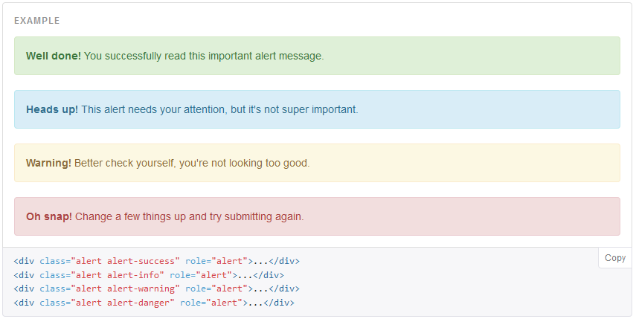

## Template – display message

*Base.html*

下面在template添加一个dismissible alert

*Base.html (src\templates)*

{% if messages %}

<div class='container'>

<div class='alert alert-success text-center alert-dismissible'>

<button type="button" class="close" data-dismiss="alert" aria-label="Close"><span aria-hidden="true">&times;</span></button>

{% for message in messages %}

<p{% if message.tags %} class="{{ message.tags }}"{% endif %}>{{ message }}</p><br/>

{% endfor %}

</div>

</div>

{% endif %}

## Settings – configure message application

确保INSTALLED_APPS已包含改APP django.contrib.messages

# Application definition

INSTALLED_APPS **=** **(**

#django app

'django.contrib.admin'**,**

'django.contrib.auth'**,**

'django.contrib.contenttypes'**,**

'django.contrib.sessions'**,**

'django.contrib.sites'**,**

'django.contrib.messages'**,**

'django.contrib.staticfiles'**,**

#third party apps

'crispy_forms'**,**

'registration'**,**

#my apps

'newsletter'**,**

**)**

## View – add message

下面列举在各个APP中对message的使用

*Views.py (src\carts)*

**from** django**.**contrib **import** messages

**class** **CheckoutFinalView(**CartOrderMixin**,** View**):**

**def** post**(**self**,** request**,** **\***args**,** **\*\***kwargs**):**

order **=** self**.**get_order**()**

order_total **=** order**.**order_total

nonce **=** request**.**POST**.**get**(**"payment_method_nonce"**)**

**if** nonce**:**

result **=** braintree**.**Transaction**.**sale**({**

"amount"**:** order_total**,**

"payment_method_nonce"**:** nonce**,**

"billing"**:** **{**

"postal_code"**:** "%s" **%(**order**.**billing_address**.**zipcode**),**

**},**

"options"**:** **{**

"submit_for_settlement"**:** **True**

**}**

**})**

**if** result**.**is_success**:**

#result.transaction.id to order

order**.**mark_completed**(**order_id**=**result**.**transaction**.**id**)**

messages**.**success**(**request**,** "Thank you for your order."**)**

**del** request**.**session**[**"cart_id"**]**

**del** request**.**session**[**"order_id"**]**

**else:**

messages**.**success**(**request**,** "%s" **%(**result**.**message**))**

**return** redirect**(**"checkout"**)**

**return** redirect**(**"order_detail"**,** pk**=**order**.**pk**)**

*Views.py (src\orders)*

**from** django**.**contrib **import** messages

**class** **AddressSelectFormView(**CartOrderMixin**,** FormView**):**

**def** dispatch**(**self**,** **\***args**,** **\*\***kwargs**):**

b_address**,** s_address **=** self**.**get_addresses**()**

**if** b_address**.**count**()** **==** 0**:**

messages**.**success**(**self**.**request**,** "Please add a billing address before continuing"**)**

**return** redirect**(**"user_address_create"**)**

**elif** s_address**.**count**()** **==** 0**:**

messages**.**success**(**self**.**request**,** "Please add a shipping address before continuing"**)**

**return** redirect**(**"user_address_create"**)**

**else:**

**return** super**(**AddressSelectFormView**,** self**).**dispatch**(\***args**,** **\*\***kwargs**)**

*Views.py (src\products)*

**from** django**.**contrib **import** messages

**class** **VariationListView(**StaffRequiredMixin**,** ListView**):**

**def** post**(**self**,** request**,** **\***args**,** **\*\***kwargs**):**

formset **=** VariationInventoryFormSet**(**request**.**POST**,** request**.**FILES**)**

**if** formset**.**is_valid**():**

formset**.**save**(**commit**=False)**

**for** form **in** formset**:**

new_item **=** form**.**save**(**commit**=False)**

#if new_item.title:

product_pk **=** self**.**kwargs**.**get**(**"pk"**)**

product **=** get_object_or_404**(**Product**,** pk**=**product_pk**)**

new_item**.**product **=** product

new_item**.**save**()**

messages**.**success**(**request**,** "Your inventory and pricing has been updated."**)**

**return** redirect**(**"products"**)**

**raise** Http404

## 效果图

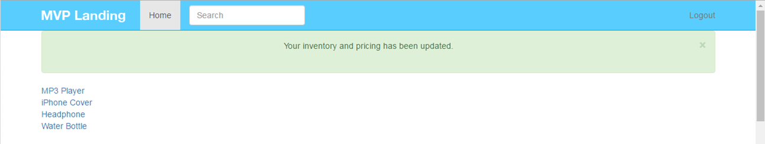

# 022 Social Share

facebook为例

<p>

Share<br/>

<a href="https://www.facebook.com/sharer/sharer.php?u={{ request.build_absolute_uri }}">

<i class="fa fa-facebook-square fa-3x"></i></a>

<a href="#">

<i class="fa fa-twitter-square fa-3x"></i></a>

</p>

## 参考

用法参考lauchwithcode：Create a social page to share 1,2,3

<https://github.com/codingforentrepreneurs/Guides/blob/master/all/social_share_links.md>

# 023 Dynamic Update Price with jQuery

## 功能：通过JQuery动态更新价格

## Tag : JQuery

包含图片和文字的两种更新方式

文字: text或者html

图片:

## 添加元素

为了能够在JS中控制这些html元素，通常会增加id或者class属性，这样JQuery比较容易定位到元素而控制它的行为。

添加价格显示, “id=**'price'**”, “class=**'variation_select'**”, 这两个都会价格更新的JavaScript函数中调用

为option添加两个属性，”data-sale-price”和”data-price”

<div class=**"col-sm-4"**>

<h3 id=**'price'**>**{{object.price}}**</h3>

**{% if object.variation_set.count > 1 %}**

<select class=**'form-control variation_select'**>

**{% for vari_obj in object.variation_set.all %}**

<!-- <option data-img="http://www.spirit1059.com/pics/Feeds/Articles/2015611/118317/Beach.jpg" data-price="{{ vari_obj.price }}" value="{{ vari_obj.id }}">{{ vari_obj }}</option> -->

<option data-sale-price=**"{{ vari_obj.sale_price }}"** data-price=**"{{ vari_obj.price }}"** value=**"{{ vari_obj.id }}"**>**{{ vari_obj }}**</option>

**{% endfor %}**

</select>

**{% endif %}**

## 添加image显示

<div class=**"col-sm-8"**>

<h2>**{{object.title}}**</h2>

**{% if object.productimage_set.count > 0 %}**

<div>

**{% for img in object.productimage_set.all %}**

<!-- {{ img.image.file }}

{{ img.image.url }} -->

<img id=**'img'** class= **'img-responsive'** src=**"{{img.image.url}}"**/>

**{% endfor %}**

</div>

**{% endif %}**

<p class=**"lead"**>

**{{object.description}}**

</p>

</div>

## Base模板添加JavaScript入口ready函数

在base.html

<script>

$(document).ready(function(){

{% block jquery %}

{% endblock %}

});

</script>

<https://learn.jquery.com/using-jquery-core/document-ready/>

If you want an event to work on your page, you should call it inside the $(document).ready() function. Everything inside it will load as soon as the DOM is loaded and before the page contents are loaded.

A page can't be manipulated safely until the document is "ready." jQuery detects this state of readiness for you. Code included inside $( document ).ready() will only run once the page Document Object Model (DOM) is ready for JavaScript code to execute. Code included inside $( window ).on( "load", function() { ... }) will run once the entire page (images or iframes), not just the DOM, is ready.

Jquery中$(document).ready()的作用类似于传统JavaScript中的window.onload方法，不过与window.onload方法还是有区别的。

**1.执行时间**

window.onload必须等到页面内包括图片的所有元素加载完毕后才能执行。

$(document).ready()是DOM结构绘制完毕后就执行，不必等到加载完毕。

**2.编写个数不同**

window.onload不能同时编写多个，如果有多个window.onload方法，只会执行一个

$(document).ready()可以同时编写多个，并且都可以得到执行

**3.简化写法**

window.onload没有简化写法

$(document).ready(function(){})可以简写成$(function(){});

## 产品模板继承block并更新价格更新函数

何时触发价格更新? $(".variation_select").change

怎么更新? $("#price").html

Product_detail.html

<script>

**{%** block jquery **%}**

**function** setPrice**(){**

**var** price **=** $**(**".variation_select option:selected"**).**attr**(**"data-price"**)**

**var** sale_price **=** $**(**".variation_select option:selected"**).**attr**(**"data-sale-price"**)**

**if** **(**sale_price **!=** "" **&&** sale_price **!=** "None" **&&** sale_price **!=** null **)** **{**

$**(**"#price"**).**html**(**"<h3>" **+** sale_price **+** " <small style='color:red;text-decoration:line-through;'>Original Price:" **+** price **+** "</small></h3>"**);**

**}** **else** **{**

$**(**"#price"**).**html**(**price**);**

**}**

**}**

setPrice**()**

$**(**".variation_select"**).**change**(function(){**

setPrice**();**

// var img = $(".variation_select option:selected").attr("data-img")

// $("img").attr("src", img);

**})**

**{%** endblock **%}**

</script>

**small**

<http://www.w3school.com.cn/tags/tag_small.asp>

<small> 标签呈现小号字体效果。

<small> 标签和它所对应的 <big> 标签一样，但它是缩小字体而不是放大。如果被包围的字体已经是字体模型所支持的最小字号，那么 <small> 标签将不起任何作用。

与 <big> 标签类似，<small> 标签也可以嵌套，从而连续地把文字缩小。每个 <small> 标签都把文本的字体变小一号，直到达到下限的一号字。

**text-decoration:line-through**

<http://www.w3school.com.cn/cssref/pr_text_text-decoration.asp>

|  |  |
| --- | --- |
| 值 | 描述 |
| none | 默认。定义标准的文本。 |
| underline | 定义文本下的一条线。 |
| overline | 定义文本上的一条线。 |
| line-through | 定义穿过文本下的一条线。 |
| blink | 定义闪烁的文本。 |
| inherit | 规定应该从父元素继承 text-decoration 属性的值。 |

**attr**

<https://learn.jquery.com/using-jquery-core/attributes/>

The .attr() method acts as both a getter and a setter. As a setter, .attr() can accept either a key and a value, or an object containing one or more key/value pairs

## 添加css

将price的style移到custom.css

style='color:red;text-decoration:line-through;'

**.**og-price **{**

**color:red;**

**text-decoration:line-through;**

**}**

修改前面的更新语句如下

$("#price").html("<h3>" + sale_price + " <small class='og-price'>" + price + "</small></h3>");

# 024 Single Variation Price

## 功能：只有一个型号时的价格显示

{% if object.variation_set.count > 1 %}

<h3 id='price'>{{ object.variation_set.first.price }}</h3>

<select class='form-control variation_select'>

{% for vari_obj in object.variation_set.all %}

<option data-sale-price="{{ vari_obj.sale_price }}" data-price="{{ vari_obj.price }}" value="{{ vari_obj.id }}">{{ vari_obj }}</option>

{% endfor %}

</select>

{% else %}

<input type="hidden" name='item' value='{{ object.variation_set.first.id }}' />

<h3 id='price'>

{% if object.variation_set.first.sale_price %}

{{ object.variation_set.first.sale_price }}

<small class='og-price'>{{ object.variation_set.first.price }}</small>

{% else %}

{{ object.variation_set.first.price }}

{% endif %}

</h3>

{% endif %}

**多个型号的显示**

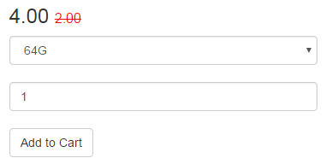



**单个型号的显示**

没有选择框，id保存在一个隐藏的input里面；价格因为不存在change的JQuery调用的动态更新，所以原始取值就要判断用sale_price还是price

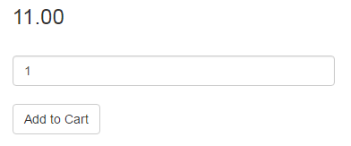

# 025 Product Categories

## 功能： 添加新Model产品类

定义产品类型，其中包含

* title
* Slug
* description
* active
* timestamp

在Product Model里面添加元素categories和default，由于Category是在Product后面定义，所以如果要引用该类，需用引号括起来’Category’

Product和Category是多对多的关系，但是每个Product有唯一的默认类

## 添加Category Model并在Product添加对应项

class Product(models.Model):

title = models.CharField(max_length=120)

description = models.TextField(blank=True, null=True)

price = models.DecimalField(decimal_places=2, max_digits=20)

active = models.BooleanField(default=True)

categories = models.ManyToManyField('Category', blank=True)

default = models.ForeignKey('Category', related_name='default_category', null=True, blank=True)

class Category(models.Model):

title = models.CharField(max_length=120, unique=True)

slug = models.SlugField(unique=True)

description = models.TextField(null=True, blank=True)

active = models.BooleanField(default=True)

timestamp = models.DateTimeField(auto_now_add=True, auto_now=False)

def __unicode__(self):

return self.title

## Admin中添加Category

在Admin中注册Category

**from** **.**models **import** Product**,** Variation**,** ProductImage**,** Category

admin**.**site**.**register**(**Category**)**

# 026 Category Detail View

## 功能：为产品类创建DetailView

(1) 添加特有的url, url_categories.py，并在url文件里添加该入口

(2) 在views添加CategoryDetailView

(3) 添加template （包括定义路径和添加模板文件）ListView的默认名字是template_name = "<appname>/<modelname>_list.html", 这儿修改为”products/product_list.html”

(4) 在views添加CategoryDetailView, 同时增加url入口

(5) 添加category_detail.html

## 添加url

urls.py

url**(**r'^categories/'**,** include**(**'products.urls_categories'**)),**

新增文件products/urls_categories.py

**from** django**.**conf **import** settings

**from** django**.**conf**.**urls **import** include**,** url

**from** django**.**conf**.**urls**.**static **import** static

**from** django**.**contrib **import** admin

**from** **.**views **import** CategoryListView**,** CategoryDetailView

urlpatterns **=** **[**

url**(**r'^$'**,** CategoryListView**.**as_view**(),** name**=**'categories'**),**

url**(**r'^(?P<slug>[\w-]+)/$'**,** CategoryDetailView**.**as_view**(),** name**=**'category_detail'**),**

#url(r'^(?P<id>\d+)', 'products.views.product_detail_view_func', name='product_detail_function'),

slug的设置可参考

<https://github.com/codingforentrepreneurs/Guides/blob/master/all/common_url_regex.md>#slugs

**Regex**

(?P<slug>[\w-]+)

**Example**

**Parameters**:

slug = "slugged-item"

**Query**:

object = Articles.objects.get(slug=slug)

**Url**:

url(r'^(?P<slug>[\w-]+)/$', 'appname.views.article'),

**View**:

def article(request,article):

...

return ...

**Live usage:**

yourdomain.com/your-slug/

## 在Model里添加get_absolute_url

products/models.py

class Category(models.Model):

title = models.CharField(max_length=120, unique=True)

slug = models.SlugField(unique=True)

description = models.TextField(null=True, blank=True)

active = models.BooleanField(default=True)

timestamp = models.DateTimeField(auto_now_add=True, auto_now=False)

def __unicode__(self):

return self.title

def get_absolute_url(self):

return reverse("category_detail", kwargs={"slug": self.slug })

## 添加Category Detail View

products/views.py

**from** **.**models **import** Product**,** Variation**,** Category

class CategoryListView(ListView):

model = Category

queryset = Category.objects.all()

template_name = "products/product_list.html"

class CategoryDetailView(DetailView):

model = Category

def get_context_data(self, *args, **kwargs):

context = super(CategoryDetailView, self).get_context_data(*args, **kwargs)

obj = self.get_object()

product_set = obj.product_set.all()

default_products = obj.default_category.all()

products = ( product_set | default_products ).distinct()

context["products"] = products

return context

## 添加Template

products/templates/products/category_detail.html

{% extends "base.html" %}

{% block content %}

<h3>{{ object }}</h3>

<div class = 'table'>

{% for product in object.product_set.all %}

<tr>

<td>

<a href='{{ product.get_absolute_url }}'>{{product.title}}</a>

</td>

</tr>

{% endfor %}

</div>

{% endblock %}

# 027 Related Products

## 功能：显示相关产品

(1) 修改ProductManager，增加related相关的信息

(2) 需改ProductDetailView，覆盖

增加额外的Manager方法参考如下：

<https://docs.djangoproject.com/en/1.8/topics/db/managers/#adding-extra-manager-methods>

models.py

更新Product排序方式

class Product(models.Model):

class Meta:

ordering = ["-title"]

class ProductManager(models.Manager):

def get_related(self, instance):

products_one = self.get_queryset().filter(categories__in=instance.categories.all())

products_two = self.get_queryset().filter(default=instance.default)

qs = (products_one | products_two).exclude(id=instance.id).distinct()

return qs

将related product添加到context

views.py

class ProductDetailView(DetailView):

model = Product

#template_name = "product.html"

#template_name = "<appname>/<modelname>_detail.html"

def get_context_data(self, *args, **kwargs):

context = super(ProductDetailView, self).get_context_data(*args, **kwargs)

instance = self.get_object()

context["related"] = Product.objects.get_related(instance).order_by("?")[:6]

return context

遍历related product并显示

products/template/product_detail.html

<h4>Related Products</h4>

{% for product in related %}

<a href='{{ product.get_absolute_url }}'>{{product.title}}</a>

{% endfor %}

# 028 Distinct Random QuerySets

## 功能：将Related Product改为图形显示

## Tag: QuerySet, sorted, random, lambda

## lambda

<http://www.diveintopython.net/power_of_introspection/lambda_functions.html>

<http://www.secnetix.de/olli/Python/lambda_functions.hawk>

<http://www.python-course.eu/lambda.php>

## random

<https://docs.python.org/2/library/random.html>

[Python中的random模块](http://www.cnblogs.com/yd1227/archive/2011/03/18/1988015.html)

Python中的random模块用于生成随机数。

random.random()用于生成一个0到1的随机符点数: 0 <= n < 1.0

## sorted

<http://www.tutorialspoint.com/python/list_sort.htm>

[python内置函数sorted排序用法](http://blog.csdn.net/songchunyi/article/details/6543369)

Python对容器内数据的排序有两种，一种是容器自己的**sort**函数，一种是内建的**sorted**函数。

sort函数和sorted函数唯一的不同是，sort是在容器内排序，sorted生成一个新的排好序的容器。

对于一个简单的数组 L=[5,2,3,1,4].

sort: L.sort()

sorted(...)

    sorted(iterable, cmp=None, key=None, reverse=False) --> new sorted list

* iterable：待排序的可迭代类型的容器;
* cmp：用于比较的函数，比较什么由key决定,有默认值，迭代集合中的一项;
* key：用列表元素的某个已命名的属性或函数（只有一个参数并且返回一个用于排序的值）作为关键字，有默认值，迭代集合中的一项;
* reverse：排序规则. reverse = True 或者 reverse = False，有默认值。
* 返回值：是一个经过排序的可迭代类型，与iterable一样。

如果是一个多维的列表 L=[(‘b’,2),(‘a’,1),(‘c’,3),(‘d’,4)].

有三种选择对这个多维列表进行排序

利用cmp函数

sorted(L, cmp=lambda x,y:cmp(x[1],y[1]))

L.sort(cmp=lambda x,y:cmp(x[1],y[1]))

利用key

sorted(L, key=lambda x:x[1]);

L.sort(key=lambda x:x[1]);

反序

以上几种排序均可加上参数reverse.

例如 sorted(reverse=True), L.sort(reverse=True). 或者改成False

**OrderedDict**是collections中的一个包，能够记录字典元素插入的顺序，常常和排序函数一起使用来生成一个排序的字典。

比如，比如一个无序的字典

d = {‘banana’:3,’apple’:4,’pear’:1,’orange’:2}

通过排序来生成一个有序的字典，有以下几种方式

collections.OrderedDict(sorted(d.items(),key = lambda t:t[0]))

或者

collections.OrderedDict(sorted(d.items(),key = lambda t:t[1]))

或者

collections.OrderedDict(sorted(d.items(),key = lambda t:len(t[0])))

views.py

**import** random

**class** **ProductDetailView(**DetailView**):**

model **=** Product

#template_name = "product.html"

#template_name = "<appname>/<modelname>_detail.html"

**def** get_context_data**(**self**,** **\***args**,** **\*\***kwargs**):**

context **=** super**(**ProductDetailView**,** self**).**get_context_data**(\***args**,** **\*\***kwargs**)**

instance **=** self**.**get_object**()**

#order_by("-title")

context**[**"related"**]** **=** sorted**(**Product**.**objects**.**get_related**(**instance**)[:**6**],** key**=** **lambda** x**:** random**.**random**())**

**return** context

在models.py

class Product(models.Model):

def get_image_url(self):

img = self.productimage_set.first() # return obj or None

if img:

return img.image.url

return img #None

product_detail.html

修改product image显示方法

<!-- {% if object.productimage_set.count > 0 %}

<div>

{% for img in object.productimage_set.all %}

<img id='img' class= 'img-responsive' src="{{img.image.url}}"/>

{% endfor %}

</div>

{% endif %} -->

**{% if object.get_image_url %}**

<div>

<img id=**'img'** class= **'img-responsive'** src=**"{{object.****get_image_url}}"**/>

</div>

**{% endif %}**

<h4>Related Products</h4>

{% for product in related %}

<!-- <a href='{{ product.get_absolute_url }}'>{{product.title}}</a> -->

{% if object.get_image_url %}

<img id='img' class= 'img-responsive' src="{{object.get_image_url}}"/><br>

{% else %}

<a href='{{ product.get_absolute_url }}'>{{product.title}}</a>

{% endif %}

{% endfor %}

# 029 Improve UI

## 功能：UI美化

## Tag: thumbnail Cycle

<http://getbootstrap.com/components/#thumbnails>

用thumbnail美化product_detail.html

<hr/>

<h4>**Related Products**</h4>

<div class=**'row'**>

**{% for product in related %}**

<div class=**'col-xs-6'**>

<div class=**'thumbnail text-center'**>

<h4><a href=**'{{ product.get_absolute_url }}'**>**{{product.title}}**</a></h4>

**{% if product.get_image_url %}**

<a href=**'{{ product.get_absolute_url }}'**><img id=**'img'** class= **'img-responsive'** src=**"{{product.get_image_url}}"**/></a><br>

**{% endif %}**

</div>

</div>

**{% cycle '' '**</div><div class=**"row"**>**'%}**

**{% endfor %}**

</div>

美化product_list.html

<h1>All Products <small><a href="{% url 'categories' %}">Categories</a></small></h1>

<div class=**'row'**>

<!-- <table> -->

**{% for product in object_list %}**

<div class=**'col-xs-4'**>

<div class=**'thumbnail text-center'**>

<h4><a href=**'{{ product.get_absolute_url }}'**>**{{product.title}}**</a></h4>

**{% if product.get_image_url %}**

<a href=**'{{ product.get_absolute_url }}'**><img id=**'img'** class= **'img-responsive'** src=**"{{product.get_image_url}}"**/></a><br>

**{% endif %}**

</div>

</div>

**{% cycle '' '' '**</div><div class=**"row"**>**'%}**

<!-- <tr>

<td><a href="{{ object.get_absolute_url }}">{{object.title}}</a></td>

</tr> -->

**{% endfor %}**

<!-- </table>-->

</div>

美化category_detail.html

<div class = **'row'**>

**{% for product in products %}**

<div class=**'col-xs-4'**>

<div class=**'thumbnail text-center'**>

<h4><a href=**'{{ product.get_absolute_url }}'**>**{{product.title}}**</a></h4>

**{% if product.get_image_url %}**

<a href=**'{{ product.get_absolute_url }}'**><img id=**'img'** class= **'img-responsive'** src=**"{{product.get_image_url}}"**/></a><br>

**{% endif %}**

</div>

</div>

**{% cycle '' '' '**</div><div class=**"row"**>**'%}**

**{% endfor %}**

</div>

# 030 Django Template Include with Variable

## 功能：将产品thumbnail模板移到公共文件

(1) 将thumbnail功能移到专门的文件

(2) 包含产品信息的文件可以通过include thumbnail并附带相应的参数(with)来显示产品

## Tag: include/with

修改models.py

**from** django**.**utils**.**safestring **import** mark_safe

class Variation(models.Model):

def get_html_price(self):

if self.sale_price is not None:

html_text = "<span class='sale-price'>%s</span> <span class='og-price'>%s</span>" %(self.sale_price, self.price)

else:

html_text = "<span class='price'>%s</span>" %(self.price)

return mark_safe(html_text)

添加product_thumbnail.html

<div class='thumbnail text-center'>

<h4><a href='{{ product.get_absolute_url }}'>{{product.title}}</a></h4>

{% if product.get_image_url %}

<a href='{{ product.get_absolute_url }}'><img id='img' class= 'img-responsive' src="{{product.get_image_url}}"/></a><br>

{% endif %}

{% if price == "True" %}

{{ product.variation_set.first.get_html_price }}

{% endif %}

</div>

product_list.html

<div class=**'row'**>

**{% for product in object_list %}**

<div class=**'col-xs-4'**>

**{% include 'products/product_thumbnail.html' with product=product price='True' %}**

</div>

**{% cycle '' '' '**</div><div class=**"row"**>**'%}**

**{% endfor %}**

</div>

product_detail.html

<h4>Related Products</h4>

<div class='row'>

{% for product in related %}

<div class='col-xs-6'>

{% include "products/product_thumbnail.html" with product=product price="True" %}

</div>

{% cycle '' '</div><div class="row">'%}

{% endfor %}

</div>

category_detail.html

<div class = **'row'**>

**{% for product in products %}**

<div class=**'col-xs-4'**>

**{% include "products/product_thumbnail.html" with product=product price="True" %}**

</div>

**{% cycle '' '' '**</div><div class=**"row"**>**'%}**

**{% endfor %}**

</div>

# 031 Featured Product on Homepage

## 功能：实现特色产品推荐

(1) 在首页增加产品显示

(2) 将jumbotron改为产品展示

(3) 增加FeatureProduct类

## Tag : ImageField upload_to

# modified: newsletter/views.py

# modified: products/admin.py

# modified: products/models.py

# modified: templates/home.html

## 添加ProductFeatured model

对于ImageField，需要定义upload_to函数

products/models.py

**def** image_upload_to_featured**(**instance**,** filename**):**

title **=** instance**.**product**.**title

slug **=** slugify**(**title**)**

basename**,** file_extension **=** filename**.**split**(**"."**)**

new_filename **=** "%s-%s.%s" **%(**slug**,** instance**.**id**,** file_extension**)**

**return** "products/%s/featured/%s" **%(**slug**,** new_filename**)**

**class** **ProductFeatured(**models**.**Model**):**

product **=** models**.**ForeignKey**(**Product**)**

image **=** models**.**ImageField**(**upload_to**=**image_upload_to_featured**)**

title **=** models**.**CharField**(**max_length**=**120**,** null**=True,** blank**=True)**

text **=** models**.**CharField**(**max_length**=**220**,** null**=True,** blank**=True)**

text_right **=** models**.**BooleanField**(**default**=False)**

text_css_color **=** models**.**CharField**(**max_length**=**6**,** null**=True,** blank**=True)**

show_price **=** models**.**BooleanField**(**default**=False)**

make_image_background **=** models**.**BooleanField**(**default**=False)**

active **=** models**.**BooleanField**(**default**=True)**

**def** __unicode__**(**self**):**

**return** self**.**product**.**title

## 在Admin添加ProductFeatured

products/admin.py

**from** **.**models **import** Product**,**Variation**,**ProductImage**,**Category**,**ProductFeatured

admin**.**site**.**register**(**ProductFeatured**)**

## 将Featured image添加到context

newsletter/views.py

**from** products**.**models **import** ProductFeatured

**def** home**(**request**):**

title **=** 'Sign Up now'

featured_image **=** ProductFeatured**.**objects**.**filter**(**active**=True).**order_by**(**"?"**).**first**()**

form **=** SignUpForm**(**request**.**POST **or** **None)**

context **=** **{**

"title"**:** title**,**

"form"**:** form**,**

"featured_image"**:**featured_image**,**

**}**

## 在Template中增加Featured Image的显示

templates/home.html

{% block jumbotron %}

{% if not request.user.is_authenticated%}

{% if featured_image %}

<div class="jumbotron">

<div class="container">

<div class="row">

<div class='{% if featured_image.make_image_background %} col-sm-12 {% else %} col-sm-6 {% endif %} text-center {% if featured_image.text_right %} pull-right {% endif %}'>

<h1>{{ featured_image.product.title }}</h1>

<p>{{ featured_image.product.description }}</p>

<p>

<a class="btn btn-lg btn-primary" href="{{ featured_image.product.get_absolute_url }}" role="button">More Details &raquo;</a>

</p>

</div>

{% if not featured_image.make_image_background %}

<div class='col-sm-6'>

<img src="{{ featured_image.image.url }}" class="img-responsive" />

</div>

{% endif %}

</div>

</div>

</div>

{% else %}

<div class="jumbotron">

## 效果图

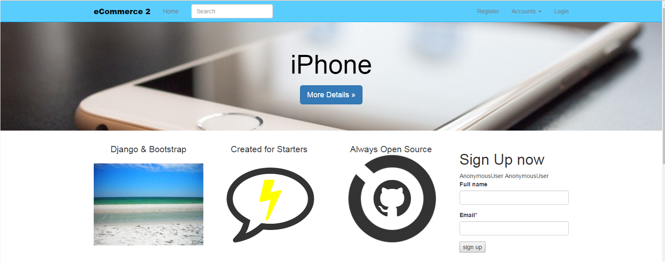

不带背景图的

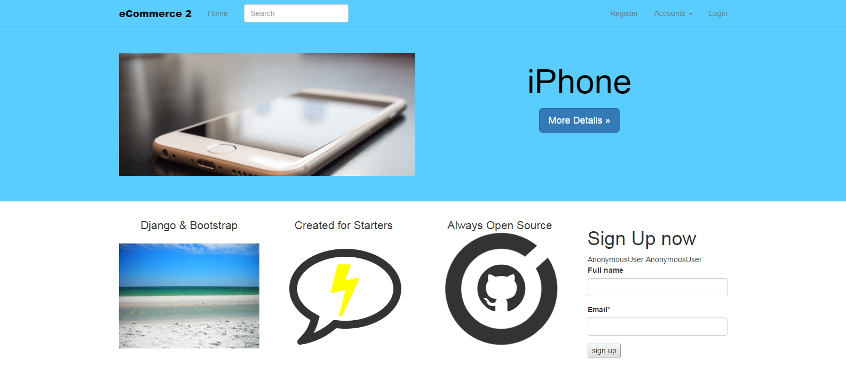

# 032 Login as Dropdown Menu

## 功能：在navbar添加dropdown menu

将账号相关的组件移到dropdown menu里

## Tag: dropdown

修改navbar.html

<ul class="nav navbar-nav navbar-right">

{% if request.user.is_authenticated %}

<li><a href="{% url 'auth_logout' %}">Logout</a></li>

{% else %}

<li><a href="{% url 'registration_register' %}">Register</a></li>

{% if not request.user.is_authenticated and not "/accounts/login" in request.get_full_path %}

<li class="dropdown">

<a href="#" class="dropdown-toggle" data-toggle="dropdown" role="button" aria-haspopup="true" aria-expanded="false">Accounts <span class="caret"></span></a>

<ul class="dropdown-menu">

<form class='navbar-form' method='POST' action='{% url "auth_login" %}'>{% csrf_token %}

<div class='form-group'>

<input type='text' class='form-control' name='username' placeholder='Username' />

</div>

<div class='form-group'>

<input type='password' class='form-control' name='password' placeholder='Password' />

</div>

<button type='submit' class='btn btn-default'>Login</button>

</form>

<p class="text-center"><a href="{% url 'auth_login' %}">Forget Password</a></p>

</ul>

</li>

{% endif %}

<li><a href="{% url 'auth_login' %}">Login</a></li>

{% endif %}

</ul>

## 学习参考 - getbootstrap.com/components/#navbar

<http://getbootstrap.com/components/#navbar>

# 033 Shopping cart icon

## 功能：添加购物车图标✓

## Tag: fa-shopping-cart, fa-navbar-cart, badge

登录界面移到下拉菜单后为cart腾出了位置

从下面网页获取icon

<http://fontawesome.io/icon/shopping-cart/>

# modified: static_in_pro/our_static/css/custom.css

# modified: templates/navbar.html

static_in_pro/our_static/css/custom.css

**.**fa-navbar-cart**{**

**font-size: 18px;**

**vertical-align: middle;**

templates/navbar.html

<ul class="nav navbar-nav navbar-right">

<li><a href="#"><i class="fa fa-shopping-cart fa-navbar-cart"></i> <span class='badge'>0</span></a></li>

{% if request.user.is_authenticated %}

<li><a href="{% url 'auth_logout' %}">Logout</a></li>

<http://www.w3school.com.cn/tags/tag_span.asp>

<span> 标签被用来组合文档中的行内元素。

提示：请使用 <span> 来组合行内元素，以便通过样式来格式化它们。

注释：span 没有固定的格式表现。当对它应用样式时，它才会产生视觉上的变化。



# 034 Product Lists on Homepage

## 功能：在主页显示产品列表

## Tag: include/with

注意：定义css类名字的时候，横线会有问题，需要用下划线

col_class_set OK

col-class-set KO

# modified: newsletter/views.py

# modified: products/templates/products/product_list.html

# modified: templates/home.html

# new : products/templates/products/products.html

## 添加产品QuerySet，加入到home模板Context中

newsletter/views.py

**def** home**(**request**):**

title **=** 'Sign Up now'

featured_image **=** ProductFeatured**.**objects**.**filter**(**active**=True).**order_by**(**"?"**).**first**()**

products **=** Product**.**objects**.**all**().**order_by**(**'?'**)[:**6**]**

products2 **=** Product**.**objects**.**all**().**order_by**(**'?'**)[:**6**]**

form **=** SignUpForm**(**request**.**POST **or** **None)**

context **=** **{**

"title"**:** title**,**

"form"**:** form**,**

"featured_image"**:**featured_image**,**

"products"**:**products**,**

"products2"**:**products2**,**

**}**

## 新建产品列表模板, 专门显示产品信息，易于被其他模板调用

products/templates/products/products.html

**{%** **for** product **in** object_list **%}**

**<**div **class=**'col-xs-4 {{col_class_set}}'**>**

**{%** include 'products/product_thumbnail.html' **with** product**=**product price**=**'True' **%}**

**</**div**>**

**{%** **if** **not** col_class_set **%}**

**{%** cycle '' '' '</div><div class="row">'**%}**

**{%** endif **%}**

**{%** endfor **%}**

## 更新产品列表模板

products/templates/products/product_list.html

{% extends "base.html" %}

{% block content %}

<h1>All Products <small><a href="{% url 'categories' %}">Categories</a></small></h1>

<div class='row'>

{% include 'products/products.html' with object_list=object_list %}

</div>

{% endblock %}

## 更新主页模板，添加推荐产品和特色产品

templates/home.html

{% block content %}

<div class="row">

<h3>Recommended Products</h3>

{% include 'products/products.html' with object_list=products col_class_set="col-sm-2" %}

</div>

<div class="row">

<h3>Featured Products</h3>

{% include 'products/products.html' with object_list=products2 %}

</div>

# 035 Product Editing with django Inline

## 功能：在Admin中Inline添加产品相关Model

包含ProductImage，Variation，Product

## Tag：TabularInline

## 学习参考 – inlinemodeladmin

<https://docs.djangoproject.com/en/1.8/ref/contrib/admin/#inlinemodeladmin-objects>

# modified: products/admin.py

class ProductImageInline(admin.TabularInline):

model = ProductImage

extra = 0

max_num = 10

class VariationInline(admin.TabularInline):

model = Variation

extra = 0

max_num = 10

class ProductAdmin(admin.ModelAdmin):

list_display = ['__unicode__', 'price']

inlines = [

ProductImageInline,

VariationInline,

]

class Meta:

model = Product

admin**.**site**.**register**(**Product**,** ProductAdmin**)**

# 036 Carts App

## 功能：创建Cart app并添加相应模型

# modified: carts/models.py

# modified: ecommerce2/settings/base.py

## 创建cart application

**>python manage.py startapp carts**

ecommerce2/settings/base.py

INSTALLED_APPS **=** **(**

'django.contrib.admin'**,**

'django.contrib.auth'**,**

'django.contrib.contenttypes'**,**

'django.contrib.sessions'**,**

'django.contrib.messages'**,**

'django.contrib.sites'**,**

'django.contrib.staticfiles'**,**

'newsletter'**,**

'products'**,**

'carts'**,**

'crispy_forms'**,**

'registration'**,**

**)**

## 定义Cart和CartItem model

carts/models.py

**from** django**.**conf **import** settings

**from** django**.**db **import** models

**from** products**.**models **import** Variation

# Create your models here.

**class** **CartItem(**models**.**Model**):**

item **=** models**.**ForeignKey**(**Variation**)**

quantity **=** models**.**PositiveIntegerField**(**default**=**1**)**

**def** __unicode__**(**self**):**

**return** self**.**item**.**title

**class** **Cart(**models**.**Model**):**

user **=** models**.**ForeignKey**(**settings**.**AUTH_USER_MODEL**,** null**=True,** blank**=True)**

items **=** models**.**ManyToManyField**(**CartItem**)**

timestamp **=** models**.**DateTimeField**(**auto_now_add**=True,** auto_now**=False)**

updated **=** models**.**DateTimeField**(**auto_now_add**=False,** auto_now**=True)**

**def** __unicode__**(**self**):**

**return** str**(**self**.**id**)**

# 037 ManyToMany through

## 功能：通过ManyToMany through方式将Cart和Variation关联起来

## Tag : ManyToMany through

## 学习参考 – m2m through

[https://docs.djangoproject.com/en/1.8/topics/db/models/#extra-fields-on-many-to-many-relationships](https://docs.djangoproject.com/en/1.8/topics/db/models/" \l "extra-fields-on-many-to-many-relationships)

**Extra fields on many-to-many relationships**[**¶**](https://docs.djangoproject.com/en/1.8/topics/db/models/#extra-fields-on-many-to-many-relationships)

When you’re only dealing with simple many-to-many relationships such as mixing and matching pizzas and toppings, a standard [**ManyToManyField**](https://docs.djangoproject.com/en/1.8/ref/models/fields/#django.db.models.ManyToManyField) is all you need. However, sometimes you may need to associate data with the relationship between two models.

For example, consider the case of an application tracking the musical groups which musicians belong to. There is a many-to-many relationship between a person and the groups of which they are a member, so you could use a[**ManyToManyField**](https://docs.djangoproject.com/en/1.8/ref/models/fields/#django.db.models.ManyToManyField) to represent this relationship. However, there is a lot of detail about the membership that you might want to collect, such as the date at which the person joined the group.

For these situations, Django allows you to specify the model that will be used to govern the many-to-many relationship. You can then put extra fields on the intermediate model. The intermediate model is associated with the[**ManyToManyField**](https://docs.djangoproject.com/en/1.8/ref/models/fields/#django.db.models.ManyToManyField) using the [**through**](https://docs.djangoproject.com/en/1.8/ref/models/fields/#django.db.models.ManyToManyField.through) argument to point to the model that will act as an intermediary. For our musician example, the code would look something like this:

**from** **django.db** **import** models

**class** **Person**(models.Model):

name = models.CharField(max_length=128)

**def** __str__(self): *# __unicode__ on Python 2*

**return** self.name

**class** **Group**(models.Model):

name = models.CharField(max_length=128)

members = models.ManyToManyField(Person, through='Membership')

**def** __str__(self): *# __unicode__ on Python 2*

**return** self.name

**class** **Membership**(models.Model):

person = models.ForeignKey(Person)

group = models.ForeignKey(Group)

date_joined = models.DateField()

invite_reason = models.CharField(max_length=64)

When you set up the intermediary model, you explicitly specify foreign keys to the models that are involved in the many-to-many relationship. This explicit declaration defines how the two models are related.

There are a few restrictions on the intermediate model:

* Your intermediate model must contain one - and only one - foreign key to the source model (this would be **Group** in our example), or you must explicitly specify the foreign keys Django should use for the relationship using[**ManyToManyField.through_fields**](https://docs.djangoproject.com/en/1.8/ref/models/fields/#django.db.models.ManyToManyField.through_fields). If you have more than one foreign key and **through_fields** is not specified, a validation error will be raised. A similar restriction applies to the foreign key to the target model (this would be**Person** in our example).
* For a model which has a many-to-many relationship to itself through an intermediary model, two foreign keys to the same model are permitted, but they will be treated as the two (different) sides of the many-to-many relationship. If there are more than two foreign keys though, you must also specify **through_fields** as above, or a validation error will be raised.
* When defining a many-to-many relationship from a model to itself, using an intermediary model, you must use[**symmetrical=False**](https://docs.djangoproject.com/en/1.8/ref/models/fields/#django.db.models.ManyToManyField.symmetrical) (see [the model field reference](https://docs.djangoproject.com/en/1.8/ref/models/fields/#manytomany-arguments)).

Now that you have set up your [**ManyToManyField**](https://docs.djangoproject.com/en/1.8/ref/models/fields/#django.db.models.ManyToManyField) to use your intermediary model (**Membership**, in this case), you’re ready to start creating some many-to-many relationships. You do this by creating instances of the intermediate model:

**>>>** ringo = Person.objects.create(name="Ringo Starr")

**>>>** paul = Person.objects.create(name="Paul McCartney")

**>>>** beatles = Group.objects.create(name="The Beatles")

**>>>** m1 = Membership(person=ringo, group=beatles,

**...**  date_joined=date(1962, 8, 16),

**...**  invite_reason="Needed a new drummer.")

**>>>** m1.save()

**>>>** beatles.members.all()

[<Person: Ringo Starr>]

**>>>** ringo.group_set.all()

[<Group: The Beatles>]

**>>>** m2 = Membership.objects.create(person=paul, group=beatles,

**...**  date_joined=date(1960, 8, 1),

**...**  invite_reason="Wanted to form a band.")

**>>>** beatles.members.all()

[<Person: Ringo Starr>, <Person: Paul McCartney>]

Unlike normal many-to-many fields, you can’t use **add**, **create**, or assignment (i.e., **beatles.members = [...]**) to create relationships:

*# THIS WILL NOT WORK*

>>> beatles.members.add(john)

*# NEITHER WILL THIS*

>>> beatles.members.create(name="George Harrison")

*# AND NEITHER WILL THIS*

>>> beatles.members = [john, paul, ringo, george]

Why? You can’t just create a relationship between a **Person** and a **Group** - you need to specify all the detail for the relationship required by the **Membership** model. The simple **add**, **create** and assignment calls don’t provide a way to specify this extra detail. As a result, they are disabled for many-to-many relationships that use an intermediate model. The only way to create this type of relationship is to create instances of the intermediate model.

The [**remove()**](https://docs.djangoproject.com/en/1.8/ref/models/relations/#django.db.models.fields.related.RelatedManager.remove) method is disabled for similar reasons. However, the [**clear()**](https://docs.djangoproject.com/en/1.8/ref/models/relations/#django.db.models.fields.related.RelatedManager.clear) method can be used to remove all many-to-many relationships for an instance:

**>>>** *# Beatles have broken up*

**>>>** beatles.members.clear()

**>>>** *# Note that this deletes the intermediate model instances*

**>>>** Membership.objects.all()

[]

Once you have established the many-to-many relationships by creating instances of your intermediate model, you can issue queries. Just as with normal many-to-many relationships, you can query using the attributes of the many-to-many-related model:

*# Find all the groups with a member whose name starts with 'Paul'*

>>> Group.objects.filter(members__name__startswith='Paul')

[<Group: The Beatles>]

As you are using an intermediate model, you can also query on its attributes:

*# Find all the members of the Beatles that joined after 1 Jan 1961*

>>> Person.objects.filter(

... group__name='The Beatles',

... membership__date_joined__gt=date(1961,1,1))

[<Person: Ringo Starr]

If you need to access a membership’s information you may do so by directly querying the **Membership** model:

**>>>** ringos_membership = Membership.objects.get(group=beatles, person=ringo)

**>>>** ringos_membership.date_joined

datetime.date(1962, 8, 16)

**>>>** ringos_membership.invite_reason

'Needed a new drummer.'

Another way to access the same information is by querying the [many-to-many reverse relationship](https://docs.djangoproject.com/en/1.8/topics/db/queries/#m2m-reverse-relationships) from a **Person** object:

**>>>** ringos_membership = ringo.membership_set.get(group=beatles)

**>>>** ringos_membership.date_joined

datetime.date(1962, 8, 16)

**>>>** ringos_membership.invite_reason

'Needed a new drummer.'

## Migration Issue

一直报错，没法解决

self.apply_migration(states[migration], migration, fake=fake, fake_initial=f

ake_initial)

File "D:\virtualenv\ecommerce-ws\lib\site-packages\django\db\migrations\execut

or.py", line 148, in apply_migration

state = migration.apply(state, schema_editor)

File "D:\virtualenv\ecommerce-ws\lib\site-packages\django\db\migrations\migrat

ion.py", line 115, in apply

operation.database_forwards(self.app_label, schema_editor, old_state, projec

t_state)

File "D:\virtualenv\ecommerce-ws\lib\site-packages\django\db\migrations\operat

ions\fields.py", line 201, in database_forwards

schema_editor.alter_field(from_model, from_field, to_field)

File "D:\virtualenv\ecommerce-ws\lib\site-packages\django\db\backends\base\sch

ema.py", line 480, in alter_field

"through= on M2M fields)" % (old_field, new_field)

ValueError: Cannot alter field carts.Cart.items into carts.Cart.items - they are

not compatible types (you cannot alter to or from M2M fields, or add or remove

through= on M2M fields)

最后暴力解决

删除migrations目录，并且在db里删除carts相对表

# modified: carts/admin.py

# modified: carts/models.py

## 通过CartItem将Cart和Variation关联

carts/models.py

**from** products**.**models **import** Variation

# Create your models here.

**class** **CartItem(**models**.**Model**):**

cart **=** models**.**ForeignKey**(**"Cart"**)** #cart class is below

item **=** models**.**ForeignKey**(**Variation**)**

quantity **=** models**.**PositiveIntegerField**(**default**=**1**)**

**def** __unicode__**(**self**):**

**return** self**.**item**.**title

**class** **Cart(**models**.**Model**):**

user **=** models**.**ForeignKey**(**settings**.**AUTH_USER_MODEL**,** null**=True,** blank**=True)**

items **=** models**.**ManyToManyField**(**Variation**,** through**=**CartItem**)**

timestamp **=** models**.**DateTimeField**(**auto_now_add**=True,** auto_now**=False)**

updated **=** models**.**DateTimeField**(**auto_now_add**=False,** auto_now**=True)**

**def** __unicode__**(**self**):**

**return** str**(**self**.**id**)**

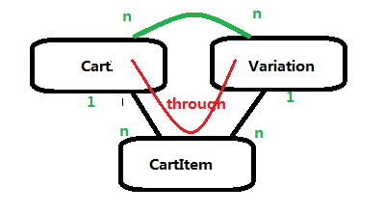

## 在Admin中添加Cart相关model

carts/admin.py

**from** **.**models **import** Cart**,** CartItem

**class** **CartItemInline(**admin**.**TabularInline**):**

model **=** CartItem

**class** **CartAdmin(**admin**.**ModelAdmin**):**

inlines **=** **[**

CartItemInline

**]**

**class** **Meta:**

model **=** Cart

admin**.**site**.**register**(**Cart**,** CartAdmin**)**

# 038 ManyToMany Through using the Python Shell

## 功能：shell方式训练ManyToMany

## Tag : ManyToMany through

**>python manage.py shell**

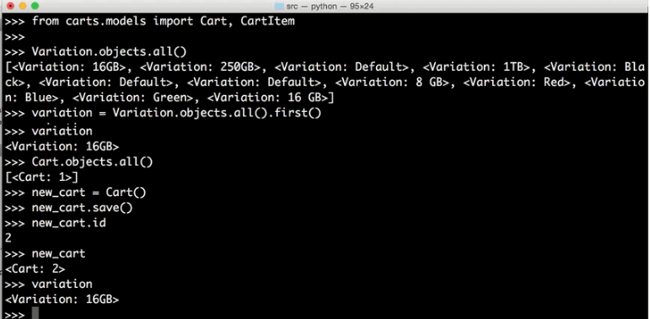

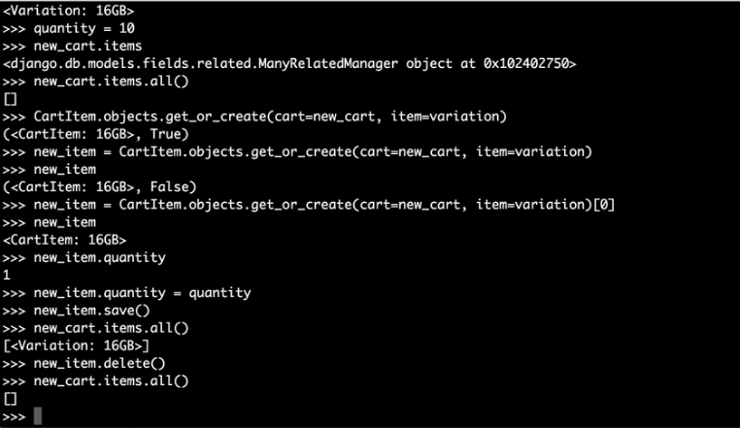

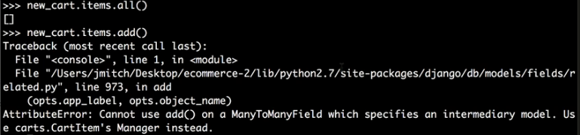

# 039 Add, Update, Remove Carts in CBV

## 功能：CartView上添加，更新和删除购物商品

## 学习参考 – class-based-view

<https://docs.djangoproject.com/en/1.8/ref/class-based-views/base/#view>

# modified: carts/views.py

# modified: ecommerce2/urls.py

## 添加URL

ecommerce2/urls.py

**from** carts**.**views **import** CartView

url**(**r'^cart/$'**,** CartView**.**as_view**(),** name**=**'cart'**),**

看上去as_view会触发view.get的调用

<http://127.0.0.1:8000/cart/?item=1&qty=10>

<http://127.0.0.1:8000/cart/?item=1&qty=10&delete=True>

## 添加类CartView

carts/views.py

**from** django**.**views**.**generic**.**base **import** View

**from** django**.**http **import** HttpResponseRedirect

**from** django**.**shortcuts **import** render**,** get_object_or_404

**from** products**.**models **import** Variation

**from** **.**models **import** Cart**,** CartItem

# Create your views here.

**class** **CartView(**View**):**

**def** get**(**self**,** request**,** **\***args**,** **\*\***kwargs**):**

item_id **=** request**.**GET**.**get**(**'item'**)**

delete_item **=** request**.**GET**.**get**(**'delete'**)**

**if** item_id**:**

item_instance **=** get_object_or_404**(**Variation**,** id**=**item_id**)**

qty**=**request**.**GET**.**get**(**'qty'**)**

cart **=** Cart**.**objects**.**all**().**first**()**

cart_item **=** CartItem**.**objects**.**get_or_create**(**cart**=**cart**,** item**=**item_instance**)[**0**]**

**if** delete_item**:**

cart_item**.**delete**()**

**else:**

cart_item**.**quantity **=** qty

cart_item**.**save**()**

**return** HttpResponseRedirect**(**'/'**)**

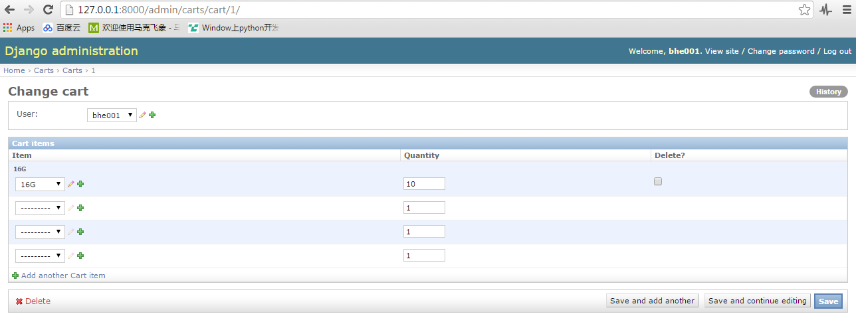

# 040 Django sessions

## 功能：实现Django session，用于存储Cart ID

## Tag : session, set_expiry

## 学习参考 – session

<https://docs.djangoproject.com/en/1.8/topics/http/sessions/#module-django.contrib.sessions>

## CartView中添加cart_id session处理

class CartView(View):

def get(self, request, *args, **kwargs):

request.session.set_expiry(0)

cart_id = request.session.get("cart_id")

if cart_id == None:

cart = Cart()

cart.save()

cart_id = cart.id

request.session["cart_id"] = cart_id

cart = Cart.objects.get(id=cart_id)

if request.user.is_authenticated():

cart.user = request.user

cart.save()

item_id = request.GET.get('item')

delete_item = request.GET.get('delete')

if item_id:

item_instance = get_object_or_404(Variation, id=item_id)

qty=request.GET.get('qty')

#cart = Cart.objects.all().first()

cart_item = CartItem.objects.get_or_create(cart=cart, item=item_instance)[0]

if delete_item:

cart_item.delete()

else:

cart_item.quantity = qty

cart_item.save()

return HttpResponseRedirect('/')

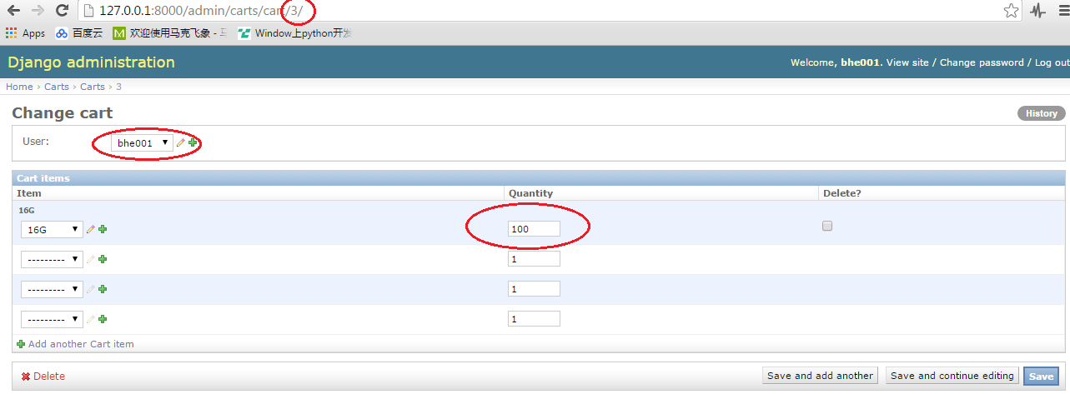

<http://127.0.0.1:8000/cart/?item=1&qty=100>

# 041 Render Cart View

## 功能 : CartView渲染

## 参考学习 – SingleObjectMixin

<https://docs.djangoproject.com/en/1.8/ref/class-based-views/mixins-single-object/#django.views.generic.detail.SingleObjectMixin>

# modified: carts/views.py

# added : carts/templates/

## 添加基类SingleObjectMixin (CartView)

SingleObjectMixin支持以下函数

- get_object

carts/views.py

**from** django**.**views**.**generic**.**detail **import** SingleObjectMixin

**class** **CartView(**SingleObjectMixin**,** View**):**

model **=** Cart

template_name **=** "carts/view.html"

**def** get_object**(**self**,** **\***args**,** **\*\***kwargs**):**

self**.**request**.**session**.**set_expiry**(**0**)**

cart_id **=** self**.**request**.**session**.**get**(**"cart_id"**)**

**if** cart_id **==** **None:**

cart **=** Cart**()**

cart**.**save**()**

cart_id **=** cart**.**id

self**.**request**.**session**[**"cart_id"**]** **=** cart_id

cart **=** Cart**.**objects**.**get**(**id**=**cart_id**)**

**if** self**.**request**.**user**.**is_authenticated**():**

cart**.**user **=** self**.**request**.**user

cart**.**save**()**

**return** cart

**def** get**(**self**,** request**,** **\***args**,** **\*\***kwargs**):**

cart **=** self**.**get_object**()**

item_id **=** request**.**GET**.**get**(**'item'**)**

delete_item **=** request**.**GET**.**get**(**'delete'**)**

**if** item_id**:**

item_instance **=** get_object_or_404**(**Variation**,** id**=**item_id**)**

qty**=**request**.**GET**.**get**(**'qty'**)**

#cart = Cart.objects.all().first()

cart_item **=** CartItem**.**objects**.**get_or_create**(**cart**=**cart**,** item**=**item_instance**)[**0**]**

**if** delete_item**:**

cart_item**.**delete**()**

**else:**

cart_item**.**quantity **=** qty

cart_item**.**save**()**

#context = self.get_context_data(request, *args, **kwargs)

context**={**

"object"**:**self**.**get_object**()**

**}**

template **=** self**.**template_name

**return** render**(**request**,** template**,** context**)**

carts/templates/view.html

{% extends "base.html" %}

{% block content %}

{{ object }}

{{ object.items.all }}

{% endblock %}

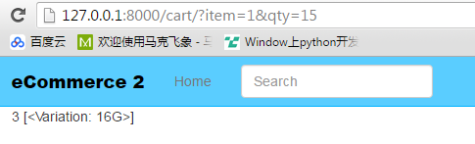

# 042 Add to cart from product view

## 功能：添加到购物车功能

# modified: carts/views.py

# modified: products/templates/products/product_detail.html

设置默认的货物数量为1，这个可以通过get函数来实现

qty=request.GET.get('qty', 1)

如果request没有传递’qty’这个元素，则默认设置quantity为1

如果将物品的数量减少到1，则表明删除该商品

carts/views.py

class CartView(SingleObjectMixin, View):

delete_item = request.GET.get('delete')

if item_id:

item_instance = get_object_or_404(Variation, id=item_id)

- qty=request.GET.get('qty')

+ qty=request.GET.get('qty', 1)

+ try:

+ if int(qty) < 1:

+ delete_item = True

+ except:

+ raise Http404

#cart = Cart.objects.all().first()

添加表单，将商品信息添加到表单内用于提交

products/templates/products/product_detail.html

<div class="col-sm-4">

+ <form id='add-form' method='GET' action="{% url 'cart' %}">

{% if object.variation_set.count > 1 %}

<h3 id='price'>{{ object.variation_set.first.price }}</h3>

- <select class='form-control variation_select'>

+ <select name='item' class='form-control variation_select'>

{% for vari_obj in object.variation_set.all %}

<option data-sale-price="{{ vari_obj.sale_price }}" data-price="{{ vari_obj.price }}" value="{{ vari_obj.id }}">{{ vari_obj }}</option>

{% endfor %}

</select>

{% else %}

+ <input type="hidden" name='item' value='{{ object.variation_set.first.id }}' />

<h3 id='price'>{% if object.variation_set.first.sale_price %}

{{ object.variation_set.first.sale_price }}

<small class='og-price'>{{ object.variation_set.first.price }}</small>

{% else %}

{{ object.variation_set.first.price }}

{% endif %}

</h3>

{% endif %}

+ <br/>

+ <input class='form-control' type='number' name='qty' value='1' />

<br/>

- <a href="#">Add to Cart</a>

+ <input id='submit-btn' type='submit' value='Add to Cart' class='btn btn-default' />

+ </form>

<p>

Share<br/>

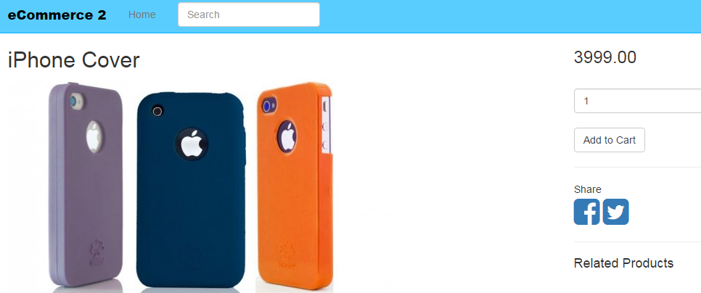

执行上面的Add to Cart会跳转到下面地址

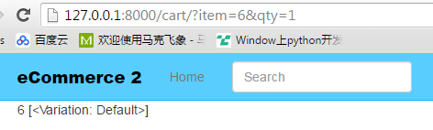

# 043 Format Cart Remove Items

## 功能：从购物车删除商品功能

# modified: carts/models.py

# modified: carts/templates/carts/view.html

# modified: products/models.py

carts/models.py

class CartItem(models.Model):

def __unicode__(self):

return self.item.title

+ def remove(self):

+ return self.item.remove_from_cart()

products/models.py

class Variation(models.Model):

def get_absolute_url(self):

return self.product.get_absolute_url()

+ def add_to_cart(self):

+ return "%s?item=%s&qty=1" %(reverse("cart"), self.id) #here cart is url name

+

+ def remove_from_cart(self):

+ return "%s?item=%s&qty=1&delete=True" %(reverse("cart"), self.id)

+

+ def get_title(self):

+ return "%s - %s" %(self.product.title, self.title)

carts/templates/carts/view.html

{% extends "base.html" %}

{% block content %}

-{{ object }}

-{{ object.items.all }}

+<table class='table'>

+{% for item in object.cartitem_set.all %}

+ <tr id='item-{{ item.item.id }}'>

+ <td>{{ item.item.get_title }}</td>

+ <td>{{ item.quantity }}</td>

+ <td>{{ item.line_total }}</td>

+ <td class='text-right' ><a href='{{ item.remove }}'>X</a>

+ </tr>

+{% endfor %}

+</table>

{% endblock %}

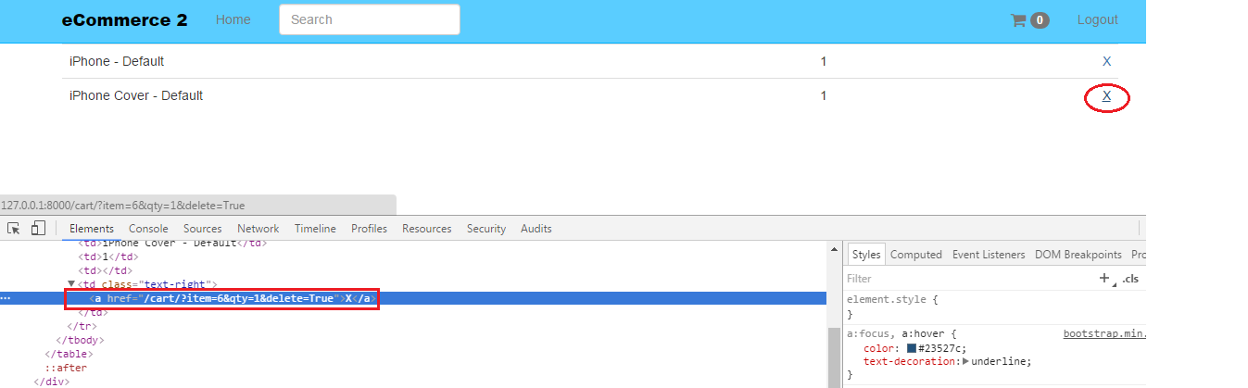

# 044 Update Cart Item quantity in Cart

## 功能：更新购物车商品数量

这个章节有一个view含多个form的，可以看看怎么处理的

html里添加q参数，传递到url，然后在view处理。这些GET参数并不影响model

# modified: carts/templates/carts/view.html

----------------------- carts/templates/carts/view.html -----------------------

{% extends "base.html" %}

+<script>

+{% block jquery %}

+$(".item-qty").change(function(){

+ $(this).next(".btn-update").fadeIn();

+});

+

+{% endblock %}

+</script>

{% block content %}

<table class='table'>

{% for item in object.cartitem_set.all %}

<tr id='item-{{ item.item.id }}'>

+ <form action="." method="GET">

<td>{{ item.item.get_title }}</td>

+ <input type='hidden' name='item' value='{{ item.item.id }}' />

- <td>{{ item.quantity }}</td>

+ <td><input type='number' class='item-qty' name='qty' value='{{ item.quantity }}' /><input type='submit' class='btn-update btn btn-link' value='Update item' style='display:none;'/></td>

<td>{{ item.line_total }}</td>

<td class='text-right' ><a href='{{ item.remove }}'>X</a></td>

+ </form>

</tr>

{% endfor %}

</table>

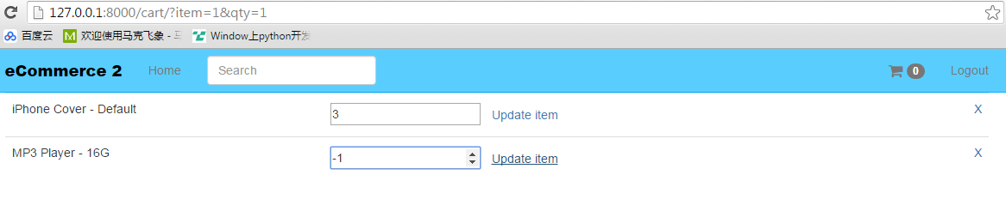

调节数字，后面的“update Item”会fade in

更新“update Item”

- 如果quantity > 0, 数字更新并且“update item”消失

- 如果quantity < 0, 该行被删除

# 045 Cart Item Line Total

## 功能：执行update item之后，价格会自动更新

## Tag : pre-save

## 学习参考– pre-save

<https://docs.djangoproject.com/en/1.8/ref/signals/#pre-save>

## 添加line_item_total到model CartItem，并为CartItem绑定pre-save函数

之前操作将migration目录删掉了，migrate不起作用

- 添加migrations目录，并添加__init__.py文件

- 执行makemigrations，这时候会生成0001_initial.py,这个是基于当前修改的文件

- 执行migrate

- 修改CartItem

- 执行makemigrations，migrate，生成0002_cartitem_line_item_total.py文件

# modified: carts/models.py

# modified: carts/templates/carts/view.html

------------------------------- carts/models.py -------------------------------

+from decimal import Decimal

from django.conf import settings

from django.db import models

+from django.db.models.signals import pre_save

class CartItem(models.Model):

cart = models.ForeignKey("Cart") #cart class is below

item = models.ForeignKey(Variation)

quantity = models.PositiveIntegerField(default=1)

+ line_item_total = models.DecimalField(max_digits=10, decimal_places=2)

+def cart_item_pre_save_receiver(sender, instance, *args, **kwargs):

+ qty = instance.quantity

+ if qty >= 1:

+ price = instance.item.get_price()

+ line_item_total = Decimal(qty) * Decimal(price)

+ instance.line_item_total = line_item_total

+

+pre_save.connect(cart_item_pre_save_receiver, sender=CartItem)

## 更新Template，line_total->line_item_total

----------------------- carts/templates/carts/view.html -----------------------

{% block content %}

<table class='table'>

{% for item in object.cartitem_set.all %}

<tr id='item-{{ item.item.id }}'>

<form action="." method="GET">

<td>{{ item.item.get_title }}</td>

<input type='hidden' name='item' value='{{ item.item.id }}' />

<td><input type='number' class='item-qty' name='qty' value='{{ item.quantity }}' /><input type='submit' class='btn-update btn btn-link' value='Update item' style='display:none;'/></td>

- <td>{{ item.line_total }}</td>

+ <td>{{ item.line_item_total }}</td>

<td class='text-right' ><a href='{{ item.remove }}'>X</a></td>

</form>

# 046 Cart Subtotal

## 功能：增加总价功能

## Tag : post_save post_delete

# modified: carts/models.py

# modified: carts/templates/carts/view.html

------------------------------- carts/models.py -------------------------------

-from django.db.models.signals import pre_save

+from django.db.models.signals import pre_save, post_save, post_delete

class CartItem(models.Model):

+def cart_item_post_save_receiver(sender, instance, *args, **kwargs):

+ instance.cart.update_subtotal()

+post_save.connect(cart_item_post_save_receiver, sender=CartItem)

+post_delete.connect(cart_item_post_save_receiver, sender=CartItem)

class Cart(models.Model):

user = models.ForeignKey(settings.AUTH_USER_MODEL, null=True, blank=True)

items = models.ManyToManyField(Variation, through=CartItem)

timestamp = models.DateTimeField(auto_now_add=True, auto_now=False)

updated = models.DateTimeField(auto_now_add=False, auto_now=True)

+ subtotal = models.DecimalField(max_digits=50, decimal_places=2)

+ def update_subtotal(self):

+ print "updating..."

+ subtotal = 0

+ items = self.cartitem_set.all()

+ for item in items:

+ subtotal += item.line_item_total

+ self.subtotal = "%.2f" %(subtotal)

+ self.save()

----------------------- carts/templates/carts/view.html -----------------------

{% block content %}

<table class='table'>

{% for item in object.cartitem_set.all %}

<tr id='item-{{ item.item.id }}'>

<form action="." method="GET">

<td>{{ item.item.get_title }}</td>

<input type='hidden' name='item' value='{{ item.item.id }}' />

<td><input type='number' class='item-qty' name='qty' value='{{ item.quantity }}' /><input type='submit' class='btn-update btn btn-link' value='Update item' style='display:none;'/></td>

<td>{{ item.line_item_total }}</td>

<td class='text-right' ><a href='{{ item.remove }}'>X</a></td>

</form>

</tr>

{% endfor %}

+ <tr>

+ <td colspan='4' class='text-right'>Subtotal: <span id='subtotal'>{{ object.subtotal }}</span></td>

+ </tr>

colspan='4'表示第四列

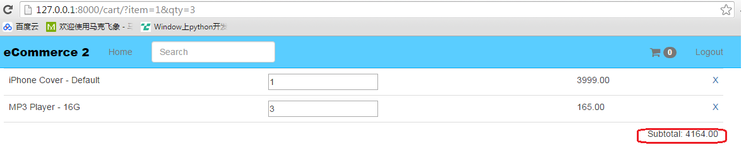

# 047 Ajax Part1 – Add to Cart

## Tag : JsonResponse is_ajax()serialize

Ajax = Asynchronous Javascript and XML

<https://docs.djangoproject.com/en/1.8/ref/request-response/#django.http.JsonResponse>

功能1： add to cart

# modified: carts/views.py

# modified: products/templates/products/product_detail.html

-------------------------------- carts/views.py --------------------------------

-from django.http import HttpResponseRedirect

+from django.http import HttpResponseRedirect, Http404, JsonResponse

class CartView(SingleObjectMixin, View):

def get(self, request, *args, **kwargs):

cart = self.get_object()

item_id = request.GET.get('item')

- delete_item = request.GET.get('delete')

+ delete_item = request.GET.get('delete', False)

+ item_added = False

+ if request.is_ajax():

+ data = {

+ "deleted": delete_item,

+ "item_added": item_added,

+ }

+ return JsonResponse(data)

--------------- products/templates/products/product_detail.html ---------------

+// ajax add to cart

+$("#submit-btn").click(function(event){

+ event.preventDefault();

+ var formData = $("#add-form").serialize();

+ console.log(formData);

+ $.ajax({

+ type: "GET", // "POST"

+ url: "{% url 'cart' %}",

+ data: formData,

+ success: function(data) {

+ console.log(data)

+ $("#jquery-message").text("Added " + data.item_added + " Deleted " + data.deleted)

+ },

+ error: function(response, error) {

+ // console.log(response)

+ // console.log(error)

+ $("#add-form").submit()

+ }

+ })

+

+ // $("#add-form").submit() # it will go to the next page

})

<div class="col-sm-4">

+ <p id='jquery-message' class='lead'>

- <form method='GET' action="{% url 'cart' %}">

+ <form **id='add-form'** method='GET' action="{% url 'cart' %}"> <!-- add form for AJAX -->

{% if object.variation_set.count > 1 %}

<h3 id='price'>{{ object.variation_set.first.price }}</h3>

<select name='item' class='form-control variation_select'>

<br/>

<input class='form-control' type='number' name='qty' value='1' />

<br/>

- <input type='submit' value='Add to Cart' class='btn btn-default' />

+ <input **id='submit-btn'** type='submit' value='Add to Cart' class='btn btn-default' /> <!-- submit-btn for AJAX -->

</form>

执行add to cart, 页面不会跳转，console.log()可打印相应的log

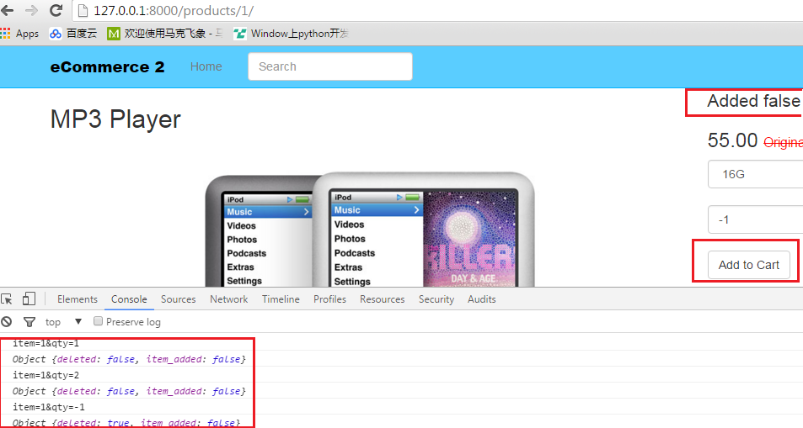

# 048 Ajax Part2 – update Total and Subtotal

功能 ： 调节数量，total和subtotal会自动调整

## Tag: HttpResponse, Redirect, is_ajax

## JQuery : $(this), text, prev, next, val, submit, fadeIn, fadeout, change

## JavaScript : event, console

# modified: carts/templates/carts/view.html

# modified: carts/views.py

-------------------------------- carts/views.py --------------------------------

class CartView(SingleObjectMixin, View):

def get(self, request, *args, **kwargs):

……

if item_id:

……

+ if not request.is_ajax():

+ return HttpResponseRedirect(reverse("cart"))

+ #return cart_item.cart.get_absolute_url()

if request.is_ajax():

+ try:

+ total = cart_item.line_item_total

+ except:

+ total = None

+ try:

+ subtotal = cart_item.cart.subtotal

+ except:

+ subtotal = None

data = {

"deleted": delete_item,

"item_added": item_added,

+ "line_total": total,

+ "subtotal": subtotal,

}

return JsonResponse(data)

----------------------- carts/templates/carts/view.html -----------------------

<script>

{% block jquery %}

$(".item-qty").change(function(){

- $(this).next(".btn-update").fadeIn();

+ // $(this).next(".btn-update").fadeIn();

+ // event.preventDefault();

+ var item = $(this).prev("input[type='hidden']").val();

+ var qty = $(this).val()

+ var data = {

+ item: item,

+ qty: qty

+ }

+ console.log(data);

+ $.ajax({

+ type: "GET", // "POST"

+ url: "{% url 'cart' %}",

+ data: data,

+ success: function(data) {

+ $("#jquery-message").text("Added " + data.item_added + " Deleted " + data.deleted)

+ if (data.deleted){

+ $("#item-"+item).fadeOut();

+ $("#subtotal").text(data.subtotal);

+ } else {

+ $("#item-line-total-"+item).text(data.line_total);

+ $("#subtotal").text(data.subtotal);

+ }

+ },

+ error: function(response, error) {

+ // console.log(response)

+ // console.log(error)

+ $("#add-form").submit()

+ }

+ })

});

<table class='table'>

{% for item in object.cartitem_set.all %}

- <tr>

- <form action="." method="GET">

- <input type='hidden' name='item' value='{{ item.item.id }}' />

- <td><input type='number' class='item-qty' name='qty' value='{{ item.quantity }}' /><input type='submit' class='btn-update btn btn-link' value='Update item' style='display:none;'/></td>

- </form>

- <td>{{ item.line_item_total }}</td>

+ <tr **id='item-{{ item.item.id }}'**> <!-- id for AJAX-->

<td>{{ item.item.get_title }}</td>

+ <td><form action="." method="GET"><input type='hidden' name='item' value='{{ item.item.id }}' /><input type='number' class='item-qty' name='qty' value='{{ item.quantity }}' /><input type='submit' class='btn-update btn btn-link' value='Update item' style='display:none;'/></form></td>

+ <td **id='item-line-total-{{ item.item.id }}**'>{{ item.line_item_total }}</td>

<td class='text-right' ><a href='{{ item.remove }}'>X</a></td>

</tr>

{% endfor %}

<tr>

- <td colspan='4' class='text-right'>Subtotal: {{ object.subtotal }}</td> <!-- id for AJAX-->

+ <td id='subtotal' colspan='4' class='text-right'>Subtotal: {{ object.subtotal }}</td> <!-- id for AJAX-->

</tr>

这边添加了三个id，为了jQuery操作使用

<tr id='item-{{ item.item.id }}'>

<td **id='item-line-total-{{ item.item.id }}**'>

<td id='subtotal'

# 049 JQuery Flash Message

## 功能： Flash Message

## Tag : alert

## 参考学习：getbootstrap.com/components/#alerts

<http://getbootstrap.com/components/#alerts>

jQuery语句include的template不能有空格回车，必须连在一起否则html显示会有问题

传递参数时用下列语句

var template = "{% include 'alert.html' with message='" + message + "' %}"

# modified: carts/templates/carts/view.html

# modified: products/templates/products/product_detail.html

# modified: static_in_pro/our_static/css/custom.css

# modified: templates/javascript.html

#

# static_in_pro/our_static/js/custom.js

# templates/alert.html

----------------------- carts/templates/carts/view.html -----------------------

$(".item-qty").change(function(){

success: function(data) {

$("#jquery-message").text("Added " + data.item_added + " Deleted " + data.deleted)

if (data.deleted){

$("#item-"+item).fadeOut();

$("#subtotal").text(data.subtotal);

} else {

$("#item-line-total-"+item).text(data.line_total);

$("#subtotal").text(data.subtotal);

}

+ showFlashMessage("cart updated");

},

--------------- products/templates/products/product_detail.html ---------------

$("#submit-btn").click(function(event){

url: "{% url 'cart' %}",

data: formData,

success: function(data) {

- console.log(data)

- $("#jquery-message").text("Added " + data.item_added + " Deleted " + data.deleted)

+ //console.log(data)

+ //$("#jquery-message").text("Added " + data.item_added + " Deleted " + data.deleted)

+ showFlashMessage("product added");

},

-------------------------- templates/javascript.html --------------------------

+ <script src="{% static 'js/custom.js' %}"></script>

------------------- static_in_pro/our_static/css/custom.css -------------------

+.container-alert-flash {

+ position: absolute;

+ top: 10px;

+ z-index: 50000;

+ width: 100%;

+ right: 0%;

+ margin: 0px;

+ display:none;

+}

static_in_pro/our_static/js/custom.js

function showFlashMessage(message) {

// var template = "{% include 'alert.html' with message='" + message + "' %}"

var template = "<div class='container container-alert-flash'>" +

"<div class='col-sm-3 col-sm-offset-8'> " +

"<div class='alert alert-success alert-dismissible' role='alert'>" +

"<button type='button' class='close' data-dismiss='alert' aria-label='Close'>" +

"<span aria-hidden='true'>&times;</span></button>"

+ message + "</div></div></div>"

$("body").append(template);

$(".container-alert-flash").fadeIn();

setTimeout(function(){

$(".container-alert-flash").fadeOut();

}, 1800);

}

# 050 Display Message from Server

## 功能：message的内容从Server获取 (ajax)

## Tag : ajax

# modified: carts/templates/carts/view.html

# modified: carts/views.py

# modified: products/templates/products/product_detail.html

----------------------- carts/templates/carts/view.html -----------------------

$(".item-qty").change(function(){

$.ajax({

type: "GET", // "POST"

url: "{% url 'cart' %}",

data: data,

success: function(data) {

+ var message = ""

+ if (data.item_added) {

+ message = "New item added"

+ } else if (data.deleted){

+ message = "Item removed"

+ } else {

+ message = "Item updated"

+ }

- showFlashMessage("cart updated");

+ showFlashMessage(message);

},

-------------------------------- carts/views.py --------------------------------

+from django.core.urlresolvers import reverse

class CartView(SingleObjectMixin, View):

cart = self.get_object()

item_id = request.GET.get('item')

delete_item = request.GET.get('delete', False)

+ flash_message = ""

item_added = False

if item_id:

- cart_item = CartItem.objects.get_or_create(cart=cart, item=item_instance)[0]

+ cart_item, **created** = CartItem.objects.get_or_create(cart=cart, item=item_instance)

+ if created:

+ flash_message = "Successfully added to the cart"

+ item_added = True

if delete_item:

+ flash_message = "Item removed successfully."

cart_item.delete()

else:

+ if not created:

+ flash_message = "Quantity has been updated successfully."

cart_item.quantity = qty

cart_item.save()

data = {

"deleted": delete_item,

"item_added": item_added,

"line_total": total,

"subtotal": subtotal,

+ "flash_message": flash_message,

}

return JsonResponse(data)

--------------- products/templates/products/product_detail.html ---------------

// ajax add to cart

$("#submit-btn").click(function(event){

event.preventDefault();

var formData = $("#add-form").serialize();

console.log(formData);

$.ajax({

success: function(data) {

//console.log(data)

//$("#jquery-message").text("Added " + data.item_added + " Deleted " + data.deleted)

- showFlashMessage("product added");

+ showFlashMessage(data.flash_message);

},

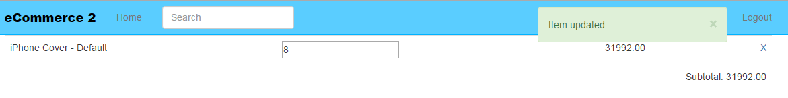

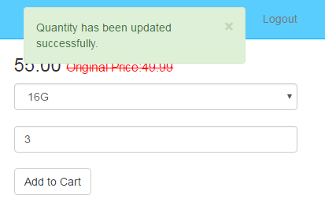

# 087 Empty Cart

## 功能：清空购物车

## Tag : ajax escape

## JQuery : include html

# modified: carts/templates/carts/view.html

# modified: carts/views.py

# carts/templates/carts/empty_cart.html

carts/models.py

-from django.db.models.signals import pre_save, post_save

+from django.db.models.signals import pre_save, post_save, post_delete

+post_delete.connect(cart_item_post_save_receiver, sender=CartItem)

-------------------------------- carts/views.py --------------------------------

class CartView(SingleObjectMixin, View):

def get(self, request, *args, **kwargs):

if request.is_ajax():

+ try:

+ total_items = cart_item.cart.items.count()

+ except:

+ total_items = 0

data = {

"deleted": delete_item,

"item_added": item_added,

"line_total": total,

"subtotal": subtotal,

"flash_message": flash_message,

+ "total_items": total_items

}

return JsonResponse(data)

----------------------- carts/templates/carts/view.html -----------------------

$(".item-qty").change(function(){

$.ajax({

success: function(data) {

+ if (data.total_items == 0 ) {

+ $(".table").fadeOut()

+ var template = "{% include 'carts/empty_cart.html' %}";

+ $(".main-content").html(template);

+ }

var message = ""

{% block content %}

+<div class='row main-content'>

+{% if object.cartitem_set.count < 1 %}

+ {% include "carts/empty_cart.html" %}

+{% else %}

<table class='table'>

{% for item in object.cartitem_set.all %}

<tr id='item-{{ item.item.id }}'> <!-- id for AJAX-->

……

+{% endif %}

+</div>

carts/templates/carts/empty_cart.html

再次强调，js里面include html时应该escape空格

**<!-- MAKE SURE YOUR DATA IS ESCAPED -->**<div class=**'col-sm-6 col-sm-offset-3 text-center'**><h1>**Your cart is empty**</h1><p>**Continue Shopping**</p></div>

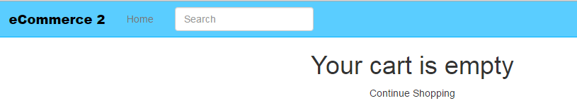

# 088 Cart Count in Navbar

## 功能：navbar上显示Cart的数量

通过新建一个View来实现，view的内容通过ajax更新

## Tag : JsonResponse, View

执行一次ajax，类似于form的submit

不把count保存到session，显示会一直闪（数字会返回为0）

# modified: carts/models.py

# modified: carts/templates/carts/view.html

# modified: carts/views.py

# modified: ecommerce2/urls.py

# modified: products/templates/products/product_detail.html

# modified: templates/javascript.html

# modified: templates/navbar.html

## 配置URL

------------------------------ ecommerce2/urls.py ------------------------------

-from carts.views import CartView

+from carts.views import CartView, ItemCountView

urlpatterns = [

url(r'^products/', include('products.urls')),

url(r'^categories/', include('products.urls_categories')),

+ url(r'^cart/count/$', ItemCountView.as_view(), name='item_count'),

]

## 更新model，添加subtotal的默认值？

------------------------------- carts/models.py -------------------------------

class Cart(models.Model):

items = models.ManyToManyField(Variation, through=CartItem)

timestamp = models.DateTimeField(auto_now_add=True, auto_now=False)

updated = models.DateTimeField(auto_now_add=False, auto_now=True)

- subtotal = models.DecimalField(max_digits=50, decimal_places=2)

+ subtotal = models.DecimalField(max_digits=50, decimal_places=2, default=25.00)

## 创建View，继承baseclass：View，在get函数里通过ajax更新数量，并通过JasonResponse返回数据

-------------------------------- carts/views.py --------------------------------

# Create your views here.

+class ItemCountView(View):

+ def get(self, request, *args, **kwargs):

+ if request.is_ajax():

+ cart_id = self.request.session.get("cart_id")

+ if cart_id == None:

+ count = 0

+ else:

+ cart = Cart.objects.get(id=cart_id)

+ count = cart.items.count()

+ request.session["cart_item_count"] = count

+ return JsonResponse({"count": count})

+ else:

+ raise Http404

## 更新Template，在ajax里面更新Cart数量

----------------------- carts/templates/carts/view.html -----------------------

$(".item-qty").change(function(){

$.ajax({

success: function(data) {

showFlashMessage(message);

+ updateCartItemCount();

},

--------------- products/templates/products/product_detail.html ---------------

$("#submit-btn").click(function(event){

$.ajax({

success: function(data) {

showFlashMessage(data.flash_message);

+ updateCartItemCount();

},

-------------------------- templates/javascript.html --------------------------

+ <script>

+ function updateCartItemCount(){

+ var badge = $("#cart-count-badge");

+ $.ajax({

+ type: "GET",

+ url: "{% url 'item_count' %}",

+ success: function(data){

+ badge.text(data.count);

+ console.log(data.count);

+ },

+ error: function(response, error) {

+ console.log(response)

+ console.log(error);

+ }

+ })

+ }

+ $(document).ready(function(){

+ updateCartItemCount()

+ })

+

+ </script>

---------------------------- templates/navbar.html ----------------------------

- <li><a href="#"><i class="fa fa-shopping-cart fa-navbar-cart"></i> <span class='badge'>0</span></a></li>

+ <li><a **href='{% url "cart" %}'**><i class="fa fa-shopping-cart fa-navbar-cart"></i> <span **id="cart-count-badge"** class='badge'>**{{ request.session.cart_item_count }}**</span></a></li>

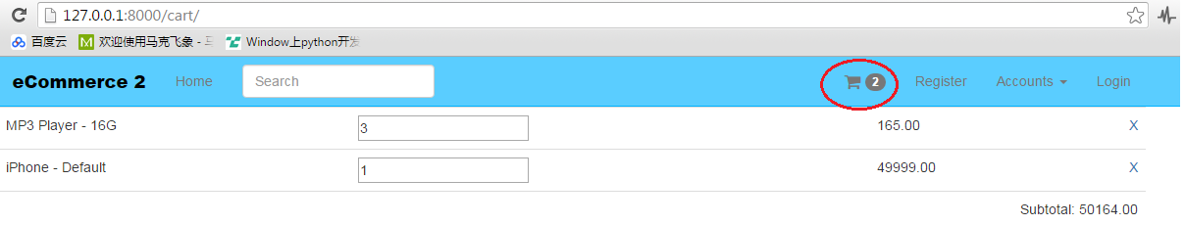



# 089 Cart Total Taxes

## 功能：更新总数和总税

## Tag : pre_save

# modified: carts/models.py

# modified: carts/templates/carts/view.html

# modified: carts/views.py

## 更新model，添加tax相关信息

------------------------------- carts/models.py -------------------------------

class Cart(models.Model):

timestamp = models.DateTimeField(auto_now_add=True, auto_now=False)

updated = models.DateTimeField(auto_now_add=False, auto_now=True)

subtotal = models.DecimalField(max_digits=50, decimal_places=2, default=25.00)

+ tax_percentage = models.DecimalField(max_digits=10, decimal_places=5, default=0.085)

+ tax_total = models.DecimalField(max_digits=50, decimal_places=2, default=25.00)

+ total = models.DecimalField(max_digits=50, decimal_places=2, default=25.00)

+ # discounts

+ # shipping

+def do_tax_and_total_receiver(sender, instance, *args, **kwargs):

+ subtotal = Decimal(instance.subtotal)

+ tax_total = round(subtotal * Decimal(instance.tax_percentage), 2) #8.5%

+ print instance.tax_percentage

+ total = round(subtotal + Decimal(tax_total), 2)

+ instance.tax_total = "%.2f" %(tax_total)

+ instance.total = "%.2f" %(total)

+ #instance.save()

+pre_save.connect(do_tax_and_total_receiver, sender=Cart)

-------------------------------- carts/views.py --------------------------------

class CartView(SingleObjectMixin, View):

def get_object(self, *args, **kwargs):

self.request.session.set_expiry(0) #5 minutes

cart_id = self.request.session.get("cart_id")

if cart_id == None:

cart = Cart()

+ cart.tax_percentage = 0.075

cart.save()

cart_id = cart.id

self.request.session["cart_id"] = cart_id

+ try:

+ cart_total = cart_item.cart.total

+ except:

+ cart_total = None

+ try:

+ tax_total = cart_item.cart.tax_total

+ except:

+ tax_total = None

data = {

"deleted": delete_item,

"item_added": item_added,

"line_total": total,

"subtotal": subtotal,

+ "cart_total": cart_total,

+ "tax_total": tax_total,

"flash_message": flash_message,

"total_items": total_items

}

## 更新Template，添加相关元素，并能够动态更新它们

----------------------- carts/templates/carts/view.html -----------------------

$(".item-qty").change(function(){

$.ajax({

success: function(data) {

$("#jquery-message").text("Added " + data.item_added + " Deleted " + data.deleted)

if (data.deleted){

$("#item-"+item).fadeOut();

$("#subtotal").text(data.subtotal);

+ $("#taxtotal").text(data.tax_total);

+ $("#carttotal").text(data.cart_total);

} else {

$("#item-line-total-"+item).text(data.line_total);

$("#subtotal").text(data.subtotal);

+ $("#taxtotal").text(data.tax_total);

+ $("#carttotal").text(data.cart_total);

}

<table class='table'>

+ <tr>

+ <td colspan='4' class='text-right'>Tax (Estimated): <span id='taxtotal'>{{ object.tax_total }}</span></td>

+ </tr>

+

+ <tr>

+ <td colspan='4' class='text-right'>Total: <span id='carttotal'>{{ object.total }}</span></td>

+ </tr>

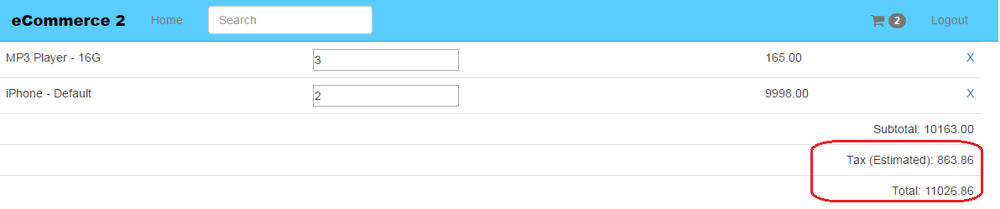

# 090 Checkout View

request.build_absolute_uri？

## Tag : redirect, DetailView, AuthenticationForm, build_absolute_uri, request.user.is_authenticated

# modified: carts/views.py

# modified: ecommerce2/urls.py

# carts/templates/carts/checkout_view.html

## 配置URL

------------------------------ ecommerce2/urls.py ------------------------------

-from carts.views import CartView, ItemCountView

+from carts.views import CartView, ItemCountView, CheckoutView

+ url(r'^checkout/$', CheckoutView.as_view(), name='checkout'),

## 创建CheckoutView (DetailView)

-------------------------------- carts/views.py --------------------------------

-from django.shortcuts import render, get_object_or_404

-from django.views.generic.detail import SingleObjectMixin

+from django.shortcuts import render, get_object_or_404, redirect

+from django.views.generic.detail import SingleObjectMixin, DetailView

+from django.contrib.auth.forms import AuthenticationForm

+class CheckoutView(DetailView):

+ model = Cart

+ template_name = "carts/checkout_view.html"

+ def get_object(self, *args, **kwargs):

+ cart_id = self.request.session.get("cart_id")

+ if cart_id == None:

+ return redirect("cart")

+ cart = Cart.objects.get(id=cart_id)

+ return cart

+ def get_context_data(self, *args, **kwargs):

+ context = super(CheckoutView, self).get_context_data(*args, **kwargs)

+ user_can_continue = False

+ if not self.request.user.is_authenticated():

+ context["login_form"] = AuthenticationForm()

+ context["next_url"] = self.request.build_absolute_uri()

+

+ if self.request.user.is_authenticated():

+ user_can_continue = True

+

+ context["user_can_continue"] = user_can_continue

+

+ return context

## 添加Checkout View template

carts/templates/carts/checkout_view.html

{% extends "base.html" %}

{% load i18n %}

{% load crispy_forms_tags %}

{% block content %}

{% if not user_can_continue %}

<div class='col-sm-6'>

<p class='lead'>Continue as Guest</p>

</div>

<div class='col-sm-6'>

<p class='lead'>Login to Continue</p>

<form method='POST' action="{% url 'auth_login' %}"> {% csrf_token %}

{{ login_form|crispy }}

<input type='hidden' name='next' value='{{ next_url }}' />

<input type='submit' class='btn btn-success' value='Login' />

</form>

<p class='text-center'>

<p>{% trans "Forgot password" %}? <a href="{% url 'auth_password_reset' %}">{% trans "Reset it" %}</a>!</p>

<p>{% trans "Not member" %}? <a href="{% url 'registration_register' %}">{% trans "Register" %}</a>!</p>

</p>

</div>

{% endif %}

{% endblock %}

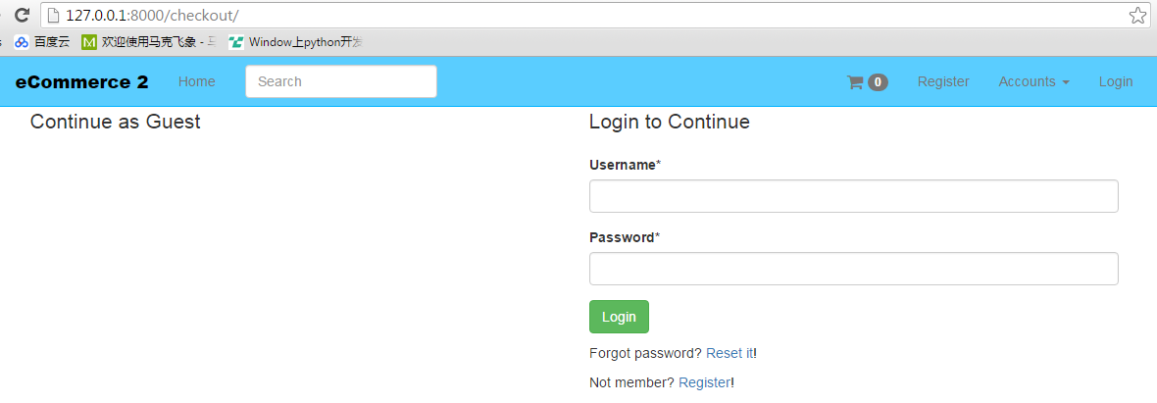

# 091 Orders App

## 功能：创建Order App

# modified: ecommerce2/settings/base.py

# orders/

<https://docs.djangoproject.com/en/1.8/topics/db/models/#one-to-one-relationships>

------------------------- ecommerce2/settings/base.py -------------------------

INSTALLED_APPS **=** **(**

'newsletter'**,**

'products'**,**

'carts'**,**

**+** 'orders'**,**

'crispy_forms'**,**

'registration'**,**

**)**

orders/

**from** django**.**conf **import** settings

**from** django**.**db **import** models

# Create your models here.

**class** **UserCheckout(**models**.**Model**):**

user **=** models**.**OneToOneField**(**settings**.**AUTH_USER_MODEL**,** null**=True,** blank**=True)** #not required

email **=** models**.**EmailField**(**unique**=True)** #--> required

**def** __unicode__**(**self**):** #def __str__(self):

**return** self**.**email

# 092 Checkout from FromMixin

功能：添加FormMixin，用于Guest的信息验证

## Tag：FormMixin

<https://docs.djangoproject.com/en/1.8/ref/class-based-views/mixins-editing/#formmixin>

**FormMixin**[¶](https://docs.djangoproject.com/en/1.8/ref/class-based-views/mixins-editing/#formmixin)

***class* django.views.generic.edit.FormMixin**[**¶**](https://docs.djangoproject.com/en/1.8/ref/class-based-views/mixins-editing/#django.views.generic.edit.FormMixin)

**get_success_url()**[¶](https://docs.djangoproject.com/en/1.8/ref/class-based-views/mixins-editing/#django.views.generic.edit.FormMixin.get_success_url)

Determine the URL to redirect to when the form is successfully validated. Returns [success_url](https://docs.djangoproject.com/en/1.8/ref/class-based-views/mixins-editing/#django.views.generic.edit.FormMixin.success_url) by default.

# modified: carts/templates/carts/checkout_view.html

# modified: carts/views.py

# modified: orders/forms.py

更新CheckoutView，添加基类FormMixin，在函数内增加form_class

post函数内添加form的validation

**--------------------------------** carts**/**views**.**py **--------------------------------**

**+from** django**.**views**.**generic**.**edit **import** FormMixin

**+from** orders**.**forms **import** GuestCheckoutForm

**-class** **CheckoutView(**DetailView**):**

**+class** **CheckoutView(**FormMixin**,** DetailView**):**

model **=** Cart

template_name **=** "carts/checkout_view.html"

**+** form_class **=** GuestCheckoutForm

context**[**"form"**]** **=** self**.**get_form**()**

**+** **def** post**(**self**,** request**,** **\***args**,** **\*\***kwargs**):**

**+** form **=** self**.**get_form**()**

**+** **if** form**.**is_valid**():**

**+** **print** form**.**cleaned_data**.**get**(**"email"**)**

**+** **return** self**.**form_valid**(**form**)**

**+** **else:**

**+** **return** self**.**form_invalid**(**form**)**

**+**

**+** **def** get_success_url**(**self**):**

**+** **return** reverse**(**"checkout"**)**

添加GuestCheckoutForm，并增加email的clean函数

**-------------------------------** orders**/**forms**.**py **-------------------------------**

**+from** django **import** forms

**+**

**+class** **GuestCheckoutForm(**forms**.**Form**):**

**+** email **=** forms**.**EmailField**()**

**+** email2 **=** forms**.**EmailField**(**label**=**'Verify Email'**)**

**+** **def** clean_email2**(**self**):**

**+** email **=** self**.**cleaned_data**.**get**(**"email"**)**

**+** email2 **=** self**.**cleaned_data**.**get**(**"email2"**)**

**+** **if** email **==** email2**:**

**+** **return** email2

**+** **else:**

**+** **raise** forms**.**ValidationError**(**"Please confirm emails are the same"**)**

添加checkout view

**-------------------** carts**/**templates**/**carts**/**checkout_view**.**html **-------------------**

**{%** block content **%}-**

**+<**div **class=**'col-sm-6'**>**

**+** **<**form method**=**'POST' action**=**''**>{%** csrf_token **%}**

**+** **{{** form**|**crispy **}}**

**+** **<**input type**=**'submit' **class=**'btn btn-success' value**=**'Continue as Guest' **/>**

**+** **</**form**>**

**+</**div**>**

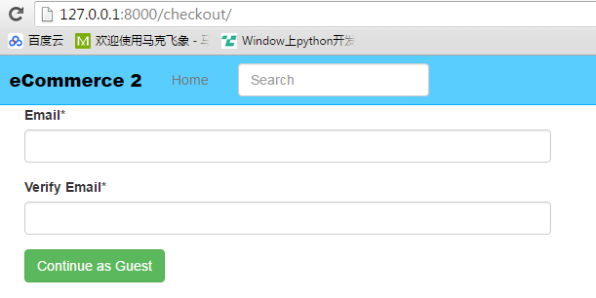

# 093 Save Guest Info

## 功能：保存Guest的信息，让Checkout支持授权用户和Guest两种情况

# modified: carts/templates/carts/checkout_view.html

# modified: carts/views.py

# modified: orders/admin.py

# modified: orders/forms.py

# modified: templates/navbar.html

-------------------------------- carts/views.py --------------------------------

**+from** orders**.**models **import** UserCheckout

**class** **CheckoutView(**FormMixin**,** DetailView**):**

**def** get_context_data**(**self**,** **\***args**,** **\*\***kwargs**):**

context **=** super**(**CheckoutView**,** self**).**get_context_data**(\***args**,** **\*\***kwargs**)**

user_can_continue **=** **False**

**+** user_check_id **=** self**.**request**.**session**.**get**(**"user_checkout_id"**)**

**-** **if** **not** self**.**request**.**user**.**is_authenticated**():**

**+** **if** **not** self**.**request**.**user**.**is_authenticated**()** **or** user_check_id **==** **None:** #or request.user.is_guest:

context**[**"login_form"**]** **=** AuthenticationForm**()**

context**[**"next_url"**]** **=** self**.**request**.**build_absolute_uri**()**

**-** **if** self**.**request**.**user**.**is_authenticated**():**

**+** **elif** self**.**request**.**user**.**is_authenticated**()** **or** user_check_id **!=** **None:**

user_can_continue **=** **True**

**+** **else:**

**+** **pass**

**def** post**(**self**,** request**,** **\***args**,** **\*\***kwargs**):**

**+** self**.**object **=** self**.**get_object**()**

form **=** self**.**get_form**()**

**if** form**.**is_valid**():**

**-** **print** form**.**cleaned_data**.**get**(**"email"**)**

**+** email **=** form**.**cleaned_data**.**get**(**"email"**)**

**+** user_checkout**,** created **=** UserCheckout**.**objects**.**get_or_create**(**email**=**email**)**

**+** request**.**session**[**"user_checkout_id"**]** **=** user_checkout**.**id

**return** self**.**form_valid**(**form**)**

**else:**

**return** self**.**form_invalid**(**form**)**

------------------------------- orders/forms.py -------------------------------

**+from** django**.**contrib**.**auth **import** get_user_model

**+**User **=** get_user_model**()**

**class** **GuestCheckoutForm(**forms**.**Form**):**

**def** clean_email2(self):

email2 **=** self**.**cleaned_data**.**get**(**"email2"**)**

**if** email **==** email2**:**

**+** user_exists **=** User**.**objects**.**filter**(**email**=**email**).**count**()**

**+** **if** user_exists **!=** 0**:**

**+** **raise** forms**.**ValidationError**(**"This User already exists. Please login instead."**)**

**return** email2

**else:**

**raise** forms**.**ValidationError**(**"Please confirm emails are the same"**)**

------------------- carts/templates/carts/checkout_view.html -------------------

{% block content %}

+{% if not user_can_continue %}

<div class='col-sm-6'>

+ <p class='lead'>Continue as Guest</p>

<form method='POST' action=''>{% csrf_token %} <!-- this POST will go to checkout view -->

{{ form|crispy }}

<input type='submit' class='btn btn-success' value='Continue as Guest' />

</form>

</div>

------------------------------- orders/admin.py -------------------------------

**+from** **.**models **import** UserCheckout

**+**admin**.**site**.**register**(**UserCheckout**)**

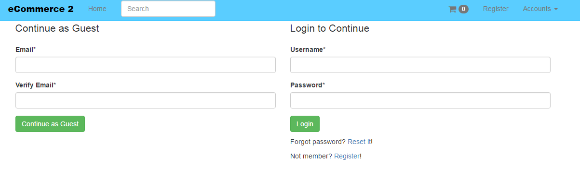

# 094 User Address Model

## 功能：添加用户地址model

# modified: carts/views.py

# modified: orders/admin.py

# modified: orders/models.py

**-------------------------------** orders**/**models**.**py **-------------------------------**

**+**ADDRESS_TYPE **=** **(**

**+** **(**'billing'**,** 'Billing'**),**

**+** **(**'shipping'**,** 'Shipping'**),**

**+)**

**+**

**+class** **UserAddress(**models**.**Model**):**

**+** user **=** models**.**ForeignKey**(**UserCheckout**)**

**+** type **=** models**.**CharField**(**max_length**=**120**,** choices**=**ADDRESS_TYPE**)**

**+** street **=** models**.**CharField**(**max_length**=**120**)**

**+** city **=** models**.**CharField**(**max_length**=**120**)**

**+** state **=** models**.**CharField**(**max_length**=**120**)**

**+** zipcode **=** models**.**CharField**(**max_length**=**120**)**

**+**

**+** **def** __unicode__**(**self**):**

**+** **return** self**.**street

**-------------------------------** orders**/**admin**.**py **-------------------------------**

**from** django**.**contrib **import** admin

# Register your models here.

**-from** **.**models **import** UserCheckout

**+from** **.**models **import** UserCheckout**,** UserAddress

**+**admin**.**site**.**register**(**UserAddress**)**

下面这儿可能是放错了

-------------------------------- carts/views.py --------------------------------

class CheckoutView(FormMixin, DetailView):

def get_context_data(self, *args, **kwargs):

+ if self.request.user.is_authenticated():

+ user_checkout, created = UserCheckout.objects.get_or_create(email=self.request.user.email)

+ user_checkout.user = self.request.user

+ user_checkout.save()

+ self.request.session["user_checkout_id"] = user_checkout.id

context["user_can_continue"] = user_can_continue

context["form"] = self.get_form()

# 095 User Address View

## 功能：用户地址选择View

## Tag : FormView, form_class, template_name

<https://docs.djangoproject.com/en/1.8/ref/class-based-views/generic-editing/#formview>

A view that displays a form. On error, redisplays the form with validation errors; on success, redirects to a new URL.

# modified: ecommerce2/urls.py

# modified: orders/forms.py

# modified: orders/views.py

# orders/templates/orders/address_select.html

## 配置URL

**------------------------------** ecommerce2**/**urls**.**py **------------------------------**

**+from** orders**.**views **import** AddressSelectFormView

urlpatterns **=** **[**

**+** url**(**r'^checkout/address/$'**,** AddressSelectFormView**.**as_view**(),** name**=**'order_address'**),**

**]**

## 创建form

包含billing地址和shipping地址

**-------------------------------** orders**/**forms**.**py **-------------------------------**

+class AddressForm(forms.Form):

+ billing_address = forms.CharField()

+ shipping_address = forms.CharField()

## 创建FormView

**-------------------------------** orders**/**views**.**py **-------------------------------**

**+from** django**.**views**.**generic**.**edit **import** FormView

**+from** **.**forms **import** AddressForm

**+**

# Create your views here.

**+class** **AddressSelectFormView(**FormView**):**

**+** form_class **=** AddressForm

**+** template_name **=** "orders/address_select.html"

## 创建模板

orders/templates/orders/address_select.html

{% extends "base.html" %}

{% load crispy_forms_tags %}

{% block content %}

{{ form|crispy }}

{% endblock %}

# 096 Model Choice Field

## 功能：地址从CharField改为多选框

## Tag : ModelChoiceField, RadioSelect, widget, empty_label

# modified: orders/forms.py

# modified: orders/templates/orders/address_select.html

# modified: orders/views.py

**-------------------------------** orders**/**forms**.**py **-------------------------------**

**+from** **.**models **import** UserAddress

**class** **AddressForm(**forms**.**Form**):**

**-** billing_address **=** forms**.**CharField**()**

**-** shipping_address **=** forms**.**CharField**()**

**+** billing_address **=** forms**.**ModelChoiceField**(**

**+** queryset**=**UserAddress**.**objects**.**filter**(**type**=**"billing"**),**

**+** widget **=** forms**.**RadioSelect**,**

**+** empty_label **=** **None** #not show enmpty

**+** **)**

**+** shipping_address **=** forms**.**ModelChoiceField**(**

**+** queryset**=**UserAddress**.**objects**.**filter**(**type**=**"shipping"**),**

**+** widget **=** forms**.**RadioSelect**,**

**+** empty_label **=** **None,**

**+**

**+** **)**

对于FormView，可以在get_form里更新queryset信息

**-------------------------------** orders**/**views**.**py **-------------------------------**

**+from** **.**models **import** UserAddress**,** UserCheckout

# Create your views here.

**class** **AddressSelectFormView(**FormView**):**

form_class **=** AddressForm

template_name **=** "orders/address_select.html"

**+** **def** get_form**(**self**,** **\***args**,** **\*\***kwargs**):**

**+** form **=** super**(**AddressSelectFormView**,** self**).**get_form**(\***args**,** **\*\***kwargs**)**

**+**

**+** form**.**fields**[**"billing_address"**].**queryset **=** UserAddress**.**objects**.**filter**(**

**+** user__email**=**self**.**request**.**user**.**email**,**

**+** type**=**'billing'**,**

**+** **)**

**+** form**.**fields**[**"shipping_address"**].**queryset **=** UserAddress**.**objects**.**filter**(**

**+** user__email**=**self**.**request**.**user**.**email**,**

**+** type**=**'shipping'**,**

**+** **)**

**+** **print** self**.**request**.**user**.**email

**+** **return** form

**+**

**+** **def** form_valid**(**self**,** form**,** **\***args**,** **\*\***kwargs**):**

**+** form **=** super**(**AddressSelectFormView**,** self**).**form_valid**(**form**,** **\***args**,** **\*\***kwargs**)**

**+** **return** form

**+**

**+** **def** get_success_url**(**self**,** **\***args**,** **\*\***kwargs**):**

**+** **return** "/checkout/"

或者 success_url = '/checkout/'

**----------------- orders/templates/orders/address_select.html -----------------**

{% block content %}

+<form method="POST" action=''>{% csrf_token %}

{{ form|crispy }}

+<input class='btn btn-default' type='submit' value='Select'/>

+</form>

{% endblock %}

# 097 Order Model

## 功能：定义Order Model，在Order里面会有Cart，User和地址相关信息，以及这些信息Form和View里的处理

Address提交后回到Order

# modified: carts/views.py

# modified: db.sqlite3

# modified: orders/models.py

# modified: orders/views.py

## 创建Order Model

**-------------------------------** orders**/**models**.**py **-------------------------------**

**+from** carts**.**models **import** Cart

**+class** **Order(**models**.**Model**):**

**+** cart **=** models**.**ForeignKey**(**Cart**)**

**+** user **=** models**.**ForeignKey**(**UserCheckout**,** null**=True)**

**+** billing_address **=** models**.**ForeignKey**(**UserAddress**,** related_name**=**'billing_address'**,** null**=True)**

**+** shipping_address **=** models**.**ForeignKey**(**UserAddress**,** related_name**=**'shipping_address'**,** null**=True)**

**+** shipping_total_price **=** models**.**DecimalField**(**max_digits**=**50**,** decimal_places**=**2**,** default**=**5.99**)**

**+** order_total **=** models**.**DecimalField**(**max_digits**=**50**,** decimal_places**=**2**,** **)**

**+**

**+** **def** __unicode__**(**self**):**

**+** **return** str**(**self**.**cart**.**id**)**

FormView验证时把地址信息都存到session里，这些信息只有在CheckoutView处理时才会真正存储到Order数据里

**-------------------------------** orders**/**views**.**py **-------------------------------**

class AddressSelectFormView(FormView):

def form_valid(self, form, *args, **kwargs):

- form = super(AddressSelectFormView, self).form_valid(form, *args, **kwargs)

- return form

+ billing_address = form.cleaned_data["billing_address"]

+ shipping_address = form.cleaned_data["shipping_address"]

+ self.request.session["billing_address"] = billing_address.id

+ self.request.session["shipping_address"] = shipping_address.id

+ return super(AddressSelectFormView, self).form_valid(form, *args, **kwargs)

**--------------------------------** carts**/**views**.**py **--------------------------------**

**-from** orders**.**models **import** UserCheckout

**+from** orders**.**models **import** UserCheckout**,** Order**,** UserAddress

**class** **CheckoutView(**FormMixin**,** DetailView**):**

**+** **def** get**(**self**,** request**,** **\***args**,** **\*\***kwargs**):**

**+** get_data **=** super**(**CheckoutView**,** self**).**get**(**request**,** **\***args**,** **\*\***kwargs**)**

**+** cart **=** self**.**get_object**()**

**+** user_checkout_id **=** request**.**session**.**get**(**"user_checkout_id"**)**

**+**

**+** **if** user_checkout_id **!=** **None:**

**+** user_checkout **=** UserCheckout**.**objects**.**get**(**id**=**user_checkout_id**)**

**+** billing_address_id **=** self**.**request**.**session**[**"billing_address"**]**

**+** shipping_address_id **=** self**.**request**.**session**[**"shipping_address"**]**

**+**

**+** **if** billing_address_id **==** **None** **or** shipping_address_id **==** **None:**

**+** **return** redirect**(**"order_address"**)**

**+** **else:**

**+** billing_address **=** UserAddress**.**objects**.**get**(**id**=**billing_address_id**)**

**+** shipping_address **=** UserAddress**.**objects**.**get**(**id**=**shipping_address_id**)**

**+**

**+** **try:**

**+** new_order_id **=** request**.**session**[**"order_id"**]**

**+** new_order **=** Order**.**objects**.**get**(**id**=**new_order_id**)**

**+** **except:**

**+** new_order **=** Order**()**

**+** request**.**session**[**"order_id"**]** **=** new_order**.**id

**+**

**+** new_order**.**cart **=** cart

**+** new_order**.**user **=** user_checkout

**+** new_order**.**billing_address **=** billing_address

**+** new_order**.**shipping_address **=** shipping_address

**+** new_order**.**save**()**

**+** **return** get_data

# 098 Crafting the Order Part 1

## 功能：解决保存时order_total为空的问题

## Tag : pre_save

**-------------------------------** orders**/**models**.**py **-------------------------------**

**+from** decimal **import** Decimal

**+from** django**.**db**.**models**.**signals **import** pre_save**,** post_save

**+def** order_pre_save**(**sender**,** instance**,** **\***args**,** **\*\***kwargs**):**

**+** shipping_total_price **=** instance**.**shipping_total_price

**+** cart_total **=** instance**.**cart**.**total

**+** order_total **=** Decimal**(**shipping_total_price**)** **+** Decimal**(**cart_total**)**

**+** instance**.**order_total **=** order_total

**-**

**+**pre_save**.**connect**(**order_pre_save**,** sender**=**Order**)**

Cart View中将order获取整理到一个函数

**--------------------------------** carts**/**views**.**py **--------------------------------**

class CheckoutView(FormMixin, DetailView):

+ def get_order(self, *args, **kwargs):

+ cart = self.get_object()

+ new_order_id = self.request.session.get("order_id")

+ if new_order_id is None:

+ new_order = Order.objects.create(cart=cart)

+ self.request.session["order_id"] = new_order.id

+ else:

+ new_order = Order.objects.get(id=new_order_id)

+ return new_order

def get(self, request, *args, **kwargs):

get_data = super(CheckoutView, self).get(request, *args, **kwargs)

cart = self.get_object()

+ new_order = self.get_order()

user_checkout_id = request.session.get("user_checkout_id")

- try:

- new_order_id = request.session["order_id"]

- new_order = Order.objects.get(id=new_order_id)

- except:

- new_order = Order()

- request.session["order_id"] = new_order.id

-

- new_order.cart = cart

new_order.user = user_checkout

new_order.billing_address = billing_address

new_order.shipping_address = shipping_address

**-------------------------------** orders**/**admin**.**py **-------------------------------**

# Register your models here.

**-from** **.**models **import** UserCheckout**,** UserAddress

**+from** **.**models **import** UserCheckout**,** UserAddress**,** Order

**+**admin**.**site**.**register**(**Order**)**

# 099 Crafting the Order Part 2

## 功能：Checkout view中显示Order信息

# modified: carts/templates/carts/checkout_view.html

# modified: carts/views.py

**--------------------------------** carts**/**views**.**py **--------------------------------**

**class** **CheckoutView(**FormMixin**,** DetailView**):**

template_name **=** "carts/checkout_view.html"

form_class **=** GuestCheckoutForm

**+** context**[**"order"**]** **=** self**.**get_order**()**

context**[**"user_can_continue"**]** **=** user_can_continue

context**[**"form"**]** **=** self**.**get_form**()**

**------------------- carts/templates/carts/checkout_view.html -------------------**

{% if not user_can_continue %}

+{% else %}

+<div class='col-sm-4 col-sm-offset-4 text-center'>

+<p class='lead'>

+Your Order</p>

+<table class='table'>

+ <tr><td>{{ order.cart.cartitem_set.count }} Item(s): <br/>{% for i in order.cart.cartitem_set.all %}

+ <b>{{ i.item.get_title }}</b><br/>

+ {% endfor %}</td></tr>

+ <tr><td>Cart Subtotal: {{ order.cart.subtotal }}</td></tr>

+ <tr><td>Tax: {{ order.cart.tax_total }}</td></tr>

+ <tr><td>Items Total: {{ order.cart.total }}</td></tr>

+ <tr><td>Shipping: {{ order.shipping_total_price }}</td></tr>

+ <tr><td>Order Total: {{ order.order_total }}</td></tr>

+</table>

+</div>

{% endif %}

# 100 Crafting the Order Part 3

## 功能：添加地址功能

A view that displays a form for creating an object, redisplaying the form with validation errors (if there are any) and saving the object.

<https://docs.djangoproject.com/en/1.8/ref/class-based-views/generic-editing/#createview>

A view that displays a form. On error, redisplays the form with validation errors; on success, redirects to a new URL.

<https://docs.djangoproject.com/en/1.8/ref/class-based-views/generic-editing/#formview>

解决Guest email为空的问题，因为Guest是没有User的 (user__email**=**self**.**request**.**user**.**email -> user=user_checkout)

Guest要解决地址不全的问题，比如shipping地址为空 (dispatch)

添加地址功能

**dispatch(request, *args, **kwargs)**[**¶**](https://docs.djangoproject.com/en/1.8/ref/class-based-views/base/#django.views.generic.base.View.dispatch)

The **view** part of the view – the method that accepts a **request** argument plus arguments, and returns a HTTP response.

The default implementation will inspect the HTTP method and attempt to delegate to a method that matches the HTTP method; a **GET** will be delegated to **get()**, a **POST** to **post()**, and so on.

By default, a **HEAD** request will be delegated to **get()**. If you need to handle **HEAD** requests in a different way than **GET**, you can override the **head()** method. See [Supporting other HTTP methods](https://docs.djangoproject.com/en/1.8/topics/class-based-views/#supporting-other-http-methods) for an example.

------------------------------ ecommerce2/urls.py ------------------------------

**-from** orders**.**views **import** AddressSelectFormView

**+from** orders**.**views **import** AddressSelectFormView**,** UserAddressCreateView

urlpatterns **=** **[**

**+** url**(**r'^checkout/address/add/$'**,** UserAddressCreateView**.**as_view**(),** name**=**'user_address_create'**),**

**]**

------------------------------- orders/forms.py -------------------------------

+class UserAddressForm(forms.ModelForm):

+ class Meta:

+ model = UserAddress

+ fields = [

+ 'street',

+ 'city',

+ 'state',

+ 'zipcode',

+ 'type'

+ ]

------------------------------- orders/views.py -------------------------------

**+from** django**.**contrib **import** messages

**-from** django**.**shortcuts **import** render

**+from** django**.**shortcuts **import** render**,** redirect

**-from** django**.**views**.**generic**.**edit **import** FormView

**+from** django**.**views**.**generic**.**edit **import** FormView**,** CreateView

**-from** **.**forms **import** AddressForm

**+from** **.**forms **import** AddressForm**,** UserAddressForm

# Create your views here.

**+class** **UserAddressCreateView(**CreateView**):**

**+** form_class **=** UserAddressForm

**+** template_name **=** "forms.html"

**+** success_url **=** "/checkout/address/"

**+**

**+** **def** get_checkout_user**(**self**):**

**+** user_check_id **=** self**.**request**.**session**.**get**(**"user_checkout_id"**)**

**+** user_checkout **=** UserCheckout**.**objects**.**get**(**id**=**user_check_id**)**

**+** **return** user_checkout

**+**

**+** **def** form_valid**(**self**,** form**,** **\***args**,** **\*\***kwargs**):**

**+** form**.**instance**.**user **=** self**.**get_checkout_user**()**

**+** **return** super**(**UserAddressCreateView**,** self**).**form_valid**(**form**,** **\***args**,** **\*\***kwargs**)**

**class** **AddressSelectFormView(**FormView**):**

form_class **=** AddressForm

template_name **=** "orders/address_select.html"

**+** **def** dispatch**(**self**,** **\***args**,** **\*\***kwargs**):**

**+** b_address**,** s_address **=** self**.**get_addresses**()**

**+** **if** b_address**.**count**()** **==** 0**:**

**+** messages**.**success**(**self**.**request**,** "Please add a billing address before continuing"**)**

**+** **return** redirect**(**"user_address_create"**)**

**+** **elif** s_address**.**count**()** **==** 0**:**

**+** messages**.**success**(**self**.**request**,** "Please add a shipping address before continuing"**)**

**+** **return** redirect**(**"user_address_create"**)**

**+** **else:**

**+** **return** super**(**AddressSelectFormView**,** self**).**dispatch**(\***args**,** **\*\***kwargs**)**

**+** **def** get_addresses**(**self**,** **\***args**,** **\*\***kwargs**):**

**+** user_check_id **=** self**.**request**.**session**.**get**(**"user_checkout_id"**)**

**+** user_checkout **=** UserCheckout**.**objects**.**get**(**id**=**user_check_id**)**

**+** b_address **=** UserAddress**.**objects**.**filter**(**

**+** user**=**user_checkout**,**

+ type**=**'billing'**,**

+ **)**

**+** s_address **=** UserAddress**.**objects**.**filter**(**

**+** user**=**user_checkout**,**

+ type**=**'shipping'**,**

+ **)**

**+** **return** b_address**,** s_address

**def** get_form**(**self**,** **\***args**,** **\*\***kwargs**):**

form **=** super**(**AddressSelectFormView**,** self**).**get_form**(\***args**,** **\*\***kwargs**)**

**-** form**.**fields**[**"billing_address"**].**queryset **=** UserAddress**.**objects**.**filter**(**

**-** user__email**=**self**.**request**.**user**.**email**,**

- type**=**'billing'**,**

- **)**

**-** form**.**fields**[**"shipping_address"**].**queryset **=** UserAddress**.**objects**.**filter**(**

**-** user__email**=**self**.**request**.**user**.**email**,**

- type**=**'shipping'**,**

- **)**

**+** b_address**,** s_address **=** self**.**get_addresses**()**

**+**

**+** # if b_address.count() == 0 or s_address.count()==0:

**+** # return redirect("user_address_create")

**+** form**.**fields**[**"billing_address"**].**queryset **=** b_address

**+** form**.**fields**[**"shipping_address"**].**queryset **=** s_address

**+**

**return** form

# 101 Crafting the Order Part 4

解决问题：Guest用户时，submit之后无法显示checkout 🡪 修正user_can_continue

创建user address view

# modified: carts/templates/carts/checkout_view.html

# modified: carts/templates/carts/view.html

# modified: carts/views.py

# modified: orders/models.py

# modified: orders/templates/orders/address_select.html

-------------------------------- carts/views.py --------------------------------

**class** **CheckoutView(**FormMixin**,** DetailView**):**

context **=** super**(**CheckoutView**,** self**).**get_context_data**(\***args**,** **\*\***kwargs**)**

user_can_continue **=** **False**

user_check_id **=** self**.**request**.**session**.**get**(**"user_checkout_id"**)**

**-** **if** **not** self**.**request**.**user**.**is_authenticated**()** **or** user_check_id **==** **None:** #or request.user.is_guest:

**-** context**[**"login_form"**]** **=** AuthenticationForm**()**

**-** context**[**"next_url"**]** **=** self**.**request**.**build_absolute_uri**()**

**-** **elif** self**.**request**.**user**.**is_authenticated**()** **or** user_check_id **!=** **None:**

**-** user_can_continue **=** **True**

**-** **else:**

**-** **pass**

**if** self**.**request**.**user**.**is_authenticated**():**

**+** user_can_continue **=** **True**

user_checkout**,** created **=** UserCheckout**.**objects**.**get_or_create**(**email**=**self**.**request**.**user**.**email**)**

user_checkout**.**user **=** self**.**request**.**user

user_checkout**.**save**()**

**+** **elif** **not** self**.**request**.**user**.**is_authenticated**()** **or** user_check_id **==** **None:** #or request.user.is_guest:

**+** context**[**"login_form"**]** **=** AuthenticationForm**()**

**+** context**[**"next_url"**]** **=** self**.**request**.**build_absolute_uri**()**

**+** **else:**

**+** **pass**

**+**

**+** **if** user_check_id **!=** **None:**

**+** user_can_continue **=** **True**

context**[**"order"**]** **=** self**.**get_order**()**

context**[**"user_can_continue"**]** **=** user_can_continue

**if** user_checkout_id **!=** **None:**

user_checkout **=** UserCheckout**.**objects**.**get**(**id**=**user_checkout_id**)**

**-** billing_address_id **=** self**.**request**.**session**[**"billing_address"**]**

**-** shipping_address_id **=** self**.**request**.**session**[**"shipping_address"**]**

**+** billing_address_id **=** self**.**request**.**session**.**get**(**"billing_address"**)**

**+** shipping_address_id **=** self**.**request**.**session**.**get**(**"shipping_address"**)**

**if** billing_address_id **==** **None** **or** shipping_address_id **==** **None:**

**return** redirect**(**"order_address"**)**

------------------------------- orders/models.py -------------------------------

class UserAddress(models.Model):

+ def get_address(self):

+ return "%s, %s, %s %s" %(self.street, self.city, self.state, self.zipcode)

------------------- carts/templates/carts/checkout_view.html -------------------

+<div class='col-sm-4 col-sm-offset-4 text-center'>

+<p><b>Billing to</b>

+<br/>

+{{ order.billing_address.get_address }}

+<p>

+<p><b>Shipping to</b>

+<br/>

+{{ order.shipping_address.get_address }}

+<p>

+<br>

+<p><b>Complete Order</b></p>

+

{% endif %}

----------------------- carts/templates/carts/view.html -----------------------

+<div class='col-sm-8 col-sm-offset-2'>

+<h1>Your cart</h1>

+

<table class='table'>

<tr>

<td colspan='4' class='text-right'>Total: <span id='carttotal'>{{ object.total }}</span></td>

</tr>

+

+ <tr>

+ <td colspan='4' class='text-right'><a class='btn btn-warning' href="{% url 'checkout' %}">Checkout </a></td>

+ </tr>

+

</table>

+</div>

----------------- orders/templates/orders/address_select.html -----------------

{% block content %}

+<div class='col-sm-4 col-sm-offset-4 text-center'>

+<p class='lead'>

+Select your addresses for this order.

+</p>

<form method="POST" action=''>{% csrf_token %}

{{ form|crispy }}

<input class='btn btn-default' type='submit' value='Select'/>

+<a class='btn btn-link' href='{% url "user_address_create" %}'>Add new</a>

</form>

+</div>

{% endblock %}

# 102 Custom Mixin for Cart Order

## 功能：将View中Order相关的一些操作提炼到Mixin作为基类

解决选完address回到checkout view不能及时显示的问题 （需要refresh）

# modified: carts/templates/carts/checkout_view.html

# modified: carts/views.py

# modified: orders/views.py

# orders/mixins.py

------------------- carts/templates/carts/checkout_view.html -------------------

{{ order.shipping_address.get_address }}

<p>

+ <a href='{% url "order_address" %}'>Change an Address</a>

+</p>

+<br/>

+<p>

<br>

<p><b>Complete Order</b></p>

将get_order功能从CheckoutView移到CardOrderMixin

地址哪儿去了？

-------------------------------- carts/views.py --------------------------------

**+from** orders**.**mixins **import** CartOrderMixin

**-class** **CheckoutView(**FormMixin**,** DetailView**):**

**+class** **CheckoutView(**CartOrderMixin**,** FormMixin**,** DetailView**):**

**-** **def** get_order**(**self**,** **\***args**,** **\*\***kwargs**):**

**-** cart **=** self**.**get_object**()**

**-** new_order_id **=** self**.**request**.**session**.**get**(**"order_id"**)**

**-** **if** new_order_id **is** **None:**

**-** new_order **=** Order**.**objects**.**create**(**cart**=**cart**)**

**-** self**.**request**.**session**[**"order_id"**]** **=** new_order**.**id

**-** **else:**

**-** new_order **=** Order**.**objects**.**get**(**id**=**new_order_id**)**

**-** **return** new_order

**def** get_object**(**self**,** **\***args**,** **\*\***kwargs**):**

**-** cart_id **=** self**.**request**.**session**.**get**(**"cart_id"**)**

**-** **if** cart_id **==** **None:**

**-** **return** **None**

**-** cart **=** Cart**.**objects**.**get**(**id**=**cart_id**)**

**+** cart **=** self**.**get_cart**()**

**+** **if** cart **==** **None:**

**+** **return** **None**

**return** cart

**def** get**(**self**,** request**,** **\***args**,** **\*\***kwargs**):**

get_data **=** super**(**CheckoutView**,** self**).**get**(**request**,** **\***args**,** **\*\***kwargs**)**

cart **=** self**.**get_object**()**

**+** **if** cart **==** **None:**

**+** **return** redirect**(**"cart"**)**

new_order **=** self**.**get_order**()**

user_checkout_id **=** request**.**session**.**get**(**"user_checkout_id"**)**

**if** user_checkout_id **!=** **None:**

user_checkout **=** UserCheckout**.**objects**.**get**(**id**=**user_checkout_id**)**

**-** billing_address_id **=** self**.**request**.**session**.**get**(**"billing_address"**)**

**-** shipping_address_id **=** self**.**request**.**session**.**get**(**"shipping_address"**)**

**-**

**-** **if** billing_address_id **==** **None** **or** shipping_address_id **==** **None:**

**-** **return** redirect**(**"order_address"**)**

**-** **else:**

**-** billing_address **=** UserAddress**.**objects**.**get**(**id**=**billing_address_id**)**

**-** shipping_address **=** UserAddress**.**objects**.**get**(**id**=**shipping_address_id**)**

**-**

**+** **if** new_order**.**billing_address **==** **None** **or** new_order**.**shipping_address **==** **None:**

**+** **return** redirect**(**"order_address"**)**

new_order**.**user **=** user_checkout

**-** new_order**.**billing_address **=** billing_address

**-** new_order**.**shipping_address **=** shipping_address

new_order**.**save**()**

**return** get_data

orders/mixins.py

**from** carts**.**models **import** Cart

**from** **.**models **import** Order

**class** **CartOrderMixin(**object**):**

**def** get_order**(**self**,** **\***args**,** **\*\***kwargs**):**

cart **=** self**.**get_cart**()**

**if** cart **is** **None:**

**return** **None**

new_order_id **=** self**.**request**.**session**.**get**(**"order_id"**)**

**if** new_order_id **is** **None:**

new_order **=** Order**.**objects**.**create**(**cart**=**cart**)**

self**.**request**.**session**[**"order_id"**]** **=** new_order**.**id

**else:**

new_order **=** Order**.**objects**.**get**(**id**=**new_order_id**)**

**return** new_order

**def** get_cart**(**self**,** **\***args**,** **\*\***kwargs**):**

cart_id **=** self**.**request**.**session**.**get**(**"cart_id"**)**

**if** cart_id **==** **None:**

**return** **None**

cart **=** Cart**.**objects**.**get**(**id**=**cart_id**)**

**if** cart**.**items**.**count**()** **<=** 0**:**

**return** **None**

**return** cart

# 103 Checkout Finalize View

## 功能：提交到支付界面Checkout Final

# modified: carts/templates/carts/checkout_view.html

# modified: carts/views.py

# modified: ecommerce2/urls.py

------------------------------ ecommerce2/urls.py ------------------------------

**-from** carts**.**views **import** CartView**,** ItemCountView**,** CheckoutView

**+from** carts**.**views **import** CartView**,** ItemCountView**,** CheckoutView**,** CheckoutFinalView

urlpatterns **=** **[**

**+** url**(**r'^checkout/final/$'**,** CheckoutFinalView**.**as_view**(),** name**=**'checkout_final'**),**

**]**

-------------------------------- carts/views.py --------------------------------

+class CheckoutFinalView(CartOrderMixin, View):

+ def post(self, request, *args, **kwargs):

+ order = self.get_order()

+ if request.POST.get("payment_token") == "ABC":

+ print order.cart.items.all()

+ return redirect("checkout")

+

+ def get(self, request, *args, **kwargs):

+ return redirect("checkout")

------------------- carts/templates/carts/checkout_view.html -------------------

-<p><b>Complete Order</b></p>

+<form id="checkout" method='POST' action="{% url 'checkout_final' %}">{% csrf_token %}

+<input type='hidden' name='payment_token' value='ABC' />

+<p><b><button type='submit'>Complete Order</button></b>

+</p>

+</form>

# 104 Order Status

## 功能：Complete Order完成订单的处理

# modified: carts/views.py

# modified: orders/models.py

------------------------------- orders/models.py -------------------------------

**+**ORDER_STATUS_CHOICES **=** **(**

**+** **(**'created'**,** 'Created'**),**

**+** **(**'completed'**,** 'Completed'**),**

**+)**

**class** **Order(**models**.**Model**):**

**+** status **=** models**.**CharField**(**max_length**=**120**,** choices**=**ORDER_STATUS_CHOICES**,** default**=**'created'**)**

cart **=** models**.**ForeignKey**(**Cart**)**

user **=** models**.**ForeignKey**(**UserCheckout**,** null**=True)**

**+** **def** mark_completed**(**self**,** order_id**=None):**

**+** self**.**status **=** "completed"

**+** self**.**save**()**

-------------------------------- carts/views.py --------------------------------

**class** **CheckoutView(**CartOrderMixin**,** FormMixin**,** DetailView**):**

**def** post**(**self**,** request**,** **\***args**,** **\*\***kwargs**):**

order **=** self**.**get_order**()**

**if** request**.**POST**.**get**(**"payment_token"**)** **==** "ABC"**:**

**-** **print** order**.**cart**.**items**.**all**()**

**+** order**.**mark_completed**()**

**+** **del** request**.**session**[**"cart_id"**]**

**+** **del** request**.**session**[**"order_id"**]**

**return** redirect**(**"checkout"**)**

# 105 Order List

## 功能：实现Order List，包括URL，model，view和template

## Tag ： ListView

<https://docs.djangoproject.com/en/1.8/ref/class-based-views/generic-display/#listview>

# modified: ecommerce2/urls.py

# modified: orders/views.py

# orders/templates/orders/order_list.html

## 配置URL

------------------------------ ecommerce2/urls.py ------------------------------

**-from** orders**.**views **import** AddressSelectFormView**,** UserAddressCreateView

**+from** orders**.**views **import** AddressSelectFormView**,** UserAddressCreateView**,** OrderList

urlpatterns **=** **[**

url**(**r'^categories/'**,** include**(**'products.urls_categories'**)),**

**+** url**(**r'^orders/$'**,** OrderList**.**as_view**(),** name**=**'orders'**),**

------------------------------- orders/views.py -------------------------------

**+from** django**.**views**.**generic**.**list **import** ListView

**-from** **.**models **import** UserAddress**,** UserCheckout

**+from** **.**models **import** UserAddress**,** UserCheckout**,** Order

**+class** **OrderList(**ListView**):**

**+** queryset **=** Order**.**objects**.**all**()**

**+**

**+** **def** get_queryset**(**self**):**

**+** user_check_id **=** self**.**request**.**session**.**get**(**"user_checkout_id"**)**

**+** user_checkout **=** UserCheckout**.**objects**.**get**(**id**=**user_check_id**)**

**+** **return** super**(**OrderList**,** self**).**get_queryset**().**filter**(**user**=**user_checkout**)**

orders/templates/orders/order_list.html

{% extends "base.html" %}

{% block content %}

{% for object in object_list %}

<li>

{{ object.id }}

{{ object.cart.items.all }}

</li>

{% endfor %}

{% endblock %}

# 106 Login Required Mixin

## 功能：实现显示订单时，必须已登录

## Tag : login_required @method_decorator

# modified: orders/mixins.py

# modified: orders/views.py

定义类 LoginRequiredMixin，给dispatch函数增加装饰器login_required

------------------------------- orders/mixins.py -------------------------------

**+from** django**.**contrib**.**auth**.**decorators **import** login_required

**+from** django**.**utils**.**decorators **import** method_decorator

**+class** **LoginRequiredMixin(**object**):**

**+** @method_decorator**(**login_required**)**

**+** **def** dispatch**(**self**,** request**,** **\***args**,** **\*\***kwargs**):**

**+** **return** super**(**LoginRequiredMixin**,** self**).**dispatch**(**request**,\***args**,** **\*\***kwargs**)**

OrderList添加基类LoginRequiredMixin，实现登录功能之后，传递过来的user_id则都为已登录的user_id，取值可以直接从request_user_id取，不需要再从session里面获取

------------------------------- orders/views.py -------------------------------

**-from** **.**mixins **import** CartOrderMixin

**+from** **.**mixins **import** CartOrderMixin**,** LoginRequiredMixin

**-class** **OrderList(**ListView**):**

**+class** **OrderList(**LoginRequiredMixin**,** ListView**):**

queryset **=** Order**.**objects**.**all**()**

**def** get_queryset**(**self**):**

**-** user_check_id **=** self**.**request**.**session**.**get**(**"user_checkout_id"**)**

**+** user_check_id **=** self**.**request**.**user**.**id

user_checkout **=** UserCheckout**.**objects**.**get**(**id**=**user_check_id**)**

**return** super**(**OrderList**,** self**).**get_queryset**().**filter**(**user**=**user_checkout**)**

# 107 Order Detail

## 功能：实现订单详情，包括URL，view和template

## Tag：messages.success

# modified: carts/templates/carts/checkout_view.html

# modified: carts/views.py

# modified: ecommerce2/urls.py

# modified: orders/views.py

#

# orders/templates/orders/order_detail.html

# orders/templates/orders/order_summary_short.html

------------------------------ ecommerce2/urls.py ------------------------------

**-from** orders**.**views **import** AddressSelectFormView**,** UserAddressCreateView**,** OrderList

**+from** orders**.**views **import** AddressSelectFormView**,** UserAddressCreateView**,** OrderList**,** OrderDetail

urlpatterns **=** **[**

**+** url**(**r'^orders/(?P<pk>\d+)/$'**,** OrderDetail**.**as_view**(),** name**=**'order_detail'**),**

-------------------------------- carts/views.py --------------------------------

**+from** django**.**contrib **import** messages

**class** **CheckoutFinalView(**CartOrderMixin**,** View**):**

order **=** self**.**get_order**()**

**if** request**.**POST**.**get**(**"payment_token"**)** **==** "ABC"**:**

order**.**mark_completed**()**

**+** messages**.**success**(**request**,** "Thank you for your order."**)**

**del** request**.**session**[**"cart_id"**]**

**del** request**.**session**[**"order_id"**]**

**-** **return** redirect**(**"checkout"**)**

**+** **return** redirect**(**"order_detail"**,** pk**=**order**.**pk**)**

------------------------------- orders/views.py -------------------------------

+class OrderDetail(DetailView):

+ model = Order

+

+ def dispatch(self, request, *args, **kwargs):

+ try:

+ user_check_id = self.request.session.get("user_checkout_id")

+ user_checkout = UserCheckout.objects.get(id=user_check_id)

+ except UserCheckout.DoesNotExist:

+ user_checkout = UserCheckout.objects.get(user=request.user)

+ except:

+ user_checkout = None

+

+ obj = self.get_object()

+ if obj.user == user_checkout and user_checkout is not None:

+ return super(OrderDetail, self).dispatch(request, *args, **kwargs)

+ else:

+ raise Http404

------------------- carts/templates/carts/checkout_view.html -------------------

<div class='col-sm-4 col-sm-offset-4 text-center'>

-<p class='lead'>

-Order Summary</p>

-<table class='table'>

- <tr><td>{{ order.cart.cartitem_set.count }} Item(s): <br/>{% for i in order.cart.cartitem_set.all %}

- <b>{{ i.item.get_title }}</b><br/>

- {% endfor %}</td></tr>

- <tr><td>Cart Subtotal: {{ order.cart.subtotal }}</td></tr>

- <tr><td>Tax: {{ order.cart.tax_total }}</td></tr>

- <tr><td>Items Total: {{ order.cart.total }}</td></tr>

- <tr><td>Shipping: {{ order.shipping_total_price }}</td></tr>

- <tr><td>Order Total: {{ order.order_total }}</td></tr>

-</table>

-</div>

-

-<div class='col-sm-4 col-sm-offset-4 text-center'>

-

-<p><b>Billing to</b>

-<br/>

-{{ order.billing_address.get_address }}

-<p>

-<p><b>Shipping to</b>

-<br/>

-{{ order.shipping_address.get_address }}

+{% include "orders/order_summary_short.html" with order=order %}

orders/templates/orders/order_detail.html

{% extends "base.html" %}

{% block content %}

{% include "orders/order_summary_short.html" with order=order %}

<p><b>Please print for your records</b></p>

{% endblock %}

orders/templates/orders/order_summary_short.html

从checkout_view.html移到这儿

# 108 Braintree Customer ID

# 109 Braintree Instance Methods

# 110 Run Braintree Transaction

# 111 UI Updates

## 功能：更新OrderList

# modified: orders/models.py

# modified: orders/templates/orders/order_list.html

# modified: orders/views.py

# modified: templates/navbar.html

------------------------------- orders/models.py -------------------------------

**+from** django**.**core**.**urlresolvers **import** reverse

**class** **Order(**models**.**Model**):**

**+** **class** **Meta:**

**+** ordering **=** **[**'-id'**]**

**+**

**def** mark_completed**(**self**,** order_id**=None):**

self**.**status **=** "completed"

self**.**save**()**

**+** **def** get_absolute_url**(**self**):**

**+** **return** reverse**(**"order_detail"**,** kwargs**={**"pk"**:** self**.**pk**})**

------------------- orders/templates/orders/order_list.html -------------------

{% block content %}

-{% for object in object_list %}

-<li>

- {{ object.id }}

- {{ object.cart.items.all }}

-</li>

-{% endfor %}

+{% if object_list|length <= 0 %}

+ <div class='col-sm-6 col-sm-offset-3 text-center'>

+ <p class='lead'>

+ You do not currently have orders.

+ </p>

+

+ </div>

+

+{% else %}

+

+ <div class='col-sm-6 col-sm-offset-3'>

+ <h1>Your Orders</h1>

+ <table class='table'>

+ {% for object in object_list %}

+ <tr>

+ <td>

+ <a href='{{ object.get_absolute_url }}'>View #{% if object.order_id %}{{ object.order_id }}{% else %}{{ object.id }}{% endif %}</a>

+ </td>

+ <td>

+ Item Count: {{ object.cart.items.count }}

+ </td>

+ </tr>

+ {% endfor %}

+

+ </table>

+ </div>

+{% endif %}

{% endblock %}

---------------------------- templates/navbar.html ----------------------------

+ <li><a href="{% url 'orders' %}">Orders</a></li>

# 113 Add On Advanced Filter for Product List

## Tag : filter_class

# modified: ecommerce2/settings/base.py

# modified: products/forms.py

# modified: products/templates/products/product_list.html

# modified: products/views.py

# modified: requirements.txt

# modified: templates/navbar.html

------------------------- ecommerce2/settings/base.py -------------------------

INSTALLED_APPS **=** **(**

'orders'**,**

'crispy_forms'**,**

'registration'**,**

**+** 'django_filters'

**)**

------------------------------ products/forms.py ------------------------------

**-from** **.**models **import** Variation

**+from** **.**models **import** Variation**,** Category

**+**

**+class** **ProductFilterForm(**forms**.**Form**):**

**+** q **=** forms**.**CharField**(**label**=**'Search'**,** required**=False)**

**+** category_id **=** forms**.**ModelMultipleChoiceField**(**

**+** label**=**'Category'**,**

**+** queryset**=**Category**.**objects**.**all**(),**

**+** widget**=**forms**.**CheckboxSelectMultiple**,**

**+** required**=False)**

**+** # category_title = forms.ChoiceField(

**+** # label='Category',

**+** # choices=CAT_CHOICES,

**+** # widget=forms.CheckboxSelectMultiple,

**+** # required=False)

**+** max_price **=** forms**.**DecimalField**(**decimal_places**=**2**,** max_digits**=**12**,** required**=False)**

**+** min_price **=** forms**.**DecimalField**(**decimal_places**=**2**,** max_digits**=**12**,** required**=False)**

------------------------------ products/views.py ------------------------------

**-from** **.**forms **import** VariationInventoryFormSet

**+from** **.**forms **import** VariationInventoryFormSet**,** ProductFilterForm

**+from** django_filters **import** FilterSet**,** CharFilter**,** NumberFilter

# Create your views here.

**+class** **ProductFilter(**FilterSet**):**

**+** title **=** CharFilter**(**name**=**'title'**,** lookup_type**=**'icontains'**,** distinct**=True)**

**+** category **=** CharFilter**(**name**=**'categories__title'**,** lookup_type**=**'icontains'**,** distinct**=True)**

**+** category_id **=** CharFilter**(**name**=**'categories__id'**,** lookup_type**=**'icontains'**,** distinct**=True)**

**+** min_price **=** NumberFilter**(**name**=**'variation__price'**,** lookup_type**=**'gte'**,** distinct**=True)** # (some_price__gte=somequery)

**+** max_price **=** NumberFilter**(**name**=**'variation__price'**,** lookup_type**=**'lte'**,** distinct**=True)**

**+** **class** **Meta:**

**+** model **=** Product

**+** fields **=** **[**

**+** 'min_price'**,**

**+** 'max_price'**,**

**+** 'category'**,**

**+** 'title'**,**

**+** 'description'**,**

**+** **]**

**+**

**+**

**+def** product_list**(**request**):**

**+** qs **=** Product**.**objects**.**all**()**

**+** ordering **=** request**.**GET**.**get**(**"ordering"**)**

**+** **if** ordering**:**

**+** qs **=** Product**.**objects**.**all**().**order_by**(**ordering**)**

**+** f **=** ProductFilter**(**request**.**GET**,** queryset**=**qs**)**

**+** **return** render**(**request**,** "products/product_list.html"**,** **{**"object_list"**:** f **})**

**+**

**+**

**+class** **FilterMixin(**object**):**

**+** filter_class **=** **None**

**+** search_ordering_param **=** "ordering"

**+**

**+** **def** get_queryset**(**self**,** **\***args**,** **\*\***kwargs**):**

**+** **try:**

**+** qs **=** super**(**FilterMixin**,** self**).**get_queryset**(\***args**,** **\*\***kwargs**)**

**+** **return** qs

**+** **except:**

**+** **raise** ImproperlyConfigured**(**"You must have a queryset in order to use the FilterMixin"**)**

**+**

**+** **def** get_context_data**(**self**,** **\***args**,** **\*\***kwargs**):**

**+** context **=** super**(**FilterMixin**,** self**).**get_context_data**(\***args**,** **\*\***kwargs**)**

**+** qs **=** self**.**get_queryset**()**

**+** ordering **=** self**.**request**.**GET**.**get**(**self**.**search_ordering_param**)**

**+** **if** ordering**:**

**+** qs **=** qs**.**order_by**(**ordering**)**

**+** filter_class **=** self**.**filter_class

**+** **if** filter_class**:**

**+** f **=** filter_class**(**self**.**request**.**GET**,** queryset**=**qs**)**

**+** context**[**"object_list"**]** **=** f

**+** **return** context

**+**

**class** **ProductListView(**FilterMixin**,** ListView**):**

model **=** Product

queryset **=** Product**.**objects**.**all**()**

**+** filter_class **=** ProductFilter

**def** get_context_data**(**self**,** **\***args**,** **\*\***kwargs**):**

context **=** super**(**ProductListView**,** self**).**get_context_data**(\***args**,** **\*\***kwargs**)**

context**[**"now"**]** **=** timezone**.**now**()**

**+** context**[**"query"**]** **=** self**.**request**.**GET**.**get**(**"q"**)** #None

**+** context**[**"filter_form"**]** **=** ProductFilterForm**(**data**=**self**.**request**.**GET **or** **None)**

**return** context

------------------------------- requirements.txt -------------------------------

**+**django**-**filter**==**0.15.3

---------------- products/templates/products/product_list.html ----------------

{% extends "base.html" %}

+{% load crispy_forms_tags %}

{% block content %}

+<div class='col-sm-2'>

+ <form method="GET" action="{% url 'products' %}">

+ {{ filter_form|crispy }}

+ <input type='hidden' name='q' value='{{ request.GET.q }}' />

+ <input type='submit' value='Apply Filter' class='btn btn-default'>

+ </form>

+

+ <a href="{% url 'products' %}">Clear Filters</a>

</div>

+<div class='col-sm-10'>

+

<h1>All Products <small><a href="{% url 'categories' %}">Categories</a></small></h1>

+ {% if object_list.count == 0 %}

+ Nothing found

+ {% else %}

{% include 'products/products.html' with object_list=object_list %}

+ {% endif %}

+

+</div>

{% endblock %}

---------------------------- templates/navbar.html ----------------------------

<div class="form-group">

- <input type="text" class="form-control" placeholder="Search" name="q">

+ <input type="text" class="form-control" placeholder="Search" name="q" value='{{ request.GET.q }}'>

</div>

# 校错

**Order List显示的不是当前用户的Order**

**class** **OrderList(**LoginRequiredMixin**,** ListView**):**

queryset **=** Order**.**objects**.**all**()**

**def** get_queryset**(**self**):**

user_check_id **=** self**.**request**.**user**.**id

user_checkout **=** UserCheckout**.**objects**.**get**(**id**=**user_check_id**)**

**return** super**(**OrderList**,** self**).**get_queryset**().**filter**(**user**=**user_checkout**)**

user_checkout **=** UserCheckout**.**objects**.**get**(**id**=**user_check_id**)**

修改为

user_checkout **=** UserCheckout**.**objects**.**get**(user_**id**=**user_check_id**)**

因为UserCheckout和admin User id并不一致，根据admin User id 获取的用户并不是对应的UserCheckout的用户

**请推荐国内外都能高速访问的 bootstrap 和 jquery 的 CDN**

我一直用的http://www.bootcdn.cn, 貌似是和又拍云合作的项目   
速度挺不错的   
  
你说的几个库都有,试试速度吧:   
<link rel="stylesheet" href="http://cdn.bootcss.com/bootstrap/3.3.0/css/bootstrap.min.css">   
<link rel="stylesheet" href="http://cdn.bootcss.com/font-awesome/4.2.0/css/font-awesome.min.css">   
<script src="http://cdn.bootcss.com/jquery/2.1.3/jquery.min.js"></script>