

**North South University**

**Department of Electrical & Computer Engineering**

**Assignment-4**

|  |  |
| --- | --- |
| **Course Code:** | CSE 440.1 |
| **Course Name:** | Artificial Intelligence |

|  |  |
| --- | --- |
| **Prepared By:** | Ridowan Ahmed |
| **Email:** | ridowan1993@gmail.com |
|  | navid.rashik@gmail.com |
| **Facebook:** | https://www.facebook.com/Ridowan.Ahmed |
|  | https://www.facebook.com/navid.rashik |

|  |  |
| --- | --- |
| **Date of Experiment:** | 10 June, 2017 |
| **Date of Submission:** | 17 June, 2017 |

|  |  |
| --- | --- |
| **Student ID:** | **Student Name:** |
| **1410649642** | Ridowan Ahmed |
| **1410951042** | Navid Anjum Chowdhury |

* **Implementing a Simulation with Drugs**

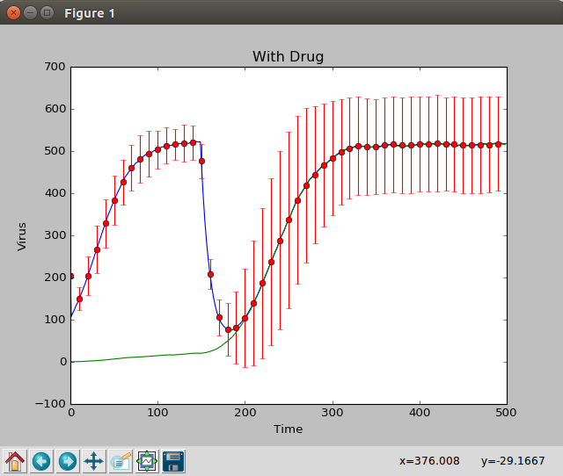

In this problem, we consider the effects of both administering drugs to the patient and the ability of virus particle offspring to inherit or mutate genetic traits that confer drug resistance. As the virus population reproduces, mutations will occur in the virus offspring, adding genetic diversity to the virus population. Some virus particles gain favorable mutations that confer resistance to drugs.

When introduce the drug for the first time, no virus is resistance to that drug. Therefore, population on the viruses decreases. However, by time virus gain resistance against that drug. The above graph shows that at the end total virus population and the number of resistance viruses will be same.

* **Designing a Treatment Plan with Two Drugs**

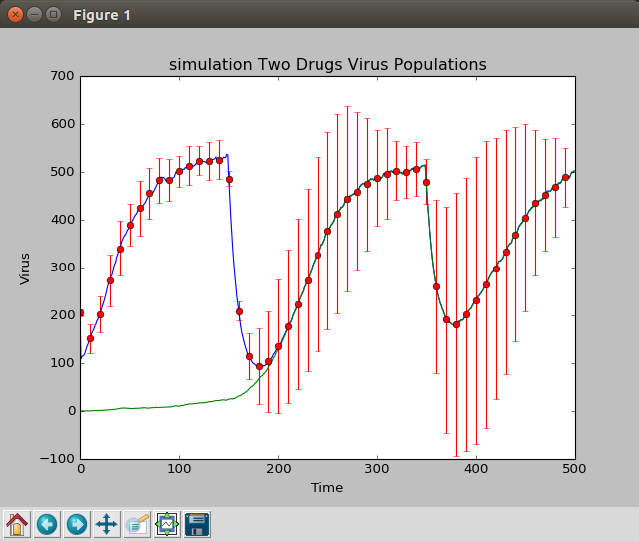

In this problem, we consider the effects of both administering two drugs to the patient and the ability of virus particle offspring to inherit or mutate genetic traits that confer drug resistance.

Whenever we introduce new drug to the patient the virus population and the number of resistance virus decreases drastically.

* **The Effect of Delaying Treatment on Patient Outcome**

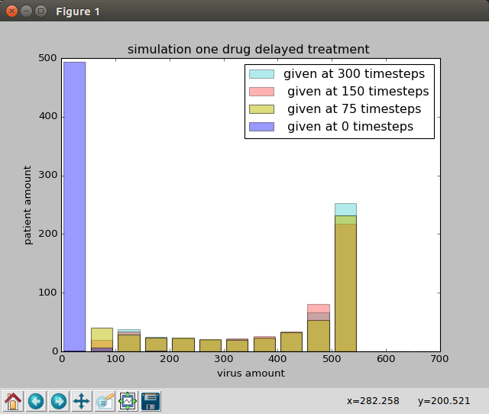

To simulate each histogram we use 30 trials. Because we think that 100 trials are enough for reasonable distribution.

For 100% cured, we get the percentage of patients in condition,

When the amount of virus in patient body is 0-50 , we assume that he is cured.

The histograms are given bellow:

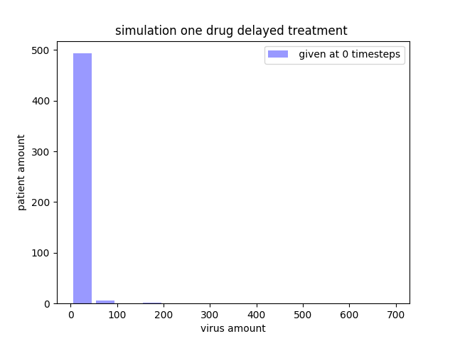

0 delay = 99.0 %

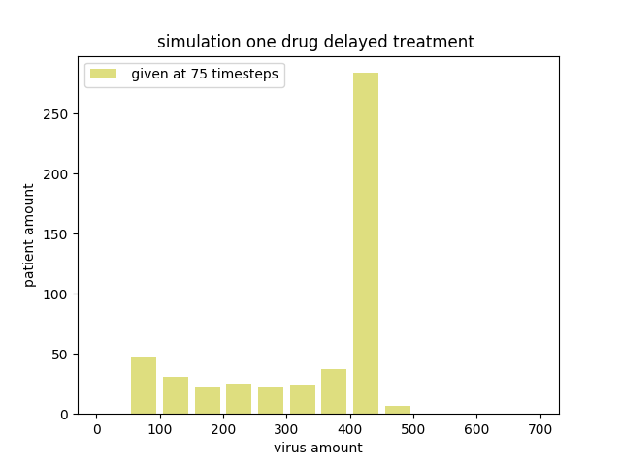

75 delay = 0.0 %

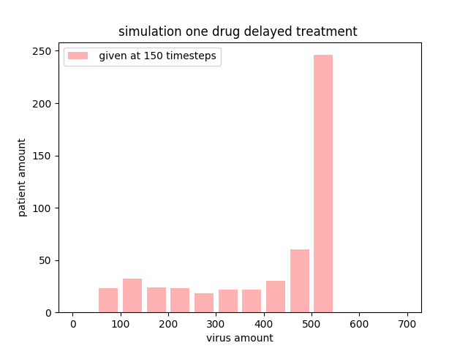

150 delay = 0.0 %

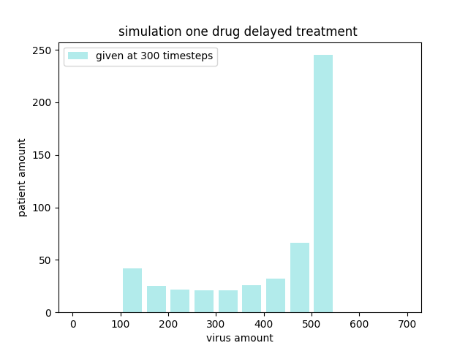

300 delay = 0.0 %

* **Analysis of Virus Population Dynamics with Two Drugs**

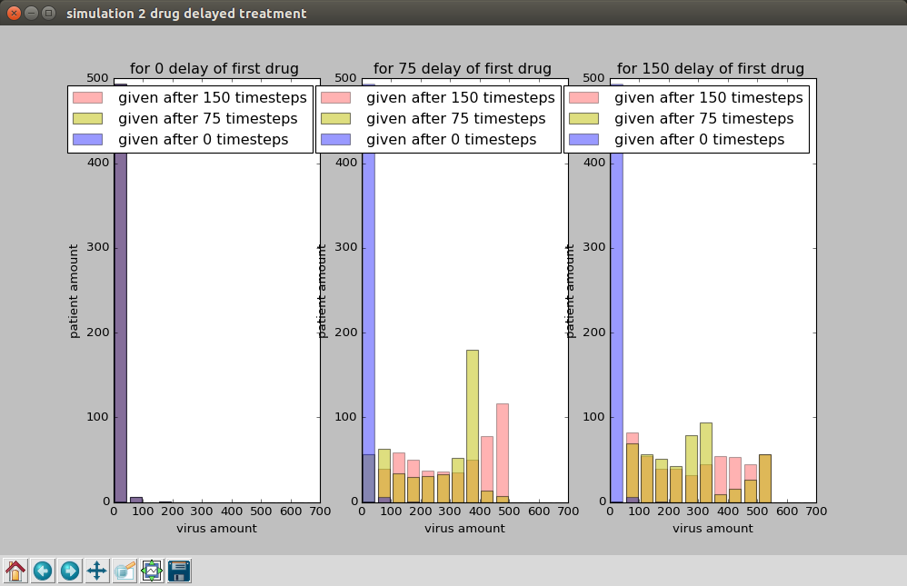

To simulate each histogram we use 30 trials. Because we think that 100 trials are enough for reasonable distribution.

For 100% cured, we get the percentage of patients in condition,

When the amount of virus in patient body is 0-50, we assume that he is cured.

The histograms are given bellow:

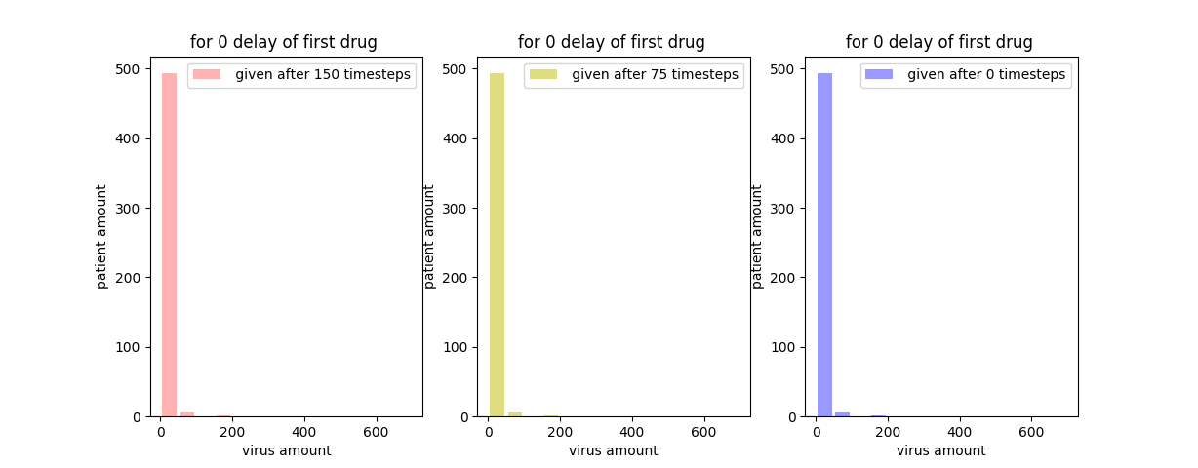

1st drug on 0 timestamp delay

150 delay = 99. 5 %

75 delay = 99. 5 %

0 delay = 99. 5 %

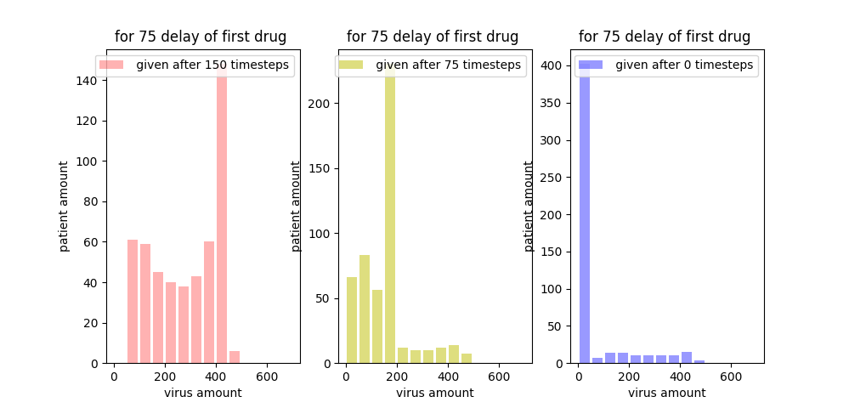

1st drug on 75 timestamp delay

150 delay = 99.5 %

75 delay = 10.0 %

0 delay = 12.0 %

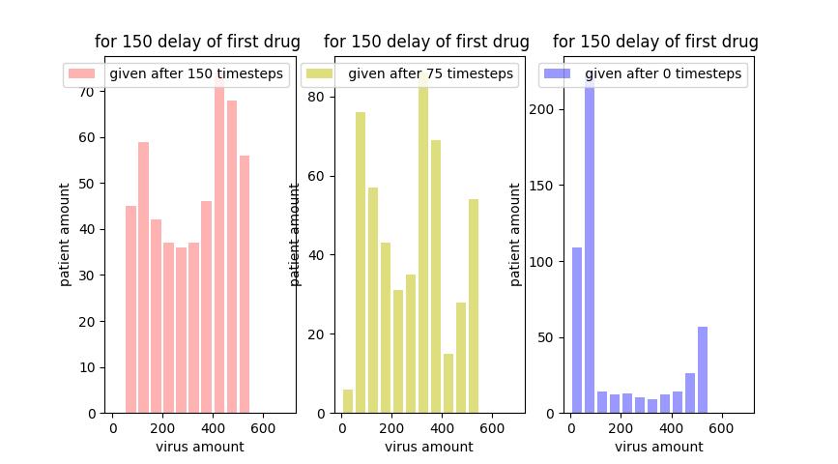

1st drug on 155 timestamp delay

150 delay = 22.0 %

75 delay = 1.0 %

0 delay = 9. 0 %

* **Patient Non-compliance**

To model this problem we can generate a random number stochastically to determine whether the patient will take the drug or not. If we run a reasonable amount of trail we can have a pretty idea what will happen a patient forget or refuse to take their drugs.