Assignment04, Unit test

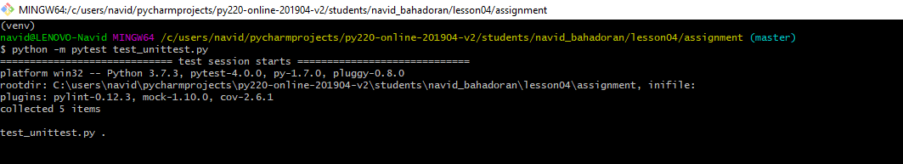

Integration Test:

