GitHub Link: https://github.com/naviddovick/Take-Home-Assignment
Part A-1
I chose to include a summary table and my visualizations because my output does not easily format every comparison for a screenshot. To summarize my findings, the “Faster R-CNN” algorithm routinely detects more objects with higher probability (confidence) but takes 8 times as long to reach that outcome when compared to the “YOLOv8” algorithm.
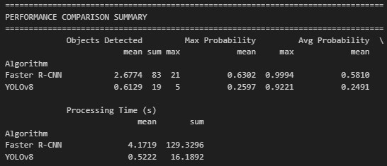
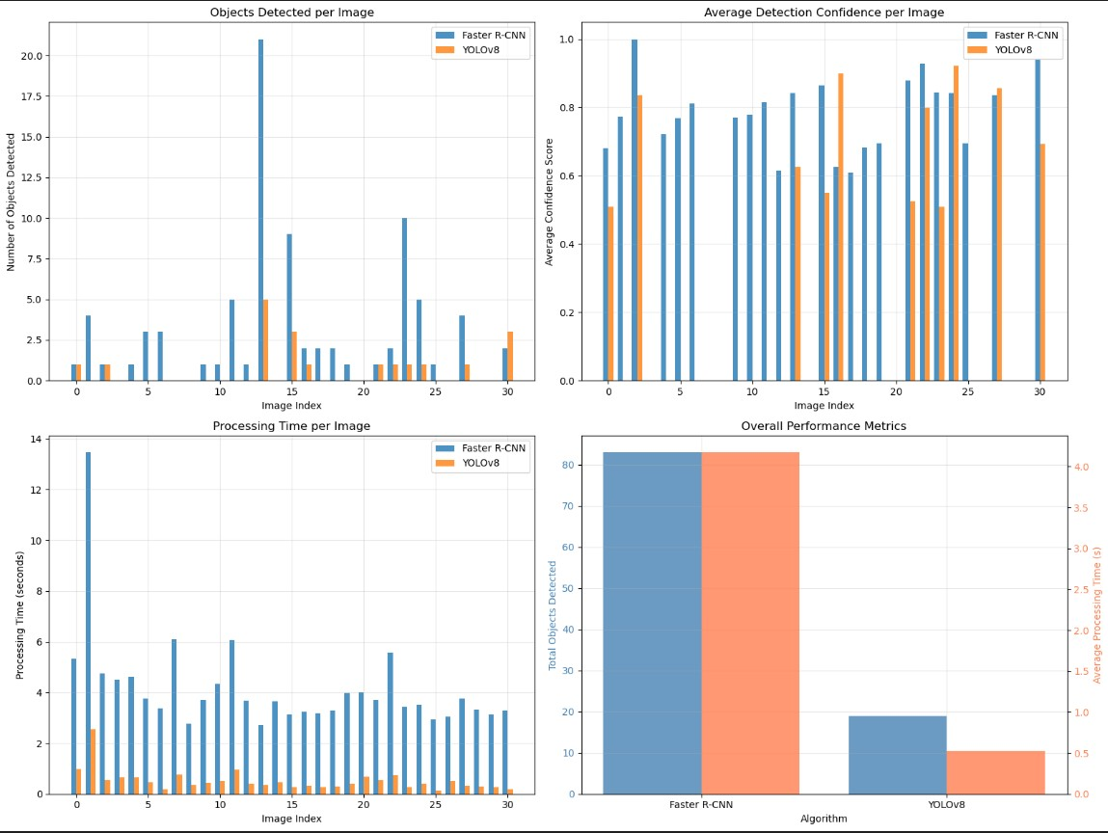
Part A-2
For my additional analysis, I chose to look at traditional values associated with image data: brightness, contrast, and texture. One of particular note is the “Texture Complexity Score”, which uses the variance of each pixel value from other nearby pixel values to determine an image’s complexity. This is commonly used to classify images as “blurry” or “sharp” and is a key feature in modern auto-focusing technology.
