Assignment 1

Navidha Jain

2020223

Question 1:

The study of an earthquake can be modelled as a Bernoulli Process as the following assumptions hold true:

1. There are only two possible outcomes:
   1. Zk=1, there is an earthquake of magnitude ≥ 6, with probability p=0.4.
   2. Zk=0, otherwise, with probability 1-p=0.6.
2. Each occurrence of earthquake is independent of each other.
3. Each occurrence of earthquake of magnitude ≥ 6 occurs with same probability p.
4. The study of the process is over discrete time.
5. The process can start at time t=0, but the arrival/success (the earthquake of magnitude >=6) can only occur at time t>=1. (Time, here, denotes when an earthquake happened)

Part A:

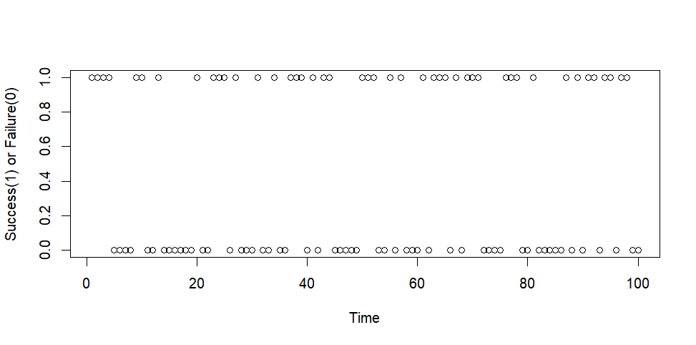The scatter plot shown is for the Bernoulli Process defined above with p=0.4. The x-axis denotes the instances of the earthquake and the y axis shows the success or the failure, i.e., whether the earthquake had magnitude >= 6(success) or <=6(failure).

Part B:

The process is a Bernoulli process so the interarrival times will follow a geometric distribution.

Let X1 denote the first interarrival time.

P(X1 = 1) = P(arrival occurs at the 1st observations) = p = 0.8

P(X1 = 2) = P(no arrival on 1st observation, arrival on second observation) = (1-p)\*p

.

.

.

P(X1 = k) = P(no arrival for k-1 observations, arrival at the kth observation) =(1-p)^(k-1) \* p

Thus, we observe the X1 ~ geometric distribution(p).

By the fresh start property, it can be shown that all X2, X3, X4, ... follow geometric distribution(p) like we have shown above.

The graph for distribution (CDF) of geometric distribution is shown below with p=0.4 and ‘t’ is taken to be 100. The x-axis denotes the first inter-arrival time and the y-axis denotes the CDF.

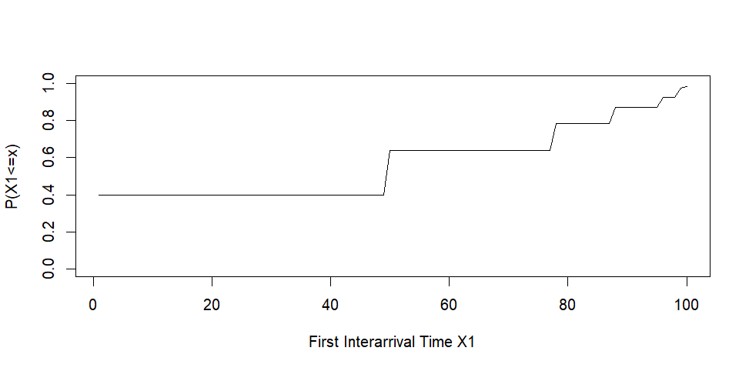

Part C:

Nk is defined as number of earthquakes of magnitude ≥ 6 till time k can also be defined as the number of arrivals till time k. As we already established that the process is a Bernoulli Process we can say Nk follows Binomial distribution with parameters k and p. Let us assume k=100.

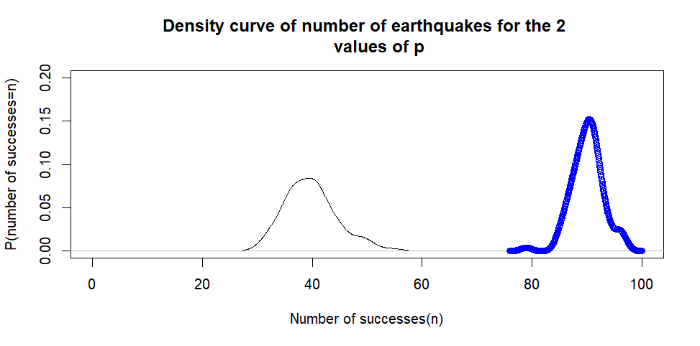

Black: p=0.4

Blue: p=0.9

The expected value of a Binomial variable is (number of trials)\*(probability) which in this case is 40 for p=0.4 and 90 for p=0.9. This can also be seen from the density graph above that the peak value, the expected value, falls at 40 and 90 respectively. As probability increases the peak value, the expected value, shifts towards the right. The variance, the deviation from the mean value, is also larger for p=0.4 as we can see from the graph that the width of the black curve is more than the blue curve which is the curve for 0.9.

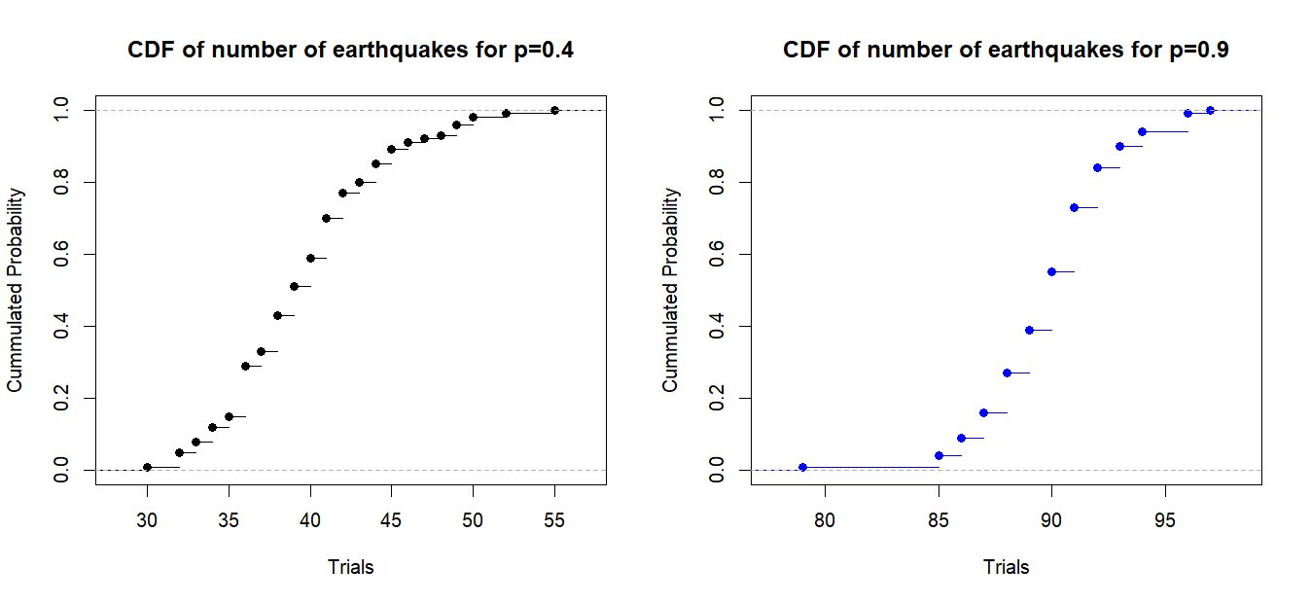

The CDF for p=0.4 is has more points than the CDF p=0.9 and also is less steep. This is because for p=0.4 the probability is accumulated to 1 over more time than for p=0.9.

Question 2:

We have been given the rate as 10 visitors per hour so lamba =10. I have assumed ‘t’ to be 100.

We also have been given that the process is a Poisson Process.

Part A:

We have taken t=100.

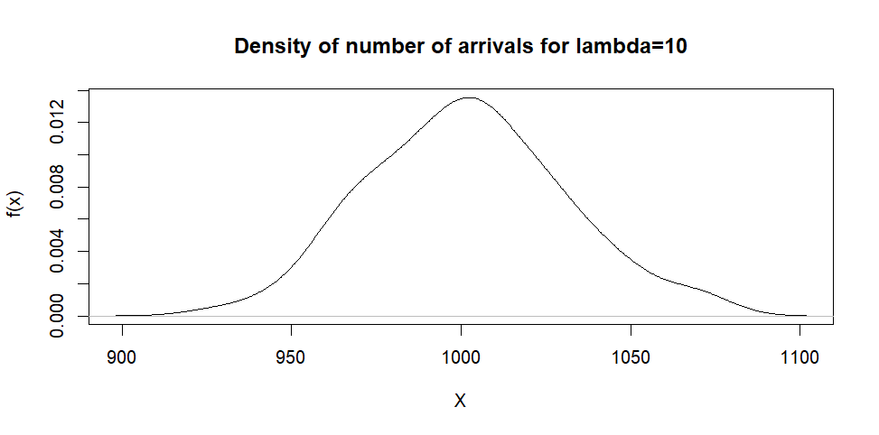

Part B:

We have taken t=100

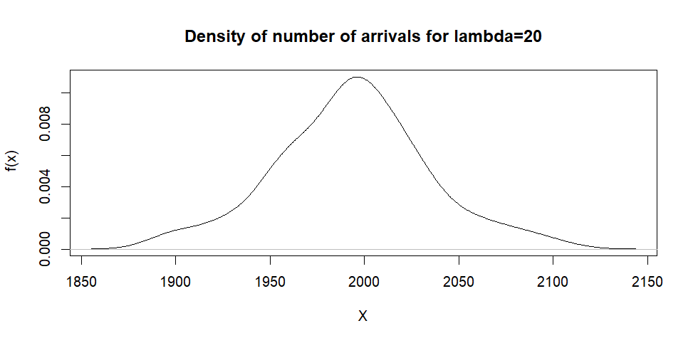

Comparing this graph to the graph obtained in part(a), we can see that the peak value of the graph, the expected value has shifted to the right. The expected value of a Poisson Random Variable is equal to the parameter lambda. In part(a) the lambda was equal to 10\*100 which was also when the peak occurred and in this case since our lambda is now equal to 20\*100 the peak value also occurs at the same. The variance of a Poisson Random Variable is also equal to the parameter lambda thus the width of the curve in this part is the more than the curve in part(a).

Part C:

We have 2 Poisson Processes, one with rate=10 (lets call that N1(t)) and one with rate=20 (lets call that N2(t). The convergence of these 2 processes is also a Poisson with the parameter lambda=lambda1+lambda2 where lambda 1 and lambda 2 are parameters of N1(t) and N2(t) respectively.

Let t=100

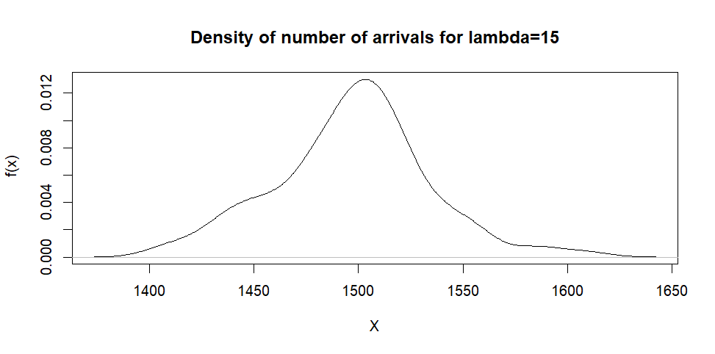

The peak occurs at 15\*100 which is the parameter of the converged Poisson process.

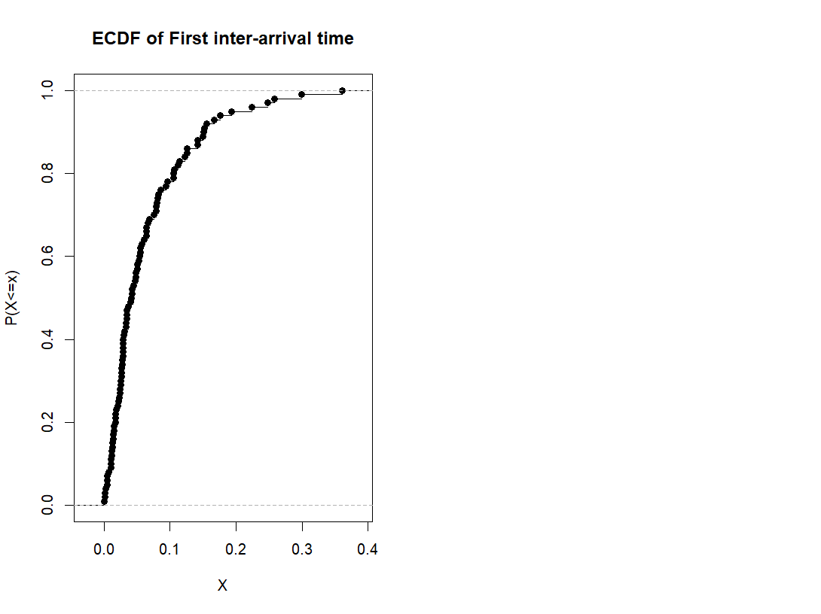

The first inter-arrival time (X1) follows Exponential Distribution as we know the process is a Poisson Process..