Assignment 1

Navidha Jain

2020223

Question 1:

a)

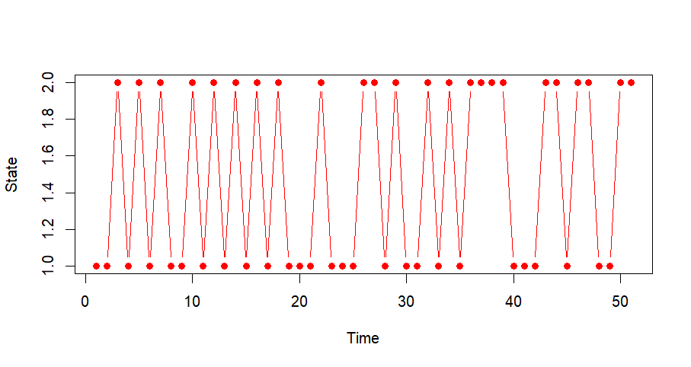

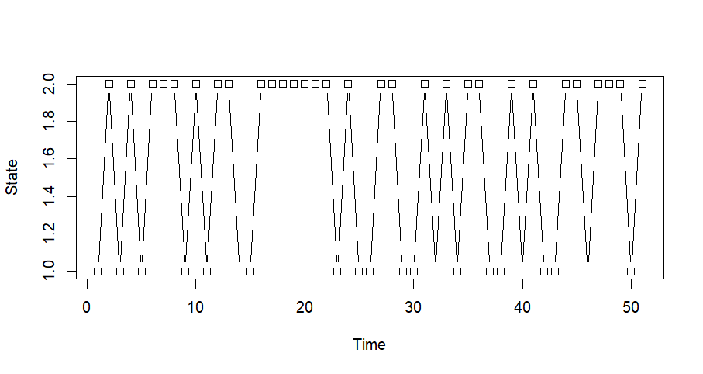

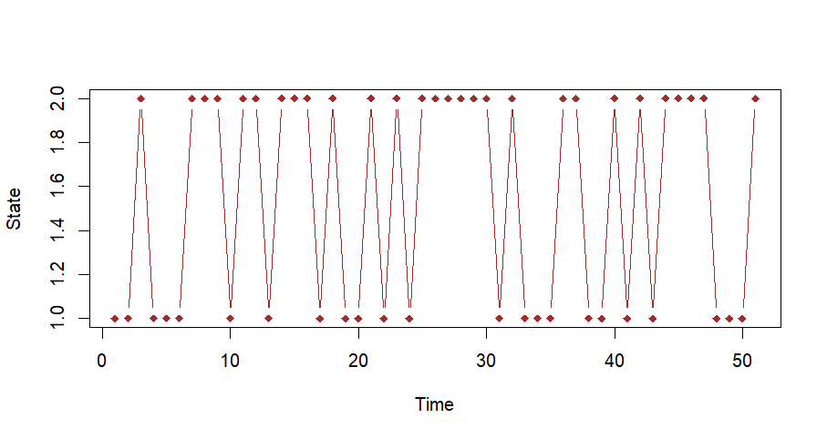

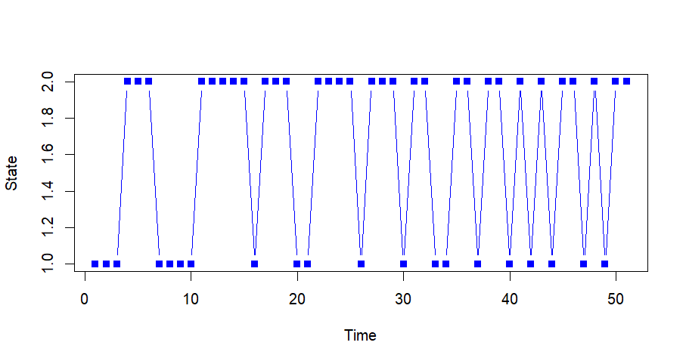

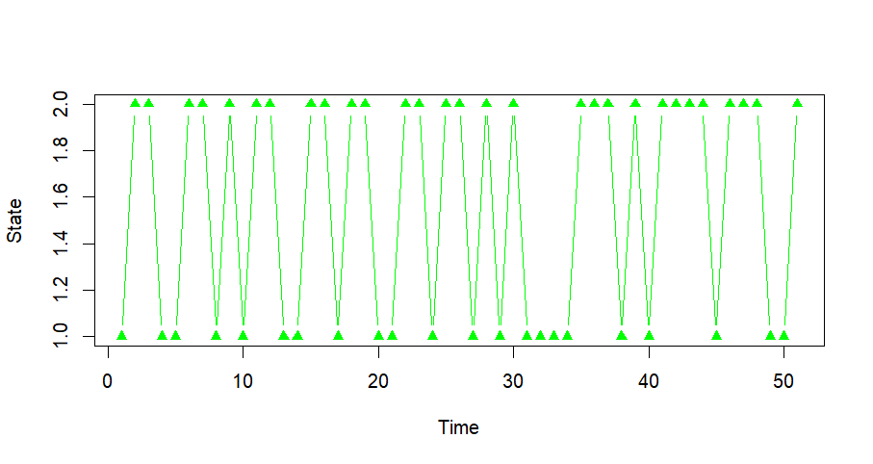

b) P10:

[0.4166667 0.5833333]

[0.4166667 0.5833333]

P20:

[0.4166667 0.5833333]

[0.4166667 0.5833333]

P50:

[0.4166667 0.5833333]

[0.4166667 0.5833333]

Each row is identical to the other row, this tells us that the limiting distribution of the given Markov Chain exists. Further we can see that we Markov chain is irreducible and aperiodic then its limiting distribution and stationary distribution is the same.

pi = [pi1 pi2]=[ 0.4166667 0.5833333] is the limiting distribution.

Question 2:

The following Graph is obtained from plotting the given problem. The Markov chain has absorbing boundaries and when it reaches i=10, the A gambler wins and when it reaches i=0, B gambler wins. In the following graph, gambler A wins at time=12.

