WinCE 6.0 MCS9900 Driver Installations:
The following procedure explains how to install the MCS9950 display driver.

Before we start we divide the whole process into two steps:
I) Selecting the required “OS design components” (optional).
II) Adding MCS9900 driver to the built “OS image” (mandatory).

I) Selecting the required “OS design components” (optional).
1. Obtain a copy of MCS9900 WinCE 6.0 driver package and extract it to your computer.
Copy the extracted “MCS9900” folder to %WINCEROOT%\Osdesigns\ Osdesign1
(Example: C:\WINCE600\OSDesigns\OSDesign1\OSDesign1 or C:\WINCE600\OSDesigns\OSDesign1\OSDesign1).
2. Start WinCE Platform Builder, select File, and open Project.

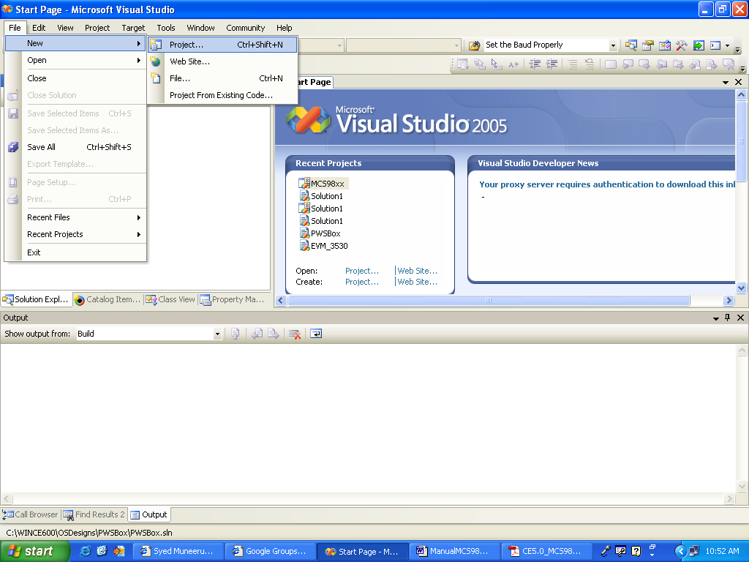

3. Name the Project / Osdesigns, Click “OK” once done with.

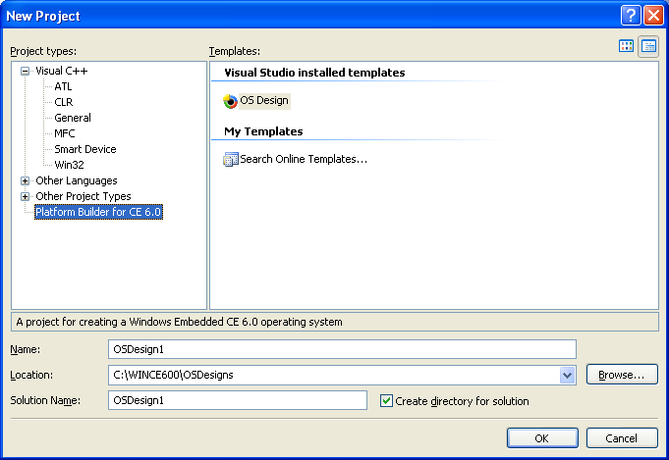

4. Click “Next” to select “BSP”.
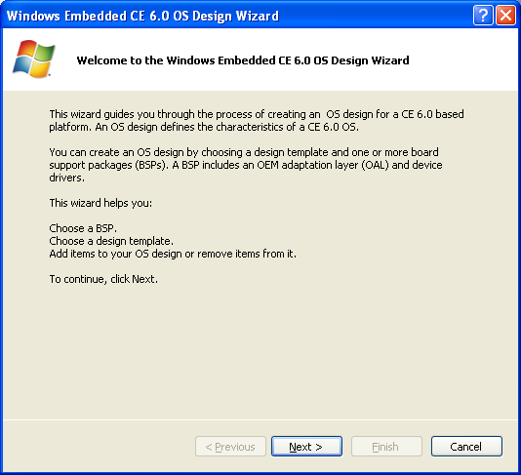

5. Now we have the BSP’s option to select for, Select “CEPC: X86” click “Next”.

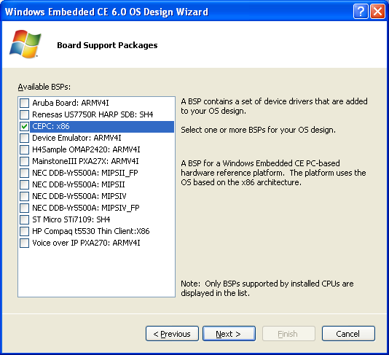

6. Select “PDA Device” and Click “Next”
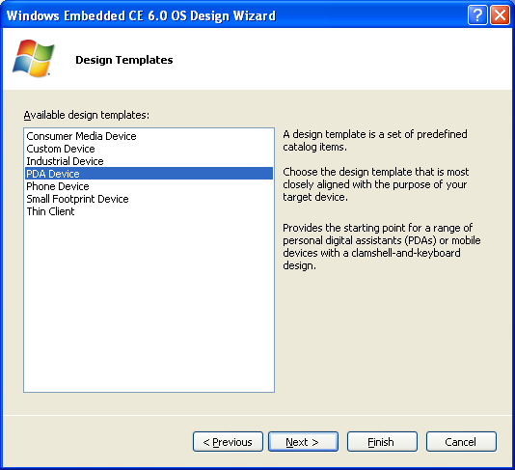

7. Select “Mobile Handheld” Click “Next”

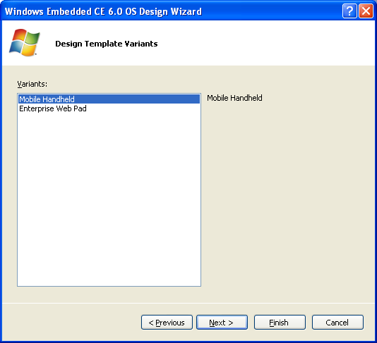

8. Click “Next” (Select the components as shown)
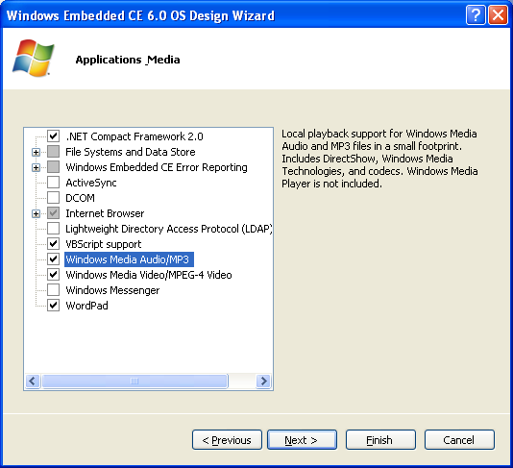

9. Select “LAN” and Select “Wired Local Area Network”, Click “Next”

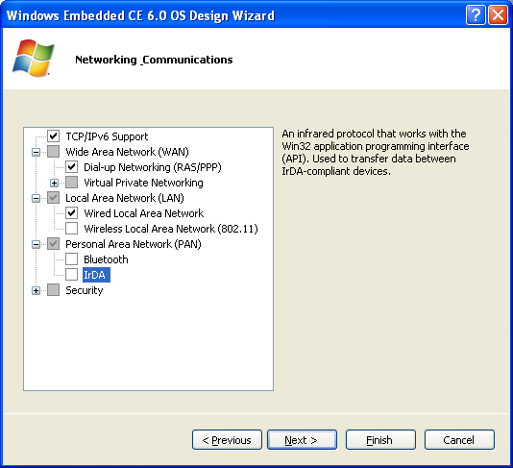

10. Click “Finish”
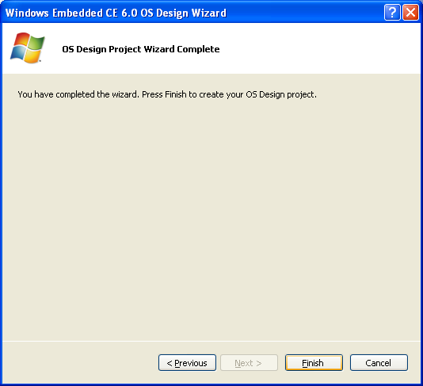

11. Click “Acknowledge” for NDIS User-mode I/O Protocol driver security warning.
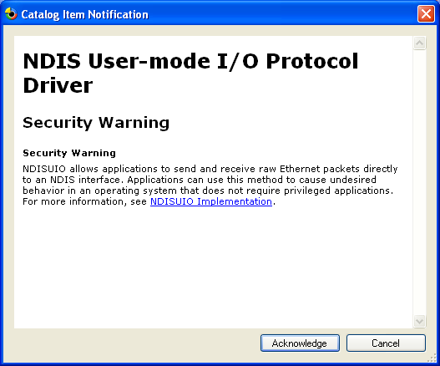

Note: Make sure you select the Build for “Retail version”
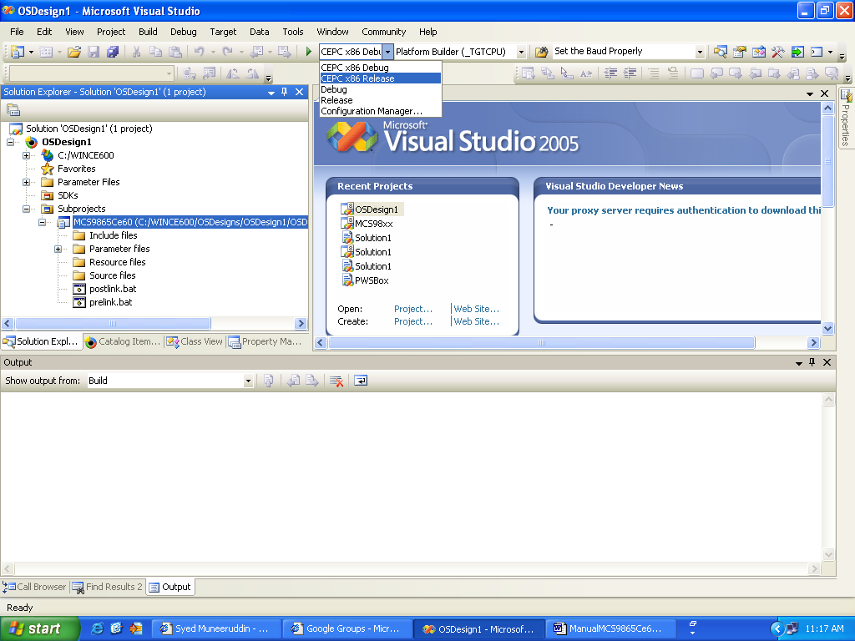

Add windows media player and the required codec’s:
a) Select “Catalog’s item view”->CoreOS->CEBASE
->Graphics and Multimedia technologies->Media->Windows Media Player->
Windows Media Player->right click mouse and add to “user specified catalog items”.
Figure illustrates step-a:
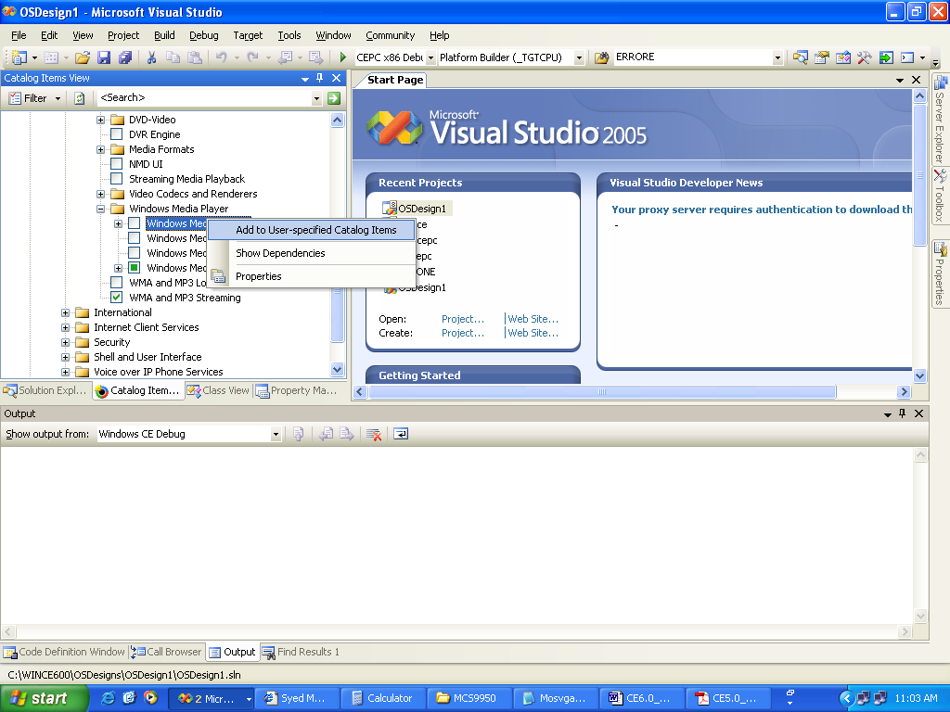

b) Select “Catalog’s item view”->CoreOS->CEBASE
->Graphics and Multimedia technologies->Media->Video Codecs and Renderers->
WMV/MPEG-4 Video Codec->right click mouse and add to
“User specified catalog items”.
c) Similarly add the “MPEG-1 Video Codec” component as well.

Note: These components will help us play video on WinCE 6.0 device.

12. From “Build” option select “Build OSdesign1”, or the name of “OSdesign”
you selected to build.

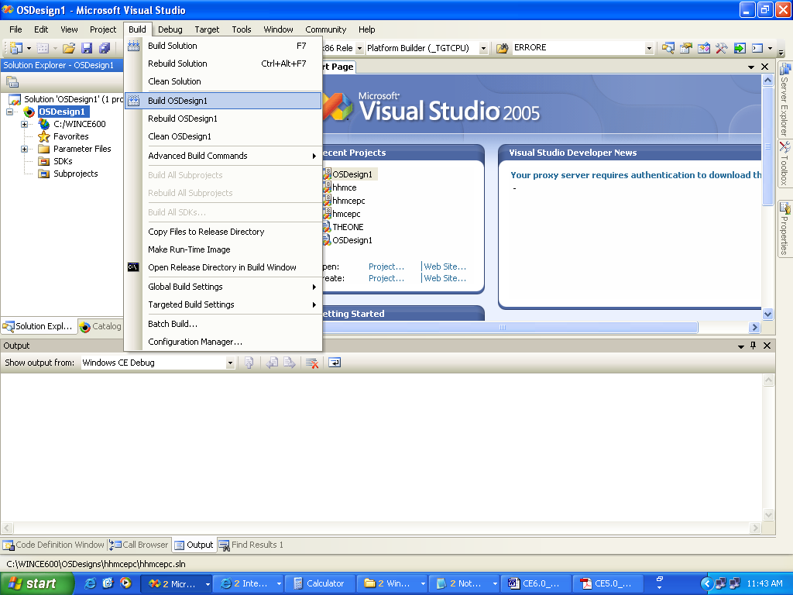

Note: Ensure that you get zero build errors, if not repeat the above steps.

III) Adding Drivers to built image
13) In Solution Explorer view of workspace, Right Click the mouse by selecting “Subprojects” and select the option “Add existing Subproject”

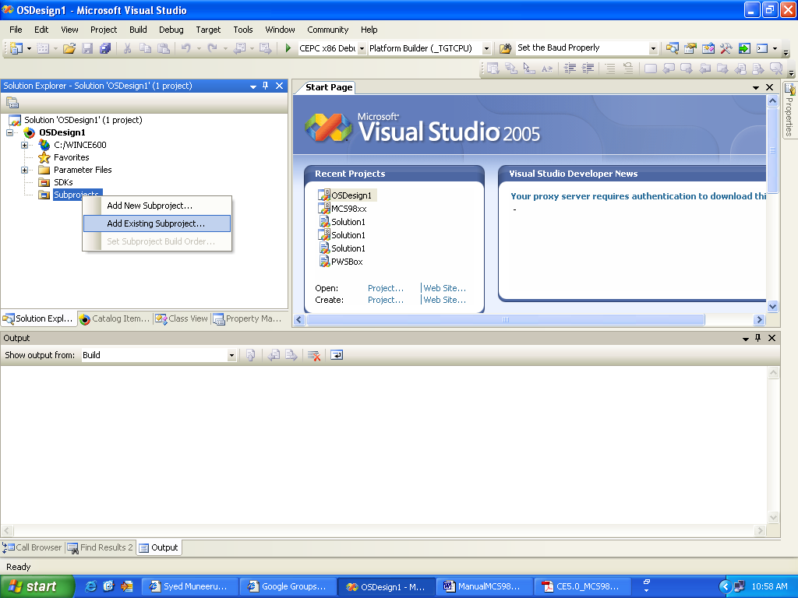

Note: Screen Shots illustrate MCS9950 driver, in similar way add MCS9900 driver.

*14. Copy the drivers (MCS9950Ce60) provided to you by “MosChip”
and Paste it in this folder.

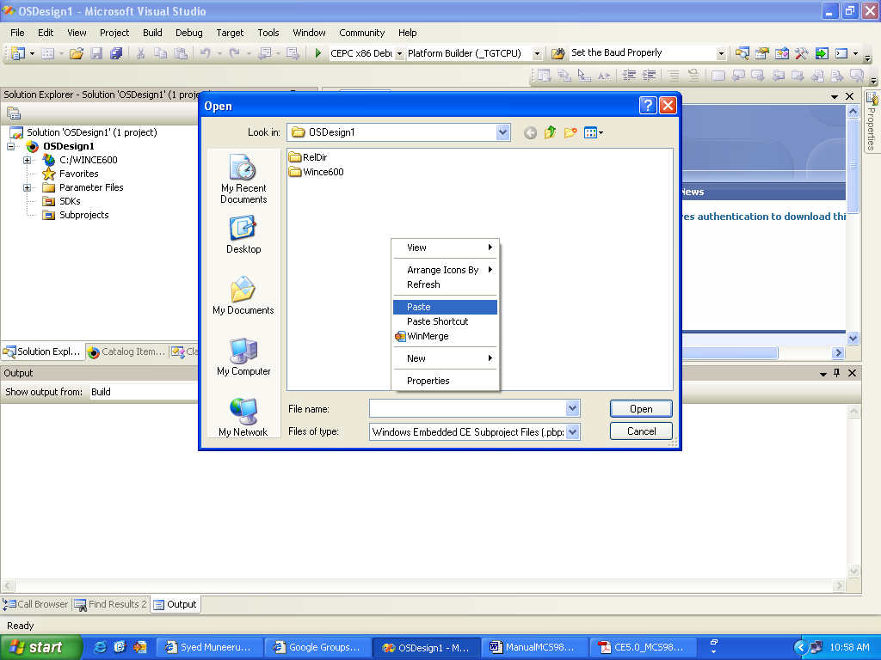

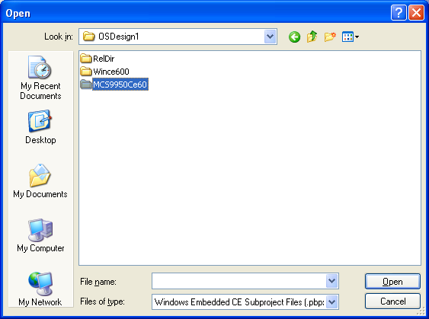

15. Select the “MCS9950Ce60.pbpxml” and Click “Open”
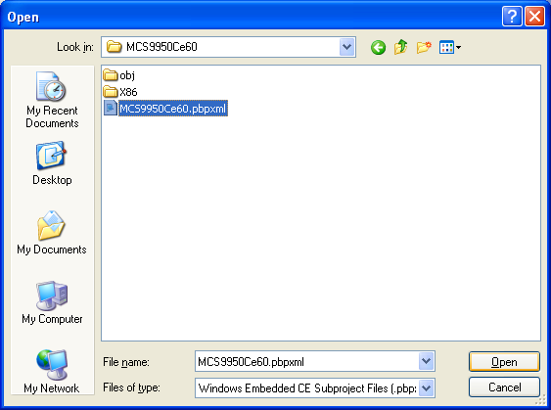

16. Now the drivers are added to the built image.
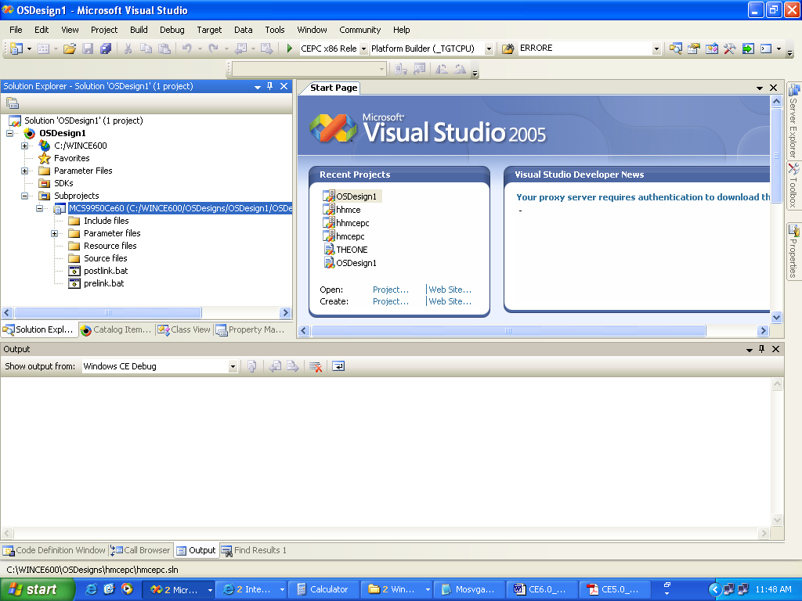

17. Build the drivers, by selecting the added subproject and right click the mouse,
Select the option “Build” make sure you get zero errors and zero warnings.

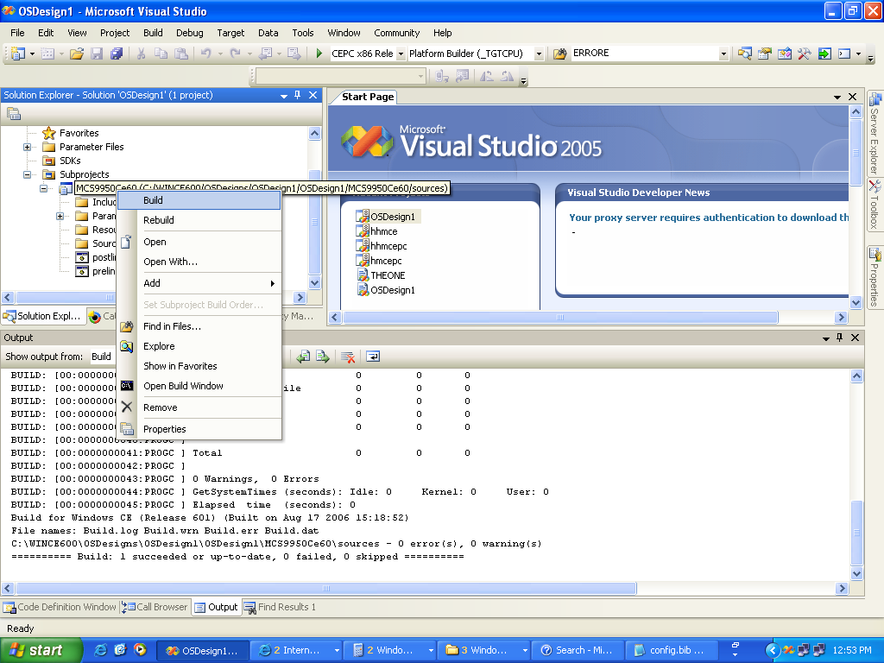

18. Make image, by selecting “Build”->”Make Run Time Image”.
Ensure zero errors.

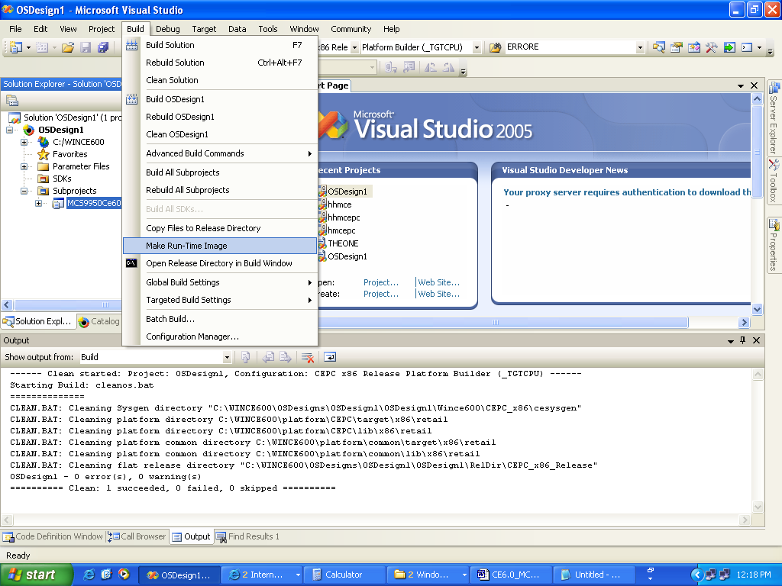

Note: It is advisable that once we add drivers better to repeat the step 12 once and then come to step 19.

19. And now we can put the image in the CEPC device and work
with hardware provided for MCS9900 device.
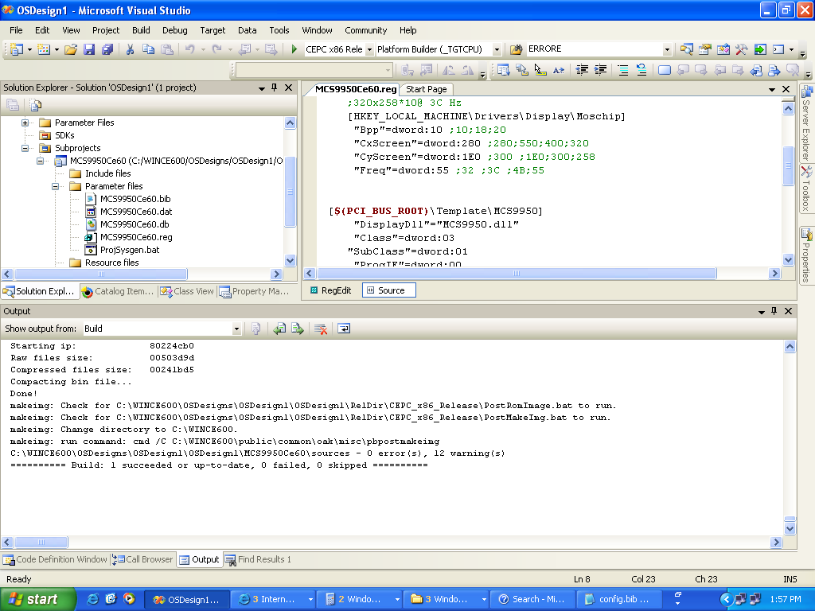

Note: If one has already the image built, then they can follow steps from 13 to 19.

