**Screenshots of P.1**

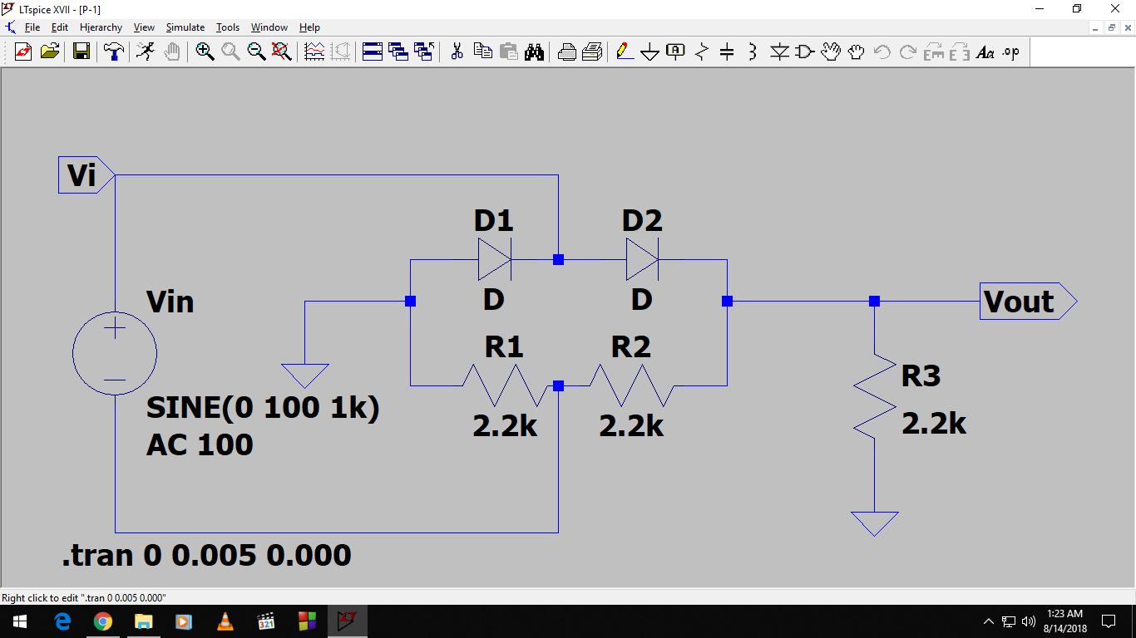

**Figure P.1 (Circuit)**

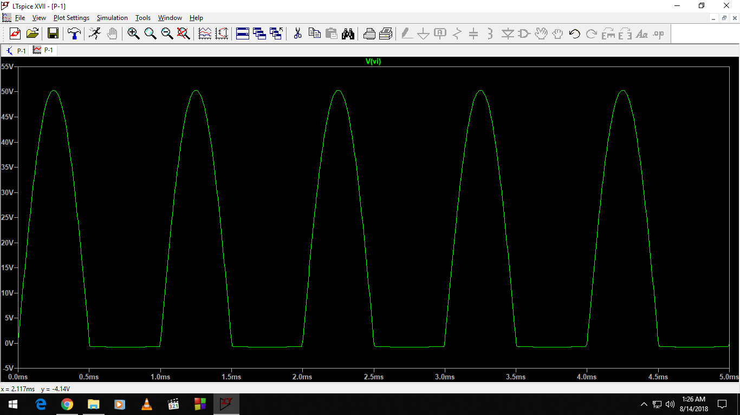  
**Figure P.1 (Input)**

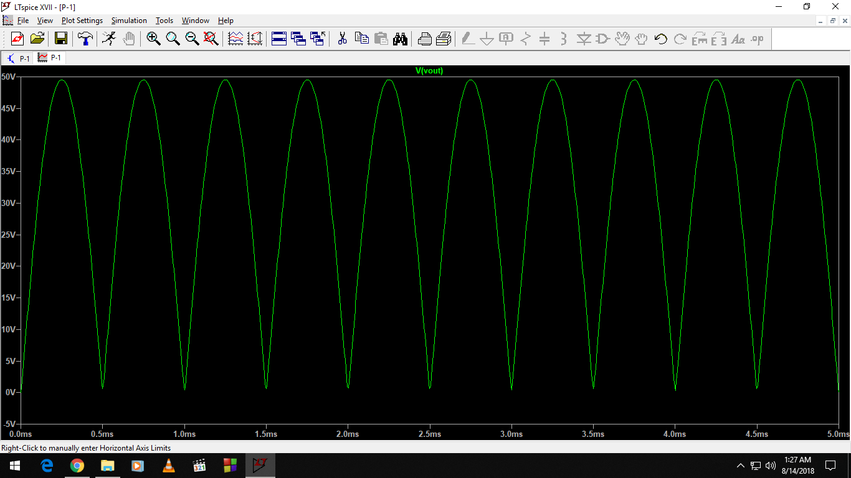

**Figure P.1 (Output)**

Vm = 49.8 V from the output graph

Therefore, value of Vdc = 0.636 * Vm

= 0.636 * 49.8 V

= 31.7 V **(Ans)**

**Screenshots of P.2**

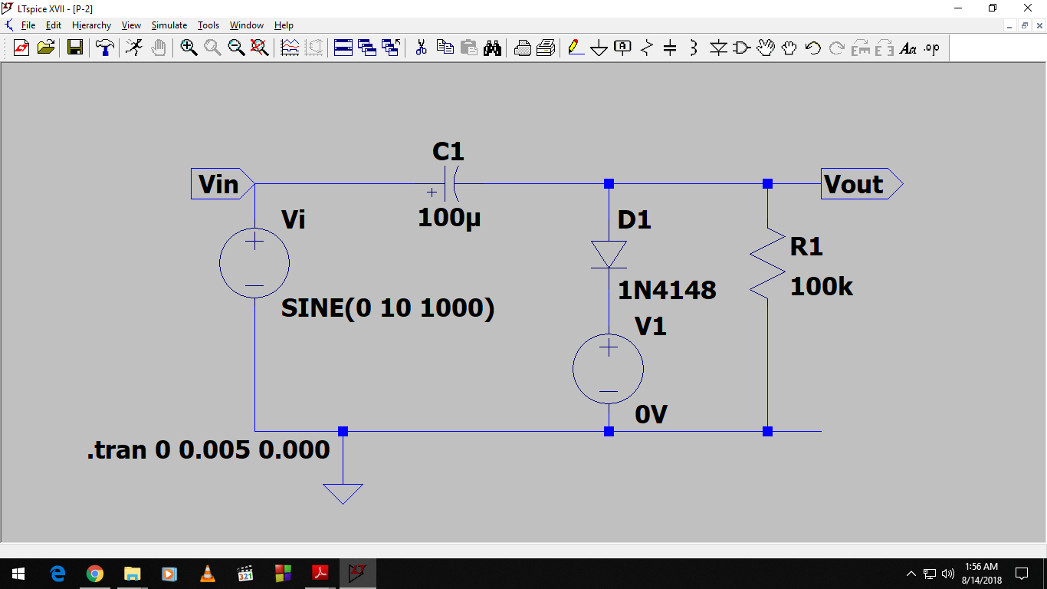  
**Figure P.2 (Circuit)**

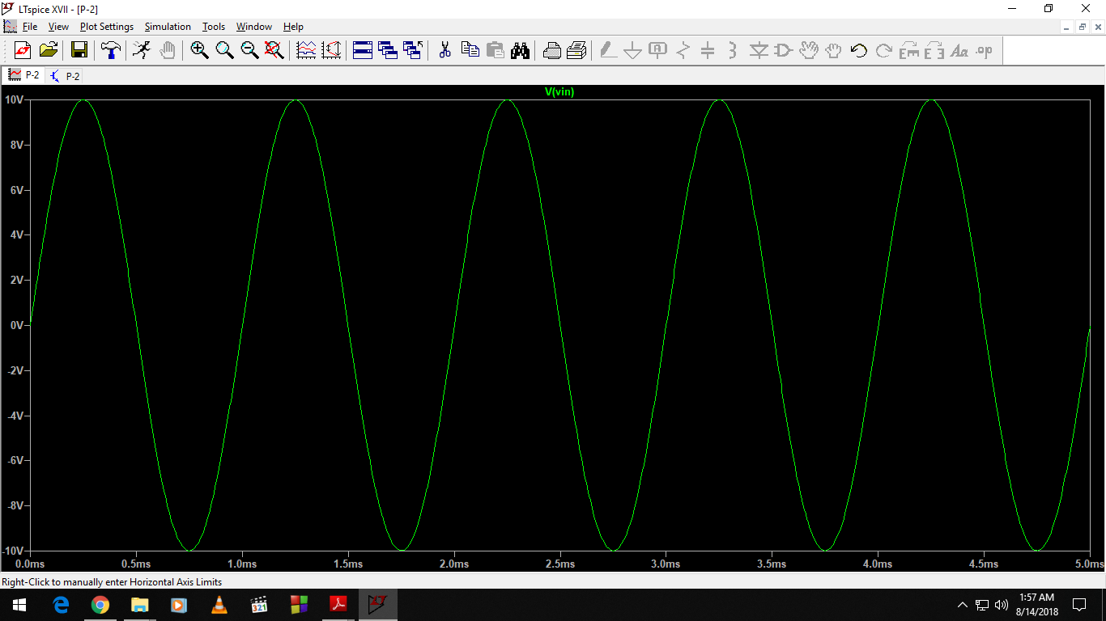

**Figure P.2 (Input)**

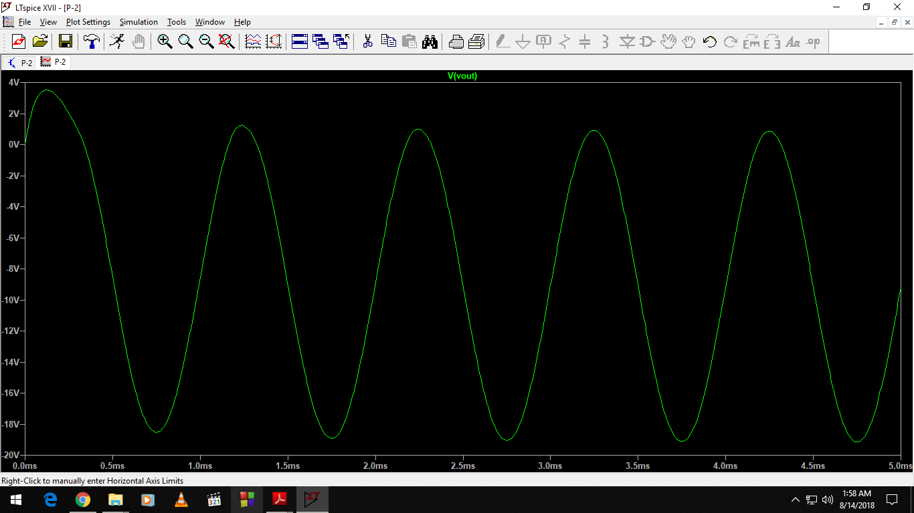

**Figure P.2 (Output)**