System Architecture Overview

Architecture Explained
This section provides a comprehensive explanation of the four-tier system architecture, detailing the purpose and structure of each tier as illustrated in the diagram.

Tier 1: Python Planning Layer
The first tier comprises the Python planning layer, which remains unchanged in its structure. Components such as coordinator_node.py, four instances of controller_node.py, and the ZMQ REQ/REP mesh are retained without modification. The cosim_manager.py module replaces plant_node.py, connecting to the coordinator through the same ZMQ plant_step protocol. It receives the nominal MPC sequence U_seq and invokes the hybrid safety filter at each inner step using the hybrid_request ZMQ message.

Tier 2: Co-Simulation Bridge Layer
Sitting between the planning layer and MATLAB, the second tier introduces three new Python modules:
- cosim_config.py: A frozen dataclass that stores all Simulink and controller parameters, including step sizes, heading gains, speed saturations, file paths, and port names. It mirrors the style of the existing NetConfig, allowing both to be passed together. The steps_per_outer property ensures that planning_dt is an exact multiple of simulink_dt upon construction.
- cosim_bridge.py: This module manages the matlab.engine session. Its public interface consists of start(), stop(), and step(outer_j, u_safe_all, inner_t). Internally, it writes u_ref_{i} = [u_x, u_y] to the MATLAB workspace, advances Simulink by exactly simulink_dt seconds using set_param('SimulationCommand', 'continue'/'start'), polls until the model pauses, and reads odo_{i}. The polling loop enforces a 10-second timeout to prevent deadlocks.
- cosim_logger.py: This module maintains four open CSV file handles—planning.csv, odometry.csv, hybrid_modes.csv, and health.csv—and flushes them every log_flush_every outer steps. A significant column in odometry.csv is err_pos, which records the Euclidean distance between the Simulink robot position and the planning-layer position at each step. This measurement is crucial for diagnosing layer mismatches, as it reflects how well the lower-level unicycle dynamics track the single-integrator abstraction assumed by the planner.

Tier 3: MATLAB Engine API
At this tier, Python initiates the MATLAB engine with matlab.engine.start_matlab() at startup. All subsequent interactions, such as writing and reading workspace variables and calling set_param, are performed through the engine object. No additional MATLAB toolboxes are required—specifically, the Instrument Control Toolbox is not necessary. The exchange of workspace variables is sufficiently fast to meet the planning rate requirements (1 Hz for outer steps and 0.01 Hz for Simulink steps within each outer step).

Tier 4: Simulink Model (build_unicycle_model.m)
The fourth tier involves the MATLAB script build_unicycle_model.m, which programmatically constructs the .slx Simulink model using add_block and add_line. This ensures the model can be fully reproduced from source code. For each agent, three nested subsystems are assembled:
- From Workspace: Reads u_ref_{i}, the Cartesian velocity reference [u_x, u_y] provided by Python, at every fixed step.
- Motion Controller: Implements the standard heading-then-speed law. The desired linear speed v_ref is calculated as the Euclidean norm of the planning command [u_x, u_y]. The desired heading θ_ref is determined by atan2(u_y, u_x). The heading error e_θ is computed as wrap(θ_ref − θ), wrapped to (−π, π] using a MATLAB Function block to avoid discontinuities. The proportional heading controller computes ω = k_heading · e_θ. Speed shaping is achieved with v = k_speed · v_ref · max(cos e_θ, 0), causing the robot to decelerate when misaligned and preventing reversal. Both v and ω are passed through saturation blocks.
- Unicycle Dynamics: Integrates the three states (x, y, θ) using Simulink Integrator blocks driven by v·cos θ, v·sin θ, and ω. A GoTo/From pair feeds θ back to the motion controller without a visible feedback wire, enhancing diagram readability. The ODE1 (Euler) solver is used, consistent with the planning layer's discrete-time model.
- To Workspace: Writes [x, y, θ, v, ω] at each fixed step, allowing Python to read the latest data after each step() call.

Closed-Loop Feedback
The key architectural decision resides in cosim_manager.py during state updates. After each Simulink step, the returned bundle.positions overwrite the planning layer's r array. This approach ensures that the planner operates based on the actual unicycle position, incorporating heading transients, speed saturation effects, and integration error, rather than an ideal single-integrator position. Consequently, the feedback loop is genuinely closed through the lower-level dynamics, which provides accurate co-simulation semantics.

Hardware guide: four-robot differential-drive lab prototype in Munich
Tier B — Recommended: Raspberry Pi 4 + custom differential-drive base (€130–180 per robot)
This gives you a full Linux SBC running Ubuntu 22.04 + ROS2 Humble on each robot. Your Python planning layer on the host PC talks to each robot's ROS2 node over the home WiFi network. The robot runs a local velocity controller that receives (v, ω) commands and publishes encoder odometry.
Per-robot bill of materials
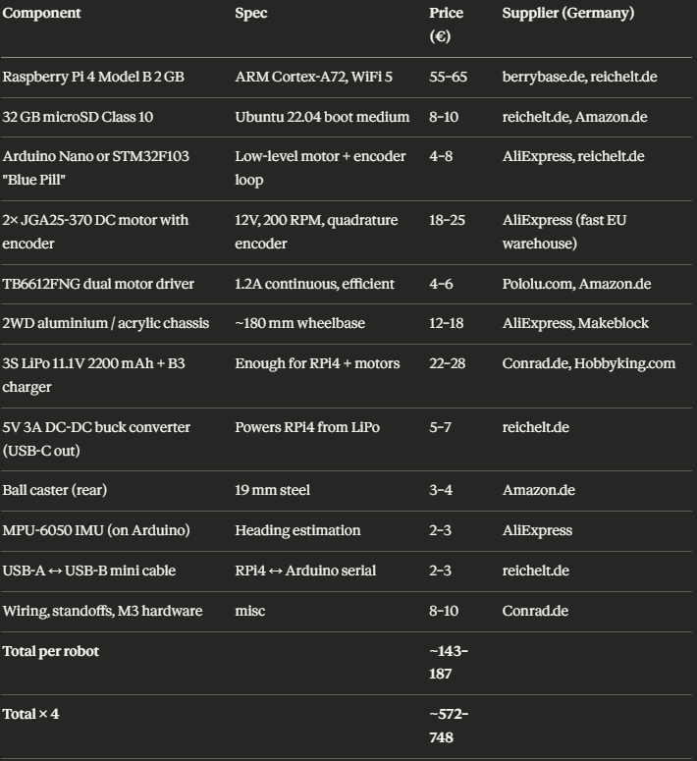
Host PC (if you don't already have one): any Linux laptop running Ubuntu 22.04 works. A used ThinkPad X1 Carbon runs ~€350–500 on eBay.de.
The recommended Tier B architecture in practice
Here is exactly how your system maps onto the hardware:
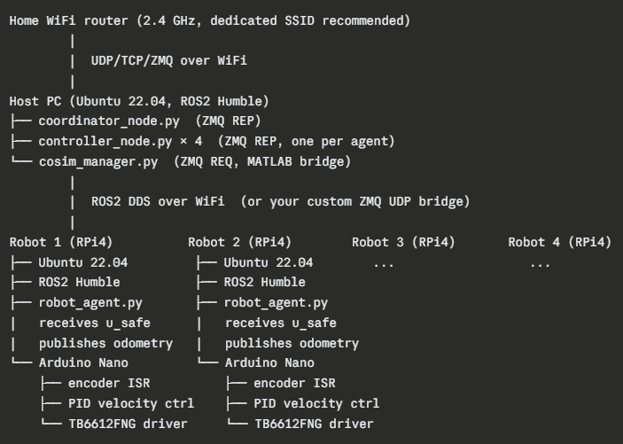
Software stack on each robot (RPi4):
- A lightweight Python node (robot_agent.py) connects back to the host over ZMQ, receives (u_x, u_y) from your cosim_manager.py, converts it to (v_ref, θ_ref) using the same motion-controller formula you implemented in Simulink, and sends (v_ref, ω) to the Arduino via serial.
- The Arduino runs a 50–100 Hz velocity PID loop: reads encoder counts, computes current wheel speeds, applies PID corrections to motor PWM, and publishes (x, y, θ) odometry back via serial.
- The RPi4 forward the odometry over ZMQ/WiFi to cosim_manager.py on the host, closing the loop.
This replaces your Simulink co-simulation with real hardware while keeping cosim_manager.py as the interface point — only cosim_bridge.py changes (from matlab.engine to a WiFi socket client).

Practical deployment steps
Step 1 — Prepare the host PC. Install Ubuntu 22.04, ROS2 Humble, your Python dependencies (pyzmq, numpy, scipy, cvxpy). Clone your planning-layer code. Assign the host a static IP on your home router (e.g. 192.168.1.10).
Step 2 — Flash the RPi4s. Use the Raspberry Pi Imager to flash Ubuntu 22.04 Server on each SD card. Enable SSH and pre-configure the WiFi SSID/password in the cloud-init file before first boot. Install ROS2 Humble, then your robot_agent.py. Assign each robot a static IP (192.168.1.21–24).
Step 3 — Flash the Arduinos. Upload a firmware that: (a) reads two quadrature encoders via interrupt, (b) maintains velocity PID for left and right wheels independently, (c) receives (v_linear, omega) commands from the RPi4 via serial at 115200 baud, and (d) streams (x, y, theta, v, omega) odometry back at 20–50 Hz. The differential-drive kinematic model for odometry is standard and well-documented.
Step 4 — Wire each robot. LiPo → buck converter → RPi4 (5V USB-C). LiPo directly → TB6612FNG (VM). TB6612FNG control pins → Arduino PWM/DIR outputs. Encoder A/B → Arduino interrupt pins. RPi4 ↔ Arduino: USB serial cable.
Step 5 — Network configuration. Use a dedicated 2.4 GHz SSID (not 5 GHz — better range, sufficient bandwidth for 4 robots sending 50-byte odometry packets at 50 Hz). Assign static IPs. Update consensus_config.py with the robot IPs as ZMQ endpoints instead of 127.0.0.1.
Step 6 — Replace the bridge. In cosim_bridge.py replace the matlab.engine calls with a UDP/ZMQ socket: step() sends u_safe to the robot's IP and receives the odometry packet back. The rest of cosim_manager.py is unchanged.
Step 7 — Lab space. Your arena should be at least 3 m × 3 m for 4 agents with safety distances of ~1.1 m as configured in your NetConfig. Tape markers or ArUco patterns on the floor help with initial position estimation. A camera mounted overhead (a single USB webcam at ~2 m height) can serve as a ground-truth localization system if encoder odometry drifts.

What variant of differential-drive robot is best for your case
Given your single-integrator planning model and the relatively slow outer-step rate (dt = 1 s), the unicycle tracking requirement is not aggressive. Any of these three physical configurations work:
2WD + rear caster (recommended): two driven wheels at centre, one passive ball caster at rear. Simplest mechanically, lowest cost, easiest to model. The only configuration matching your unicycle model exactly.
2WD + front caster (alternative): same as above but caster at front. Slightly less stable at higher speeds but acceptable at the low speeds your safety constraints enforce.
3-wheel (avoid): adding a third passive wheel complicates the kinematics and introduces slip if the floor is uneven. Not worth it here.
The TurtleBot3 Burger uses exactly the 2WD + rear caster layout with DYNAMIXEL XL430 servos that give very accurate, direct velocity control — which is why it is the zero-hassle option. Your DIY Tier B robots with JGA25-370 geared DC motors and quadrature encoders are mechanically equivalent at a fraction of the price; the tradeoff is that you need to tune the velocity PID yourself.
Open-source foundations: what Tier B is based on
Your Tier B design is not invented from scratch — it is a carefully assembled combination of three well-documented, actively-maintained open-source projects. You should bookmark all of them before ordering anything.
1. linorobot2 — github.com/linorobot/linorobot2
linorobot2 is a ROS2 package that takes your robot from bare hardware to fully autonomous navigation. It supports 2WD, 4WD, and Mecanum drive base configurations, and ships with working configurations for the full ROS2 autonomous navigation stack including Nav2, SLAM Toolbox, and robot_localization EKF already wired together. GitHub This is the core software backbone for each of your four robots.
2. linorobot2_hardware — github.com/linorobot/linorobot2_hardware
This firmware performs the low-level real-time interaction with robot hardware. It accepts commands from and delivers robot data to ROS2 software. The firmware subscribes to /cmd_vel, converts the Twist message and commands motor drivers to move the wheels under PID control, and publishes wheel odometry to /odom/unfiltered and IMU data to /imu/data. GitHub This runs on the ESP32 and gives you encoder odometry + IMU out of the box.
3. Articulated Robotics — articulatedrobotics.xyz/tutorials/mobile-robot/project-overview/
This is the single best beginner video tutorial series for building exactly this kind of robot with ROS2. The YouTube playlist (youtube.com/playlist?list=PLunhqkrRNRhYAffV8JDiFOatQXuU-NnxT) walks through every step from mechanical assembly to ROS2 bringup, in ~20 videos of ~20 minutes each. Several community builds (such as the minibot and lidarbot projects) explicitly follow these tutorials.

Revised simplified Tier B BOM using ESP32 (following linorobot2)
The original Tier B BOM I gave you used an Arduino Nano. The linorobot2_hardware project has replaced that with an ESP32, which is simpler (no separate programming adapter needed, better documented, USB-C built in). Here is the revised, exact buying list.
Build one robot first. Once it works, replicate × 3. Do not order all four sets simultaneously.

Exact shopping list — one robot
From berrybase.de (ships 1–3 days to Munich, free shipping above €29)
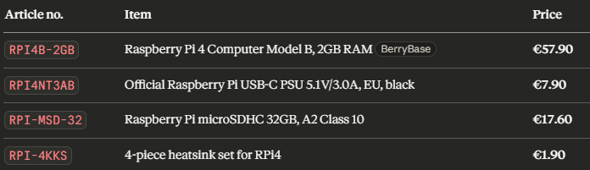
Subtotal berrybase.de: ~€85.30 (free shipping, 1–3 days)
From reichelt.de (or Conrad Munich store — Stachus/Kaufingerstraße)
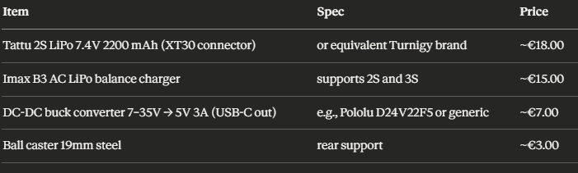
Subtotal Conrad.de: ~€43.00
From AliExpress (use "European Warehouse" filter — 7–14 day delivery to Germany)
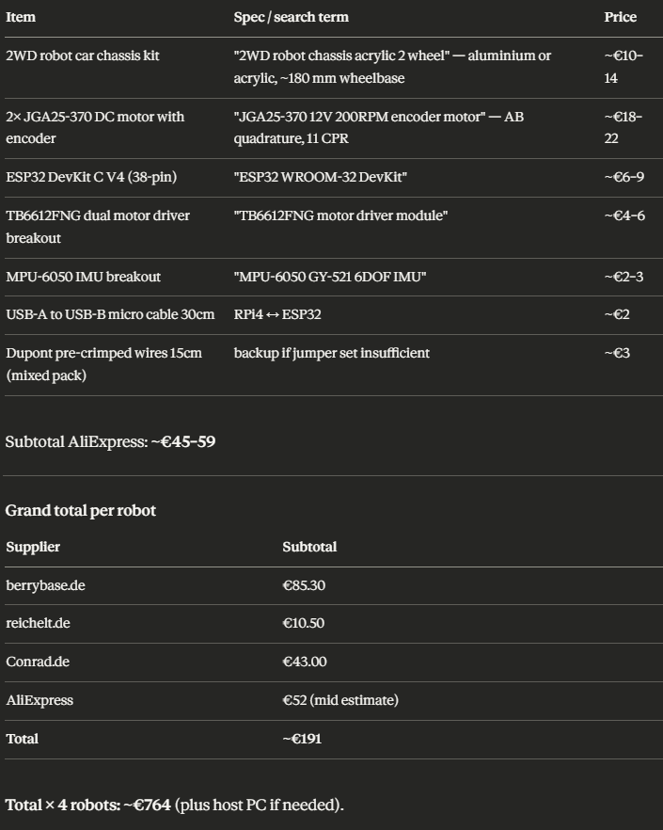
Step-by-step: Phase 1 — Mechanical assembly
Do this before touching any software. Estimated time: 2–3 hours for the first robot.
Step 1.1 — Unbox and inventory. Lay all components on a table. Confirm you have: acrylic chassis plates (usually 2), 2 motors, 4 screws per motor, 2 wheels, 1 ball caster, all electronics.
Step 1.2 — Mount the motors. Each JGA25-370 motor has two screw holes on its gearbox face. Align the motor so the output shaft points outward through the wheel cutout in the chassis bottom plate. Use M3 × 8 mm screws. Tighten firmly — a loose motor causes odometry drift.
Step 1.3 — Attach wheels. Press-fit or screw the wheels onto the motor output shafts. The flat face of the D-shaped shaft must align with the flat inside the wheel hub.
Step 1.4 — Mount ball caster. Screw the ball caster to the rear underside of the bottom chassis plate using M3 screws and the 10 mm standoffs if needed to level it.
Step 1.5 — Stack the chassis layers. Most acrylic kits have two layers connected by M3 standoffs (~30–40 mm). Use 4 standoffs at the corners. This creates the electronics deck.
Step 1.6 — Mount the Raspberry Pi 4. Attach 4 × 10 mm brass standoffs to the top deck using M3 screws from below. Then seat the RPi4 onto the standoffs and secure with M3 nuts from above. Orient the USB-C power port toward the rear.
Step 1.7 — Stick heatsinks onto RPi4. Peel the adhesive backing and press the small copper heatsinks onto the BCM2711 chip, RAM chip, and USB controller chip. This prevents thermal throttling.
Step-by-step: Phase 2 — Wiring
Keep wires short and tidy. Work on a non-conductive surface.
Step 2.1 — Motor wires to TB6612FNG. The TB6612FNG board has two channels (A and B). Connect:
Left motor: red → AO1, black → AO2
Right motor: red → BO1, black → BO2
If a motor spins the wrong direction later in software testing, just swap those two wires for that motor.
Step 2.2 — Power the TB6612FNG. VM pin → LiPo positive (7.4V). GND → LiPo negative. VCC pin → 3.3V from ESP32 (for logic level).
Step 2.3 — TB6612FNG control pins to ESP32. Use Dupont wires: Step-by-step: Phase 1 — Mechanical assembly
Do this before touching any software. Estimated time: 2–3 hours for the first robot.
Step 1.1 — Unbox and inventory. Lay all components on a table. Confirm you have: acrylic chassis plates (usually 2), 2 motors, 4 screws per motor, 2 wheels, 1 ball caster, all electronics.
Step 1.2 — Mount the motors. Each JGA25-370 motor has two screw holes on its gearbox face. Align the motor so the output shaft points outward through the wheel cutout in the chassis bottom plate. Use M3 × 8 mm screws. Tighten firmly — a loose motor causes odometry drift.
Step 1.3 — Attach wheels. Press-fit or screw the wheels onto the motor output shafts. The flat face of the D-shaped shaft must align with the flat inside the wheel hub.
Step 1.4 — Mount ball caster. Screw the ball caster to the rear underside of the bottom chassis plate using M3 screws and the 10 mm standoffs if needed to level it.
Step 1.5 — Stack the chassis layers. Most acrylic kits have two layers connected by M3 standoffs (~30–40 mm). Use 4 standoffs at the corners. This creates the electronics deck.
Step 1.6 — Mount the Raspberry Pi 4. Attach 4 × 10 mm brass standoffs to the top deck using M3 screws from below. Then seat the RPi4 onto the standoffs and secure with M3 nuts from above. Orient the USB-C power port toward the rear.
Step 1.7 — Stick heatsinks onto RPi4. Peel the adhesive backing and press the small copper heatsinks onto the BCM2711 chip, RAM chip, and USB controller chip. This prevents thermal throttling.
Step-by-step: Phase 2 — Wiring
Keep wires short and tidy. Work on a non-conductive surface.
Step 2.1 — Motor wires to TB6612FNG. The TB6612FNG board has two channels (A and B). Connect:
Left motor: red → AO1, black → AO2
Right motor: red → BO1, black → BO2
If a motor spins the wrong direction later in software testing, just swap those two wires for that motor.
Step 2.2 — Power the TB6612FNG. VM pin → LiPo positive (7.4V). GND → LiPo negative. VCC pin → 3.3V from ESP32 (for logic level).
Step 2.3 — TB6612FNG control pins to ESP32. Use Dupont wires:
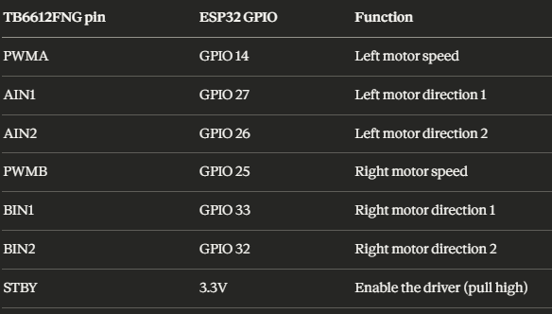
Step 2.4 — Encoder wires to ESP32. Each JGA25-370 encoder has 6 wires: VCC, GND, A, B (+ sometimes index). Connect:
Encoder VCC → 3.3V on ESP32
Encoder GND → GND on ESP32
Left encoder A → GPIO 34, Left encoder B → GPIO 35
Right encoder A → GPIO 18, Right encoder B → GPIO 19

Step 2.5 — MPU-6050 IMU to ESP32 via I2C:
VCC → 3.3V, GND → GND, SDA → GPIO 21, SCL → GPIO 22
Step 2.6 — Power the RPi4. Buck converter input → LiPo (7.4V). Buck converter output (USB-C 5V) → RPi4 USB-C port. The buck converter regulates the LiPo voltage to a stable 5V for the RPi4.
Step 2.7 — ESP32 to RPi4 via USB cable: ESP32 USB-C/micro → any RPi4 USB-A port. This carries both power (to ESP32 from RPi4) and the serial data link used by micro-ROS.
Step 2.8 — Mount electronics with double-sided foam tape. Stick the TB6612FNG board, ESP32, and buck converter to the top deck of the chassis. Keep the LiPo accessible for charging — attach it with a Velcro strap to the underside of the bottom deck.
Step-by-step: Phase 3 — ESP32 firmware (linorobot2_hardware)
This replaces what Arduino firmware would have done. Estimated time: 1–2 hours.
Step 3.1 — Install Arduino IDE 2 on your host PC. Download from arduino.cc.
Step 3.2 — Add ESP32 board support. In Arduino IDE: File → Preferences → Additional Boards Manager URLs → paste https://raw.githubusercontent.com/espressif/arduino-esp32/gh-pages/package_esp32_index.json. Then Tools → Board → Boards Manager → search ESP32 → Install.
Step 3.3 — Clone linorobot2_hardware. On your host PC terminal:
git clone https://github.com/linorobot/linorobot2_hardware
Step 3.4 — Install micro-ROS Arduino library. Follow the instructions in the linorobot2_hardware README: download the micro-ROS library for Arduino from the releases page and add it via Arduino IDE → Sketch → Include Library → Add .ZIP Library.
Step 3.5 — Configure the firmware. Open linorobot2_hardware/firmware/lib/config/lino_base_config.h and set:
#define LINO_BASE DIFFERENTIAL_DRIVE
#define USE_TB6612_MOTOR_DRIVER
#define USE_MPU6050_IMU
// Set your encoder CPR and wheel diameter here
#define COUNTS_PER_REV 44 // 11 CPR × 4 (quadrature)
#define WHEEL_DIAMETER 0.065 // meters
#define WHEEL_SEPARATION 0.17 // meters (measure on your chassis)
Step 3.6 — Set GPIO pin numbers in the motor driver config to match your wiring from Step 2.3 and 2.4.
Step 3.7 — Flash the firmware. Connect ESP32 to your host PC via USB. In Arduino IDE: select board "ESP32 Dev Module", select the correct COM port, click Upload. The ESP32 now runs micro-ROS and waits for a ROS2 micro-ROS agent on the RPi4.
Step-by-step: Phase 4 — Raspberry Pi 4 software
Step 4.1 — Flash Ubuntu Server 22.04. On your host PC, download the Raspberry Pi Imager from raspberrypi.com. Insert the microSD card. Choose OS → Other general-purpose OS → Ubuntu → Ubuntu Server 22.04 LTS (64-bit). Before writing, click the gear icon and set: hostname = robot1, enable SSH, set WiFi SSID and password, set username = pi, password of your choice. Write to SD card. Insert SD into RPi4 and power on.
Step 4.2 — SSH into the RPi4. From your host PC:
ssh pi@robot1.local
Wait ~2 minutes for first boot. If robot1.local does not resolve, find the IP in your router's DHCP list.
Step 4.3 — Install ROS2 Humble. On the RPi4 via SSH:
sudo apt update && sudo apt upgrade -y
sudo apt install software-properties-common curl -y
sudo curl -sSL https://raw.githubusercontent.com/ros/rosdistro/master/ros.key \
-o /usr/share/keyrings/ros-archive-keyring.gpg
echo "deb [arch=$(dpkg --print-architecture) signed-by=/usr/share/keyrings/ros-archive-keyring.gpg] \
http://packages.ros.org/ros2/ubuntu jammy main" \
| sudo tee /etc/apt/sources.list.d/ros2.list
sudo apt update
sudo apt install ros-humble-ros-base -y
echo "source /opt/ros/humble/setup.bash" >> ~/.bashrc
source ~/.bashrc
Step 4.4 — Install linorobot2 on the RPi4. The project provides a one-line install script:
source /opt/ros/humble/setup.bash
cd /tmp
wget https://raw.githubusercontent.com/linorobot/linorobot2/humble/install_linorobot2.bash
bash install_linorobot2.bash 2wd lidar
This installs all dependencies and creates a ~/robot_ws workspace. It takes 10–20 minutes.

Step-by-step: Phase 5 — Integration with your formation control system
This is where your existing Python planning layer connects to the physical robots.
Step 5.1 — Write the robot agent node. On each RPi4, create a small Python node ~/robot_ws/src/robot_agent.py that:
Connects to your host PC ZMQ coordinator via WiFi
Receives u_safe = (u_x, u_y) from cosim_manager.py
Converts to (v_ref, ω) using the same motion-controller formula: v_ref = ||[u_x, u_y]||, θ_ref = atan2(u_y, u_x), ω = k_heading · wrap(θ_ref − θ)
Publishes geometry_msgs/Twist to /cmd_vel
Reads /odom and sends (x, y, θ, v, ω) back to the host via ZMQ

Step 5.2 — Update cosim_bridge.py on the host. Replace the matlab.engine step logic with a ZMQ UDP socket that sends u_safe to each robot's IP and receives odometry back. You already have this architecture designed — only the transport changes from MATLAB workspace to ZMQ WiFi.
Step 5.3 — Configure static IPs. Set each RPi4 to a static IP in your router: 192.168.1.21, .22, .23, .24. Update consensus_config.py accordingly.
Step 5.4 — Run the full stack. On the host:
python cosim_experiment_runner.py \
--n-agents 4 --model single_integrator \
--outer-steps 18 --cosim-mode hardware
This starts coordinator, 4 controller nodes, and the cosim manager. The manager now talks to real robots over WiFi instead of MATLAB.
Recommended learning sequence
Before attempting to run four robots simultaneously, follow this progression:
Week 1 — Build one robot mechanically. Flash ESP32. Confirm motors spin when commanded.
Week 2 — Set up RPi4 with linorobot2. Confirm odometry publishes. Drive robot manually with a keyboard using teleop_twist_keyboard.
Week 3 — Connect robot to your host PC over WiFi. Write robot_agent.py. Confirm the ZMQ bridge works: host sends a velocity, robot moves, odometry comes back.
Week 4 — Run your single-agent version of the planning layer (set n_agents=1). Close the loop: planning → robot → odometry → planning.
Week 5–6 — Build robots 2, 3, 4 (much faster now that you know the process). Run the full 4-agent formation control experiment.
The Articulated Robotics YouTube playlist (youtube.com/playlist?list=PLunhqkrRNRhYAffV8JDiFOatQXuU-NnxT) is the best companion for Weeks 1–3, covering every step with clear explanations. The linorobot2 documentation at github.com/linorobot/linorobot2 covers Week 4 onward.

Hardware Guide: Four-Robot Differential-Drive Lab Prototype in Munich

Tier B — Recommended: Raspberry Pi 4 + Custom Differential-Drive Base (€130–180 per robot)
This gives you a full Linux SBC running Ubuntu 22.04 + ROS2 Humble on each robot. Your Python planning layer on the host PC talks to each robot's ROS2 node over the home WiFi network. The robot runs a local velocity controller that receives (v, ω) commands and publishes encoder odometry.

Per-Robot Bill of Materials
- Host PC (if you don't already have one): any Linux laptop running Ubuntu 22.04 works. A used ThinkPad X1 Carbon runs ~€350–500 on eBay.de.

The Recommended Tier B Architecture in Practice
Here is exactly how your system maps onto the hardware:

Software Stack on Each Robot (RPi4)
- A lightweight Python node (robot_agent.py) connects back to the host over ZMQ, receives (u_x, u_y) from your cosim_manager.py, converts it to (v_ref, θ_ref) using the same motion-controller formula you implemented in Simulink, and sends (v_ref, ω) to the Arduino via serial.
- The Arduino runs a 50–100 Hz velocity PID loop: reads encoder counts, computes current wheel speeds, applies PID corrections to motor PWM, and publishes (x, y, θ) odometry back via serial.
- The RPi4 forward the odometry over ZMQ/WiFi to cosim_manager.py on the host, closing the loop.
This replaces your Simulink co-simulation with real hardware while keeping cosim_manager.py as the interface point — only cosim_bridge.py changes (from matlab.engine to a WiFi socket client).

Practical Deployment Steps
- Step 1 — Prepare the host PC. Install Ubuntu 22.04, ROS2 Humble, your Python dependencies (pyzmq, numpy, scipy, cvxpy). Clone your planning-layer code. Assign the host a static IP on your home router (e.g. 192.168.1.10).
- Step 2 — Flash the RPi4s. Use the Raspberry Pi Imager to flash Ubuntu 22.04 Server on each SD card. Enable SSH and pre-configure the WiFi SSID/password in the cloud-init file before first boot. Install ROS2 Humble, then your robot_agent.py. Assign each robot a static IP (192.168.1.21–24).
- Step 3 — Flash the Arduinos. Upload a firmware that: (a) reads two quadrature encoders via interrupt, (b) maintains velocity PID for left and right wheels independently, (c) receives (v_linear, omega) commands from the RPi4 via serial at 115200 baud, and (d) streams (x, y, theta, v, omega) odometry back at 20–50 Hz. The differential-drive kinematic model for odometry is standard and well-documented.
- Step 4 — Wire each robot. LiPo → buck converter → RPi4 (5V USB-C). LiPo directly → TB6612FNG (VM). TB6612FNG control pins → Arduino PWM/DIR outputs. Encoder A/B → Arduino interrupt pins. RPi4 ↔ Arduino: USB serial cable.
- Step 5 — Network configuration. Use a dedicated 2.4 GHz SSID (not 5 GHz — better range, sufficient bandwidth for 4 robots sending 50-byte odometry packets at 50 Hz). Assign static IPs. Update consensus_config.py with the robot IPs as ZMQ endpoints instead of 127.0.0.1.
- Step 6 — Replace the bridge. In cosim_bridge.py replace the matlab.engine calls with a UDP/ZMQ socket: step() sends u_safe to the robot's IP and receives the odometry packet back. The rest of cosim_manager.py is unchanged.
- Step 7 — Lab space. Your arena should be at least 3 m × 3 m for 4 agents with safety distances of ~1.1 m as configured in your NetConfig. Tape markers or ArUco patterns on the floor help with initial position estimation. A camera mounted overhead (a single USB webcam at ~2 m height) can serve as a ground-truth localization system if encoder odometry drifts.

What Variant of Differential-Drive Robot is Best for Your Case
Given your single-integrator planning model and the relatively slow outer-step rate (dt = 1 s), the unicycle tracking requirement is not aggressive. Any of these three physical configurations work:
- 2WD + rear caster (recommended): two driven wheels at centre, one passive ball caster at rear. Simplest mechanically, lowest cost, easiest to model. The only configuration matching your unicycle model exactly.
- 2WD + front caster (alternative): same as above but caster at front. Slightly less stable at higher speeds but acceptable at the low speeds your safety constraints enforce.
- 3-wheel (avoid): adding a third passive wheel complicates the kinematics and introduces slip if the floor is uneven. Not worth it here.
