



| **Course Title:** | Fundamentals of Data Engineering |
| --- | --- |
| **Course Number:** | COE 848 |
| **Semester/Year (e.g.F2016):** | W2024 |

| **Instructor:** | Faezeh Ensan |
| --- | --- |

| *Assignment/Lab Number:* | 5 |
| --- | --- |
| *Assignment/Lab Title:* | Database Programming |

| *Submission Date:* | Mar 25, 2024 |
| --- | --- |
| *Due Date:* | Mar 25, 2024 |

| **Student**  **LAST Name** | **Student**  **FIRST Name** | **Student**  **Number** | **Section** | **Signature \*** |
| --- | --- | --- | --- | --- |
| Abdur-Rahman | Taskin | 500973553 |  |  |
|  |  |  |  |  |
|  |  |  |  |  |



# Setup and Installation

#### Environment Requirements

* Windows 10/11
* 4GB RAM
* VSCode version 1.87.2
  + If not installed on the system, then install the latest version for Windows using the following guide <https://code.visualstudio.com/download>.
* java version "21.0.2" 2024-01-16 LTS
  + If not installed on the system, then install the latest version for Windows using the following guide <https://code.visualstudio.com/docs/java/java-tutorial>.
  + Ensure that the *Coding Pack for Java* is installed.
* Java(TM) SE Runtime Environment (build 21.0.2+13-LTS-58)

#### Steps

1. Open Visual Studio Code
2. Open the HotelDatabase folder by going to *File→Open Folder*.
3. Open the *HotelDatabase.java* file in the *src* folder.
4. On the top right corner of the VSCode window, click *Run Java*, to run the program.

# Running the Program

#### Startup

Upon running the *HotelDatabase.java* file, the following message should appear.

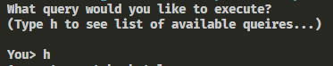

Typing ‘h’ should display the list of commands available.

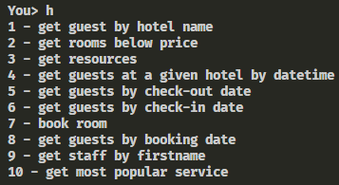

#### Queries

To execute the queries simply type in the number corresponding to the query of choice and press enter. The first time a query is executed you should see a warning message like the one below.

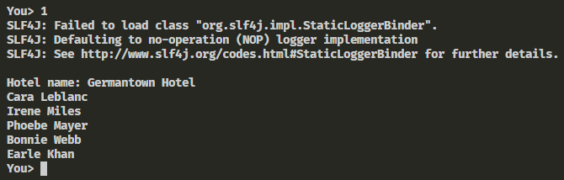

1. Display list of guests for whom a booking was created at a particular hotel.
   1. get guest by hotel name
   2. You will be prompted for the hotel name. Once you have entered it, the list of guest should be displayed.

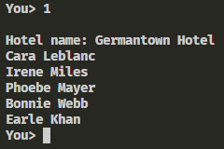

1. Display rooms that are at a price lower than the given maximum at a particular hotel.
   1. get rooms below price
   2. You will be prompted to enter the hotel name and then the maximum price. Once both are entered correctly, the list of RoomNo’s with the price shall be displayed.

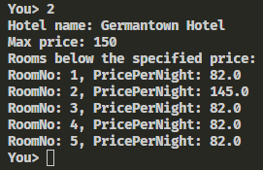

1. Display list of resources in the database.
   1. get resources
   2. List of resources found in the database shall be displayed.

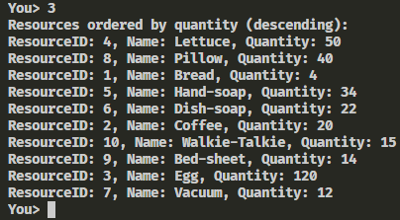

1. Display the guests with bookings in a hotel at a given time.
   1. get guests at a given hotel by datetime
   2. Prompts user for hotel name and specific datetime before displaying the list of guests.

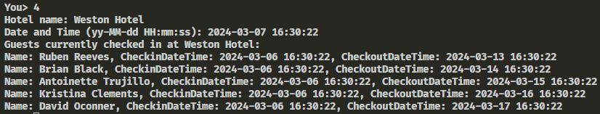

1. Display the guests that are checking out on a specific date.
   1. get guests by checkout date
   2. Prompts user for hotel name and specific date, before displaying list of guests.

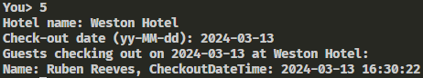

1. Display the guests that are checking in on a specific date.
   1. get guests by check-in date.
   2. Prompts user for hotel name and specific date, before displaying list of guests.

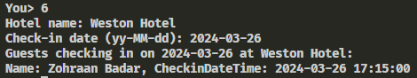

1. Create a new booking for a guest
   1. book room
   2. Prompts the user for email, hotel name, check-in time, checkout time, # of adults, Room number, before creating a booking.

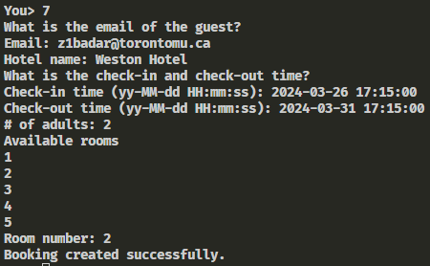

1. Display all guests that made a booking on a given date at a particular hotel.
   1. get guests by booking date.
   2. Prompts the user for hotel name and booking date before printing the list of guests.

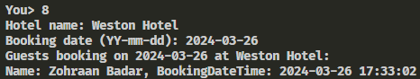

1. Display all staff whose first names start with a given string.
   1. get staff by first name
   2. Prompts the user for hotel name and firstname before listing the staff members.

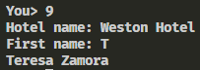

1. Display the most popular service at a particular hotel.
   1. get most popular service
   2. Prompts the user for the hotel name then displays the most popular service.



# SQL Dump

PRAGMA foreign_keys=OFF;

BEGIN TRANSACTION;

CREATE TABLE Staff (

StaffID *INTEGER* PRIMARY KEY,

HotelCode *INTEGER*,

FirstName *TEXT*,

LastName *TEXT*,

DOB *DATE*,

Gender *TEXT*,

Email *TEXT*,

Phone *TEXT*,

Password *TEXT*,

Position *TEXT*,

Salary *REAL*,

FOREIGN KEY (HotelCode) REFERENCES Hotel (HotelCode)

);

INSERT INTO Staff VALUES(1,1,'Bethan','Ramirez',NULL,'M','bramirez@hotel.com',NULL,'$2b$12$r7b.2pj7WfBm3JiHGQsQr.J96CRNoLUafwtCXdLiBW/diI64fCI.C',NULL,NULL);

INSERT INTO Staff VALUES(2,1,'Eoin','Colon',NULL,'M','eoin.colon@hotel.com',NULL,'$2b$12$DnLwxMa21nv5tIl/dldz7uUpLfWzPqYN4fk3ZmGTfU23yXTzOMVP6',NULL,NULL);

INSERT INTO Staff VALUES(3,1,'Pablo','Rivers',NULL,'M','pablo.rivers@hotel.com',NULL,'$2b$12$nyrSDwO1cSMd8VEt4tRhSe71u1mi7zSkFQMMTg/u4gILCFupDwYF6',NULL,NULL);

INSERT INTO Staff VALUES(4,1,'Richard','Gilmore',NULL,'M','richard.gilmore@hotel.com',NULL,'$2b$12$iMtAxDvhkThUugFNAs1erunaBi416zrb0IajY0tBp4e2VinNN3g1S',NULL,NULL);

INSERT INTO Staff VALUES(5,1,'Zahraa','Woodward',NULL,'F','zwoodward@hotel.com',NULL,'$2b$12$hQCcjv31Gantt.i4DzGLGOOkIMhEf8mo.SkLBjV3PFb4KSi9J2euu',NULL,NULL);

INSERT INTO Staff VALUES(6,1,'Abigail','Rivera',NULL,'F','abigail.rivera@hotel.com',NULL,'$2b$12$QnAMdbcx5YBotDfOcXZj8ujhVLwN4KTezSAmphfHTBuGLOZYnrLXG',NULL,NULL);

INSERT INTO Staff VALUES(7,2,'Marco','Clements',NULL,'M','mclements@hotel.com',NULL,'$2b$12$Drs/KX6XP/WIHTBfgazkeO5nqvKIbb/QzwS6IdZnKKydpcHRO9VSq',NULL,NULL);

INSERT INTO Staff VALUES(8,2,'Teresa','Zamora',NULL,'F','tzamora@hotel.com',NULL,'$2b$12$z1OBIUpcXbq.Y3Gs3j1oSOlwaquX1iAvbWf5koa4wjLEyRudRDJxK',NULL,NULL);

INSERT INTO Staff VALUES(9,2,'Leanne','Davies',NULL,'F','ldavies@hotel.com',NULL,'$2b$12$7N8.hEbaVha8da/lKOld6uLpPkal9biNj1Uqent8.1LwrTr345v1W',NULL,NULL);

INSERT INTO Staff VALUES(10,3,'Shakira','Luna',NULL,'F','shakira.luna@hotel.com',NULL,'$2b$12$iigjxuH.sGRfrtEI5xO3iepEYEk3r0gk1DtGtlSmeCMx3dcmZrWI.',NULL,NULL);

CREATE TABLE Room (

RoomNo *INT* NOT NULL,

HotelCode *INTEGER* NOT NULL,

RoomType *TEXT*, PricePerNight *REAL*, NumBeds *INTEGER*,

PRIMARY KEY (HotelCode, RoomNo)

FOREIGN KEY (HotelCode) REFERENCES Hotel (HotelCode)

);

INSERT INTO Room VALUES(1,1,'Guest',81.999999999999999998,1);

INSERT INTO Room VALUES(2,1,'Guest',145.0,2);

INSERT INTO Room VALUES(3,1,'Guest',81.999999999999999998,1);

INSERT INTO Room VALUES(4,1,'Office',81.999999999999999998,1);

INSERT INTO Room VALUES(5,1,'Public',81.999999999999999998,1);

INSERT INTO Room VALUES(1,2,'Guest',81.999999999999999998,1);

INSERT INTO Room VALUES(2,2,'Guest',145.0,2);

INSERT INTO Room VALUES(3,2,'Guest',81.999999999999999998,1);

INSERT INTO Room VALUES(4,2,'Office',81.999999999999999998,1);

INSERT INTO Room VALUES(5,2,'Public',81.999999999999999998,1);

CREATE TABLE Guest (

GuestID *INTEGER* PRIMARY KEY,

FirstName *TEXT* NOT NULL,

LastName *TEXT* NOT NULL,

DOB *DATE*,

Gender *TEXT*,

Email *TEXT* NOT NULL,

Password *TEXT* NOT NULL,

Address *TEXT*,

Phone *TEXT*

);

INSERT INTO Guest VALUES(1,'Irene','Miles',NULL,'F','irene.miles@gmail.com','irenemiles',NULL,NULL);

INSERT INTO Guest VALUES(2,'Phoebe','Mayer',NULL,'F','phoebe.mayer@gmail.com','phoebemayer',NULL,NULL);

INSERT INTO Guest VALUES(3,'Cara','Leblanc',NULL,'F','cara.leblanc@gmail.com','caraleblanc',NULL,NULL);

INSERT INTO Guest VALUES(4,'Bonnie','Webb',NULL,'F','bonnie.webb@gmail.com','bonniewebb',NULL,NULL);

INSERT INTO Guest VALUES(5,'Earle','Khan',NULL,'M','earle.khan@gmail.com','earlekhan',NULL,NULL);

INSERT INTO Guest VALUES(6,'Ruben','Reeves',NULL,'M','ruben.reeves@gmail.com','rubenreeves',NULL,NULL);

INSERT INTO Guest VALUES(7,'Brian','Black',NULL,'M','brian.black@gmail.com','brianblack',NULL,NULL);

INSERT INTO Guest VALUES(8,'Antoinette','Trujillo',NULL,'F','antoinette.trujillo@gmail.com','antoinettetrujillo',NULL,NULL);

INSERT INTO Guest VALUES(9,'Kristina','Clements',NULL,'F','kristina.clements@gmail.com','kristinaclements',NULL,NULL);

INSERT INTO Guest VALUES(10,'David','Oconner',NULL,'M','david.oconner@gmail.com','davidoconner',NULL,NULL);

INSERT INTO Guest VALUES(11,'Zohraan','Badar',NULL,NULL,'z1badar@torontomu.ca','abdurr_6621*',NULL,NULL);

CREATE TABLE Resource (

ResourceID *INTEGER* PRIMARY KEY,

HotelCode *INTEGER* NOT NULL,

Name *TEXT* NOT NULL,

Quantity *TEXT*,

FOREIGN KEY (HotelCode) REFERENCES Hotel (HotelCode)

);

INSERT INTO Resource VALUES(1,1,'Bread','4');

INSERT INTO Resource VALUES(2,1,'Coffee','20');

INSERT INTO Resource VALUES(3,1,'Egg','120');

INSERT INTO Resource VALUES(4,1,'Lettuce','50');

INSERT INTO Resource VALUES(5,1,'Hand-soap','34');

INSERT INTO Resource VALUES(6,1,'Dish-soap','22');

INSERT INTO Resource VALUES(7,2,'Vacuum','12');

INSERT INTO Resource VALUES(8,2,'Pillow','40');

INSERT INTO Resource VALUES(9,3,'Bed-sheet','14');

INSERT INTO Resource VALUES(10,3,'Walkie-Talkie','15');

CREATE TABLE Expense (

ExpenseID *INTEGER* PRIMARY KEY,

HotelCode *INTEGER* NOT NULL,

Name *TEXT* NOT NULL,

Amount *REAL* NOT NULL,

FOREIGN KEY (HotelCode) REFERENCES Hotel (HotelCode)

);

INSERT INTO Expense VALUES(1,1,'Resupply bread',50.0);

INSERT INTO Expense VALUES(2,1,'Resupply coffee',60.0);

INSERT INTO Expense VALUES(3,1,'Guest speaker event',150.0);

INSERT INTO Expense VALUES(4,2,'Resupply broom',24.0);

INSERT INTO Expense VALUES(5,2,'Resupply towel',70.0);

INSERT INTO Expense VALUES(6,2,'Resupply carrot',45.0);

INSERT INTO Expense VALUES(7,3,'Resupply bed sheet',76.999999999999999998);

INSERT INTO Expense VALUES(8,3,'Resupply back-up keys',12.0);

INSERT INTO Expense VALUES(9,3,'Resupply back-up monitors',400.0);

INSERT INTO Expense VALUES(10,3,'Cisco network testing service',120.0);

CREATE TABLE Booking (

BookingID *INTEGER* PRIMARY KEY,

HotelCode *INTEGER* NOT NULL,

RoomNo *INTEGER* NOT NULL,

GuestID *INTEGER* NOT NULL,

BookingDateTime DATETIME NOT NULL,

CheckinDateTime DATETIME NOT NULL,

CheckoutDateTime DATETIME NOT NULL,

NumAdults *INTEGER* NOT NULL,

FOREIGN KEY (HotelCode) REFERENCES Hotel (HotelCode),

FOREIGN KEY (RoomNo) REFERENCES Room (RoomNo),

FOREIGN KEY (GuestID) REFERENCES Guest (GuestID)

);

INSERT INTO Booking VALUES(1,1,2,3,'2024-04-10 12:00:00','2024-05-01 14:00:00','2024-05-05 10:00:00',2);

INSERT INTO Booking VALUES(2,1,1,1,'2024-03-06 16:30:22','2024-03-06 16:30:22','2024-03-08 16:30:22',1);

INSERT INTO Booking VALUES(3,1,2,2,'2024-03-06 16:30:22','2024-03-06 16:30:22','2024-03-09 16:30:22',2);

INSERT INTO Booking VALUES(4,1,3,3,'2024-03-06 16:30:22','2024-03-06 16:30:22','2024-03-10 16:30:22',1);

INSERT INTO Booking VALUES(5,1,4,4,'2024-03-06 16:30:22','2024-03-06 16:30:22','2024-03-11 16:30:22',1);

INSERT INTO Booking VALUES(6,1,5,5,'2024-03-06 16:30:22','2024-03-06 16:30:22','2024-03-12 16:30:22',1);

INSERT INTO Booking VALUES(7,2,1,6,'2024-03-06 16:30:22','2024-03-06 16:30:22','2024-03-13 16:30:22',2);

INSERT INTO Booking VALUES(8,2,2,7,'2024-03-06 16:30:22','2024-03-06 16:30:22','2024-03-14 16:30:22',1);

INSERT INTO Booking VALUES(9,2,3,8,'2024-03-06 16:30:22','2024-03-06 16:30:22','2024-03-15 16:30:22',1);

INSERT INTO Booking VALUES(10,2,4,9,'2024-03-06 16:30:22','2024-03-06 16:30:22','2024-03-16 16:30:22',2);

INSERT INTO Booking VALUES(11,2,5,10,'2024-03-06 16:30:22','2024-03-06 16:30:22','2024-03-17 16:30:22',1);

INSERT INTO Booking VALUES(12,2,2,11,'2024-03-26 17:33:02','2024-03-26 17:15:00','2024-03-31 17:15:00',2);

CREATE TABLE Bill (

InvoiceNum *INTEGER* PRIMARY KEY,

BookingID *INTEGER* NOT NULL,

Amount *REAL* NOT NULL,

PaidDate *DATE*,

PaymentMode *TEXT*,

ExpireDate *DATE* NOT NULL,

FOREIGN KEY (BookingID) REFERENCES Booking (BookingID)

);

INSERT INTO Bill VALUES(1,1,100.0,'2024-04-10','Debit','2024-04-15');

INSERT INTO Bill VALUES(2,2,150.0,'2024-04-10','Debit','2024-04-15');

INSERT INTO Bill VALUES(3,3,120.0,'2024-04-12','Debit','2024-04-17');

INSERT INTO Bill VALUES(4,4,80.0,'2024-04-10','Debit','2024-04-15');

INSERT INTO Bill VALUES(5,5,200.0,'2024-04-10','Debit','2024-04-15');

INSERT INTO Bill VALUES(6,6,179.99999999999999999,'2024-04-12','Debit','2024-04-17');

INSERT INTO Bill VALUES(7,7,90.0,'2024-04-10','Debit','2024-04-15');

INSERT INTO Bill VALUES(8,8,110.0,'2024-04-10','Debit','2024-04-15');

INSERT INTO Bill VALUES(9,9,129.99999999999999999,'2024-04-12','Debit','2024-04-17');

INSERT INTO Bill VALUES(10,10,95.0,'2024-04-12','Debit','2024-04-17');

CREATE TABLE Service (

ID *INTEGER* PRIMARY KEY,

BillNum *INTEGER* NOT NULL,

Name *TEXT* NOT NULL,

Cost *REAL*,

Description *TEXT*,

FOREIGN KEY (BillNum) REFERENCES Bill (InvoiceNum)

);

INSERT INTO Service VALUES(1,1,'Room Service',25.0,'Food and drinks delivered to the room');

INSERT INTO Service VALUES(2,1,'WiFi Access',10.0,'High-speed internet access');

INSERT INTO Service VALUES(3,2,'Room Service',20.0,'Food and drinks delivered to the room');

INSERT INTO Service VALUES(4,3,'Laundry',15.0,'Cleaning and ironing of clothes');

INSERT INTO Service VALUES(5,3,'Room Service',30.0,'Food and drinks delivered to the room');

INSERT INTO Service VALUES(6,4,'WiFi Access',12.0,'High-speed internet access');

INSERT INTO Service VALUES(7,5,'Laundry',17.999999999999999999,'Cleaning and ironing of clothes');

INSERT INTO Service VALUES(8,6,'Room Service',22.0,'Food and drinks delivered to the room');

INSERT INTO Service VALUES(9,7,'WiFi Access',8.0,'High-speed internet access');

INSERT INTO Service VALUES(10,8,'Laundry',20.0,'Cleaning and ironing of clothes');

CREATE TABLE IF NOT EXISTS "Hotel" (

HotelCode *INTEGER* PRIMARY KEY,

Address *TEXT*,

Postcode *TEXT*,

City *TEXT*,

Country *TEXT*,

NumRooms *INTEGER*,

DeskPhone *TEXT*,

ManagementPhone *TEXT*,

StaffCount *INTEGER*,

EstablishmentDate *DATE*

, Name *TEXT*);

INSERT INTO Hotel VALUES(1,'4944 Germantown Ave, Philadelphia, Pennsylvania, United States','PA 19144','Philadelphia','USA',345,'+12673686167',NULL,NULL,NULL,'Germantown Hotel');

INSERT INTO Hotel VALUES(2,'874-A Weston Rd, York, ON','M6N 3R6','York','Canada',455,'+14162435320',NULL,NULL,NULL,'Weston Hotel');

INSERT INTO Hotel VALUES(3,'41 Lebovic Ave Unit A110, Scarborough, ON','M1L 0H2','Scarborough','Canada',277,'+14162859973',NULL,NULL,NULL,'Scarborough Hotel');

INSERT INTO Hotel VALUES(4,'1172 Walkley Rd, Ottawa, ON','K1V 2P7','Ottawa','Canada',510,'+16135239600',NULL,NULL,NULL,'Ottawa Hotel');

INSERT INTO Hotel VALUES(5,'2 Whitehall Ct, London, United Kingdom','SW1A 2EJ','London','United Kingdom',332,'+442075235062',NULL,NULL,NULL,'London Hotel');

INSERT INTO Hotel VALUES(6,'4 Woodcock St, Birmingham, United Kingdom','B7 4BL','Birmingham','United Kingdom',510,'+441218206000',NULL,NULL,NULL,'Birmingham Hotel');

INSERT INTO Hotel VALUES(7,'19 Loughborough Rd, Leicester, United Kingdom','LE4 5LJ','Leicester','United Kingdom',82,'+441162682626',NULL,NULL,NULL,'Leicester Hotel');

INSERT INTO Hotel VALUES(8,'4289, Al Hajlah, Makkah, Saudi Arabia','24231','Makkah','Saudi Arabia',602,'+966125768888',NULL,NULL,NULL,'Makkah Hotel');

INSERT INTO Hotel VALUES(9,'JPRC+PF3, Omar Almukhtar St, Al Amal, Riyadh, Saudi Arabia','11561','Riyadh','Saudi Arabia',188,'+966114024121',NULL,NULL,NULL,'Riyadh Hotel');

INSERT INTO Hotel VALUES(10,'Mutlaq Abbas Munawir St, Kuwait City, Kuwait','','Kuwait City','Kuwait',734,'+96522262000',NULL,NULL,NULL,'Kuwait City Hotel');

INSERT INTO Hotel VALUES(11,'Al Mahatta - Al Qasimia - Sharjah - United Arab Emirates','89XR+V9XAl','Sharjah','United Arab Emirates',221,'+97165066222',NULL,NULL,NULL,'Sharjah Hotel');

CREATE UNIQUE INDEX idx_unique_name ON Hotel (Name);

COMMIT;