XSLT Queries

# Query 1 - List the first and last names of all Staff

**<?xml version="1.0" encoding="UTF-8"?>**

**<xsl:stylesheet version="1.0" xmlns:xsl="http://www.w3.org/1999/XSL/Transform">**

**<xsl:template match="/">**

**<StaffNames>**

**<xsl:for-each select="Hotel/Staff">**

**<Staff>**

**<FirstName><xsl:value-of select="FirstName"/></FirstName>**

**<LastName><xsl:value-of select="LastName"/></LastName>**

**</Staff>**

**</xsl:for-each>**

**</StaffNames>**

**</xsl:template>**

**</xsl:stylesheet>**

# Query 2 - List all RoomNo’s for a given hotel name

**<!-- XSLT query 2: List all room details -->**

**<?xml version="1.0" encoding="UTF-8"?>**

**<xsl:stylesheet version="1.0" xmlns:xsl="http://www.w3.org/1999/XSL/Transform">**

**<!-- Define a parameter for the hotel name -->**

**<xsl:param name="hotelName">Grand Hotel</xsl:param>**

**<!-- Key to match HotelCode with HotelName -->**

**<xsl:key name="hotel-by-name" match="Hotel" use="HotelName"/>**

**<!-- Template to match HotelCode for the given hotel name -->**

**<xsl:template match="/">**

**<!-- Find the HotelCode for the given hotel name -->**

**<xsl:variable name="hotelCode" select="key('hotel-by-name', $hotelName)/HotelCode"/>**

**<!-- Apply the template to select RoomNo for the matched HotelCode -->**

**<xsl:apply-templates select="/Database/Room[HotelCode = $hotelCode]"/>**

**</xsl:template>**

**<!-- Template to select RoomNo for the matched HotelCode -->**

**<xsl:template match="Room">**

**<xsl:value-of select="RoomNo"/>**

**<xsl:text>, </xsl:text> <!-- Add comma and space for separation -->**

**</xsl:template>**

**</xsl:stylesheet>**

# Query 3 - List all guest first and last names

**<?xml version="1.0" encoding="UTF-8"?>**

**<xsl:stylesheet version="1.0" xmlns:xsl="http://www.w3.org/1999/XSL/Transform">**

**<!-- Template to match all first and last names -->**

**<xsl:template match="/">**

**<xsl:apply-templates select="//FirstName | //LastName"/>**

**</xsl:template>**

**<!-- Template to output first and last names -->**

**<xsl:template match="FirstName | LastName">**

**<xsl:value-of select="."/>**

**<xsl:text> </xsl:text> <!-- Add space for separation -->**

**</xsl:template>**

**</xsl:stylesheet>**

# Query 4 - List all resource name and quantities

**<?xml version="1.0" encoding="UTF-8"?>**

**<xsl:stylesheet version="1.0" xmlns:xsl="http://www.w3.org/1999/XSL/Transform">**

**<!-- Template to match all resource names and quantities -->**

**<xsl:template match="/">**

**<xsl:apply-templates select="//Resource"/>**

**</xsl:template>**

**<!-- Template to output resource names and quantities -->**

**<xsl:template match="Resource">**

**<xsl:value-of select="concat(Name, ' - ', Quantity)"/>**

**<xsl:text>&#10;</xsl:text> <!-- Add newline for separation -->**

**</xsl:template>**

**</xsl:stylesheet>**

# Query 5 - List all expense names for a given hotel name

**<?xml version="1.0" encoding="UTF-8"?>**

**<xsl:stylesheet version="1.0" xmlns:xsl="http://www.w3.org/1999/XSL/Transform">**

**<!-- Parameter to specify the hotel name -->**

**<xsl:param name="hotelName" select="'Grand Hotel'"/>**

**<!-- Template to match the expenses for the specified hotel -->**

**<xsl:template match="/">**

**<xsl:for-each select="//Expense[../HotelCode = //Hotel[HotelName = $hotelName]/HotelCode]">**

**<!-- Output the expense name -->**

**<xsl:value-of select="Name"/>**

**<xsl:text>&#10;</xsl:text> <!-- Line break -->**

**</xsl:for-each>**

**</xsl:template>**

**</xsl:stylesheet>**

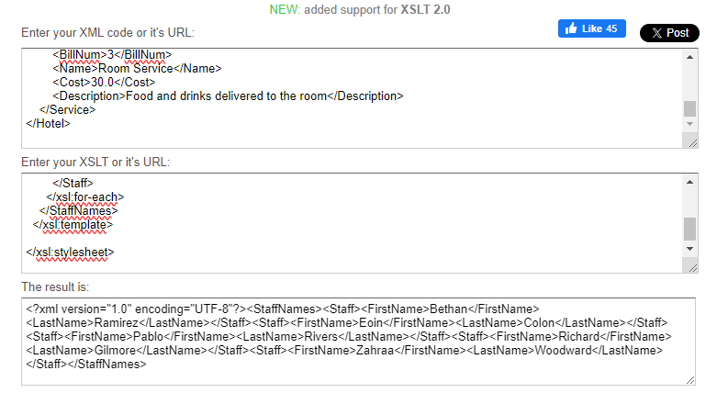

**Figure 1**: Query 1 results.

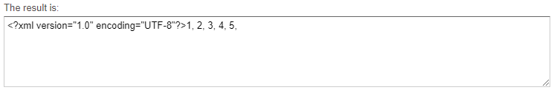

**Figure 2**: Query 2 results.

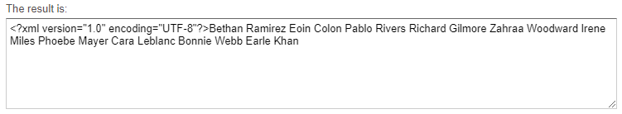

**Figure 3**: Query 3 results.

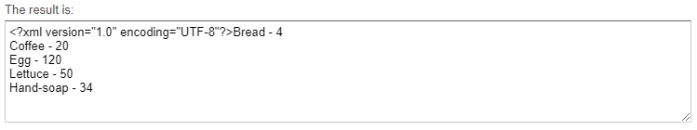

**Figure 4**: Query 4 results.