GU Oncology
Clinical Trial Finder
Southern California
Physician Validation Protocol
Version 2.0 · April 2026
210 active interventional trials · 17 SoCal institutions · Prostate + Bladder + Kidney + Testicular classified

Purpose of this document
This protocol explains how the SoCal GU Oncology pipeline works — step by step — so that a physician can validate its outputs and use it to find trials for real patients. It covers data sources, the classification method, and three worked patient examples shown in the live UX.

STEP 1 — DATA SOURCE: WHAT WE PULL FROM CLINICALTRIALS.GOV

ClinicalTrials.gov (CT.gov) is the U.S. federal registry of all clinical studies, maintained by the NIH. The pipeline queries it weekly via a public REST API.

Only interventional trials with status RECRUITING are retrieved — observational studies, expanded access programmes, and paused trials are excluded.
CT.gov Field | What It Tells Us
NCT ID + brief title | Trial identity and short description
Phase + status | Phase 1–3; RECRUITING only
Conditions | Disease(s) the sponsor registered
Interventions | Drug, device, or procedure being tested
Eligibility criteria | Who can enrol (inclusion + exclusion text)
Sites + investigators | Where the trial runs and with which PI
Brief summary | Plain-language trial description
Primary / secondary outcomes | What the trial is measuring
WE FILTER TO SOUTHERN CALIFORNIA ONLY
CT.gov lists over 500,000 registered studies globally. Filtering by state = California and matching against a curated list of SoCal GU academic centres converts a global registry into a locally actionable map.
Institution | City
UC Irvine / Chao Family NCI Cancer Center | Orange
UC San Diego / Moores Cancer Center | La Jolla
UCLA / Jonsson Comprehensive Cancer Center | Los Angeles
USC / Norris Comprehensive Cancer Center | Los Angeles
City of Hope National Medical Center | Duarte
Cedars-Sinai Medical Center | Los Angeles
Hoag Hospital Newport Beach | Newport Beach
Scripps MD Anderson Cancer Center | La Jolla
Loma Linda University Cancer Center | Loma Linda
Table shows primary NCI-designated academic centres. The full pipeline covers 18 institutions; see README for the complete list
Important caveat
CT.gov reflects what the sponsor reports. Whether a specific site is actively enrolling today requires a call to the research coordinator. If a PI appears with fewer trials than expected, they may not have registered all active studies on CT.gov — the system can only surface what is publicly registered.
STEP 2 — WHAT IS MISSING FROM CT.GOV

CT.gov tells you a trial exists and lists its eligibility criteria as free text. It does not tell you three things a physician needs to match a patient to a trial:

Missing from CT.gov | Why It Matters
Disease state classification | The "Conditions" field is free text. One sponsor writes "mCRPC," another writes "Prostate Adenocarcinoma." Neither is wrong, but they cannot be compared or searched by treatment line.
Treatment pathway position | There is no field for "post-ARPI," "BCG-unresponsive," or "BCR post-RP." This context exists only inside the eligibility text, buried in paragraphs of criteria.
Patient-to-trial matching | CT.gov has no query for "show me trials for a 65-year-old with PSMA-positive mCRPC who failed enzalutamide." A physician must read every eligibility text manually.
This is the gap the pipeline fills.

STEP 3 — WHY WE USE NCCN GUIDELINES
NCCN (National Comprehensive Cancer Network) publishes consensus-based clinical practice guidelines that define how oncologists categorize and treat each cancer at each disease stage. NCCN represents the shared clinical language between the physician treating a patient and the trial team enrolling patients.

The core insight
Every trial targets a specific disease state. Every patient occupies a specific disease state. If both are expressed in NCCN terminology, matching becomes systematic rather than manual. Without NCCN: "BCG-unresponsive NMIBC" (trial language) and "high-grade T1 bladder cancer after two BCG courses" (clinical language) are harder to automatically match. With NCCN: both map to the same taxonomy node → match fires.

NCCN guidelines are used to build a machine-readable taxonomy — one per cancer type. The taxonomy encodes clinical expertise as structured, verifiable rules that can be applied programmatically to any trial's eligibility text.

Current:
Cancer type | NCCN version | Categories | Sections | Clinical axes
Prostate | v5.2026 | 15 | 4 | 8
Bladder/Urothelial | v3.2025 | 15 | 4 | 2 (BCG status, Cisplatin status)
Kidney/RCC | v1.2026 | 18 | 4 | 9
Testicular/GCT | v1.2026 | 17 | 3 | 9

STEP 4 — THE TAXONOMY ARCHITECTURE

For each GU cancer type, we build a JSON taxonomy file that translates NCCN guidelines into pattern-matching rules. Each file has three components:

Component 1: Disease Categories
Clinically ordered list of disease states from NCCN. Each category has a unique ID, label, NCCN page reference, include patterns (regex), exclude patterns, and a confidence base (HIGH or MEDIUM).

Prostate — 15 categories across 4 sections:
Section | Categories (in clinical order)
Localized (5) | Low/Favorable IR · Unfavorable IR · High/Very High Risk · Regional N1 · General
BCR (3) | BCR post-RP · BCR post-RT · BCR General
mCSPC (3) | Oligometastatic/Low-Volume · High-Volume (CHAARTED) · General/Hormone-Sensitive
CRPC (4) | nmCRPC/M0 · mCRPC Pre-ARPI (1L) · mCRPC Post-ARPI (2L+) · General

Component 2: Clinical Axes
Per-trial attributes extracted from eligibility text using detection rules. These enable multi-dimensional filtering beyond disease state.
Axis | Values Detected
Castration status | Castration-sensitive / castration-resistant / unknown
Metastatic status | Localized / regional N1 / nmCRPC / metastatic / unknown
Disease volume | Low-volume / high-volume / oligometastatic / unknown
Prior ARPI | Yes (post-enzalutamide/abiraterone) / no (ARPI-naive) / unknown
Prior docetaxel | Yes / no / unknown
HRR biomarker | Positive (BRCA1/2, ATM, CDK12) / not required / unknown
PSMA status | Positive (PET-confirmed) / not required / unknown
Genomic classifier | Decipher / Oncotype GPS / Prolaris / required / unknown

Component 3: Confidence Scoring
Classification philosophy: inclusive. When a trial is ambiguous, it is tagged to all adjacent categories. A physician missing a potentially eligible trial is worse than seeing one that does not quite fit.
Confidence | Meaning
HIGH | ≥3 patterns matched, or a single unambiguous anchor term. Strong evidence from eligibility text.
MEDIUM | 2 patterns matched, or 1 pattern at a medium-base category. Likely correct; verify with eligibility.
LOW | 1 weak pattern. Flagged for physician review before referral.
UNCLASSIFIED | No patterns matched. Trial requires manual review.

Real-world validation — two test cases
INDICATE (NCT04423211): Eligibility-blind classification correctly identified BCR — Post-RP as primary setting, with oligometastatic as secondary (PET-positive arm). Confirmed by title: "Post-ProstatEctomy Biochemical Recurrence." GUIDANCE (NCT05050084): Correctly classified as Localized — Unfavorable IR. Genomic classifier axis detected Decipher. Confirmed by title: "Genomic-Risk Stratified Unfavorable Intermediate Risk Prostate Cancer."

STEP 5 — HOW THE UX WORKS: THREE SCREENS
The classified trial database sits behind a physician-facing search interface. A physician describes their patient in plain language — disease state, prior treatments, biomarkers — and receives a ranked list of locally available trials with the specific PI and contact at their institution.

Screen 1 — Home / Search
The physician types a natural-language patient description into the search bar. Quick-filter buttons allow browsing by cancer type without a query. The footer shows the last sync date and total trial count.
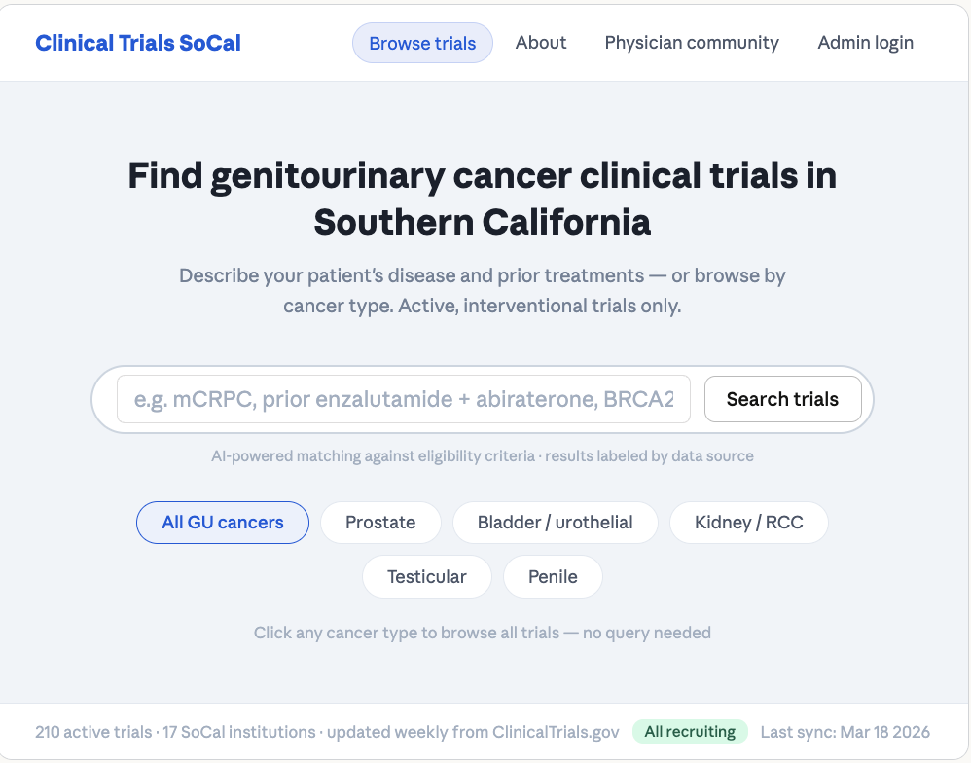
Screen 1 — Clinical Trials SoCal home page. Physician types patient description; system searches against classified eligibility criteria.
Screen 2 — Results Page
The query is parsed into structured chips: disease, prior treatments, biomarkers, and any notes (e.g. chemo-naive). Results are split into Strong matches and Possible matches. Each card shows: trial title, phase, treatment type, reason for match, and the local PI at each SoCal site. Data source tags (CT.gov, NCCN-inferred, AI-extracted) are shown on every field so the physician knows where each piece of information comes from.
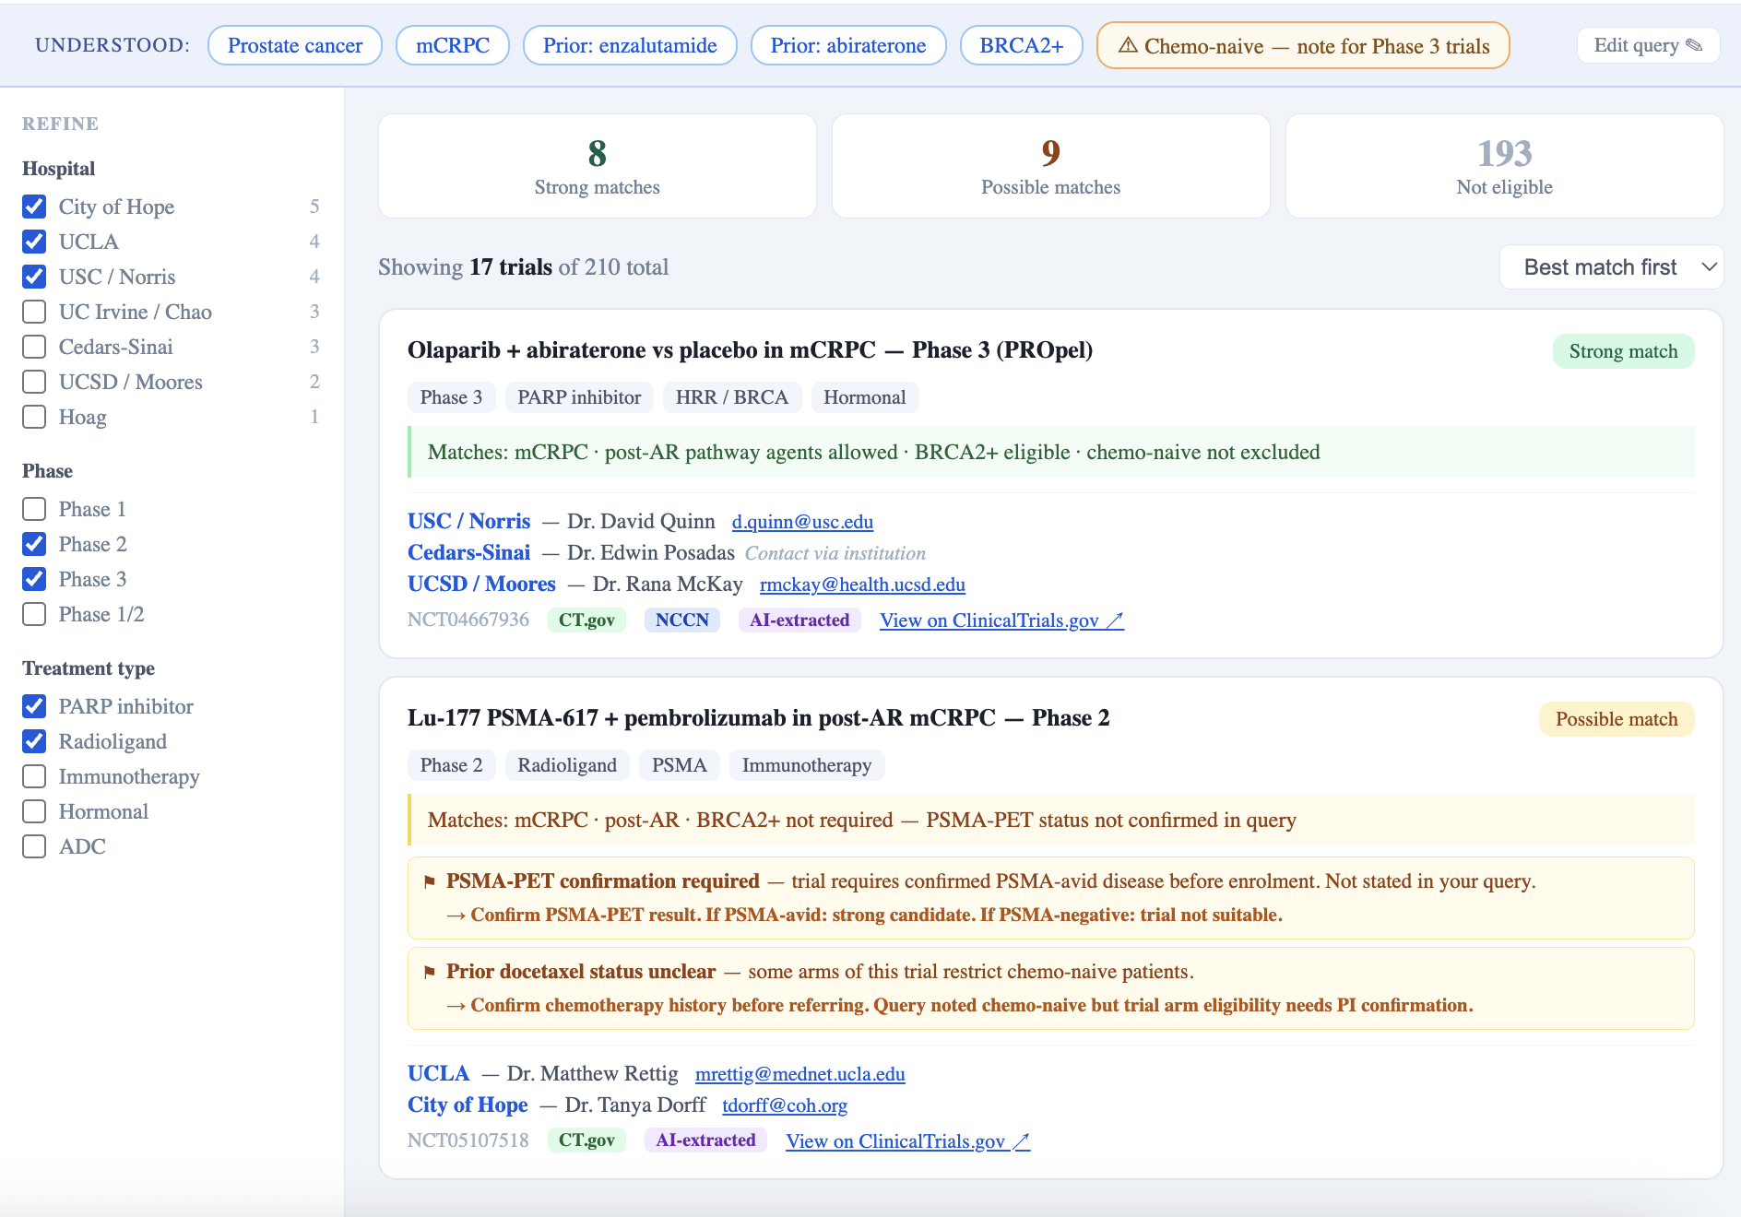
Screen 2 — Results for "mCRPC, prior enzalutamide + abiraterone, BRCA2+, no prior chemo." 8 strong matches, 9 possible matches shown with local PIs.

Screen 3 — Trial Detail
Clicking a trial card opens the full detail view. This shows: a plain-language description of the trial, key facts with their data source tags, eligibility criteria matched to the patient query (green tick / red cross), SoCal sites with PI name and contact, and action buttons. Every field is labelled with its source: CT.gov (direct registry data), NCCN-inferred (disease setting), or AI-extracted (eligibility signals). A disclaimer reminds the physician to verify with the trial team before referring a patient.
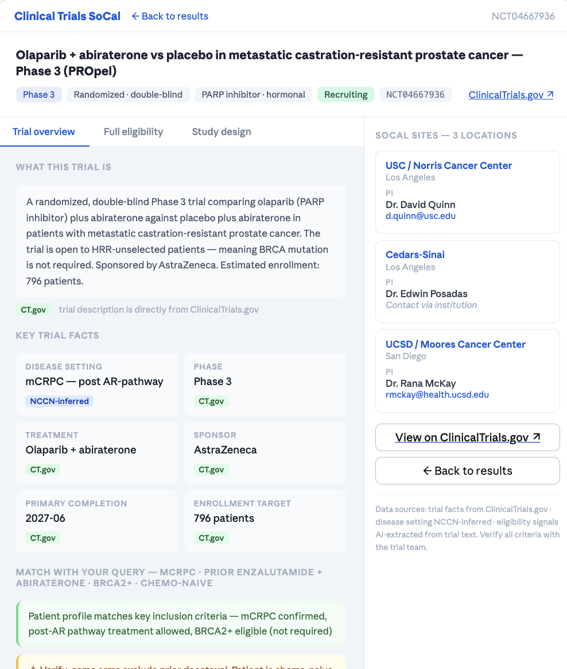

Screen 3 — Trial detail for Olaparib + abiraterone (PROpel). Match reasoning, eligibility signals, and SoCal site contacts shown.

Step 6 / Section 6
How to Use the Search
A physician's guide — what to type, what the results mean, and what to check before making a referral

The search never hides a trial because your query is incomplete. It always surfaces relevant trials — and tells you exactly what to verify before making a referral. The more you include in your query, the fewer follow-up checks you will need.

6.1 What to type

Write in plain language — exactly as you would describe the patient to a colleague. You do not need to use specific codes or abbreviations, though they work too.

Include as many of these as you know:

What to mention | Example phrasing | Why it matters
Disease stage / setting | "mCRPC" / "castration-sensitive, metastatic" / "unfavorable intermediate risk, localized" | Determines which of 15 NCCN categories apply — narrows the trial pool immediately
Prior treatments | "Progressed on enzalutamide" / "ADT + abiraterone, PSA rising" / "no prior chemo" | Many trials require exactly 1 prior ARPI; others exclude chemo-naive or require prior docetaxel
Key biomarkers | "BRCA2+" / "PSMA-PET confirmed" / "Decipher score 0.72" / "HRR wild-type" | Resolves eligibility for PARP inhibitor, radioligand, and genomic classifier-stratified trials
Disease volume (if metastatic) | "6 bone mets, lung nodule" / "high-volume disease" / "3 bone lesions, no visceral" | Triplet therapy trials (ADT + ARPI + docetaxel) restrict to high-volume (≥4 bone or any visceral)
What you are looking for | "Radioligand trial" / "PARP inhibitor study" / "Phase 3 only" / "patient prefers not to have chemotherapy" | Filters treatment modality and helps rank results
Location preference | "SoCal centre" / "prefers San Diego" / "needs to stay near LA" | All results are already filtered to SoCal; site-level preference further ranks by proximity

Tip: if you are unsure about a biomarker, still submit the query. The search will surface relevant trials and flag exactly which test to order.

6.2 Reading the output

Every result shows a match badge, a reason line, and — where relevant — verification flags.

What you see | What it means | What to do
Strong match | All available eligibility axes in your query are consistent with the trial. High confidence. | Review the trial detail page and contact the PI to confirm slot availability.
Possible match | Disease setting matches but one or more eligibility factors could not be confirmed from the query alone. | Check the verification flags — each one tells you what to confirm before referring.
⚑ Flag | A specific eligibility criterion in the trial requires information that was not in your query. The trial is not excluded — it is flagged for verification. | Each flag names exactly what to check (e.g., "Confirm BRCA status", "Confirm PSMA-PET"). One phone call to the PI usually resolves it.
CT.gov / NCCN / AI-extracted | Data source tags on each fact: CT.gov = directly from the registry; NCCN = guideline-inferred; AI-extracted = pulled from free-text eligibility criteria. | Always verify AI-extracted eligibility signals with the trial team before referring.

A | mCRPC post-ARPI — PSMA-avid, BRCA2+, chemo-naive

Patient: Male, 65. Metastatic castration-resistant prostate cancer. Progressed on ADT + enzalutamide. PSA rising. BRCA2+ (germline). PSMA-PET: multiple PSMA-avid bone metastases. No prior chemotherapy. Patient declines further hormonal therapy.

Full query — all key facts included

Search bar
Male, 65. mCRPC. Progressed on ADT + enzalutamide. PSA rising.
PSMA-PET: multiple PSMA-avid bone mets. BRCA2+. No prior docetaxel.
Patient declines further hormonal therapy.
Seeking radioligand or novel-agent trial at SoCal centre.

177Lu-PSMA-617 + pembrolizumab in post-AR mCRPC — Phase 2 Strong match
Matches: mCRPC · post-enzalutamide · PSMA-confirmed · chemo-naive permitted

Olaparib + abiraterone in mCRPC — Phase 3 (PROpel-type) Strong match
Matches: mCRPC · post-ARPI · BRCA2+ eligible · chemo-naive permitted

All eligibility axes resolved. No verification flags. Proceed to trial detail and contact PI.

What if... you did not mention BRCA status?

Search bar
Male, 65. mCRPC. Progressed on ADT + enzalutamide. PSA rising.
PSMA-PET confirmed. No prior docetaxel. Seeking radioligand or novel-agent trial.

177Lu-PSMA-617 + pembrolizumab in post-AR mCRPC — Phase 2 Strong match
Matches: mCRPC · post-enzalutamide · PSMA-confirmed · chemo-naive permitted

Olaparib + abiraterone in mCRPC — Phase 3 (PROpel-type) Possible match
Matches: mCRPC · post-ARPI · chemo-naive permitted — BRCA/HRR status unconfirmed
⚑ BRCA/HRR mutation status not confirmed — germline and somatic testing recommended before referring to PARP inhibitor trials (olaparib, rucaparib, niraparib). Most labs return in 2–3 weeks.

PARP inhibitor trials still surface, but as Possible match. The flag tells you exactly what to order: germline/somatic HRR testing.

What if... you did not mention PSMA-PET results?

Search bar
Male, 65. mCRPC. Progressed on ADT + enzalutamide. PSA rising.
BRCA2+. No prior docetaxel. Patient declines further hormonal therapy.

177Lu-PSMA-617 + pembrolizumab in post-AR mCRPC — Phase 2 Possible match
Matches: mCRPC · post-enzalutamide · chemo-naive permitted — PSMA status not confirmed
⚑ PSMA-PET required for radioligand trial eligibility — confirm PSMA imaging has been performed and result. If PSMA-avid: strong candidate. If PSMA-negative: trial not suitable.

Olaparib + abiraterone in mCRPC — Phase 3 (PROpel-type) Strong match
Matches: mCRPC · post-ARPI · BRCA2+ eligible · chemo-naive permitted

Radioligand trial drops to Possible. PARP inhibitor trial remains Strong — PSMA status does not affect its eligibility. The flag tells you specifically what to image.

What if... you only typed the basics?

Search bar
Male, 65. mCRPC. Progressed on enzalutamide.

177Lu-PSMA-617 + pembrolizumab in post-AR mCRPC — Phase 2 Possible match
Matches: mCRPC · post-ARPI — multiple eligibility axes unresolved
⚑ PSMA-PET required — confirm PSMA imaging before referring to radioligand trials.
⚑ Prior docetaxel status unknown — confirm chemotherapy history. Some arms exclude chemo-naive; others require it.

Olaparib + abiraterone in mCRPC — Phase 3 (PROpel-type) Possible match
Matches: mCRPC · post-ARPI — BRCA/HRR status unresolved
⚑ BRCA/HRR mutation status not confirmed — order germline + somatic testing before referring to PARP inhibitor trials.

Same trials still appear. The minimal query just generates more flags — each one is a specific action item. You can refine the query or go directly to the PI with the flag list.

B | Newly diagnosed unfavorable intermediate-risk — de-intensification vs intensification

Patient: Male, 58. Newly diagnosed prostate cancer. Gleason 4+3 (Grade Group 3), PSA 14 ng/mL, cT2c. Unfavorable intermediate risk. No prior treatment. Radiation therapy candidate. Physician wants to discuss de-intensification vs intensification options.

Full query — genomic risk score included

Search bar
Male, 58. Newly diagnosed unfavorable intermediate-risk prostate cancer.
Gleason 4+3 (Grade Group 3), PSA 14 ng/mL, cT2c. No prior treatment.
Genomic risk classifier score: 0.72 (high risk).
Eligible for radiation. Considering de-intensification vs intensification.

GUIDANCE — Genomic-Risk Stratified Unfavorable IR, Phase 3 Strong match
Matches: unfavorable IR · Gleason 4+3 · cT2c · genomic classifier confirmed → intensification arm (ADT + RT + ARPI)

Genomic score confirmed at 0.72. The system resolves which trial arm the patient maps to: intensification. No flags. Proceed to trial detail.

What if... the genomic classifier has not been done yet?

Search bar
Male, 58. Newly diagnosed unfavorable intermediate-risk prostate cancer.
Gleason 4+3, PSA 14 ng/mL, cT2c. No prior treatment.
Eligible for radiation. Considering de-intensification vs intensification.

GUIDANCE — Genomic-Risk Stratified Unfavorable IR, Phase 3 Possible match
Matches: unfavorable IR · Gleason 4+3 · cT2c — but genomic risk classifier result is needed to determine trial arm
⚑ Genomic risk classifier result needed — confirm test has been performed (e.g., Decipher by Veracyte, Oncotype GPS by Exact Sciences, Artera AI, or equivalent). GUIDANCE uses this score to assign the patient to de-intensification (RT alone) or intensification (ADT + RT + ARPI) arm.
⚑ Order genomic classifier now: result typically takes 1–2 weeks. Patient can be referred once score is available.

GUIDANCE still surfaces — the missing score is a flag, not a disqualifier. The flag tells you exactly what to order and why. Once the result is back, resubmit the query with the score to see the specific arm match.

What if... you only mention disease and stage, with no treatment intent?

Search bar
Male, 58. Unfavorable intermediate-risk prostate cancer. Gleason 4+3, PSA 14.

GUIDANCE — Genomic-Risk Stratified Unfavorable IR, Phase 3 Possible match
Matches: disease setting — multiple eligibility axes unresolved
⚑ Genomic risk classifier result needed before trial arm can be determined.
⚑ Confirm treatment modality eligibility: GUIDANCE requires radiation therapy. Confirm patient is a radiation candidate.
⚑ Confirm no prior systemic treatment.

Broader set of localized prostate cancer trials also appears at this query depth. The flags give you a complete checklist: order the genomic test, confirm radiation candidacy, confirm treatment-naive status — then refer.

A note on genomic classifier naming

The search uses the generic term "genomic risk classifier" rather than specific brand names. Several tests serve this function:
• Genomic expression tests — Decipher (Veracyte), Oncotype GPS (Exact Sciences), Prolaris (Myriad Genetics). These require RNA extraction from biopsy tissue.
• AI-based pathology tools — Artera AI, applied to digital H&E slide images, does not require additional tissue processing. FDA-cleared for predicting ADT benefit.

Any of these tools satisfies the requirement. The trial team will specify which they accept. The flag in the search output deliberately does not name a brand — it names the function: "confirm a genomic risk classifier result exists."

C | Newly diagnosed mCSPC — high-volume, ADT-naive

Patient: Male, 70. Newly diagnosed metastatic castration-sensitive prostate cancer. Gleason 4+4. PSA 340 ng/mL. Conventional imaging: 6 bone metastases, 2 lung nodules (high-volume by CHAARTED criteria). No prior ADT. BRCA wild-type. Performance status ECOG 1.

Full query — volume and ADT status included

Search bar
Male, 70. Newly diagnosed mCSPC. Gleason 4+4. PSA 340.
High-volume: 6 bone mets + 2 lung nodules. ADT-naive. BRCA wild-type. ECOG 1.
Looking for intensification trial — triplet or novel combination at SoCal.

ADT + darolutamide + docetaxel in high-volume mCSPC — Phase 3 (ARANOTE-type) Strong match
Matches: mCSPC · high-volume confirmed · ADT-naive · chemo-eligible · BRCA not required

ADT + abiraterone in mCSPC — Phase 3 (LATITUDE-type) Strong match
Matches: mCSPC · high-risk features · ADT-naive · chemo-naive permitted

Volume confirmed as high. ADT history confirmed as naive. Eligibility axes resolved for triplet and doublet intensification trials.

What if... you did not state disease volume?

Search bar
Male, 70. Newly diagnosed mCSPC. PSA 340. ADT-naive. Gleason 4+4.
Looking for intensification trial at SoCal.

ADT + darolutamide + docetaxel in high-volume mCSPC — Phase 3 (ARANOTE-type) Possible match
Matches: mCSPC · ADT-naive — but disease volume is not confirmed
⚑ Confirm disease volume — count of bone metastases and presence of visceral disease (lung, liver). High-volume = ≥4 bone mets OR any visceral metastasis. This trial requires high-volume by CHAARTED criteria.

ADT + abiraterone in mCSPC — Phase 3 (LATITUDE-type) Possible match
Matches: mCSPC · ADT-naive — volume not confirmed; this trial uses LATITUDE high-risk criteria
⚑ Confirm LATITUDE high-risk features: ≥3 bone mets, Gleason ≥8, or visceral disease. At least 2 of 3 required.

Both intensification trials still appear. The flags explain exactly which volume criteria apply to each trial — they differ between CHAARTED and LATITUDE definitions. Confirming volume with imaging resolves both.

What if... you did not state ADT history?

Search bar
Male, 70. mCSPC. High-volume: 6 bone mets + 2 lung nodules. Gleason 4+4. PSA 340.
Looking for intensification trial.

ADT + darolutamide + docetaxel in mCSPC — Phase 3 Possible match
Matches: mCSPC · high-volume confirmed — ADT history unconfirmed
⚑ Confirm ADT history — has the patient received GnRH agonist or antagonist therapy? Most mCSPC intensification trials require ADT-naive or restrict to fewer than 3 months of prior ADT.

Without ADT history, the system cannot confirm the trial's prior-treatment requirements. One question to the patient resolves this.

6.6 Verification flags — quick reference

This table lists every flag the system can generate, what it means, and the fastest way to resolve it.

Flag | What it means | How to resolve it
BRCA/HRR status not confirmed | A PARP inhibitor or HRR-stratified trial in your results requires germline or somatic HRR/BRCA testing | Order germline panel (blood) and somatic testing (tumour biopsy or liquid biopsy). Results typically in 2–3 weeks.
PSMA-PET required — confirm imaging | A radioligand therapy trial requires PSMA-PET to confirm expression or for dosimetry | Order 68Ga-PSMA-11 or 18F-DCFPyL PET/CT if not yet done. If PSMA-avid: strong candidate. If PSMA-negative: trial not suitable.
Confirm disease volume | Trial restricts eligibility by metastatic burden (high-volume or oligometastatic) — not specified in your query | Review imaging: count bone lesions; confirm presence/absence of visceral (lung, liver, brain) involvement. CHAARTED high-volume = ≥4 bone mets OR any visceral.
Confirm ARPI history | Trial specifies 0 or 1 prior ARPIs (enzalutamide, abiraterone, apalutamide, darolutamide) | Ask patient directly. Note the specific agent(s) and approximate duration. Many trials allow only 1 prior ARPI.
Confirm chemotherapy history | Trial eligibility depends on whether patient has received docetaxel | Ask about prior docetaxel use (including in mCSPC setting). Confirm cabazitaxel status if relevant.
Genomic classifier result needed | Trial requires a genomic expression test or AI pathology risk score to assign arm or confirm eligibility | Order Decipher, Oncotype GPS, or Artera AI — discuss with your local pathology team. Ensure tissue block is available for submission.
Confirm castration status | Trial targets CSPC or CRPC specifically and castration state was not stated in your query | Confirm testosterone level: <50 ng/dL = castration-resistant (CRPC); ≥50 ng/dL on ADT = castration-sensitive (CSPC).
Confirm staging (distant mets) | Trial is metastatic-only or non-metastatic-only and staging was not confirmed in your query | Review most recent CT and bone scan (or PSMA-PET). M0 vs M1 is the single most important factor narrowing your trial list.
Verify with trial team — AI-extracted | An eligibility criterion was extracted from free text by AI and may not be 100% accurate | Always verify directly with the trial coordinator or PI before referring. Trial teams respond promptly to eligibility queries.

One principle throughout: the search always surfaces, never suppresses. Every flag is a specific action item — not a reason to stop. Most flags are resolved with a single question to the patient, one blood test, or one imaging report.

STEP 7 — VALIDATION SUMMARY

Of the 39 UCI/Hoag control NCT IDs in our validation dataset, all prostate controls were correctly classified at HIGH or MEDIUM confidence when the prostate classifier was applied. The table below shows key validation results:

NCT ID | Trial | Expected Setting | Pipeline Output
NCT05050084 | GUIDANCE | Localised — Unfav IR | ✓ Localised — Unfav IR (HIGH)
NCT04423211 | INDICATE | BCR — Post-RP | ✓ BCR — Post-RP (HIGH)
NCT06592924 | Docetaxel + ARPI mCSPC | mCSPC General | ✓ mCSPC General (HIGH)
NCT03678025 | SST ± SBRT oligomets | mCSPC Oligomets | ✓ mCSPC Oligomets (HIGH)
NCT06136650 | MK-5684 (opevesostat) | CRPC General | ✓ CRPC General (HIGH)
NCT06235151 | PSMA diagnostic study | Localised Unfav IR | ✓ Localised Unfav IR (HIGH)
NCT06925737 | Ifinatamab deruxtecan | CRPC General | ✓ CRPC General (HIGH)

Overall classification rate — prostate pipeline
72 of 104 prostate trials (69%) classified at HIGH or MEDIUM confidence using the new NCCN v5.2026 taxonomy. The remaining 32 trials are DIAGNOSTIC, LIFESTYLE, or Phase 1 first-in-human studies whose eligibility criteria do not use standard NCCN disease-state language — these require physician review.

