# GAM531

# Midterm Project

# Steven Bouttarath

# Navid Najarali Vadsariya

Table of contents: Page number

1. Introduction 3
2. Screenshots and description 3
3. Conclusion 4

**Introduction**

This project displays a simple game called Arkanoid. On pressing Spacebar the sphere on the platform will start moving towards the blocks. For now the sphere will pass the blocks without hitting and returning back as no collision are added yet.

If the user presses Escape the game will exit.

OpenGL has been used to create this project.

**Screenshots and description**

1. Window: The game is rendered in a window of 1024x768 dimensions.

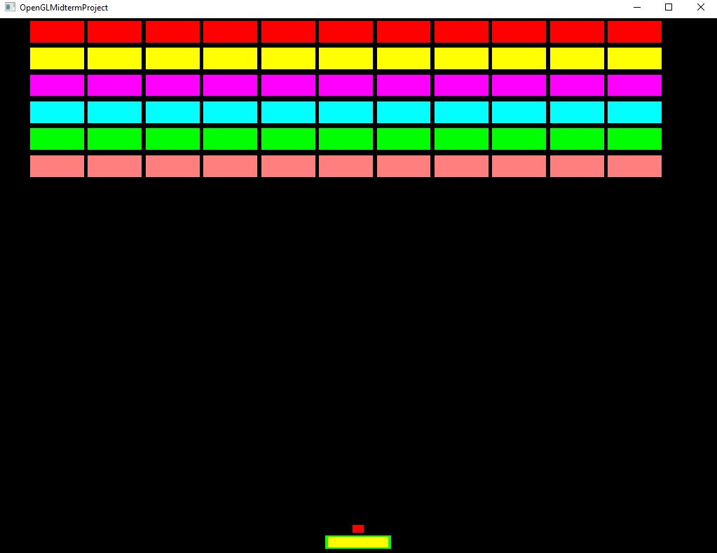

1. Platform at the bottom with sphere:



1. On pressing Spacebar: The sphere moves continuously in a smooth motion towards the blocks. As there is no collision the sphere passes the blocks.

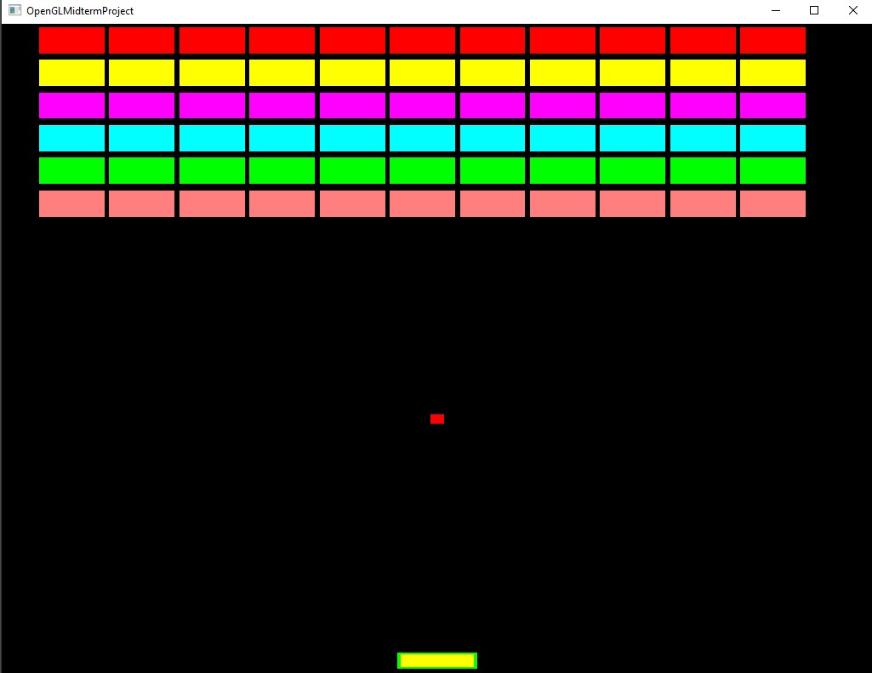

1. On pressing Escape: The game exits.

**Conclusion**

All the requirements for this assignment have been implemented successfully. To implement these functionality labs and code provided by Professor has been used.