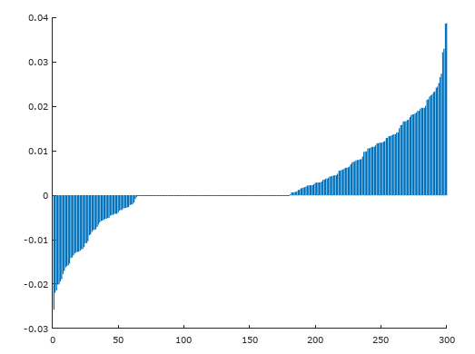

Tau 500 niter 8000 ans = 1474.4

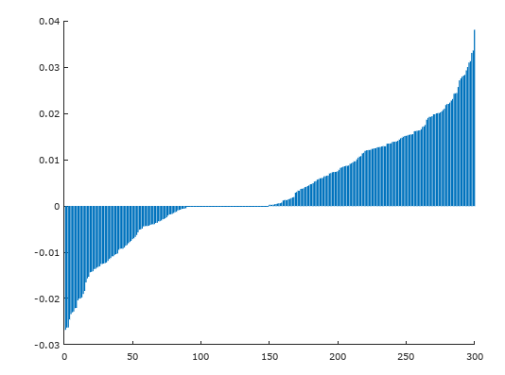

Tau 500 niter 4000 ans= 2466.8

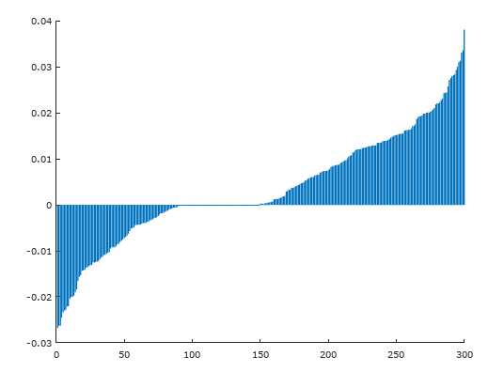

Tau 500 niter 2000 ans= 2953.5

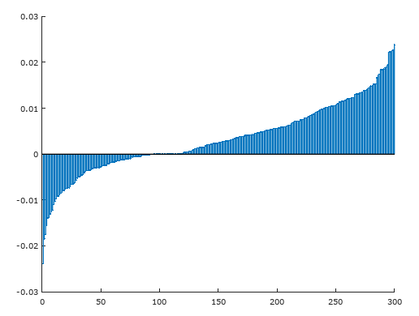

Tau 500 niter 1000 ans=3614.4

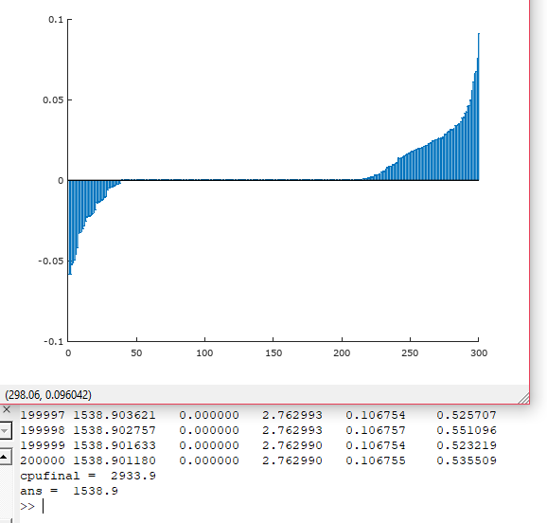

Tau 500 niter 200.000 ans=1538

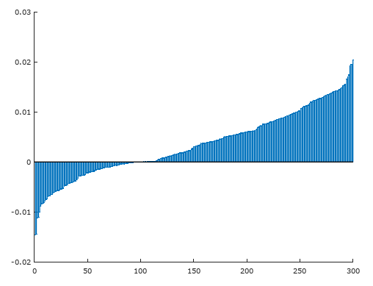

Tau 500 niter 700

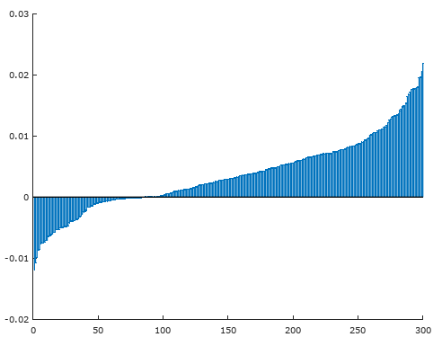

Tau 500 niter 500

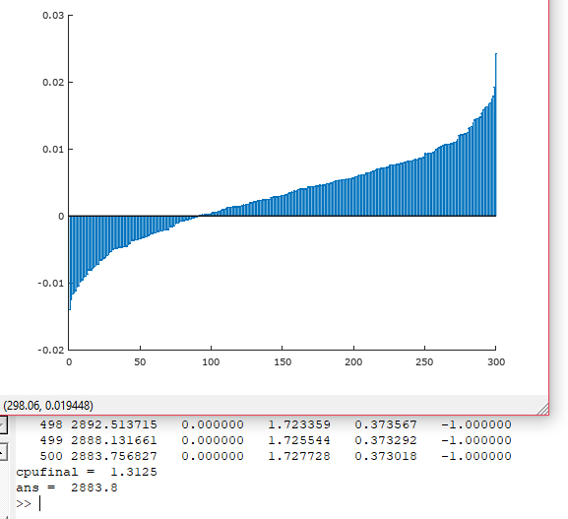

Tau 0 niter 500

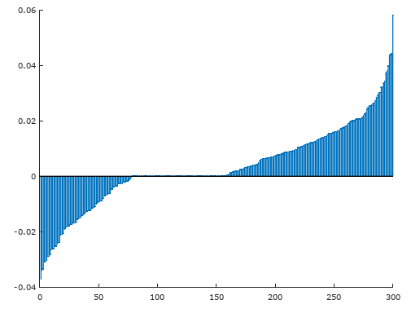

Tau 500 niter 10.000

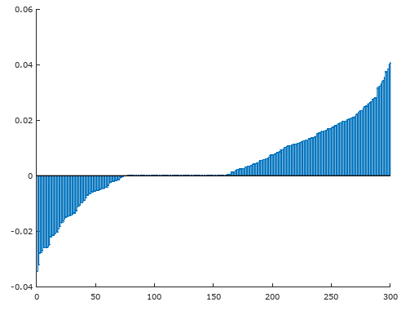

Tau 500 niter 15.000

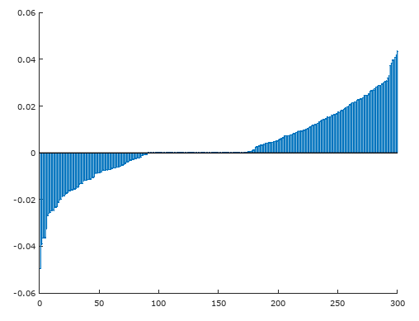

Tau 500 niter 20000

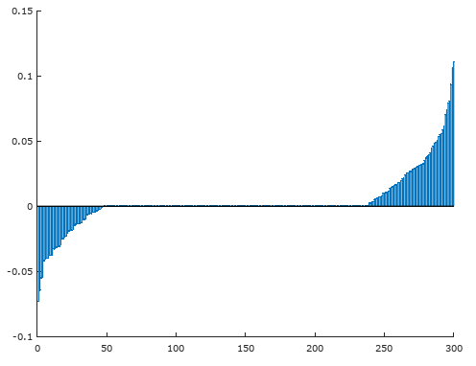

Tau 500 niter 500.000