DRAFT — FOR REVIEW
Pelvic Block Supplier Personnel Training
| Owner: SH Operations Supervisor | Prepared and designed by: Supplier Engineer |

1. PURPOSE
1.1 This procedure establishes the process to train, monitor, and certify the competency of supplier personnel who perform activities affecting the quality of pelvic block tissue material, so that tissues meet the applicable specification at the targeted scrap rate.

2. SCOPE
2.1 This procedure applies to designated supplier personnel and harvest technicians performing pelvic block harvest and processing/tissue tasks for Intuitive ATM, and to the QC inspection personnel supporting these activities.

3. REFERENCES
668005 | SOP, Training, ATM
668729 | WI, Manufacturing Training & Certification, ATM
1176680 | MPI — Pelvic block process instruction (primary course material)
666541,666506 | Specs and WI — Pelvic Harvest; contains the acceptance specifications used in training and QC inspection
800082 | FORM, Training Record
[Smartsheet] | Supplier Training Log — interim record of training, Monitoring results, and certification status

4. DEFINITIONS / ACRONYMS
SME Harvesting Tech (Initial Trainer) | The subject matter expert for pelvic block harvest who owns and delivers harvest technique training to trainees per MPI 1176680 and WI and spec 666541 & 666506.
SH QC Inspector (Qualifying Trainer) | The quality resource performing IQC inspection at the slaughterhouse at the time of harvest. Inspects pelvic blocks to spec 666541 & 666506, identifies nonconformances and determines their root cause, and produces the pass/fail, yield, and defect data used to qualify trainees. Holds diagnostic and defect-identification expertise beyond the harvest technique held by the SME Harvesting Tech.
IQC at SH | Incoming Quality Control inspection performed at the slaughterhouse (SH) at the time of harvest — a recently added inspection point that positions the SH QC Inspector to detect nonconformances and determine root cause at the point of creation.
SH Operations Supervisor | Procedure owner. Owns and maintains this procedure, assists with training delivery and shadows trainees during the Training and Monitoring Phases; the SME Harvesting Tech ultimately leads the in-person training Supports personnel availability and adherence to the trained process.
ATM QC Inspection Tech | Quality Control inspector who performs the independent ATM incoming/pre-dye inspection of pelvic blocks against specification (the downstream product-acceptance gate; see 6.1.3), before production.
Training Department | Owns and maintains training records.
Trainee | Supplier personnel (SH tech, build staff (Parks)) who has not yet completed certification.
Training Phase | Initial instructional phase in which the SME Harvesting Tech reviews MPI 1176680 and specs 666541 or 666506 with the Trainee and conducts side-by-side demonstration/builds; trainers may provide direct support without penalty.
Monitoring Phase | The evaluation phase replacing the traditional Mentoring Phase from 668729. During Monitoring, the Trainee performs the task and builds are inspected by QC. Peer questions to trainers and certified peers are permitted without penalty. Successful completion of Monitoring constitutes certification. No formal Mentor role is assigned at the supplier site.
Certification | Verification that the Trainee has successfully completed the Monitoring Phase against the established criteria, based on QC data produced by the SH QC Inspector and evaluated by the Supplier Engineer data, recorded on FORM 800082 and logged in the Supplier Training Log.
First Pass Yield (FPY) | Percentage of harvested tissue passing QC inspection on the first attempt. For this process, this will be measured over the Monitoring evaluation window.
MPI (1176680) | Manufacturing Process Instruction — the controlled document defining the pelvic block process steps being trained.
WI or Spec (666541 & 666506) | Work Instruction, Pelvic Harvest — contains the acceptance specifications used in training and QC inspection.

5. RESPONSIBILITIES
5.1 SH Operations Supervisor (procedure owner): Owns and maintains this procedure and the associated training records; assists with training delivery, supports personnel availability and adherence to the trained process. The SME Harvesting Tech owns and leads the in-person training..
5.2 SME Harvesting Tech (Initial Trainer): Owns and delivers harvest technique training to trainees per MPI 1176680 and Spec 666541 & 666506; subject matter expert for pelvic block harvest.
5.3 SH QC Inspector (Qualifying Trainer): Performs IQC inspection of pelvic blocks at the slaughterhouse at the time of harvest, per Spec 666541 & 666506; identifies nonconformances and helps determine root causes; produces the pass/fail, yield, and defect data used for Monitoring, certification, and corrective action. The SH QC Inspector is the ultimate expert on the “why” of the defects.
5.4 Supplier Engineer (author of this procedure): Oversees and checks the quality and effectiveness of the training using the IQC data already compiled from SH inspections; consolidates the QC data and evaluates training against the certification criteria and the data trend; surfaces skill-versus-capability findings for corrective action.
5.5 Quality (designated role): Owns ongoing training of future SH QC inspection techs; ensures inspection consistency against the pelvic block specification.
[OPEN] Confirm who is the SH quality inspection training owner, or whether another Quality role takes this on going forward.
5.6 ATM QC Inspection Techs: Perform the independent ATM incoming/pre-assembly inspection of pelvic blocks against specification (see 6.1.3) for product acceptance, before assembly.
5.7 Supplier site lead: Ensures personnel availability for training and Monitoring; supports adherence to the trained process; participates in ongoing monthly supplier calls (see 6.5).
5.8 Trainees: Complete assigned training, build to the MPI and specification, participate in the Monitoring Phase, and may ask questions of trainers or certified peers without penalty.

6. PROCEDURE

6.1 General
6.1.1 Training shall be conducted by qualified personnel using controlled MPI 1176680 and Spec 666541 & 666506 as the primary course materials.
6.1.2 Every pelvic block is inspected by QC; only blocks passing the specification are released downstream (product disposition). The criterion used to certify personnel is a yield rate over the Monitoring window (see 6.3), which is distinct from per-block disposition.
6.1.3 IQC inspection at the slaughterhouse supports personnel qualification and immediate feedback at the point of harvest. It does not replace the standard ATM incoming/pre-assembly inspection; all pelvic blocks remain subject to that independent ATM inspection before assembly, regardless of training status. The two inspections serve different purposes: IQC at SH for qualification and feedback, ATM inspection for final product acceptance.

6.2 Training Phase
6.2.1 The SME Harvesting Tech delivers harvest training to SH techs and supplier (Parks) staff, and Quality delivers training to SH QC inspection techs, each using controlled MPI 1176680 and SPEC 666541 & 666506. The SH Operations Supervisor assists with training delivery, shadows trainees, and ultimately owns the procedure.
6.2.2 Training includes a review of MPI 1176680 and WI 666541 & 666506 and a minimum of one side-by-side demonstration/build per MPI.
6.2.3 Training covers the role-relevant knowledge area: harvest technique (SH techs), processing/build (supplier (Parks) staff), or quality inspection to specification (QC techs).
6.2.4 During the Training Phase, trainers may provide direct support, demonstration, and rework guidance without affecting the Trainee’s evaluation.
6.2.5 When the SME Harvesting Tech and SH QC Inspector agree the Trainee can perform the task per the MPI, the Trainee enters the Monitoring Phase.

6.3 Monitoring Phase
6.3.1 During Monitoring, the Trainee performs the trained task and the SH QC Inspector inspects every build to the WI 666541 specifications via IQC at the slaughterhouse, recording pass/fail and the associated defect and root-cause data. The Supplier Engineer consolidates this data and evaluates First Pass Yield against the certification criteria and the data trend, using the defect/root-cause detail to distinguish trainee skill issues from process-capability issues.
6.3.2 Harvest and build trainees (SH techs, supplier (Parks) staff) remain in Monitoring until they achieve ≥95% First Pass Yield over a minimum of two (2) consecutive working days of QC inspection. QC inspection personnel are certified per 6.4.3.
[OPEN] Sample-size floor needed. ≥95% with one allowable defect requires ≥20 inspections per evaluation window. Proposed: ≥20 units per Monitoring day, or ≥40 total across the 2-day window.
6.3.3 Asking questions to the trainers or certified peers during Monitoring is permitted and does not constitute a failure event. Direct rework guidance from the trainers ends when the Training Phase ends.

6.4 Certification
6.4.1 Successful completion of the Monitoring Phase (per 6.3.2) constitutes certification for the Trainee on the trained task: Female Pelvics Harvesting
6.4.2 The SH QC Inspector produces the pass/fail inspection data. The Supplier Engineer, holding the consolidated QC data, evaluates the Monitoring results against the certification criteria and the data trend; the result is recorded on FORM 800082, Training Record, and logged in the Supplier Training Log (Smartsheet).
[OPEN] QC-inspector competency: the FPY gate measures harvest/build output, not inspection accuracy. Confirm how a QC inspection tech’s own competency is verified (e.g., attribute agreement against the SH QC Inspector), since FPY does not directly apply to an inspector.

6.4.3 QC inspection personnel are certified by attribute agreement, not First Pass Yield. Because an inspector’s competency is the accuracy of their pass/fail judgments and defect identification rather than tissue output, the FPY gate (6.3.2) does not apply. A trainee QC inspector dispositions a known reference set of pelvic blocks (expert-confirmed against WI 666541, mixing clear passes, clear fails, and borderline cases with known defect types) and must both disposition correctly and correctly identify the defect, meeting the agreement criteria established by Quality.
[PROPOSED] Criteria for Quality to confirm: ≥90% agreement with the reference dispositions and correct defect classification; zero missed safety-critical defects (no false accepts of a safety-critical nonconformance), with a tolerance for a limited number of false rejects; reference-set size and composition; and whether a repeatability re-test (same inspector, same set) is required. Root-cause/causal-analysis skill is developed by working alongside the SH QC Inspector and assessed qualitatively.

6.5 Ongoing Feedback (Post-Certification)
6.5.1 After certification, ongoing performance is monitored through the existing monthly supplier calls between Intuitive ATM and the supplier site.
6.5.2 Monthly Supplier Quality and Supply chain calls serve as the feedback loop for quality issues, process drift, and re-training triggers that emerge after certification, in lieu of a continuous on-site Mentor role.
6.5.3 The Supplier Engineer maintains the consolidated SH QC data trend, reviews it for sustained training effectiveness, and shares it with the Quality department. A negative trend may trigger a return to training under 6.3.4, independent of any single Monitoring window.

6.6 Records
6.6.1 Training and certification evidence is documented on FORM 800082, Training Record, and logged in the Supplier Training Log (Smartsheet) as the interim record system.
6.6.2 The procedure owner (SH Operations Supervisor) owns archival of the 800082 forms. Smartsheet ownership and long-term record-system ownership (Training team, Engineering, or Quality) will be determined at a stakeholder meeting.

7. PROCESS FLOW
Sequence:

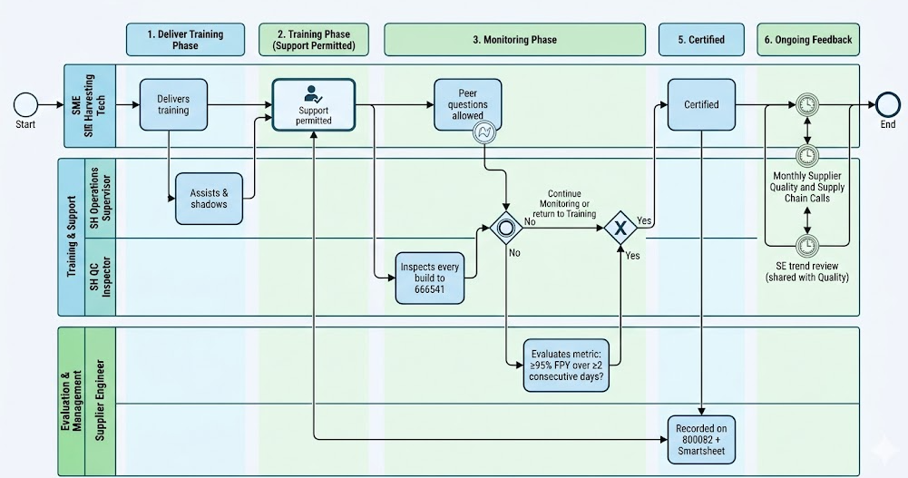
SME Harvesting Tech delivers training (SH Operations Supervisor assists & shadows) → Training Phase (support permitted) → Monitoring Phase (SH QC Inspector inspects every build to 666541; peer questions allowed) → [Supplier Engineer evaluates: ≥95% FPY over ≥2 consecutive days? No → continue Monitoring or return to Training] → Certified (recorded on 800082 + Smartsheet) → Ongoing feedback via monthly Supplier Quality and Supply chain calls + SE trend review (shared with Quality) → End

REMAINING OPEN ITEMS (First draft)
- Sample-size floor during Monitoring. A 95% gate with one allowable defect requires ≥20 inspections per evaluation window. Proposed: ≥20 units per Monitoring day, or ≥40 total across the 2-day window, to avoid the same defect failing a trainee on a low-volume day and passing them on a high-volume day.
- Parts where 95% FPY has not been demonstrated achievable. Pick one: (a) part-specific FPY gate with documented rationale, (b) extended Monitoring window before the 95% rule applies on those parts, or (c) prove capability first (e.g., best FPY in a week, high moving average) before certification is attempted.
- QC-inspector agreement criteria (6.4.3). Quality to confirm the agreement threshold, correct-defect-classification requirement, the size/composition of the reference set, the asymmetric rule on safety-critical misses, and whether a repeatability re-test is required.
- Quality’s ongoing training owner for future SH QC-inspection techs — confirm whether the SH QC Inspector is the named owner, or another Quality role.
- Records ownership and Smartsheet setup — to be addressed at a stakeholder meeting (Training team / Engineering / Quality). Interim approach (800082 + Smartsheet) remains.

