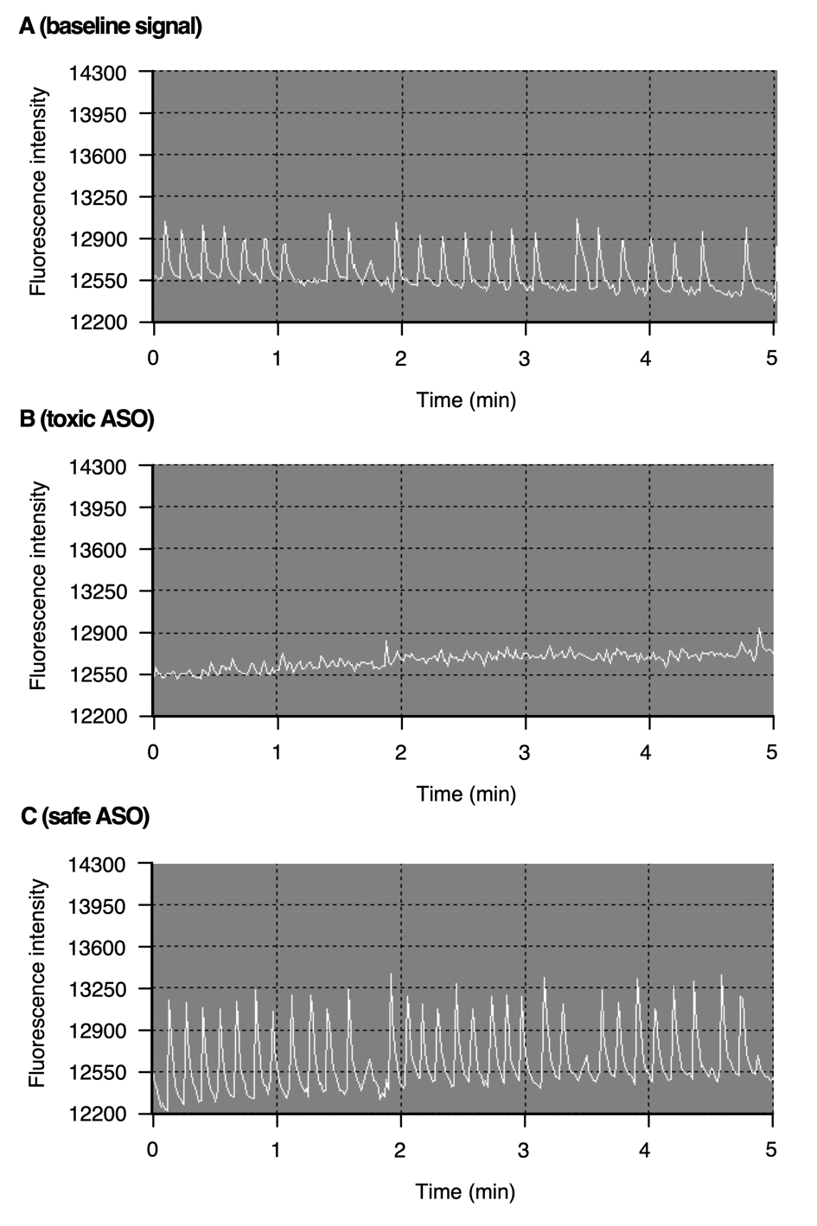
Figure S1 Representative calcium oscillations in cortical neurons measured by FLIPR assay as traces of fluorescence levels in a 5-minute time window A) Baseline signal of intracellular calcium oscillations in the absence of ASO. The average control amplitude value for the 24 peaks detected is 584 units. B) Calcium oscillations for a toxic ASO, see Suppl. Table 1. Only two peaks (circled) have amplitudes > 292 units (50% of average control amplitude). As percent of control the calcium oscillation score is 2/24 * 100 = 8. C) Calcium oscillations for a safe ASO, see Suppl. Table 1. In all 31 peaks have amplitudes > 292 units. The calcium oscillation score is 31/24 *100 = 129.

