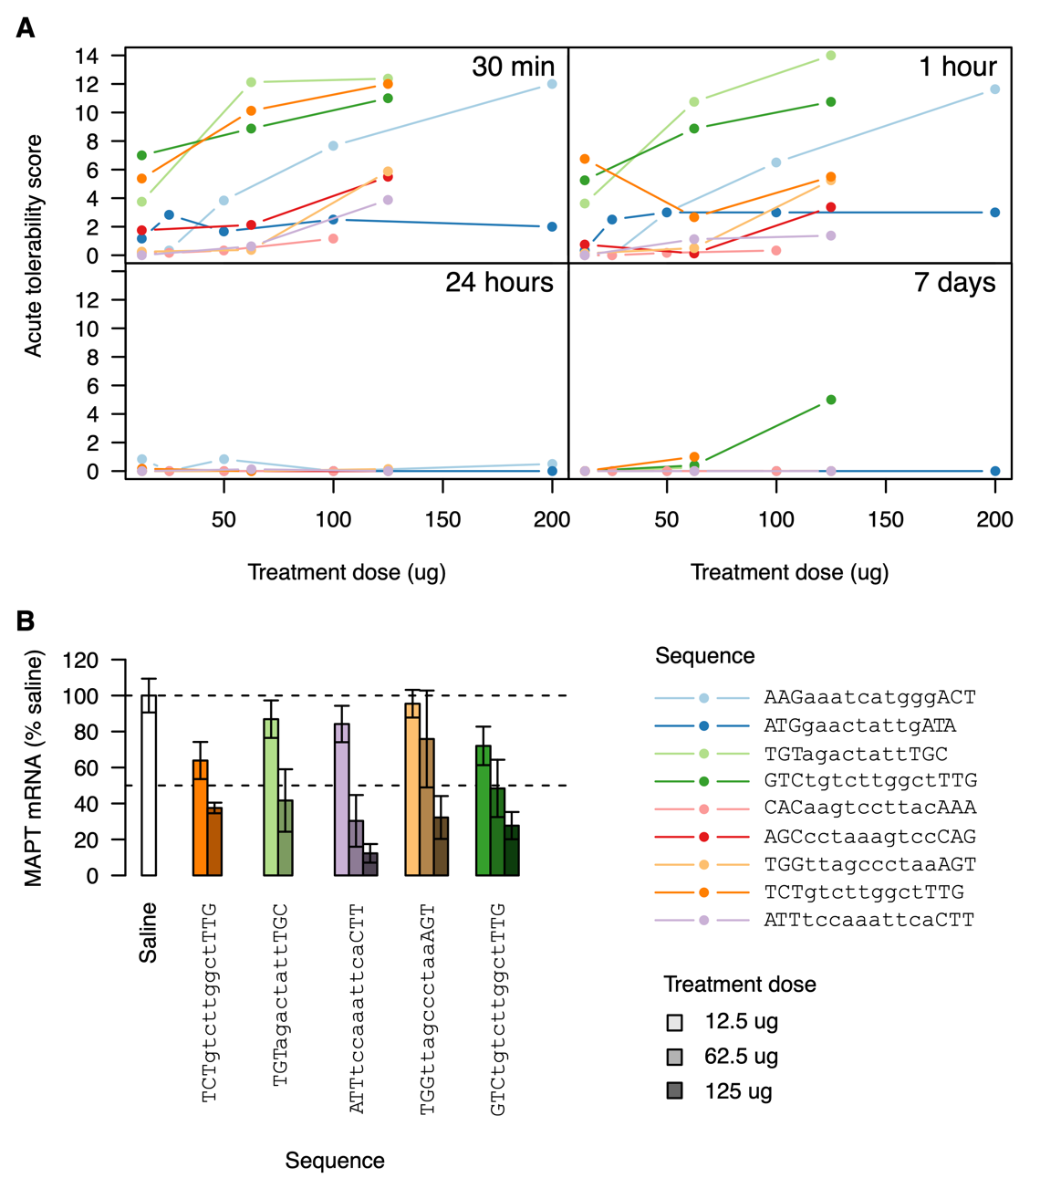
Figure S2 Dose response evaluations of ASOs A) Evaluation of acute tolerability scores for 9 ASOs at 30 min, 1 hour, 24 hours, and 7 days after injection of 12.5, 25, 50, 62.5, 100, 125 and 200 ug (depending on the ASO). B) Evaluation of MAPT mRNA knockdown in brain samples 7 days after treatment with 5 out of the 9 ASOs at three different doses. Error bars indicate 1 SD (n = 8).

