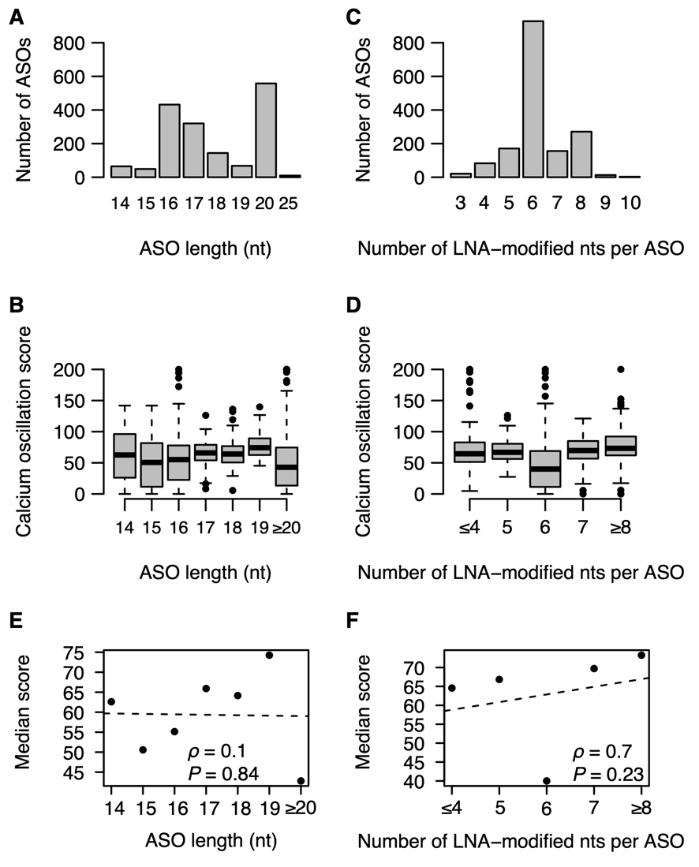
Figure S4 Associations between additional sequence features and calcium oscillation scores A) Distribution of ASO lengths for all ASOs evaluated in neuronal cells for calcium oscillations. B) Boxplots of calcium oscillation scores stratified by ASO length. C) Distribution of the number of LNA-modified nucleotides per ASO for all ASOs. D) Boxplots of calcium oscillation scores stratified by number of LNA-nucleotides per ASO. E) Scatterplot of median calcium oscillation scores stratified by ASO length. Nonparametric correlation coefficient calculated as Spearman's rank correlation (⍴) with test for significance (P) using an ﻿asymptotic approximation of the Student's t-distribution. Dashed trend line calculated by linear least-square fitting. F) Same as E), but stratified by number of LNA-nucleotides.

