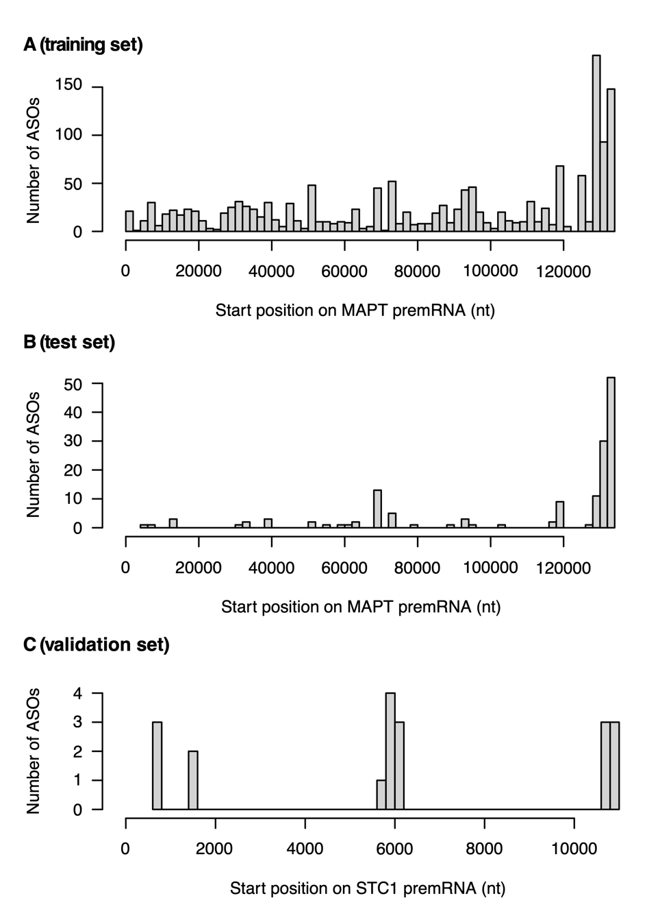
Figure S5 Distribution of ASO target regions across pre-mRNA A) For the 1645 ASOs in the training set. This covers a total of 7063 nts distributed across 313 nonoverlapping regions on the MAPT pre-mRNA. B) For the 148 ASOs in the test set. This covers a total of 882 nts distributed across 44 nonoverlapping regions on the MAPT pre-mRNA. Out of these, 813 nts are overlapping with the training set. C) For the 19 ASOs in the validation set. This covers a total of 147 nts distributed across 7 nonoverlapping regions on the STC1 pre-mRNA.

