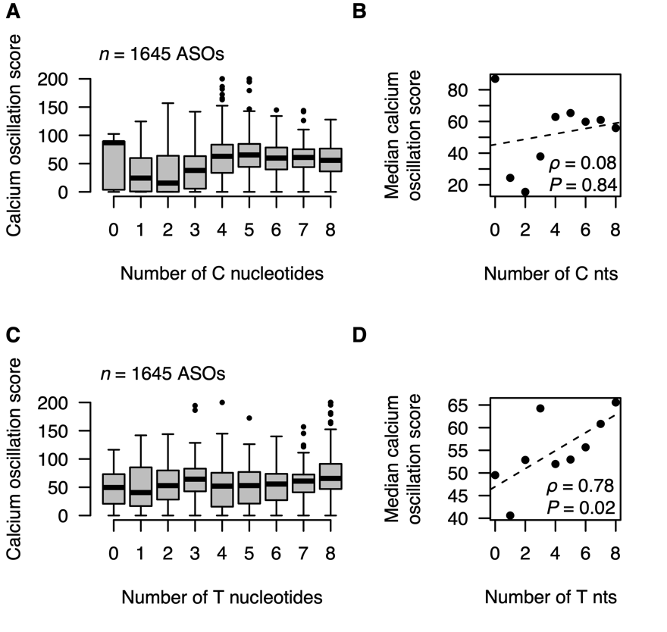
Figure S6 Associations between C/T nucleotide counts and calcium oscillation scores A) Boxplots showing distributions of calcium oscillation scores for ASOs grouped based on the number of cytosine (C) nucleotides. B) Scatterplot of median calcium oscillation scores for ASOs with a given number of C nucleotides. Nonparametric correlation coefficient calculated as Spearman's rank correlation (⍴) with test for significance (P) using an ﻿asymptotic approximation of the Student's t-distribution. Dashed trend line calculated by linear least-square fitting. C) Boxplots showing distributions of calcium oscillation scores for ASOs grouped based on the number of thymine (T) nucleotides. D) As B) but for T nucleotides.

