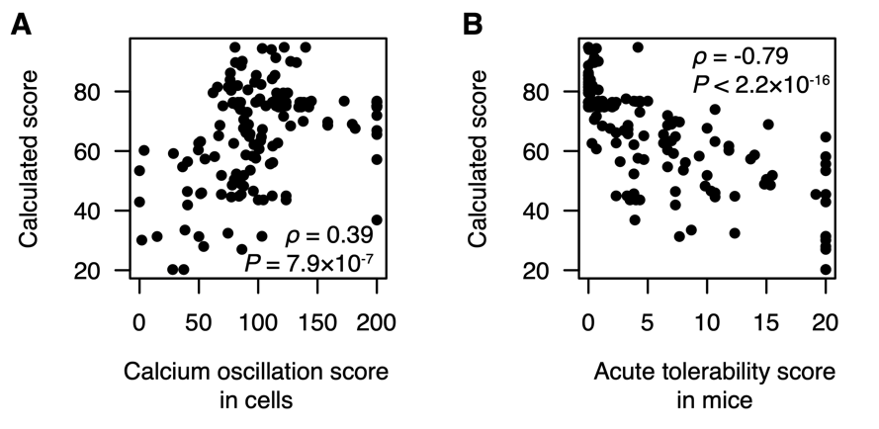
Figure S7 Association between acute tolerability and reductions in calculated score A) Scatterplot of calcium oscillation scores evaluated in cells and calculated scores (equation 1) for n = 148 ASOs. Nonparametric correlation coefficient calculated as Spearman's rank correlation (⍴) with test for significance (P) using an ﻿asymptotic approximation to the Student's t-distribution. B) Scatterplot of acute tolerability scores evaluated in mice and calculated scores (equation 1) for n = 148 ASOs.

