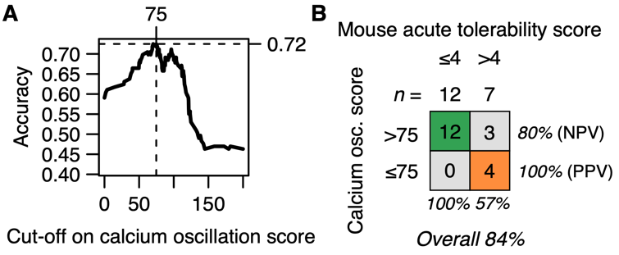
Figure S8 Classification performance of calcium oscillation scores evaluated in cells A) Accuracy of the classification of ASOs in the test set as a function of the cut-off chosen for the measured calcium oscillation scores. Vertical dashed line indicates cut-off score resulting in maximal accuracy. B) Classification performance in the validation set using measured calcium oscillation scores with optimal cut-off score at 75. NPV, negative predictive value. PPV, positive predictive value.

