PLAYING-SALE-STOCK

Prerequisite

Mongo DB
The playing-sale-stock uses mongo db as database storage. So you need to download and install it from https://www.mongodb.org/downloads. And do this step:
- The default db folder is : C:\data\db. Make sure you have it in your computer.
- Double click mongod.exe on this path : C:\Program Files\MongoDB\Server\3.2\bin
- Run cmd ( command prompt ) for that folder and type mongo to run the console for configuring the mongo db
- The name of database for this application is test.
- Create the collection for products and categories

Detail

Playing-sale-stock UI
Here is some screenshot about this application :

HOME
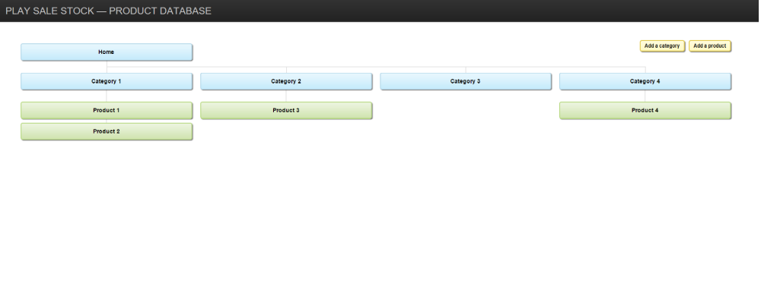
Here is Home view where there is hierarchy tree data for categories and products. Also there is buttons to add a category and add a product. The user also can click on specific category or product to update the detail or delete.

ADD A CATEGORY
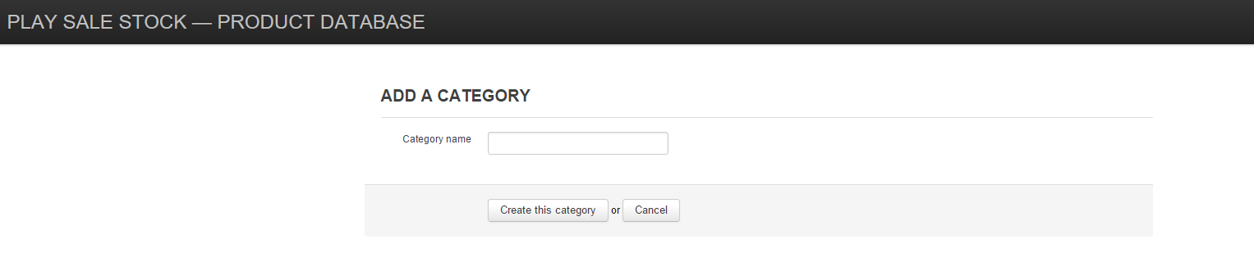
Here is view to add a category.

UPDATE CATEGORY
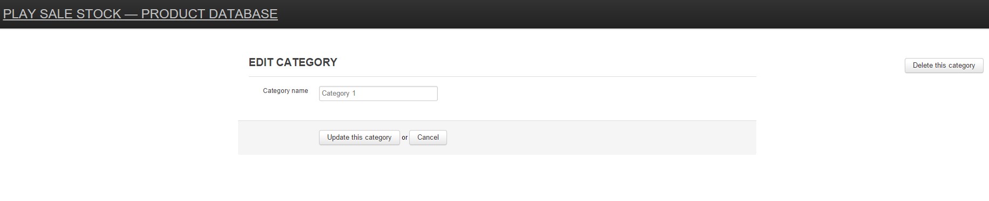
Here is view to update category or delete category.

ADD A PRODUCT
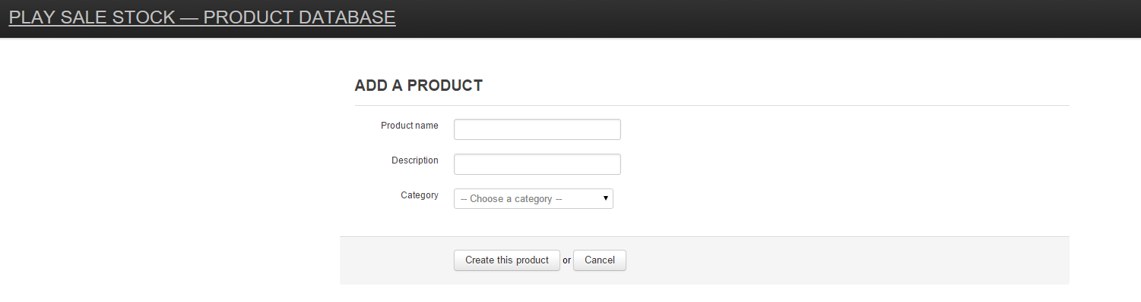
Here is view to add a product.

UPDATE PRODUCT
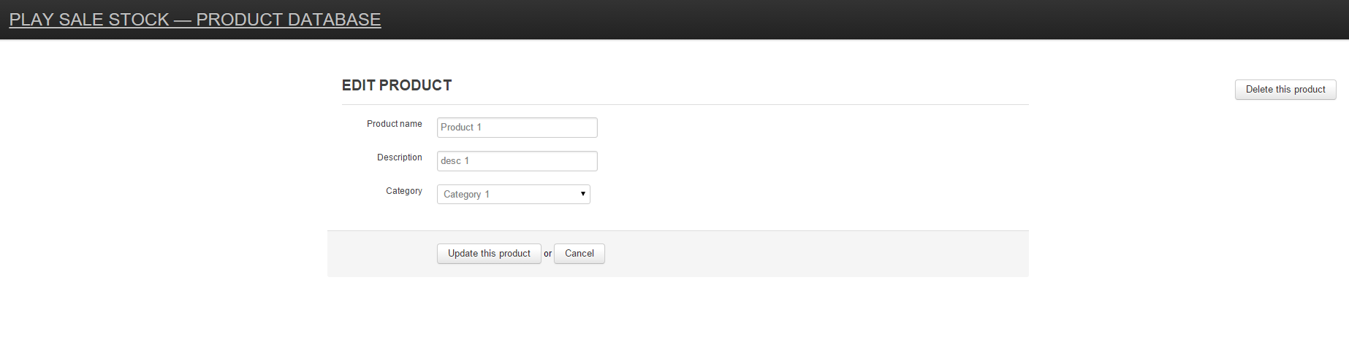
Here is view to update product or delete product.

