UC200 Pro

IP PBX
UC200 Pro is a powerful and reliable IP PBX designed to meet the communication needs of SMEs, with up to 500 SIP users, 50 concurrent calls. With its versatile features, UC200 Pro ensures seamless communication and enhanced productivity, while saving the phone bills of SMEs.

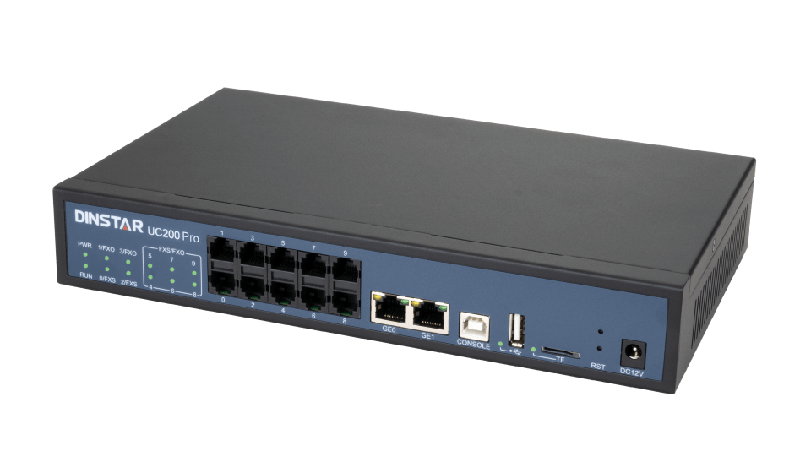
- 
SIP
- 
Multi-level IVR
- 
Voicemail
- 
Auto-provision
- 
Recording
- 
VPN

Small Size, Big Potential
SIP Extensions | 60/200/500
Concurrent Calls | 15/30/50
Default Analog Ports | 2 FXS, 2 FXO
Max FXS Ports | 8
Max FXO Ports | 8

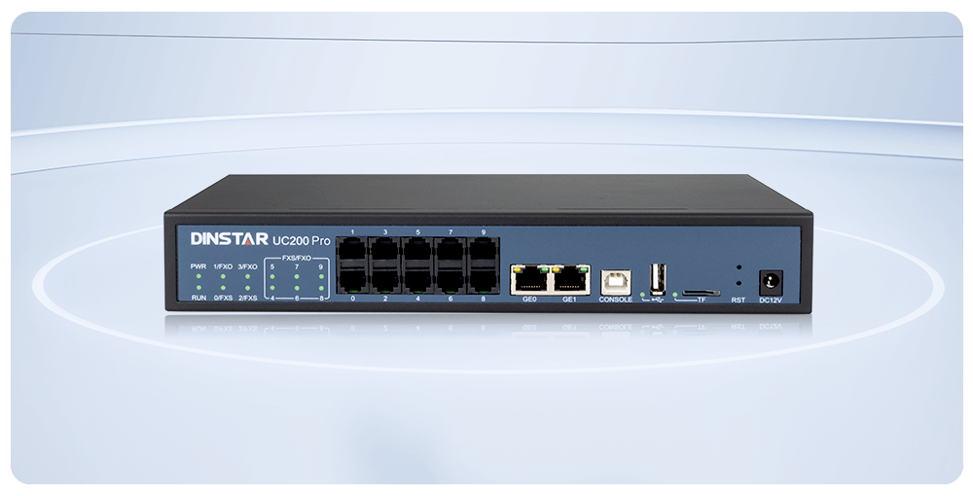

Easy Expandable and Scalable
The UC200 Pro features 3 additional user board slots, allowing flexible system expansion with 2S, 2O, or 1S1O modules.
3 kinds of software licenses to increase the system's SIP users and concurrent calls, simply by clicks.
This enables you customize the system to meet specific communication needs, ensuring adaptability and scalability for your growing business.
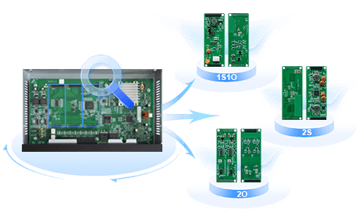

Cost-saving Phone System for SMEs
Affordable Upfront System: Cost-effective IP PBX and IP phones. No annual licensing fees or recurring fees.
Slashed Communication Cost: Free internal calls and low-cost external calls via SIP trunks.
Reduce Installation & Maintenance Cost: Easy to use, manage and maintain, remote management and remote upgrade in bulk.
Retain Old Legacy Equipment: Retain your legacy equipment like analog phones, fax and legacy PBX using VoIP gateways.



Rich Functions
Call Forward | Call Transfer | Call Park | Call Pickup
Distinctive Ringtone | Custom Music On Hold | Multi-level IVR | Intercom & Paging
Barge | Conferences | Video Call | DID
Call Queue | Follow me | Ring Group | Recording
Billing | Phone Book | Voicemail | Fail2ban
Voicemail to Email | Attendant Console | Flexible Routing | T.30/T.38 FAX

Enhanced Security
Attack defense: Fail2ban, whitelist, blacklist, ACL, etc.
TLS, SRTP, ZRTP encryption
Data protection with multi-level user permissions
Built-in IP firewall to prevent malicious attacks
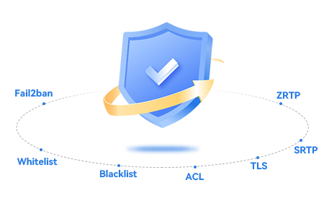

Smooth Transition
Various Dinstar VoIP gateways enable you a smooth transition from analog to IP system without interruption, utilize your exsiting analog phones, fax, legacy PBXs and PSTN lines.


Seamless Integration
The UC200 Pro is designed for seamless integration with a wide range of 3rd-party applications and systems, including Hotel PMS, Billing Systems, CRM, Conference Systems, Paging Systems, and Security Systems.
This flexibility allows the UC200 Pro to adapt to various business needs, ensuring it can be tailored to fit the specific applications and workflows required by different industries and environments.
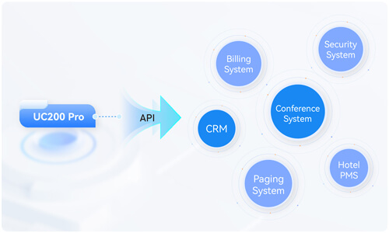

Easy to Use & Manage
- Intuitive web interface
Configuration backup & restore
Remote management
- IP phone auto-provisioning
Dinstar NMS management system
Advanced debug tools on web interface
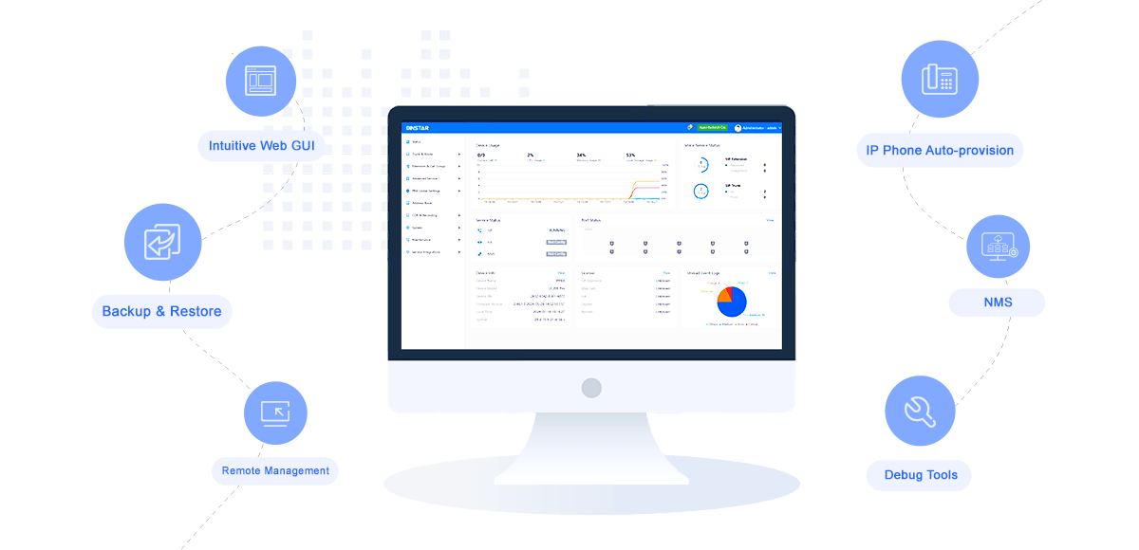
- Features
- Download
- Up to 500 SIP users and 50 concurrent calls

2 FXO and 2 FXS Ports

Up to 3 additional modules

Expand with 2S/2O/1S1O modules

Built-in VPN server/client

User-friendly web interface

Call Forward

Call Waiting

Call Holding

Call Transfer

Hotline

Do-not-disturb

3-Way Conference

Ring Group

Call Queue

Routing Groups

Caller/Called Number Manipulation

Routing Based on Time Period

Routing Based on Caller/Called Prefixes

Routing Based on Source Trunks

Dial Rules

Failover Routing

Multi-level IVR

Auto-attendant Function

Voicemail to Email

Voicemail

CDRs

Paging

Event Report

Email Client

Local Recording (Support USB Storage)

Power Supply: 12VDC, 2A

Power Consumption: 10W

Operating Temperature. 0 ℃ ~ 40 ℃

Storage Temperature: -10 ℃ ~90 ℃

Humidity: 10%-90% Non-Condensing

Dimensions (W/D/H): 260×154×42mm

Unit Weight: 1.1kg

UC350/UC350 Pro

High-end IP PBX
UC350 Series IP PBX is a new generation IP PBX for large capacity unified communication solutions. Based on powerful hardware platform, UC350 Series IP PBX includes UC350 and UC350 Pro. UC350 and UC350 Pro support 1,000/5,000 extensions and 100/500 concurrent calls which is integrated voice, video, paging, fax, conference, recording and other useful functions. It also provides four slots which are able to install E1/T1 boards, FXS and FXO boards by hot-plug mode, so that it can be flexibly configured and combined according to the actual use scenarios. It is suitable for helping to build the telephony system of large and medium-sized enterprises, and can meet the branch office needs of large group enterprises and government agencies, helping enterprises and industry customers to establish a convenient and efficient IP telephone system.
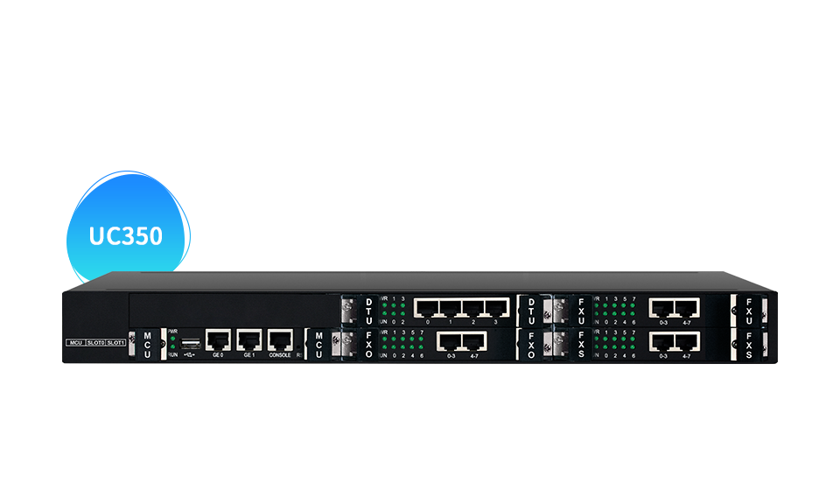
- 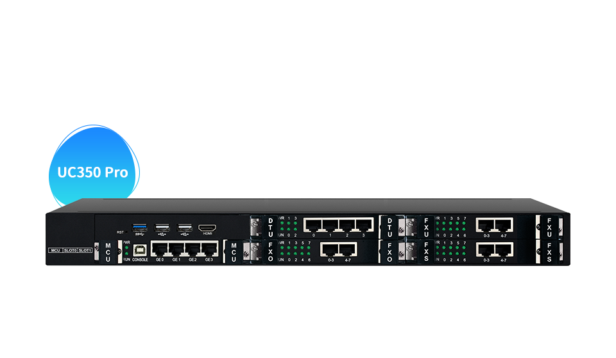
- 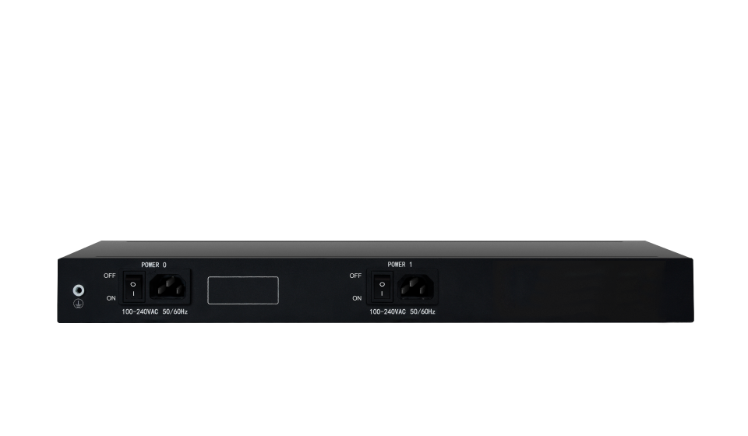
- 
Modular Design
- 
Auto Provisioning
- 
Intelligent IVR
- 
Hot Standby
- 
IP Firewall
- 
TLS/SRTP

High Performance
Max to 5,000 SIP extensions
Max to 500 concurrent calls
Max to 32 FXS/FXO ports, 16S16O or 16 E1/T1 ports
2/4 GE ports for efficient data forwarding
New hardware architecture with powerful CPU and DSP
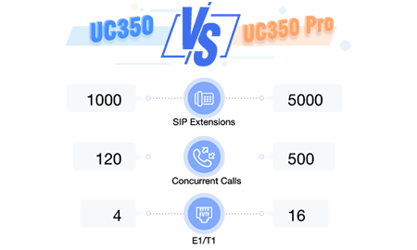

High Reliability
Hot standby: dual-server redundancy without downtime
1+1 redundant power supplies
Modular design, hot-swappable and customizable telephony boards (8FXS, 8FXO, 4FXS4FXO, 1/2/4E1s)
Flexible routing, PSTN failover, load balance
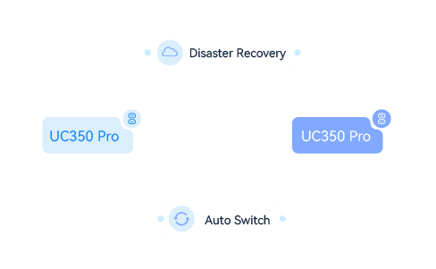

Enhanced Security
Attack defense: Fail2ban, whitelist, blacklist, ACL, etc.
TLS, SRTP, ZRTP encryption
Data protection with multi-level user permissions
Built-in IP firewall to prevent malicious attacks

Rich Functions
Call Forward | Call Transfer | Call Park | Call Pickup
Distinctive Ringtone | Custom Music On Hold | Multi-level IVR | Intercom & Paging
Barge | Conferences | Video Call | DID
Call Queue | Follow me | Ring Group | Recording
Billing | Phone Book | Voicemail | Fail2ban
Voicemail to Email | Attendant Console | Flexible Routing | T.30/T.38 FAX

Easy Management
- Intuitive web interface
Multiple language support
Automatic deployment of IP phones
- Dinstar NMS Management System
Status monitoring and fault alarms
Rich logs and diagnostic tools
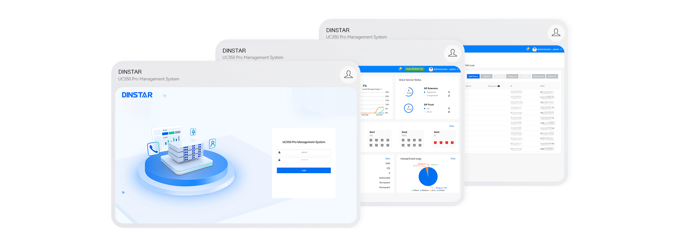
- Features
- Download
- 3-way Calling, Conference call

Call Forward (Always/No Answer/Busy)

Video call

Call Forwarding for particular user

Voicemail Forwarding

Blind/Attended Transfer

Voicemail, Voicemail to Email

Redial/Call Return

Call Control

Speed dial

Call with Password Protection

Call transfer, Call parking, Call waiting

Call Priority

Do-not-disturb (DND)

Call Group Control

DISA

Instant meeting, Scheduling meeting(Audio only)

Music on Hold

Blacklist/Whitelist

Emergency Call

CDRs/Call Signaling Recording

Alarm Call

One Touch Recording

Broadcast/Broadcast group

Auto-recording

Call pickup/pickup group

Playback recording on web

Intercom/ Multicast

One SIP account with multi device registrations

Call Queue

One device multiple numbers

Call Routing Group, Ring Group

Auto Provisioning

Coloring Ring Back Tone(CRBT)

Auto-attendant Function

Custom Prompt, Distinctive Ringtone

Multi-level IVRs

Feature codes

Designated Pickup

Caller ID display

Manager/Secretary Function

Caller/Called Number Manipulation

Routing Based on Time Period

Routing Based on Caller/Called Prefixes

Attendant Console

Mobile Extension

Auto-Configuration

IP Blacklist

Multi-language System Prompt

Extension User Management Interface

Random Password for Extension

Intercom/paging, Hot-desk

UC8000

Software Edition IP PBX
UC8000 is Dinstar software edition IP PBX, full featured, reliable and affordable. You can run it on-premise on your own hardware appliance, a virtual machine, or in cloud. Fully interoperable with Dinstar IP phones and VoIP gateways, UC8000 offers a total IP telephony solution to medium and large enterprises, single location and multi-branch, governments and industry verticals.
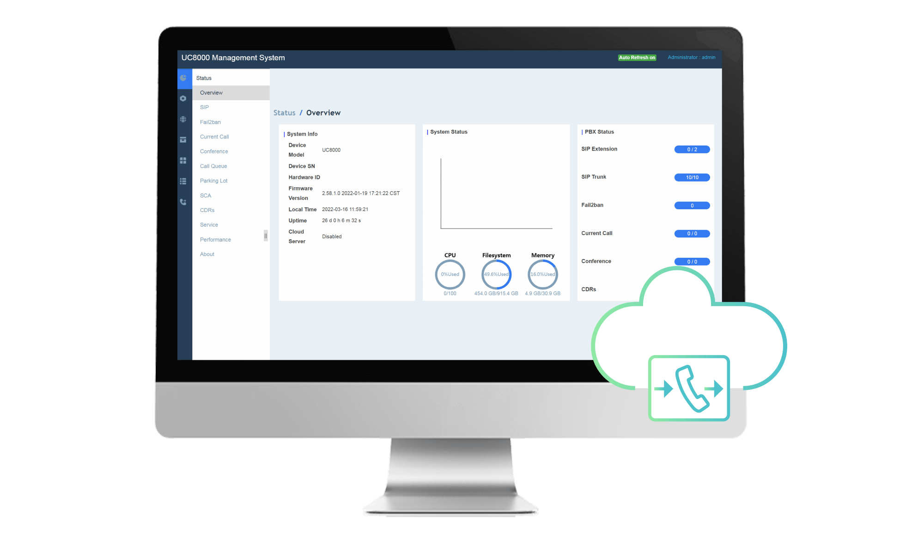
- 
Software Deployment
- 
Scalable
- 
Easy Deployment
High Availability
- 
Intelligent IVR
- 
TLS/SRTP

Scalable, Large Capacity, Reliable IP PBX
Up to 20,000 SIP extensions, up to 4,000 concurrent calls
Highly scalable and adaptable to medium and large enterprises
Flexible and simple licensing, grow with your business
Easy to use and manage with user-friendly Web GUI
Interoperable with Dinstar and mainstream SIP terminals: IP phones, VoIP gateways, SIP intercoms
Auto-provisioning on IP Phones
A reliable solution with Softswitch architecture and hot standby redundancy
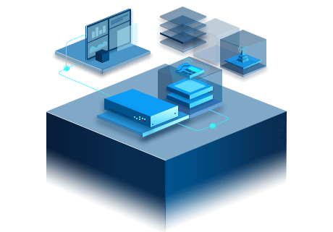

High Availability & Reliability
Hot standby redundancy without service disruptions, no-downtime
Load balancing and redundant routings for disaster recovery
Multi-branch connectivity with local survivability
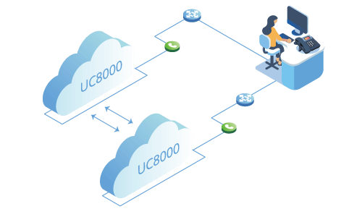

Enhanced Security
TLS and SRTP encryption
Built-in IP firewall to prevent malicious attacks
Data protection with multi-level user permissions
Secure (HTTPS) Web Administration
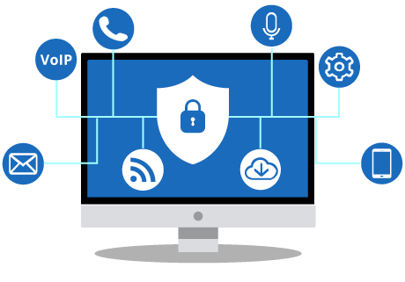

Full Telephony Features
Voice, video, fax in one IP PBX
Built-in audio conference with multiple conference modes
Voicemail, Call recording, Auto-attendance, Voicemail-to-email, Flexible call routing, Ring group, Music-on-hold, Call forwarding, Call transfer, Call parking, Call waiting, CDRs, Billing API&many more
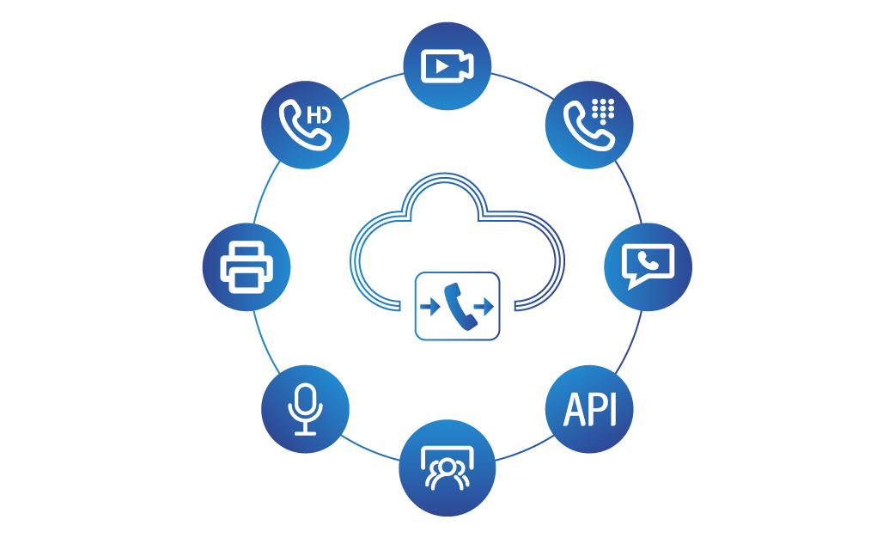

Flexible to Deploy
- On-premise or in Cloud, always your choices
Centralized or Distributed deployment
Operating System: Ubuntu, Centos, openEuler, Kylin
- Hardware Architecture: X86, ARM
Virtual Machine: VMware, Fusionsphere, FusionComputer, KVM
In your private Cloud: Amazon AWS, Azure, Google, Alibaba, Huawei KunPeng...

- Features
- Download
- 3-way Calling, Conference call

Call Forward (Always/No Answer/Busy)

Video call

Call Forwarding for particular user

Voicemail Forwarding

Blind/Attended Transfer

Voicemail, Voicemail to Email

Redial/Call Return

Call Control

Speed dial

Call with Password Protection

Call transfer, Call parking, Call waiting

Call Priority

Do-not-disturb (DND)

Call Group Control

DISA

Instant meeting, Scheduling meeting(Audio only)

Music on Hold

Blacklist/Whitelist

Emergency Call

CDRs/Call Signaling Recording

Alarm Call

One Touch Recording

Broadcast/Broadcast group

Auto-recording

Call pickup/pickup group

Playback recording on web

Intercom/ Multicast

One SIP account with multi device registrations

Call Queue

One device multiple numbers

Call Routing Group, Ring Group

Auto Provisioning

Coloring Ring Back Tone(CRBT)

Auto-attendant Function

Custom Prompt, Distinctive Ringtone

Multi-level IVRs

Feature codes

Designated Pickup

Caller ID display

Manager/Secretary Function

Caller/Called Number Manipulation

Routing Based on Time Period

Routing Based on Caller/Called Prefixes

Attendant Console

Mobile Extension

Auto-Configuration

IP Blacklist

Multi-language System Prompt

Extension User Management Interface

Random Password for Extension

Intercom/paging, Hot-desk

UC200 (EOL)

VoIP PBX
UC200 is a compact yet powerful IP PBX designed to meet the communication needs of SMEs, with up to 500 SIP users, 30 concurrent calls. With its versatile features, UC200 ensures seamless communication and enhanced productivity, while saving the phone bills of SMEs.
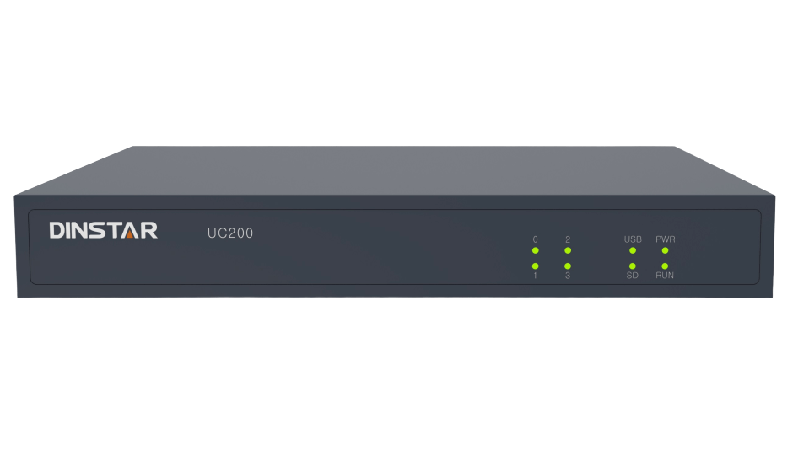
- 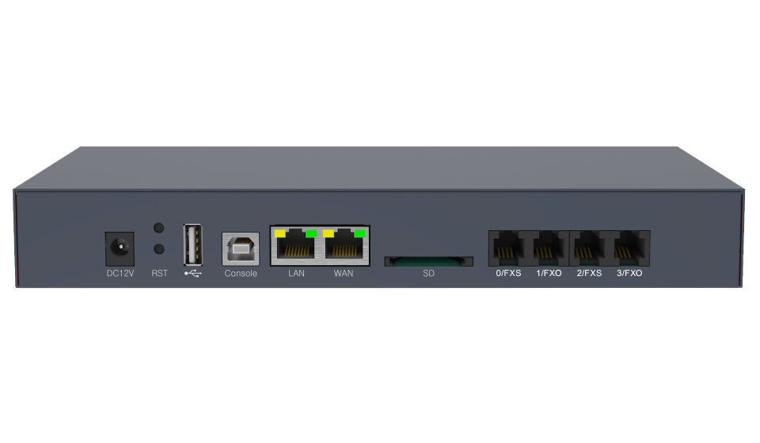
SIP
Multi-level IVR
Voicemail
Auto-provision
Recording
VPN

Small Size, Big Potential
Max SIP Extensions | 500
Max Concurrent Calls | 30
Max FXS port | 2
Max FXO ports | 2
Ethernet Interfaces | 1*LAN, 1*WAN

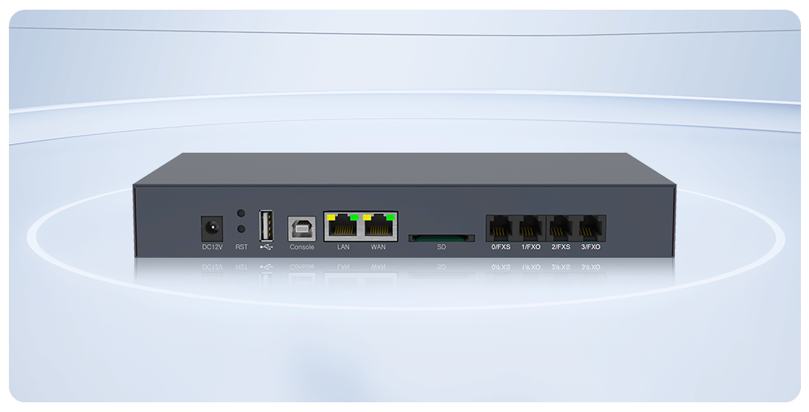

Cost-saving Phone System for SMEs
Affordable Upfront System: Cost-effective IP PBX and IP phones. No annual licensing fees or recurring fees.
Slashed Communication Cost: Free internal calls and low-cost external calls via SIP trunks.
Reduce Installation & Maintenance Cost: Easy to use, manage and maintain, remote management and remote upgrade in bulk.
Retain Old Legacy Equipment: Retain your legacy equipment like analog phones, fax and legacy PBX using VoIP gateways.

Rich Functions
Call Forward | Call Transfer | Call Park | Call Pickup
Distinctive Ringtone | Custom Music On Hold | Multi-level IVR | Intercom & Paging
Barge | Conferences | Video Call | DID
Call Queue | Follow me | Ring Group | Recording
Billing | Phone Book | Voicemail | Fail2ban
Voicemail to Email | Attendant Console | Flexible Routing | T.30/T.38 FAX

Smooth Transition & Seamless Integration
Various Dinstar VoIP gateways enable you a smooth transition from analog to IP system without interruption, utilize your exsiting analog phones, fax, legacy PBXs, PSTN lines, and ISDN PRI (E1/T1) lines.

Easy to Use & Manage
- Intuitive Web interface
Configuration Backup & Restore
Remote Management
- IP Phone Automated provisioning
Dinstar NMS Management System
Advanced Debug tools on web interface
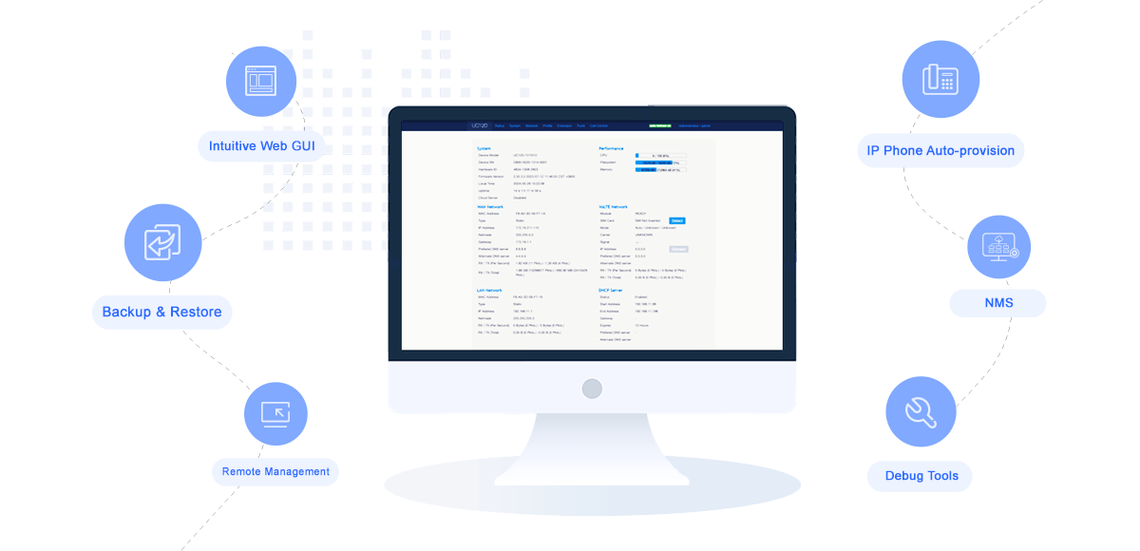
- Features
- Download
- Up to 500 SIP users and 30 concurrent calls

2 FXO and 2 FXS Ports

Built-in VPN server/client

User-friendly web interface

Call Forward

Call Waiting

Call Holding

Call Transfer

Hotline

Do-not-disturb

3-Way Conference

Ring Group

Call Queue

Routing Groups

Caller/Called Number Manipulation

Routing Based on Time Period

Routing Based on Caller/Called Prefixes

Routing Based on Source Trunks

Dial Rules

Failover Routing

Multi-level IVR

Auto-attendant Function

Voicemail to Email

Voicemail

CDRs

Paging

Event Report

Email Client

Local Recording (Support USB Storage)

Power Supply: 12VDC, 2A

Power Consumption: 18W

Operating Temperature. 0 ℃ ~ 40 ℃

Storage Temperature: -10 ℃ ~90 ℃

Humidity: 10%-90% Non-Condensing

Dimensions (W/D/H): 240×180×35mm

Unit Weight: 1 kg

DinLink Softphone
DinLink APP is a softphone application designed for enterprise IPPBX users, providing users with comprehensive communication functions and efficient collaboration tools.
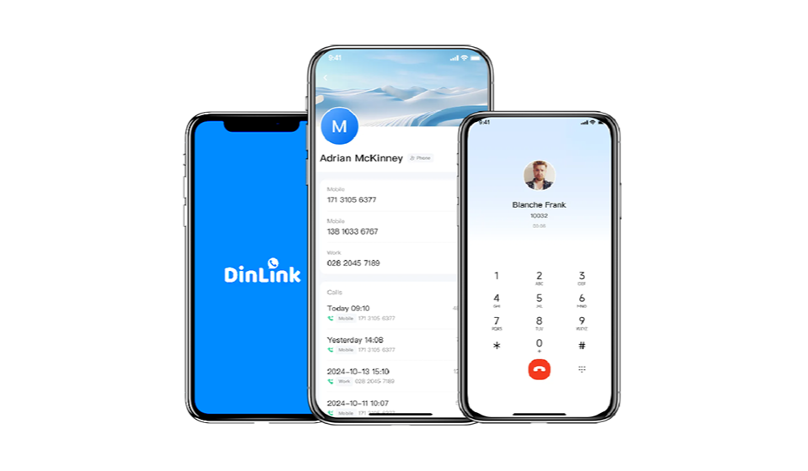
- 
Mobile Extension
- 
Android / iOS
- 
Unified Management
- 
Free On-Net Calls
- 
Flexible Scaling
- 
One-Tap Outbound Calling

Softphone App, Flexible & Efficient

Multi-Device Contacts, Improved Efficiency
Integrates cloud, local and phone contacts in one address book. Easily search public contacts and enterprise organization members without switching apps.

Security Encryption, Full Protection
Adopts WSS protocol to encrypt communications, effectively protecting privacy, ensuring data integrity, and preventing data from malicious tampering or forgery.

One Number, Multiple Devices
One extension account across multiple devices: desk phone, mobile phone, and iPad. Answer calls as you like.
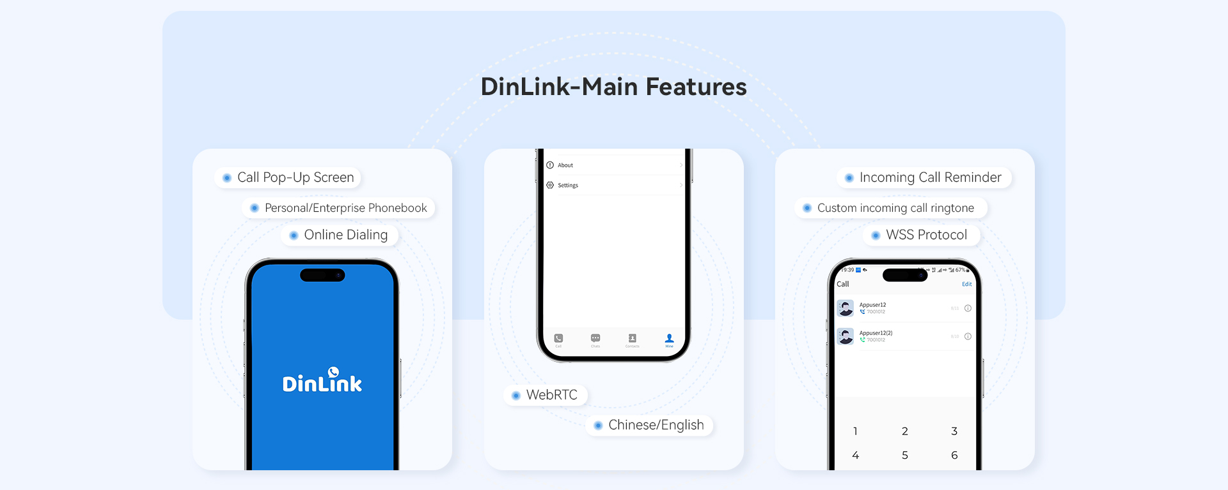

Support Android & iOS
Supports mobile & tablet installation (Android & iOS), covering broad users with premium communication services.
The minimum supported version for all UC models is UC200 Pro V2.46.3.0.
Please contact us via sales@dinstar.com for a trial or demo.

iOS App Store

Download

Google Play

Download

Android 安装包

Download APK
- Features
- Download

