**Computational Finance**

UECM 3723_assign2

**Task 1: Generating Brownian Motion**

E(S3) = 51.9524579415 ~expectation

Var(S3) = 587.748471217 ~variance

P(S3 > 39) = 0.657

E(S3 | S3 > 39) = 63.8620896869

**Theoritical expectation and variance:**

E(3) = 52.6444934955

Var(3) = 623.09647233

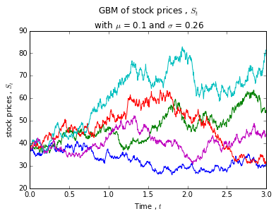

**Simulating mean reversal process**

E(R1) = 1.15312272106

P(R1 > 2) = 0.014

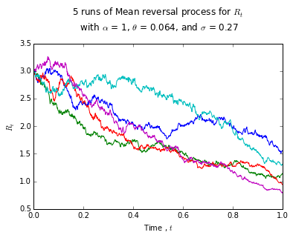

Task 2 -- Downloading and manipulating stock data

There are total of 30 components stocks; below the list of the components:

|  |  |  |  |  |  |  |
| --- | --- | --- | --- | --- | --- | --- |
| No. | Stock sector | Stock Name | Stock Code | Net Market Capital (Billion) | PE Ratio | Weightage%  FTSEKLCI |
| 1. | Banks | CIMB Group Holdings Berhad | 1023 | 46.69 | 17.57 | 4.661401915 |
| 2. | Banks | HONG LEONG BANK BHD | 5819 | 24.05 | 11.19 | 2.401086229 |
| 3. | Banks | HONG LEONG FINANCIAL GROUP BHD | 1082 | 16.22 | 9.96 | 1.619360442 |
| 4. | Banks | MALAYAN BANKING BHD | 1155 | 88.04 | 12.42 | 8.789672833 |
| 5. | Banks | PUBLIC BANK BHD | 1295 | 73.37 | 15.21 | 7.325060152 |
| 6. | Banks | RHB CAPITAL BHD | 1066 | 19.01 | 9.19 | 1.897906413 |
| 7. | Banks | AMMB HOLDINGS BHD | 1015 | 16.92 | 8.82 | 1.689246528 |
| 8. | Media | ASTRO MALAYSIA HOLDINGS BERHAD | 6399 | 15.76 | 28.32 | 1.5734353 |
| 9. | Telecommunications | AXIATA GROUP BERHAD | 6888 | 55.35 | 24.27 | 5.525992632 |
| 10. | Food & Beverage | BRITISH AMERICAN TOBACCO (M) | 4162 | 18.45 | 20.05 | 1.841997544 |
| 11. | Telecommunications | DIGI.COM BHD | 6947 | 41.83 | 21.02 | 4.176192806 |
| 12. | Travel & Leisure | GENTING BHD | 3182 | 30.75 | 16.44 | 3.069995907 |
| 13. | Travel & Leisure | GENTING MALAYSIA BERHAD | 4715 | 24.10 | 20.24 | 2.406078093 |
| 14. | Health care | IHH HEALTHCARE BERHAD | 5225 | 48.76 | 63.76 | 4.868065054 |
| 15. | Personal & Household Goods | IOI CORPORATION BHD | 1961 | 26.67 | 64.92 | 2.662659864 |
| 16. | Real Estate | KLCC PROP&REITS-STAPLED SEC | 5235SS | 12.73 | 26.6 | 1.270928387 |
| 17. | Industrial Goods & Services | KUALA LUMPUR KEPONG BHD | 2445 | 23.98 | 29.21 | 2.394097621 |
| 18. | Telecommunications | MAXIS BERHAD | 6012 | 49.41 | 30.18 | 4.932959276 |
| 19. | Industrial Goods & Services | MISC BHD | 3816 | 35.26 | 15.99 | 3.520261973 |
| 20. | Chemicals | PETRONAS CHEMICALS GROUP BHD | 5183 | 50.64 | 21.83 | 5.055759113 |
| 21. | Oil & Gas | PETRONAS DAGANGAN BHD | 5681 | 20.45 | 37.01 | 2.041672075 |
| 22. | Oil & Gas | PETRONAS GAS BHD | 6033 | 42.74 | 22.78 | 4.267044717 |
| 23. | Food & Beverages | PPB GROUP BHD | 4065 | 18.23 | 18.14 | 1.820033346 |
| **24.** | **Oil & Gas** | **SAPURAKENCANA PETROLEUM BHD** | **5218** | **14.27** | **12.07** | **1.424677775** |
| 25. | General Industries | SIME DARBY BHD | 4197 | 51.42 | 20.53 | 5.13363218 |
| 26. | Telecommunications | TELEKOM MALAYSIA BHD | 4863 | 24.66 | 32.5 | 2.461986961 |
| 27. | Utilities | TENAGA NASIONAL BHD | 5347 | 69.3 | 9.25 | 6.918722482 |
| 28. | Automobile & Parts | UMW HOLDINGS BHD | 4588 | 11.99 | 20.6 | 1.19704881 |
| 29. | Industrial Goods & Services | WESTPORTS HOLDINGS BERHAD | 5246 | 13.91 | N/A | 1.38873636 |
| 30. | Utilities | YTL CORPORATION BHD | 4677 | 16.67 | 14.81 | 1.664287212 |

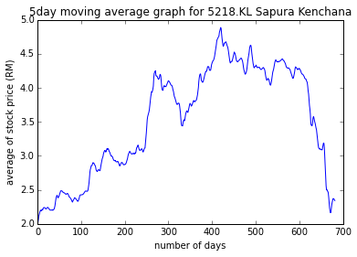

The correlation of 5218.Kl Sapura Kenchana with FTSEKLCI is

5218. KL KLSE

5218.KL 1.000000 0.879815

KLSE 0.879815 1.000000

The correlation is 0.879815 ; shows that a positive correlation. .Kl Sapura Kenchana with FTSEKLCI will move in the same direction (as one increases, the other will increase too)