**Rabobank Customer Statement Processor**

Rabobank receives monthly deliveries of customer statement records. This information is delivered in two formats, CSV and XML. These records need to be validated.

**Technologies used:**

Spring Boot

JAXB for XML processing

Apache Commons for CSV processing

Spring Thymeleaf for report table

JUnit/Mockito for Unit testing and mocking.

**Architecture**:

**UI Controller:**

This controller controls the flow for default input

**Rest Controller:**

This controller controls the flow for user defined input

**Service:**

This layer embeds actual business logic through below methods.

findDuplicateTransactionRefRecords

findInvalidMutationRecords

**Domain:**

Data for the application comes from this layer through parsers.

CsvFileParserImpl – for parsing CSV file

XmlFileParserImpl – for parsing XML file

FileParserFactory – a factory design pattern implementation which abstracts the implementation of actual parsers based on given input.

**Application Reports and Screenshots:**

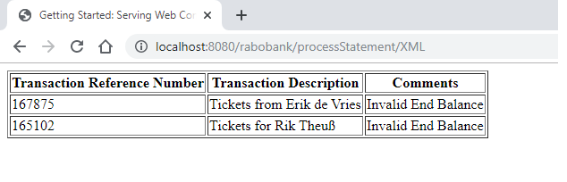

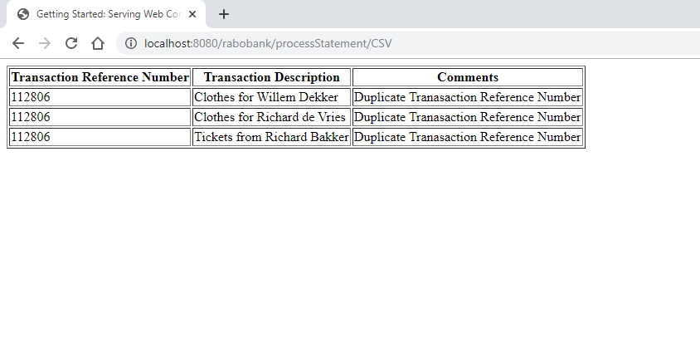

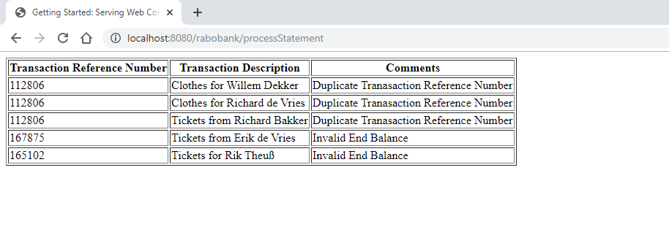

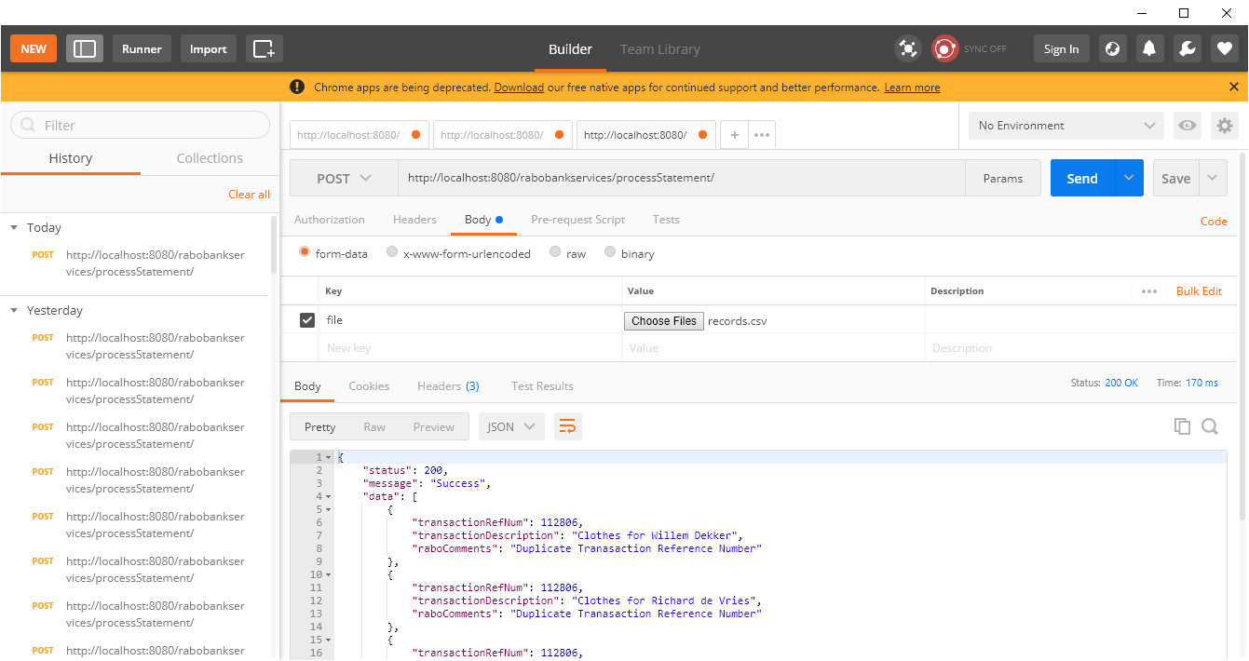

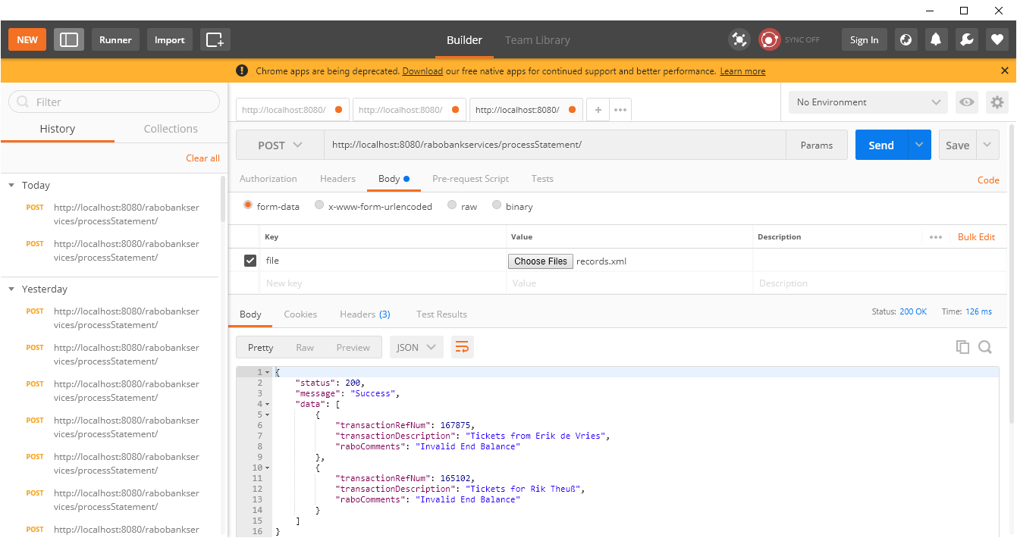

**Test Case report:**

