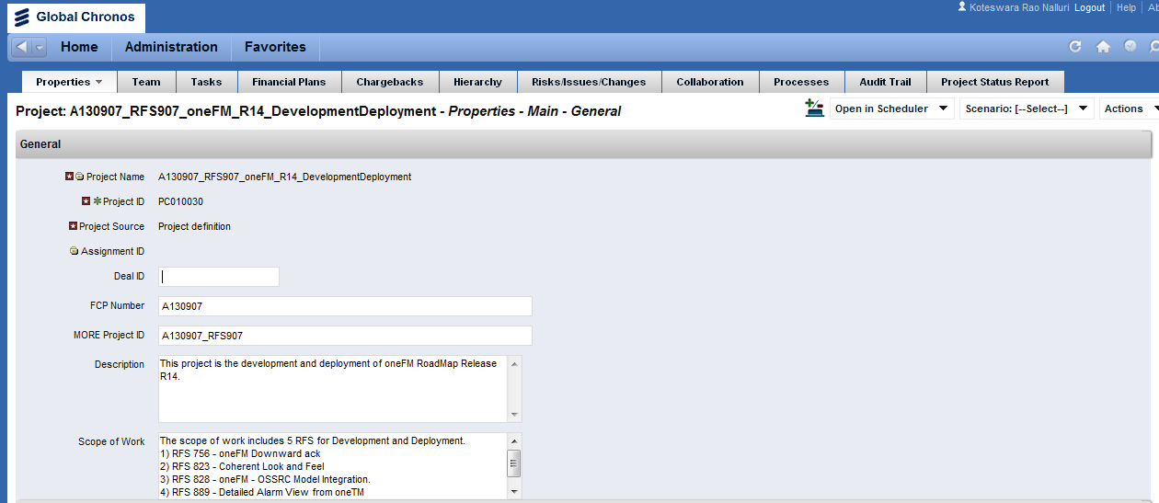
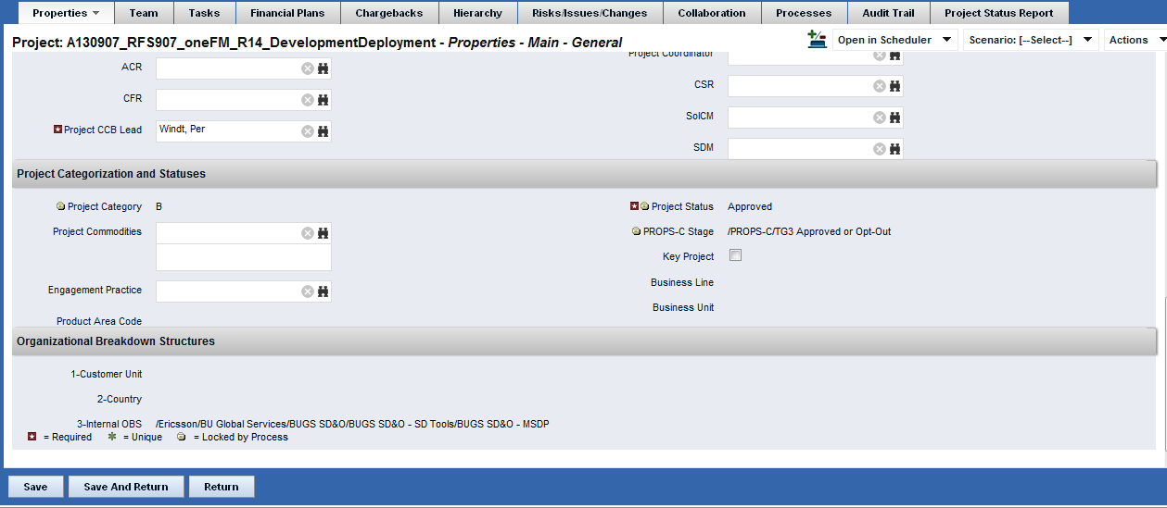
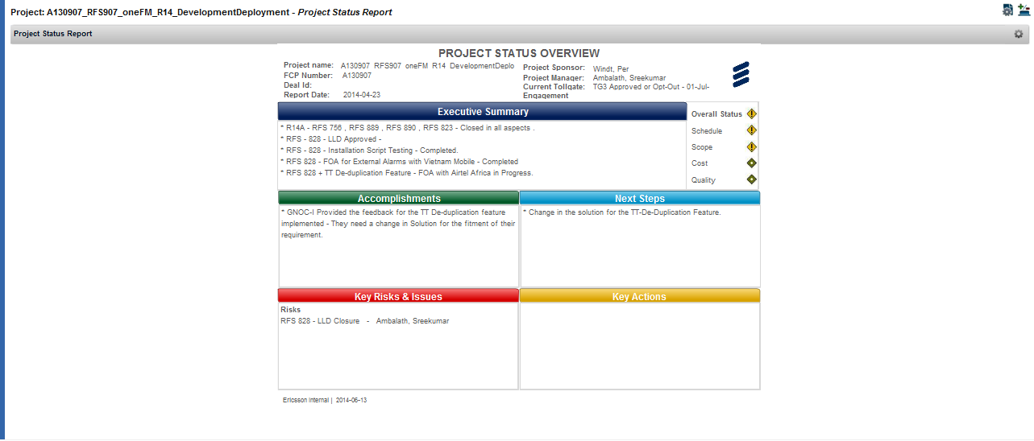
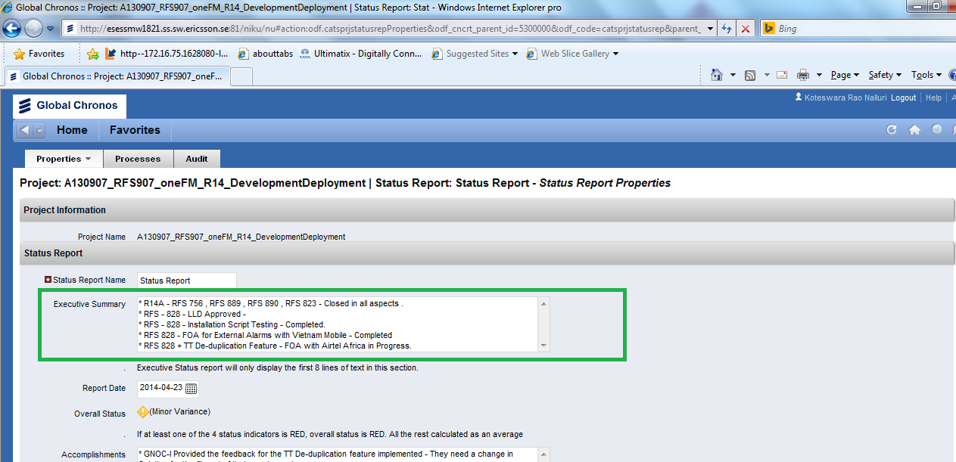
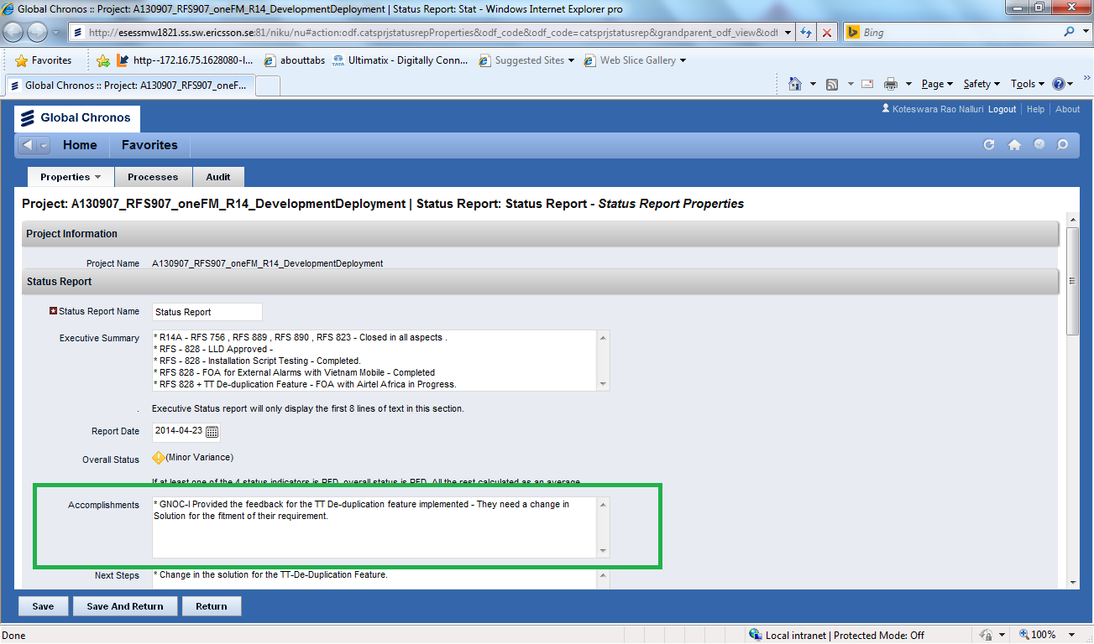
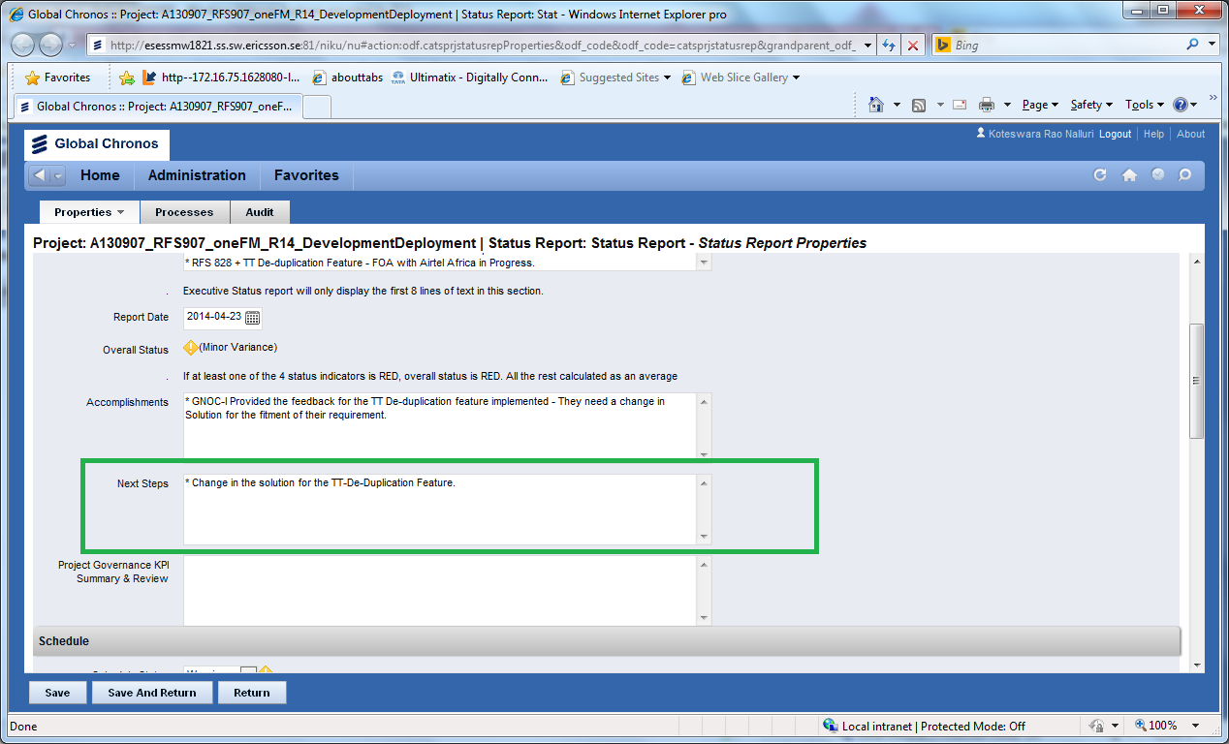
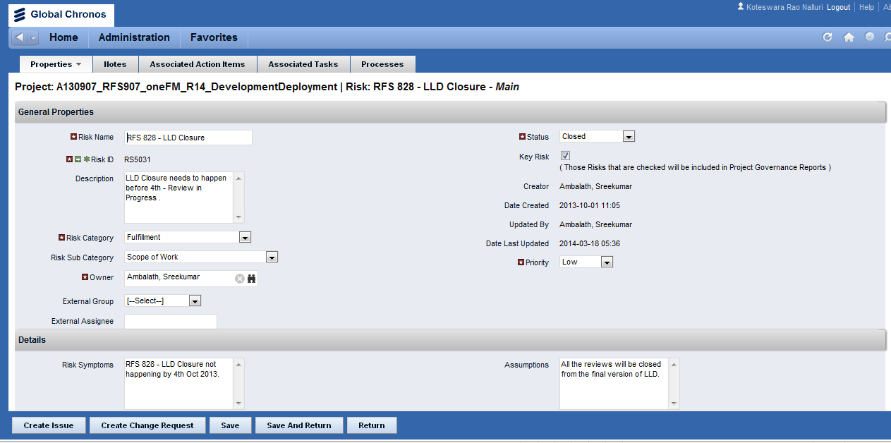
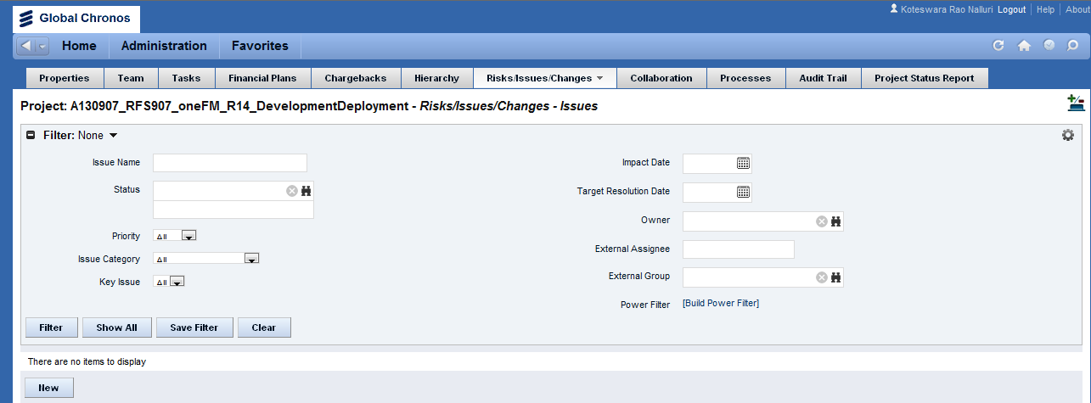
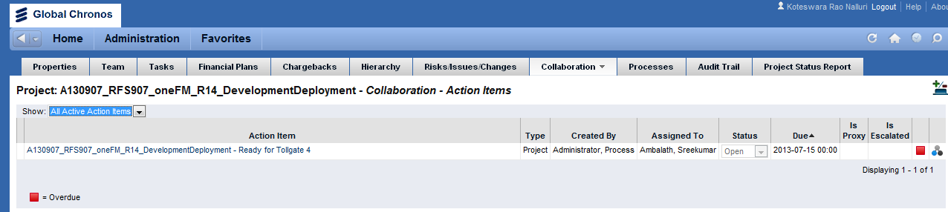
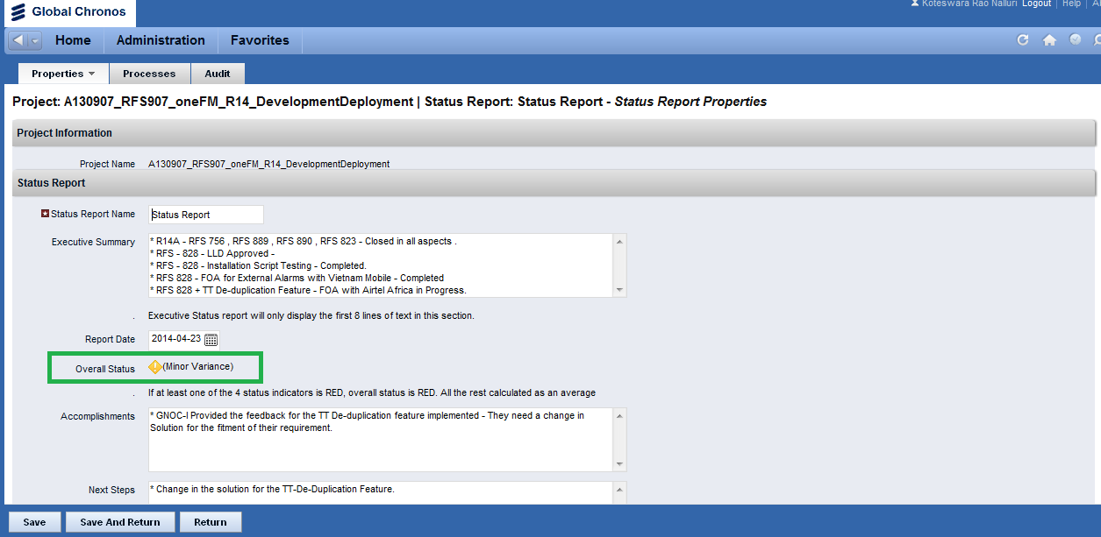
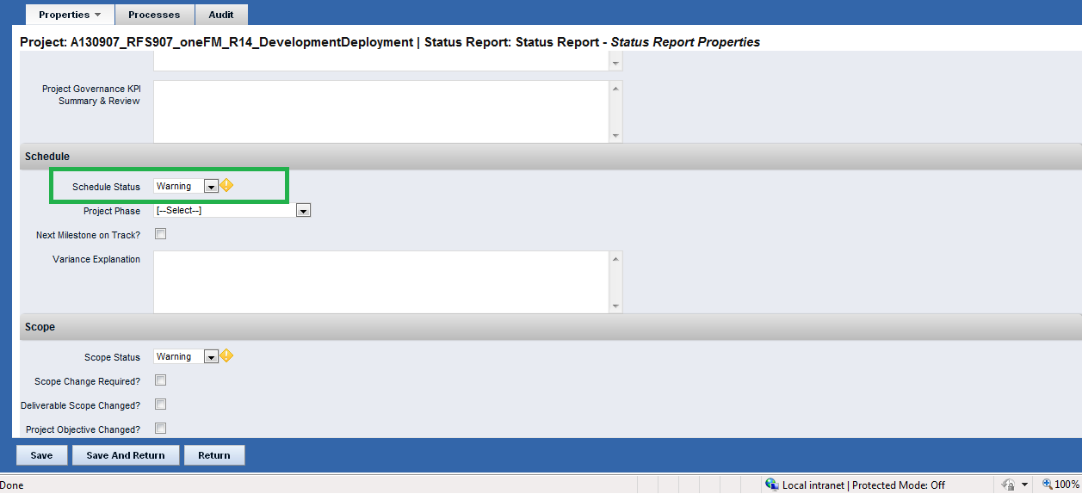
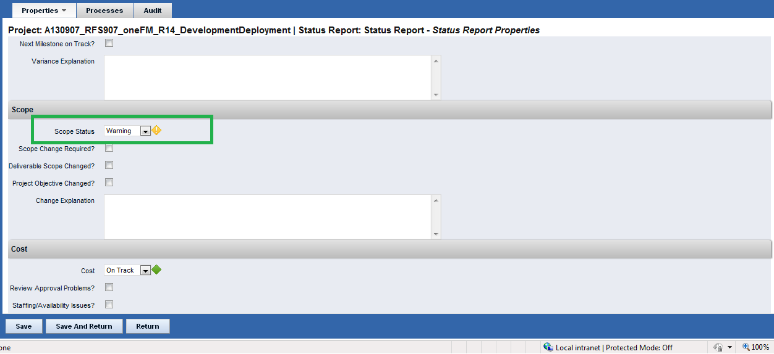
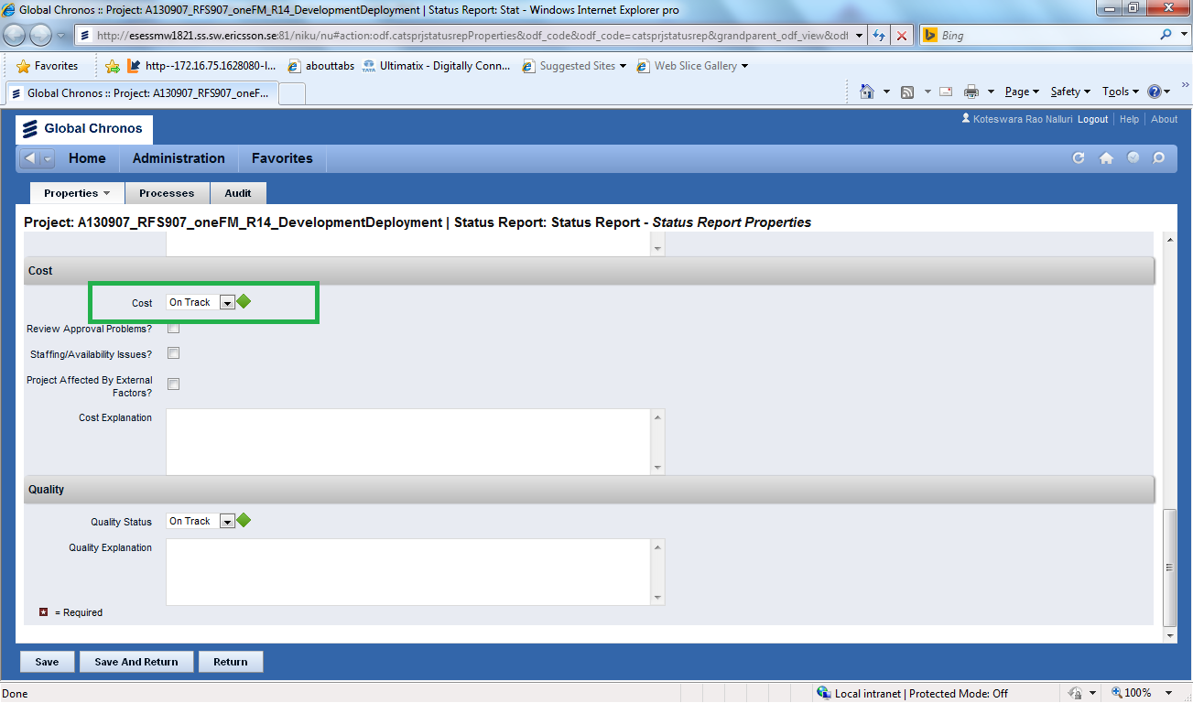
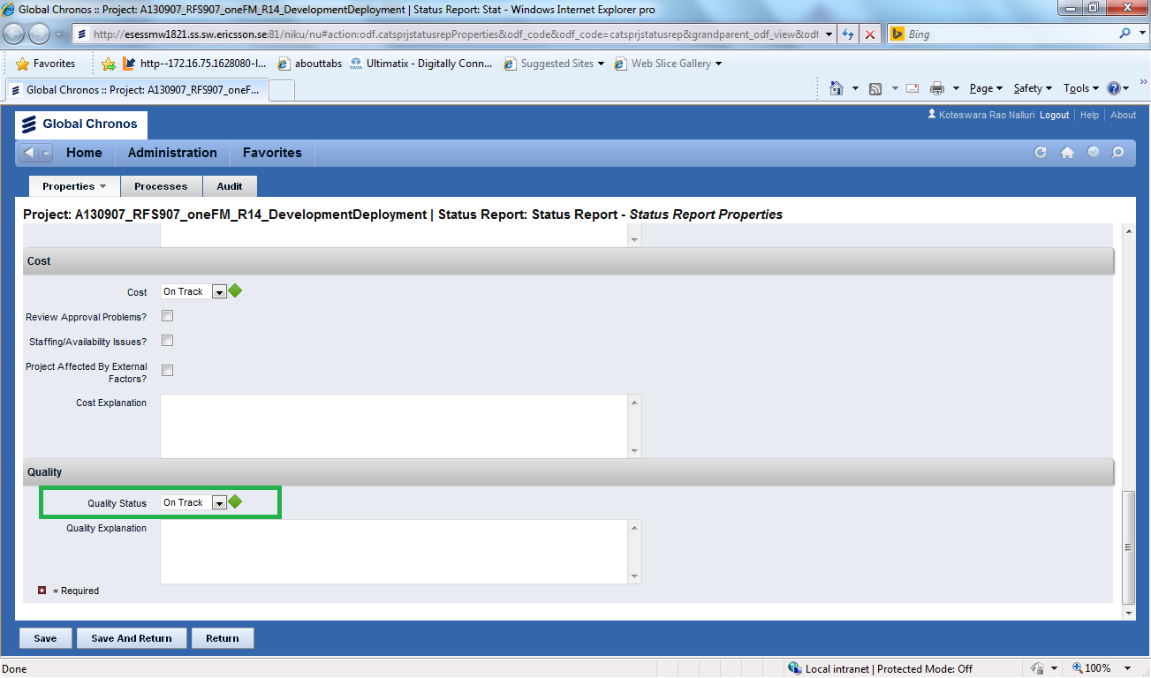
Screenshot-1:
Screenshot-2: Project Status online Report of the project
Screenshot-3:When I click on the Executive summary section ,it is navigated to the executive summary of the Status report properties page which is shown below
Screenshot-4: When I click on the Accomplishments section ,it is navigated to the Accomplishments of the Status report properties page which is shown below
Screenshot-5: When I click on the Nextstep section ,it is navigated to the Nextstep section of the Status report properties page which is shown below
Screenshot-6:when I click on the Risk present in Key Risks and Issue section, it is navigated to corresponding Risk page which is shown below.
Screenshot-7: when I click on the Key Risks and Issue section bar , it is navigated to corresponding page which is shown below.

Screenshot-8: When I click on the Action item section it is navigated to the below page
Screenshot-10: when I click on the Overall Status symbol, it is navigated to the corresponding Status Report Properties page which is shown below

Screenshot-11: when I click on the Schedule symbol, it is navigated to the corresponding Status Report Properties page which is shown below

Screenshot-12: when I click on the Scope symbol, it is navigated to the corresponding Status Report Properties page which is shown below

Screenshot-13: when I click on the Cost symbol, it is navigated to the corresponding Status Report Properties page which is shown below

Screenshot-13: when I click on the Quality symbol, it is navigated to the corresponding Status Report Properties page which is shown below

