**U18ISI6204 – Machine Learning Techniques**

**LAB- EXPERIMENT 6**

**NAME:** Navina G A

**ROLL_NO:** 20BIS028

Implement KNN algorithm using the balanced iris data set for multiclass classification and predict the flower species.

**INTRODUCTION**

In this experiment, we have to perform k nearest neighbor on the iris dataset. The K-NN working can be explained on the basis of the below algorithm:

o **Step-1:** Select the number K of the neighbors

o **Step-2:** Calculate the Euclidean distance of **K number of neighbors**

o **Step-3:** Take the K nearest neighbors as per the calculated Euclidean distance.

o **Step-4:** Among these k neighbors, count the number of the data points in each category.

o **Step-5:** Assign the new data points to that category for which the number of the neighbor is maximum.

# **OBJECTIVE OF THE EXERCISE/EXPERIMENT**

To perform K- nearest neighbor on the given dataset, using scikit library

# **STEP 2: ACQUISITION PROCEDURE:**

**STEP-1:** Start the program.

**STEP-2:** import all the necessary libraries

iv) Numpy – array manipulation

v) Pandas – dataframe manipulation

vi) Matplotlib and seaborn – for data visualization

vii) Sklearn.model_selection – train test data split and cross_val_score

viii) Sklearn.metrics – model evaluation.

ix) Sklearn.datasets – For iris dataset

x) Sklearn.neighbor – For KNeighborsClassifier

**STEP-3:** Loading the dataset using load_iris method in sklearn.datasets module.

**STEP-4:** Analyze the dataset using info method, which gives its data types and number of non- null values in each columns.

**STEP-5:** Perform basic statistic operation using describe() method.

**STEP-6:** Use heatmaps, correlation matrix, regression plots and pairplots in seaborn to find the relationship between features.

**STEP-7:** Implement KNeighborClassifier with k value ranging from 1 to 25 and save the accuracy score of test dataset for each k value in a score list.

**STEP-8:** Plot the accuracy_score in y axis and k value in x axis, find out the k value which gives high accuracy on test data.

**STEP-9:** Do the step 7 and 8 for 10-fold validation set.

**STEP-10:** Conclude the best k value which works good in both test and validation set. **STEP-11:** Use that K value to build the final KNN model and print the accuracy_score. **STEP-12:** Stop the Program.

# **PROGRAM:**

from sklearn.datasets import load_iris

from sklearn.model_selection import train_test_split, cross_val_score

import matplotlib.pyplot as plt

import seaborn as sns

import pandas as pd

import numpy as np

iris=load_iris()

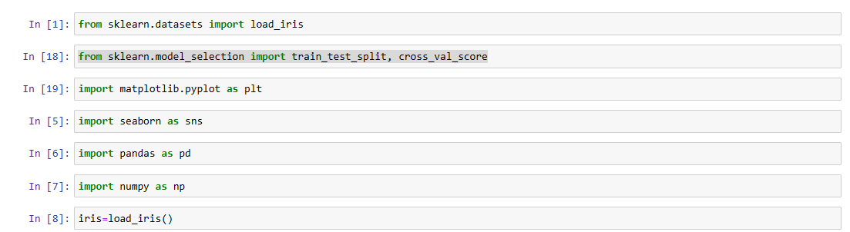

x=iris.data

y=iris.target

print(x.shape)

data=np.c_[iris.data, iris.target]

columns= np.append(iris.feature_names, ["target"])

df= pd.DataFrame(data, columns=columns)

print(df)

print(iris.feature_names)

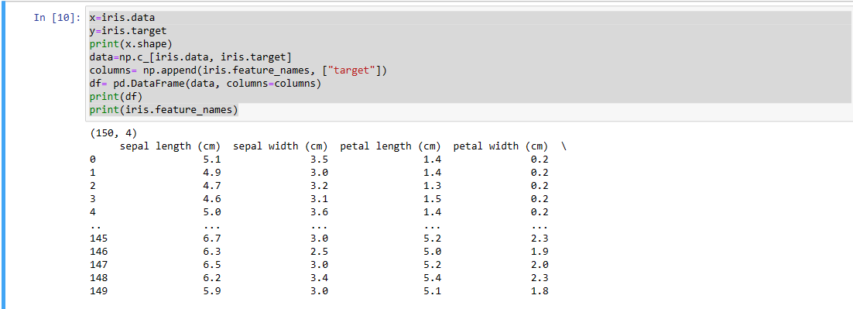

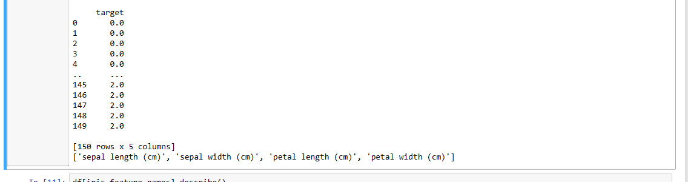

df[iris.feature_names].describe()

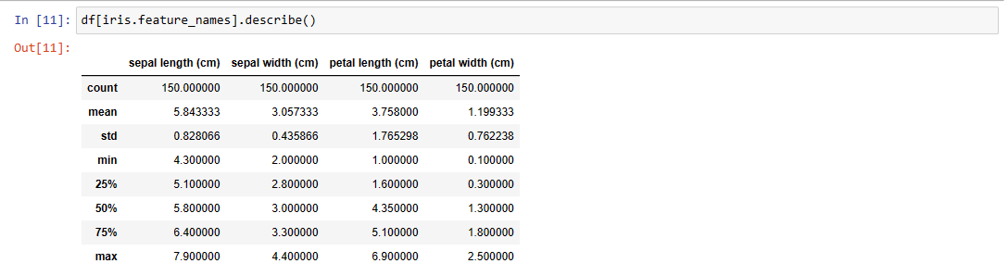

sns.heatmap(df[iris.feature_names].corr(),annot=True)

plt.plot()

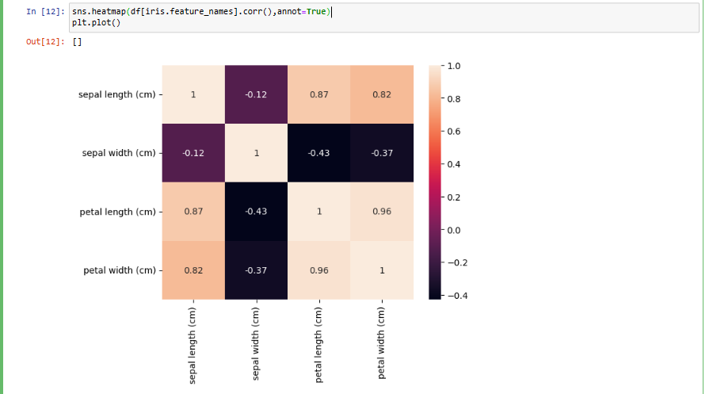

x_train, x_test, y_train, y_test= train_test_split(x,y,test_size=0.2, random_state=4)

print(x_train.shape)

print(x_test.shape)

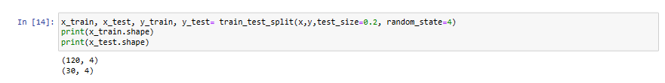

from sklearn.neighbors import KNeighborsClassifier

from sklearn import metrics

test_k= range(1,26)

scores=[]

for k in test_k:

knn= KNeighborsClassifier(n_neighbors=k)

knn.fit(x_train, y_train)

y_pred= knn.predict(x_test)

scores.append(metrics.accuracy_score(y_test,y_pred))

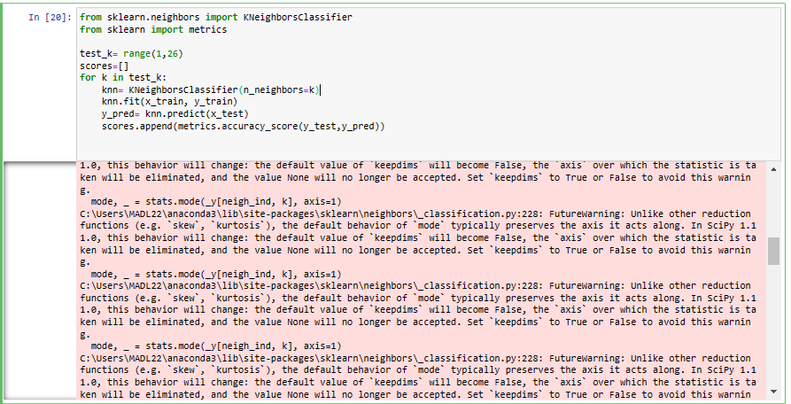

plt.plot(test_k,scores)

plt.xlabel('k value for kNN')

plt.ylabel('Accuracy on test data')

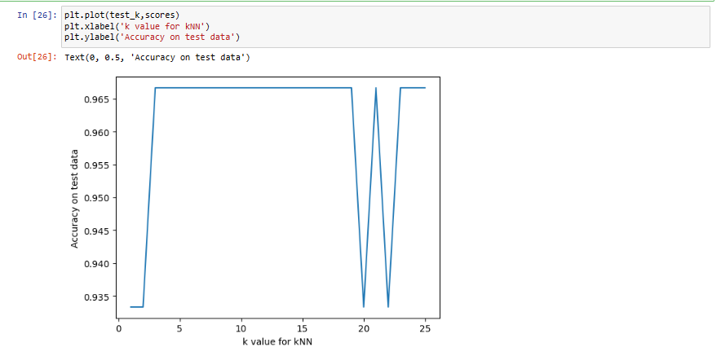

cv_scores=[]

for k in test_k:

knn = KNeighborsClassifier(n_neighbors=k)

score= cross_val_score(knn, x_train, y_train, cv=10, scoring='accuracy')

cv_scores.append(score.mean())

MSE= [1-x for x in cv_scores]

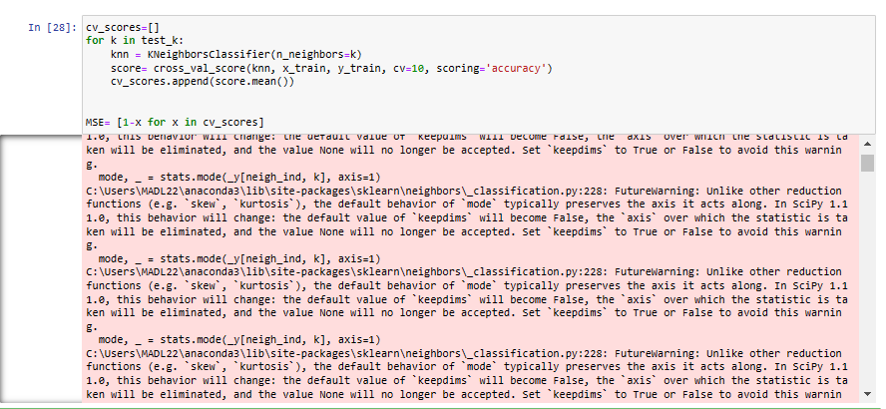

plt.title('The optimal number of neighbors')

plt.xlabel('Number of Neighbors K')

plt.ylabel('Misclassification Error')

plt.plot(test_k, MSE)

plt.show()

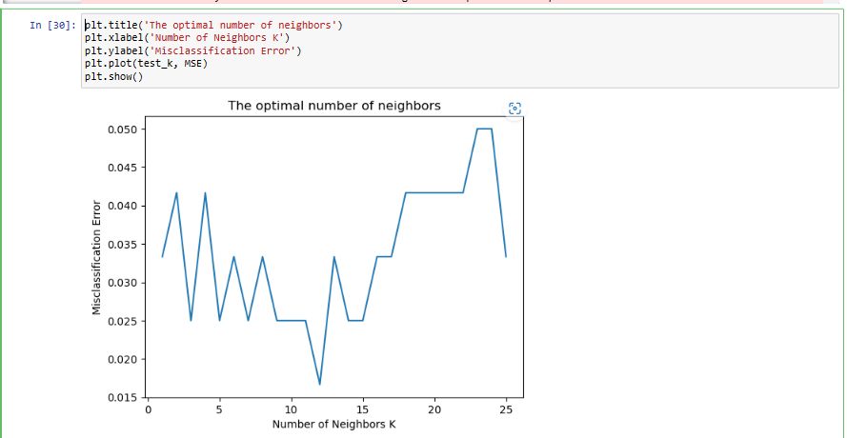

knn =KNeighborsClassifier(n_neighbors=12)

knn.fit(x_train, y_train)

y_pred = knn.predict(x_test)

metrics.confusion_matrix(y_test, y_pred)

metrics.accuracy_score(y_test, y_pred)

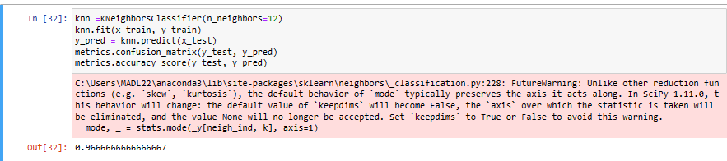

WITHOUT USING PYTHON LIBRARY

# **KNN implementation on Iris Dataset**

Python · [Iris Flower Dataset](https://www.kaggle.com/datasets/arshid/iris-flower-dataset)

import pandas as pd

import warnings

warnings.filterwarnings("ignore")

import seaborn as sns

import numpy as np

import matplotlib.pyplot as plt

sns.set(style="white", color_codes=True)

from sklearn import datasets

from sklearn.model_selection import train_test_split

from sklearn.preprocessing import StandardScaler

from sklearn.model_selection import train_test_split

from sklearn.preprocessing import StandardScaler

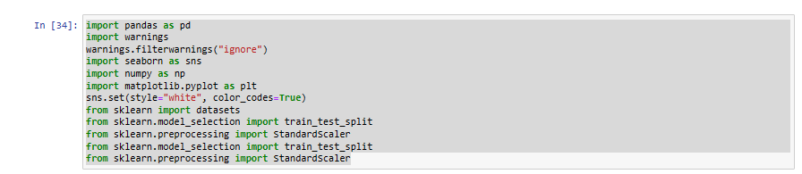

LOADING DATASET

iris = datasets.load_iris()

df = pd.DataFrame(data=iris.data, columns=iris.feature_names)

df['target'] = iris.target

df.head()

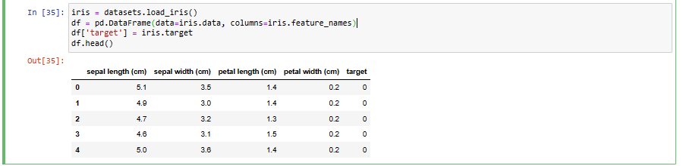

# Checking if the dataset is balanced or not

df.groupby('target').size().plot(kind='barh')

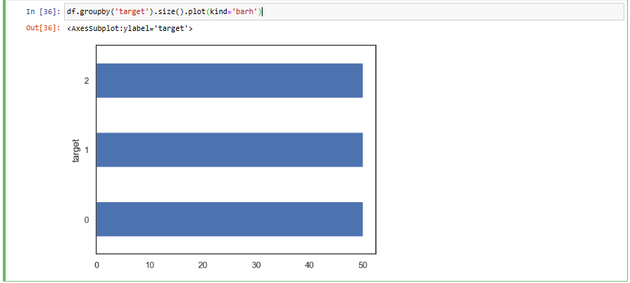

# Euclidean distance function

def dis(a, b, p=1):

l = len(a)

d = 0

for i **in** range(l):

d += abs(a[i] - b[i]) ** p

d = d ** (1/p)

return d

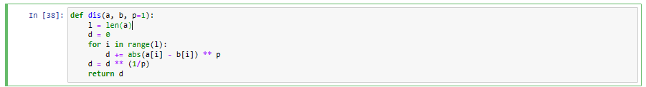

X = df.drop('target', axis=1)

y = df.target

test_pt = [4.8, 2.7, 2.5, 0.7]

distances = []

for i **in** X.index:

a = dis(test_pt, X.iloc[i])

distances.append(a)

dists = pd.DataFrame(data=distances, index=X.index, columns=['dist'])

dists.head()

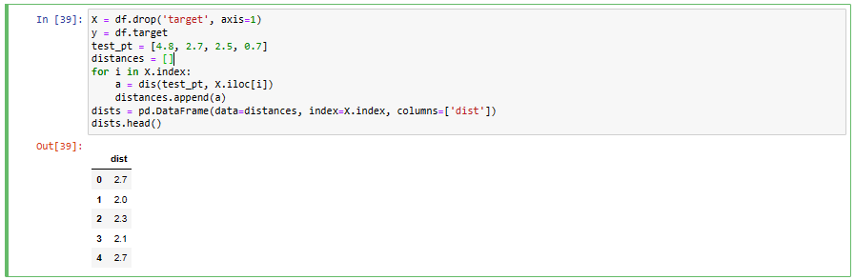

# Distance DataFrame is sorted to measure which class the nearest

def knn_sort(k,dists): return dists.sort_values(by = 'dist')[:k]

# 

# 

# Value of k is determined.[¶](https://www.kaggle.com/code/abirhasan1703100/knn-implementation-on-iris-dataset#Value-of-k-is-determined.)

sorted_dists = knn_sort(5, dists)

print(sorted_dists)

count_set = {}

for i in sorted_dists.index:

if y[i] not in count_set:

count_set[y[i]] = 1

else:

count_set[y[i]] += 1

print(max(count_set))

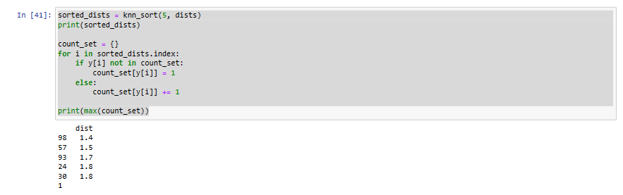

# Split the data - 75% train, 25% test

X_train, X_test, y_train, y_test = train_test_split(X, y, test_size=0.25,random_state=1)

scaler = StandardScaler()

X_train = scaler.fit_transform(X_train)

X_test = scaler.transform(X_test)

# Training and predicting the test set and checking accuracy.

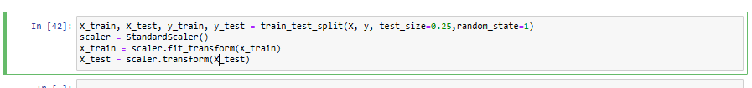

def KNN(X_train, X_test, y_train, y_test, k, p):

y_predict = []

for test_pt **in** X_test:

distances = []

for i **in** X_train:

a = dis(test_pt, i, p)

distances.append(a)

dists = pd.DataFrame(data=distances, index=y_train.index, columns=['dist'])

sorted_dists = knn_sort(k, dists)

*#print(sorted_dists)*

count_set = {}

for i **in** sorted_dists.index:

if y_train[i] **not** **in** count_set:

count_set[y_train[i]] = 1

else:

count_set[y_train[i]] += 1

y_predict.append(max(count_set))

y = y_test.tolist()

accr = 0

for i **in** range(len(y)):

if y[i] == y_predict[i]:

accr += 1

return accr/len(y)

*#print('Accuracy',accr/len(y))*

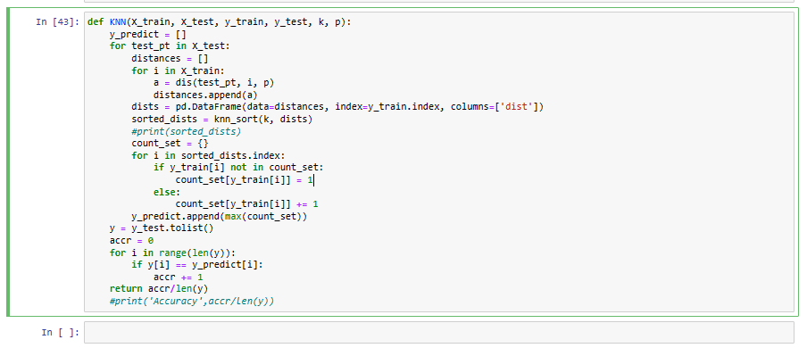

# Calling the function

KNN(X_train, X_test, y_train, y_test, 5,1)

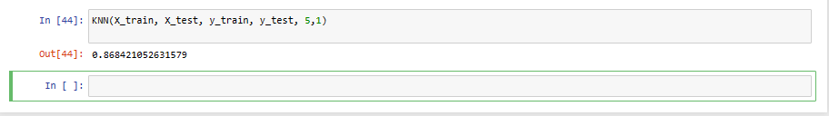

ACCURACY:

accuracies = []

for i **in** range(1,100):

accuracies.append(KNN(X_train, X_test, y_train, y_test, i,1))

print(max(accuracies))

fig, ax = plt.subplots(figsize=(8,6))

ax.plot(range(1,100), accuracies)

ax.set_xlabel('# of Nearest Neighbors (k)')

ax.set_ylabel('Accuracy (%)')

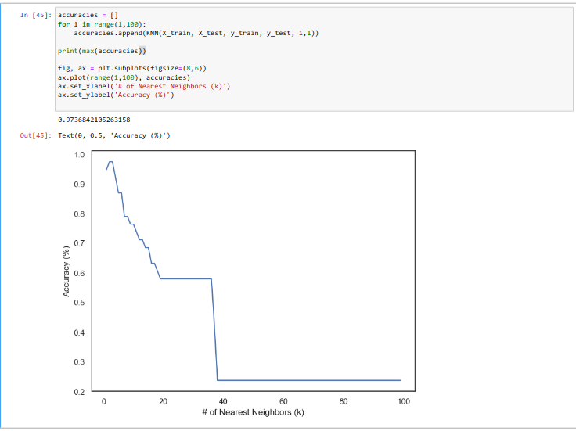

# Data Visualization

df.plot(kind="scatter", x="sepal length (cm)", y="sepal width (cm)")

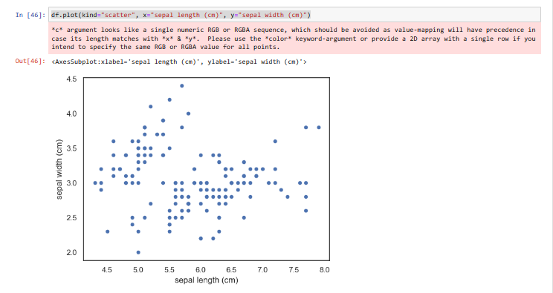

sns.jointplot(x="sepal length (cm)", y="sepal width (cm)", data=df, size=5)

Out[13]:

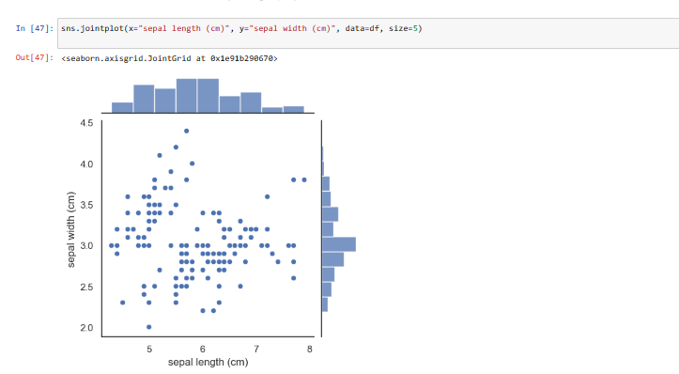

sns.boxplot(x="target", y="petal length (cm)", data=df)

Out[14]:

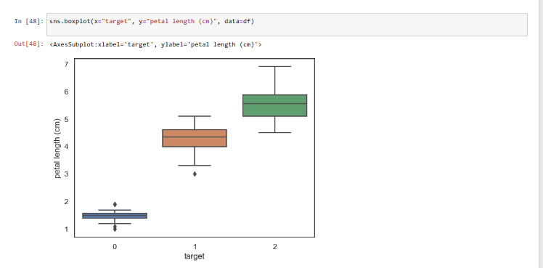

cx = sns.boxplot(x="target", y="petal length (cm)", data= df )

cx = sns.stripplot(x="target", y="petal length (cm)", data=df, jitter=True, edgecolor="gray")

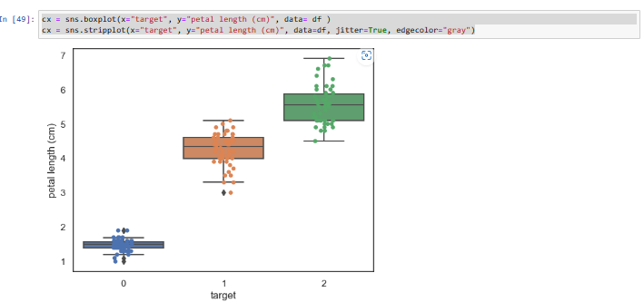

K=2

sorted_dists = knn_sort(2, dists)

print(sorted_dists)

count_set = {}

for i in sorted_dists.index:

if y[i] not in count_set:

count_set[y[i]] = 1

else:

count_set[y[i]] += 1

print(max(count_set))

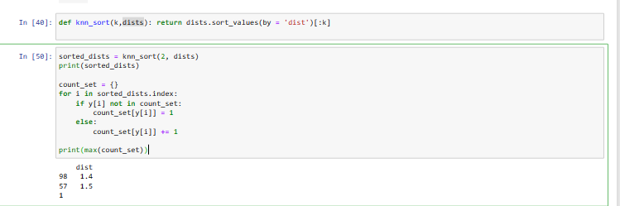



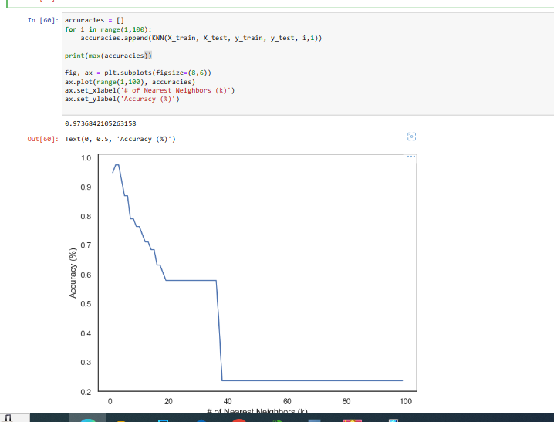

K=3

