**U18ISI6204 – Machine Learning Techniques**

**LAB- EXPERIMENT 8**

**NAME:** Navina G A

**ROLL_NO:** 20BIS028

Write a program to implement k-means clustering algorithm for iris dataset.

**With libraries:**

import pandas as pd

import numpy as np

import matplotlib.pyplot as plt

import seaborn as sns

from sklearn.cluster import KMeans

from sklearn.metrics import silhouette_score

from sklearn.preprocessing import MinMaxScaler

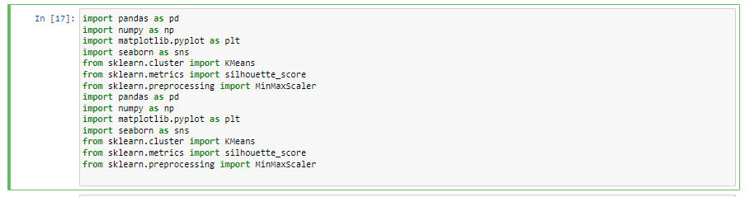

iris= pd.read_csv("C:/Users/Documents/3rdYear/ML/LAB/archive (7)/IRIS.csv")

x=iris.iloc[:,[0,1,2,3]].values

iris.info()

iris[0:10]

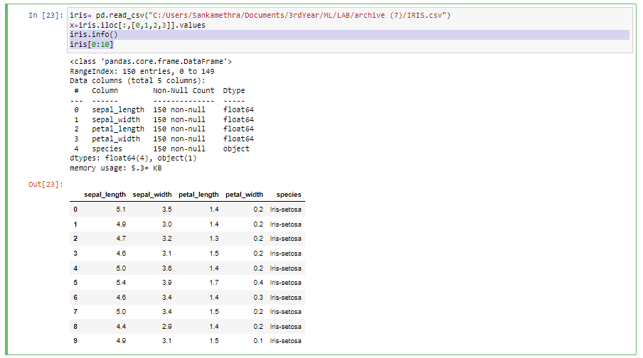

iris_outcome=pd.crosstab(index=iris["species"],columns="count")

iris_outcome

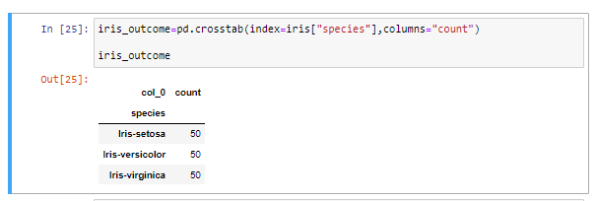

iris_setosa= iris.loc[iris["species"]=="Iris-setosa"]

iris_virginica=iris.loc[iris["species"]=="Iris-virginica"]

iris_versicolor=iris.loc[iris["species"]=="Iris-versicolor"]

sns.FacetGrid(iris,hue="species",size=3).map(sns.distplot,"petal_length").add_legend()

sns.FacetGrid(iris,hue="species",size=3).map(sns.distplot,"petal_width").add_legend()

sns.FacetGrid(iris,hue="species",size=3).map(sns.distplot,"sepal_length").add_legend()



