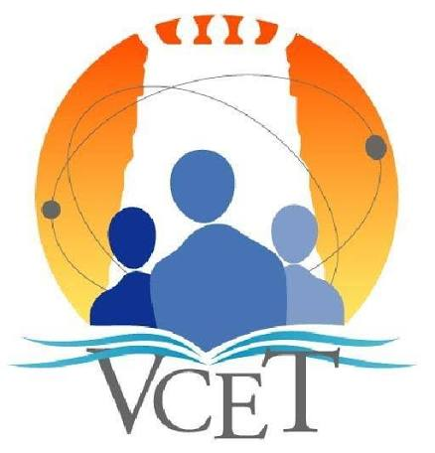

VELAMMAL COLLEGE OF ENGINEERING & TECHNOLOGY, MADURAI
(An Autonomous Institution | Affiliated to Anna University | Accredited by NAAC with A Grade)
NBA Accredited - CSE, IT, ECE, EEE, MECH, CIVIL


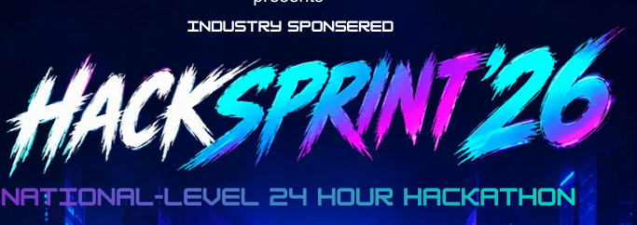

Theme: Agentic ai

prize pool 30000
1st price 15000
2nd prize 10000
3rd prize 5000
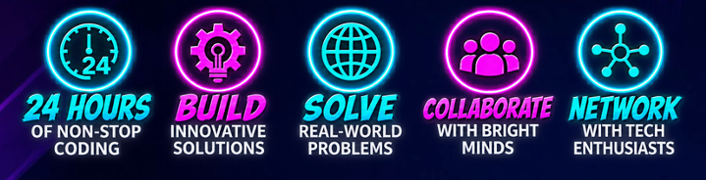
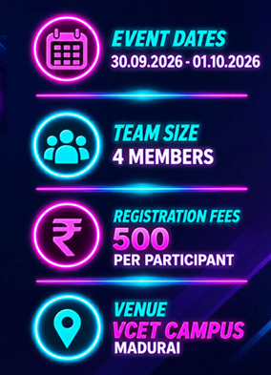

TECHINICAL SUPPORT FROM

AND SPONSERED FROM

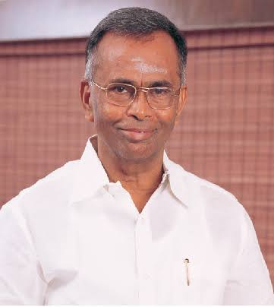

CHIEF PATRON

Shri. M.V Muthuramalingam

Chairman, VET
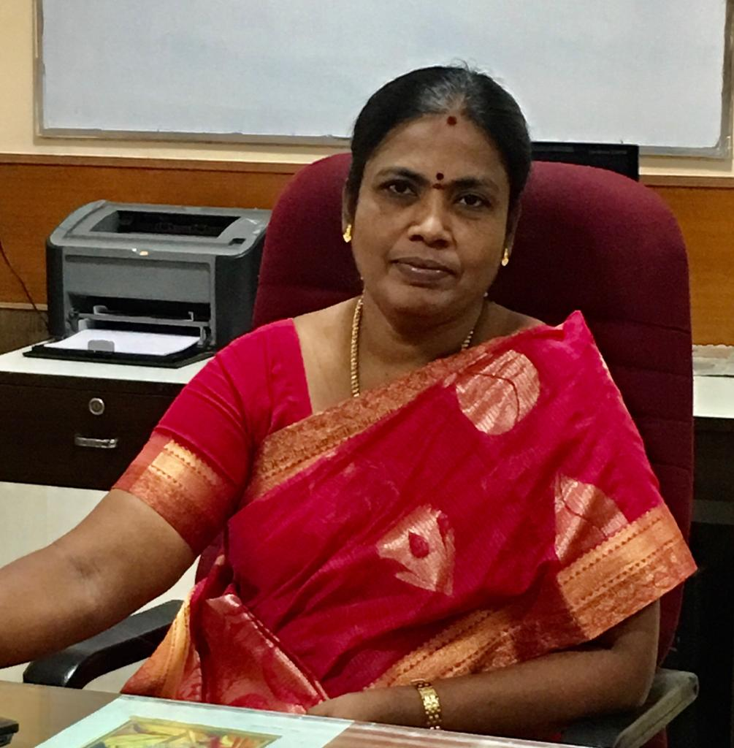

PATRON Dr. P. Alli

Principal
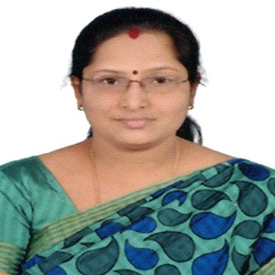
CONVENER

Dr. R. Kavitha

Professor and head/IT

CO-ORDINATORS

- Dr. R. RAJA SUDHARSAN ASP/IT 
- Mr. S. JEGADEESAN AP-II/IT 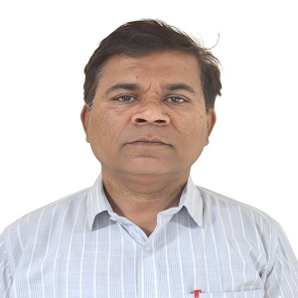
- Ms. G. SIVAKARTHI AP-III/IT 
STUDENT CO-ORDINATORS
- RITHESH R N
- VISWAKSENA M
- HARI ROSHAN B G
- REHANA SITTHIKA M S
- RITHANAYA R

ABOUT VCET
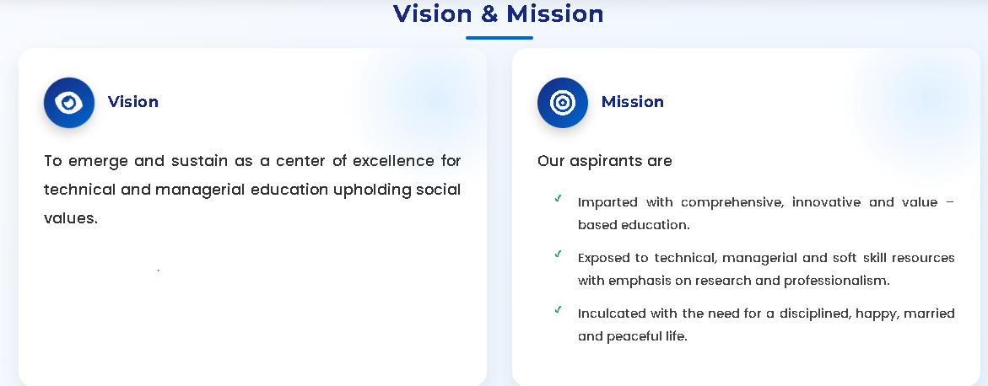
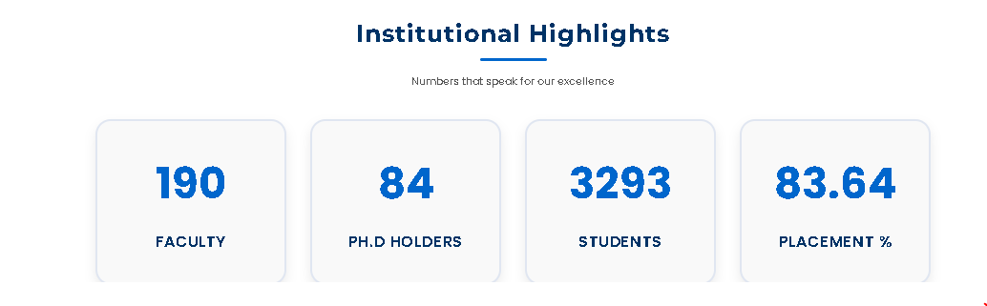
ABOUT IT DEPARTMENT
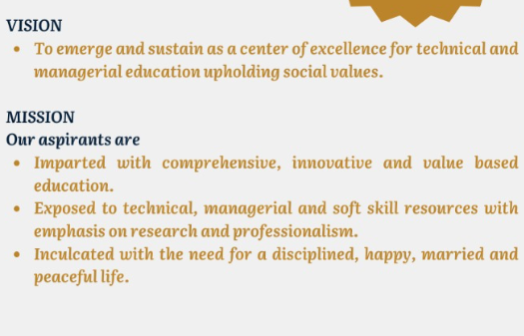

CONTACT
ADDRESS
Velammal College of Engineering and Technology
Madurai to Rameshwaram Highway, Viraganoor
Madurai - 625 009
Tamil Nadu, India
LOCATION
https://maps.app.goo.gl/NzrXARGoVX9TNccr5?g_st=aw
PHONE NO
99441 22667
EMAIL CONTACT
hacksprint26@gmail.com
LINK
www.vcet.ac.in
