import os import tensorflow as tf os.environ['TFHUB_MODEL_LOAD_FORMAT'] = 'COMPRESSED'

from google.colab import drive drive.mount('/content/drive')

Drive already mounted at /content/drive; to attempt to forcibly remount, call

import IPython.display as display

import matplotlib.pyplot as plt import matplotlib as mpl mpl.rcParams['figure.figsize'] = (12, 12) mpl.rcParams['axes.grid'] = False

import numpy as np import PIL.Image import time import functools

def tensor_to_image(tensor):

tensor = tensor*255

tensor = np.array(tensor, dtype=np.uint8)

if np.ndim(tensor)>3:

assert tensor.shape[0] == 1

tensor = tensor[0]

return PIL.Image.fromarray(tensor)

def load_img(path_to_img):

max_dim = 512

img = tf.io.read_file(path_to_img)

img = tf.image.decode_image(img, channels=3)

img = tf.image.convert_image_dtype(img, tf.float32)

shape = tf.cast(tf.shape(img)[:-1], tf.float32)

long_dim = max(shape)

scale = max_dim / long_dim

new_shape = tf.cast(shape * scale, tf.int32)

img = tf.image.resize(img, new_shape)

img = img[tf.newaxis, :]

return img

def imshow(image, title=None):

if len(image.shape) > 3:

image = tf.squeeze(image, axis=0)

plt.imshow(image) if title:

if title:

plt.title(title)

content_image = load_img("/owl.jpg") style_image = load_img("/style.jpeg")

plt.subplot(1, 2, 1) imshow(content_image, 'Content Image')

plt.subplot(1, 2, 2) imshow(style_image, 'Style Image')

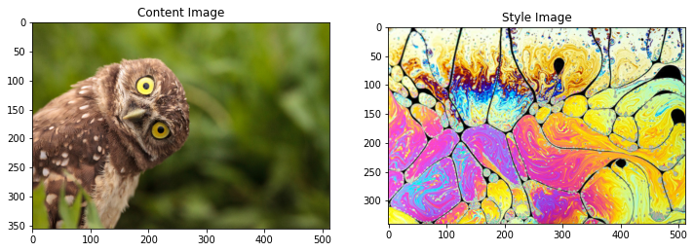

import tensorflow_hub as hub hub_model = hub.load('https://tfhub.dev/google/magenta/arbitrary-image-stylizationstylized_image = hub_model(tf.constant(content_image), tf.constant(style_image))[0] tensor_to_image(stylized_image)

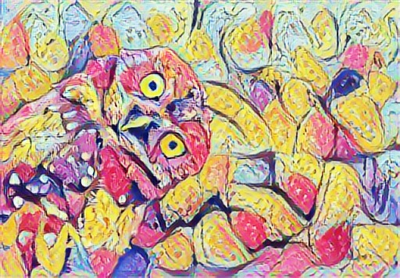

x = tf.keras.applications.vgg19.preprocess_input(content_image*255) x = tf.image.resize(x, (224, 224))

tf k li ti VGG19(i l d t T i ht 'i t')

vgg = tf.keras.applications.VGG19(include_top=True, weights='imagenet') prediction_probabilities = vgg(x) prediction_probabilities.shape

TensorShape([1, 1000])

predicted_top_5 = tf.keras.applications.vgg19.decode_predictions(prediction_probabi

[(class_name, prob) for (number, class_name, prob) in predicted_top_5]

[('great_grey_owl', 0.73142934),

('ringlet', 0.051973876),

('bittern', 0.049039505),

('vulture', 0.03952588), ('kite', 0.029020881)]

vgg = tf.keras.applications.VGG19(include_top=False, weights='imagenet')

print() for layer in vgg.layers: print(layer.name)

input_17 block1_conv1 block1_conv2 block1_pool block2_conv1 block2_conv2 block2_pool block3_conv1 block3_conv2 block3_conv3 block3_conv4 block3_pool block4_conv1 block4_conv2 block4_conv3 block4_conv4 block4_pool block5_conv1 block5_conv2 block5_conv3 block5_conv4 block5_pool

content_layers = ['block5_conv2']

style_layers = ['block1_conv1', 'block2_conv1',

'block3_conv1',

'block4_conv1',

'block5_conv1']

num_content_layers = len(content_layers) num_style_layers = len(style_layers)

def vgg_layers(layer_names):

vgg = tf.keras.applications.VGG19(include_top=False, weights='imagenet')

vgg.trainable = False

outputs = [vgg.get_layer(name).output for name in layer_names]

model = tf.keras.Model([vgg.input], outputs)

return model

style_extractor = vgg_layers(style_layers) style_outputs = style_extractor(style_image*255) for name, output in zip(style_layers, style_outputs):

print(name)

print(" shape: ", output.numpy().shape)

print(" min: ", output.numpy().min())

print(" max: ", output.numpy().max())

print(" mean: ", output.numpy().mean()) print()

block1_conv1

shape: (1, 341, 512, 64) min: 0.0 max: 836.31885 mean: 49.30245

block2_conv1

shape: (1, 170, 256, 128) min: 0.0 max: 5778.871 mean: 260.07843

block3_conv1

shape: (1, 85, 128, 256) min: 0.0 max: 12648.359 mean: 290.02325

block4_conv1

shape: (1, 42, 64, 512) min: 0.0 max: 25104.59 mean: 917.1499

block5_conv1

shape: (1, 21, 32, 512) min: 0.0 max: 3712.8596 mean: 59.95148

def gram_matrix(input_tensor):

result = tf.linalg.einsum('bijc,bijd->bcd', input_tensor, input_tensor)

input_shape = tf.shape(input_tensor)

num_locations = tf.cast(input_shape[1]*input_shape[2], tf.float32) return result/(num_locations)

class StyleContentModel(tf.keras.models.Model):

def __init__(self, style_layers, content_layers):

super(StyleContentModel, self).__init__()

self.vgg = vgg_layers(style_layers + content_layers)

self.style_layers = style_layers

self.content_layers = content_layers

self.num_style_layers = len(style_layers)

self.vgg.trainable = False

def call(self, inputs):

"Expects float input in [0,1]"

inputs = inputs*255.0

preprocessed_input = tf.keras.applications.vgg19.preprocess_input(inputs)

outputs = self.vgg(preprocessed_input)

style_outputs, content_outputs = (outputs[:self.num_style_layers], outputs[self.num_style_layers:])

style_outputs = [gram_matrix(style_output)

for style_output in style_outputs]

content_dict = {content_name: value

for content_name, value

in zip(self.content_layers, content_outputs)}

style_dict = {style_name: value

for style_name, value

in zip(self.style_layers, style_outputs)}

return {'content': content_dict, 'style': style_dict}

extractor = StyleContentModel(style_layers, content_layers)

results = extractor(tf.constant(content_image)) print('Styles:') for name, output in sorted(results['style'].items()):

print(" ", name)

print(" shape: ", output.numpy().shape)

print(" min: ", output.numpy().min())

print(" max: ", output.numpy().max())

print(" mean: ", output.numpy().mean())

print() print("Contents:") for name, output in sorted(results['content'].items()):

print(" ", name)

print(" shape: ", output.numpy().shape)

print(" min: ", output.numpy().min())

print(" max: ", output.numpy().max())

print(" mean: ", output.numpy().mean()) Styles: block1_conv1 shape: (1, 64, 64) min: 0.002655763 max: 16853.451 mean: 337.22418

block2_conv1 shape: (1, 128, 128) min: 0.0 max: 48416.816 mean: 9061.926

block3_conv1 shape: (1, 256, 256) min: 0.0 max: 317588.75 mean: 8140.998

block4_conv1 shape: (1, 512, 512) min: 0.0 max: 3212877.0 mean: 145063.1

block5_conv1 shape: (1, 512, 512) min: 0.0 max: 129496.65 mean: 1231.7739

Contents:

block5_conv2 shape: (1, 22, 32, 512) min: 0.0 max: 1756.408 mean: 12.337271

style_targets = extractor(style_image)['style'] content_targets = extractor(content_image)['content']

image = tf.Variable(content_image)

def clip_0_1(image):

return tf.clip_by_value(image, clip_value_min=0.0, clip_value_max=1.0)

opt = tf.optimizers.Adam(learning_rate=0.02, beta_1=0.99, epsilon=1e-1)

style_weight=1e-2 content_weight=1e4

def style_content_loss(outputs): style_outputs = outputs['style']

content_outputs = outputs['content']

style_loss = tf.add_n([tf.reduce_mean((style_outputs[name]-style_targets[name])

for name in style_outputs.keys()])

style_loss *= style_weight / num_style_layers

content_loss = tf.add_n([tf.reduce_mean((content_outputs[name]-content_targets[

for name in content_outputs.keys()])

content_loss *= content_weight / num_content_layers

loss = style_loss + content_loss

return loss

@tf.function() def train_step(image):

with tf.GradientTape() as tape:

outputs = extractor(image)

loss = style_content_loss(outputs)

grad = tape.gradient(loss, image)

opt.apply_gradients([(grad, image)]) image.assign(clip_0_1(image))

train_step(image) train_step(image) train_step(image) tensor_to_image(image)

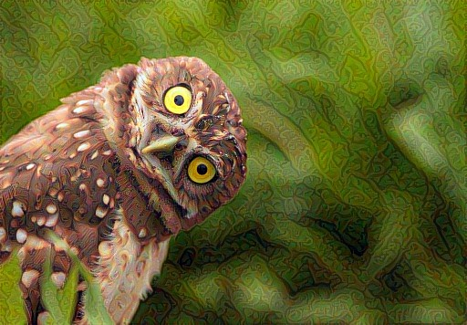

import time start = time.time() epochs = 10

steps_per_epoch = 100

step = 0 for n in range(epochs): for m in range(steps per epoch): for m in range(steps_per_epoch):

step += 1

train_step(image)

print(".", end='', flush=True)

display.clear_output(wait=True)

display.display(tensor_to_image(image))

print("Train step: {}".format(step))

end = time.time()

print("Total time: {:.1f}".format(end-start))

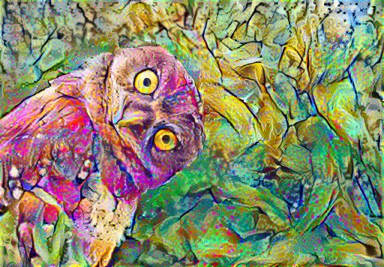

Train step: 1000

Total time: 69.7

def high_pass_x_y(image):

x_var = image[:, :, 1:, :] - image[:, :, :-1, :] y_var = image[:, 1:, :, :] - image[:, :-1, :, :]

return x_var, y_var

x_deltas, y_deltas = high_pass_x_y(content_image) plt.figure(figsize=(14, 10)) plt.subplot(2, 2, 1) imshow(clip_0_1(2*y_deltas+0.5), "Horizontal Deltas: Original")

plt.subplot(2, 2, 2) imshow(clip_0_1(2*x_deltas+0.5), "Vertical Deltas: Original")

x_deltas, y_deltas = high_pass_x_y(image) plt.subplot(2, 2, 3) imshow(clip_0_1(2*y_deltas+0.5), "Horizontal Deltas: Styled")

plt.subplot(2, 2, 4) imshow(clip 0 1(2*x deltas+0.5), "Vertical Deltas: Styled") ( p_ _ ( _ ), y )

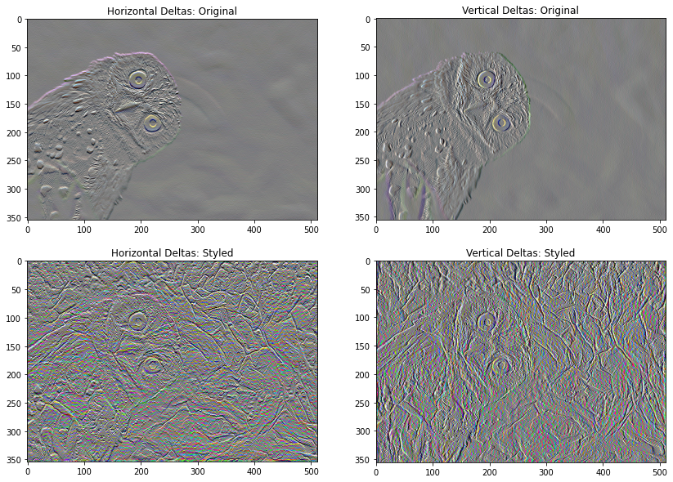

plt.figure(figsize=(14, 10))

sobel = tf.image.sobel_edges(content_image) plt.subplot(1, 2, 1) imshow(clip_0_1(sobel[..., 0]/4+0.5), "Horizontal Sobel-edges") plt.subplot(1, 2, 2) imshow(clip_0_1(sobel[..., 1]/4+0.5), "Vertical Sobel-edges")

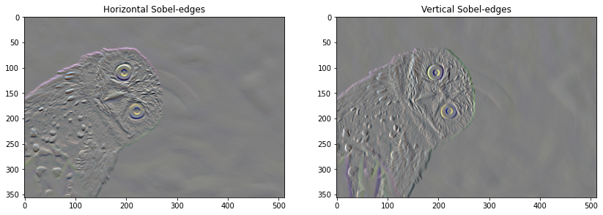

def

total_variation_loss

(

image

):

x_deltas, y_deltas = high_pass_x_y(image)

return

tf.reduce_sum(tf.

abs

(

x_deltas)) + tf.reduce_sum(tf.

abs

(

y_deltas

))

total_variation_loss(image).numpy()

144818.97

tf.image.total_variation(image).numpy() array([144818.97], dtype=float32)

total_variation_weight=30

@tf.function() def train_step(image):

with tf.GradientTape() as tape:

outputs = extractor(image)

loss = style_content_loss(outputs)

loss += total_variation_weight*tf.image.total_variation(image)

grad = tape.gradient(loss, image)

opt.apply_gradients([(grad, image)]) image.assign(clip_0_1(image))

image = tf.Variable(content_image)

import time start = time.time() epochs = 10 steps_per_epoch = 100

step = 0 for n in range(epochs):

for m in range(steps_per_epoch):

step += 1

train_step(image)

print(".", end='', flush=True)

display.clear_output(wait=True)

display.display(tensor_to_image(image))

print("Train step: {}".format(step))

end = time.time() print("Total time: {:.1f}".format(end-start))

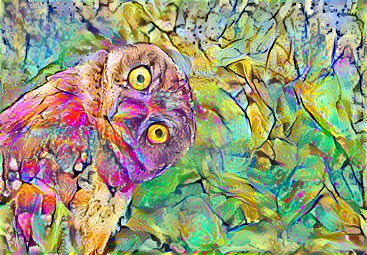

Train step: 1000

Total time: 69.6

file_name =

'stylized_tranfer_image.png'

tensor_to_image(image).save(file_name)

try

:

from

google.colab

import

files

except

ImportError:

pass

else

:

files.download(file_name)