FitTrack
Dynamic Web Applications · Report
Student ID: 33776900 | Repository: 10_health_33776900

Outline
FitTrack is a health and fitness web application for recording and reviewing personal workouts. A visitor can view the home and about pages, then register or use the sample administrator account. Once logged in, each user has a dashboard showing total workouts, active minutes and estimated calories. Users can add a workout with an exercise name, category, duration, calories, date and notes. They can list, edit and delete only their own entries, display sessions of 30 minutes or less, and search the MySQL database by exercise, category or notes. An administrator can view registered users and a record of successful and failed login attempts. The project uses Node.js, Express, EJS and MySQL and runs on port 8000. It includes database setup and test-data scripts, a sample administrator account, deployment links and this report.

Architecture
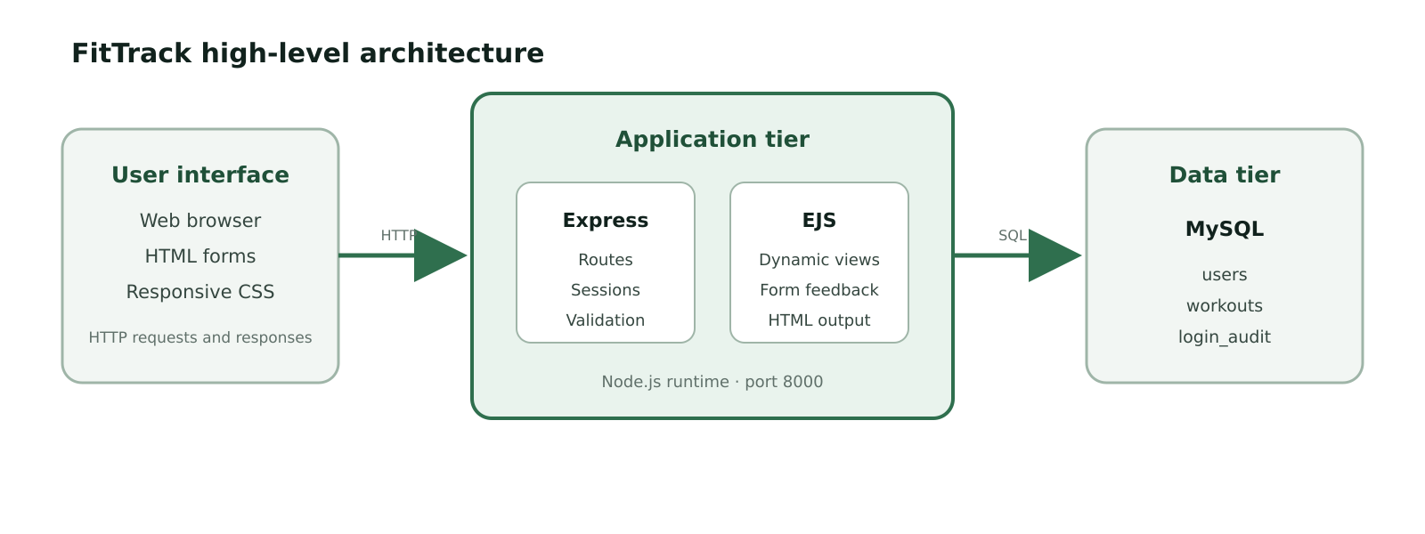
Figure 1. Browser, application and data tiers.
Requests from the browser are handled by Node.js and Express. Express routes validate forms, manage the login session, run parameterised SQL queries and pass results to EJS. EJS renders HTML styled by public/main.css. MySQL forms the data tier and stores users, workouts and login attempts. The application starts from index.js and listens on port 8000.

Data Model
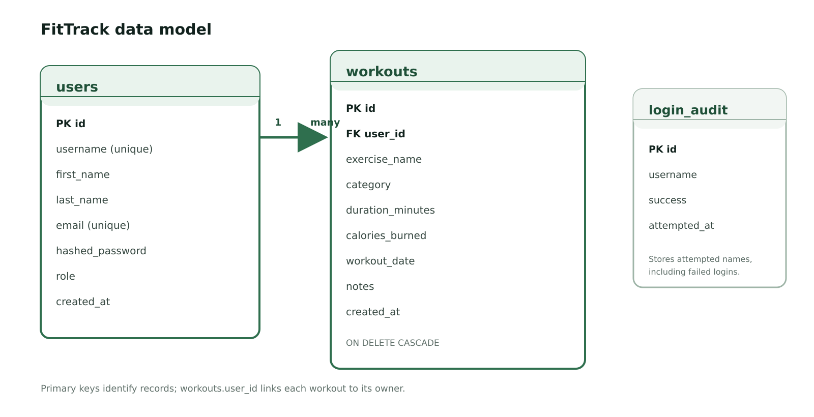
Figure 2. MySQL tables and the users-to-workouts relationship.
The users table stores account details, a bcrypt password hash and a member or admin role. Each workouts row belongs to one user through user_id; the foreign key uses ON DELETE CASCADE so dependent workouts cannot be orphaned. The login_audit table stores the username, outcome and time of each login attempt. It intentionally has no user foreign key because a failed attempt may use a username that does not exist. create_db.sql builds the tables and insert_test_data.sql adds the sample administrator account and workout records.

User functiomality
Public visitors can open a home page that explains the three main tasks and an about page that explains the application and technology stack. Registration collects names, email, username and password. Validation shows useful errors and bcrypt stores only a password hash. The sample gold administrator account can log in using the documented credentials. After login, the navigation exposes the dashboard, workouts and search; administrators also receive an Admin link.
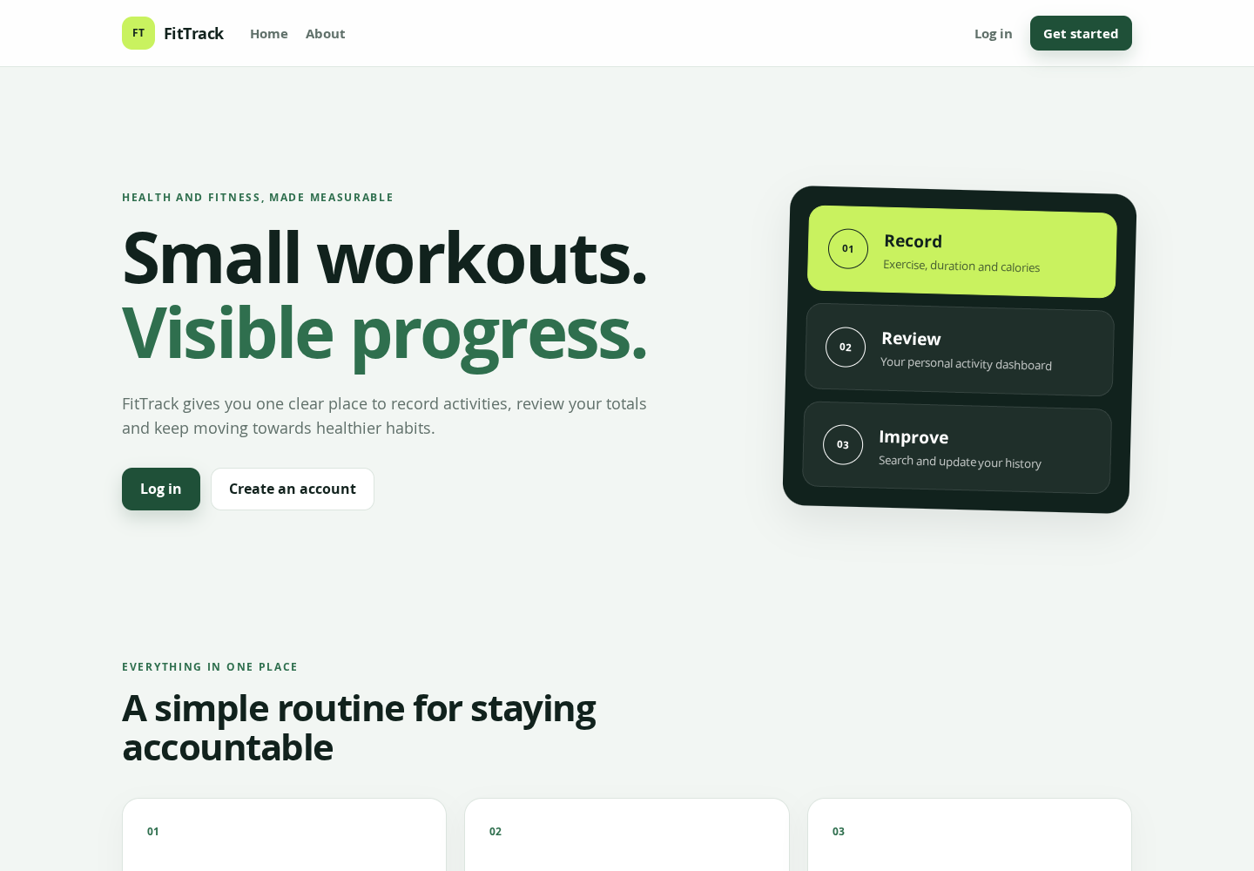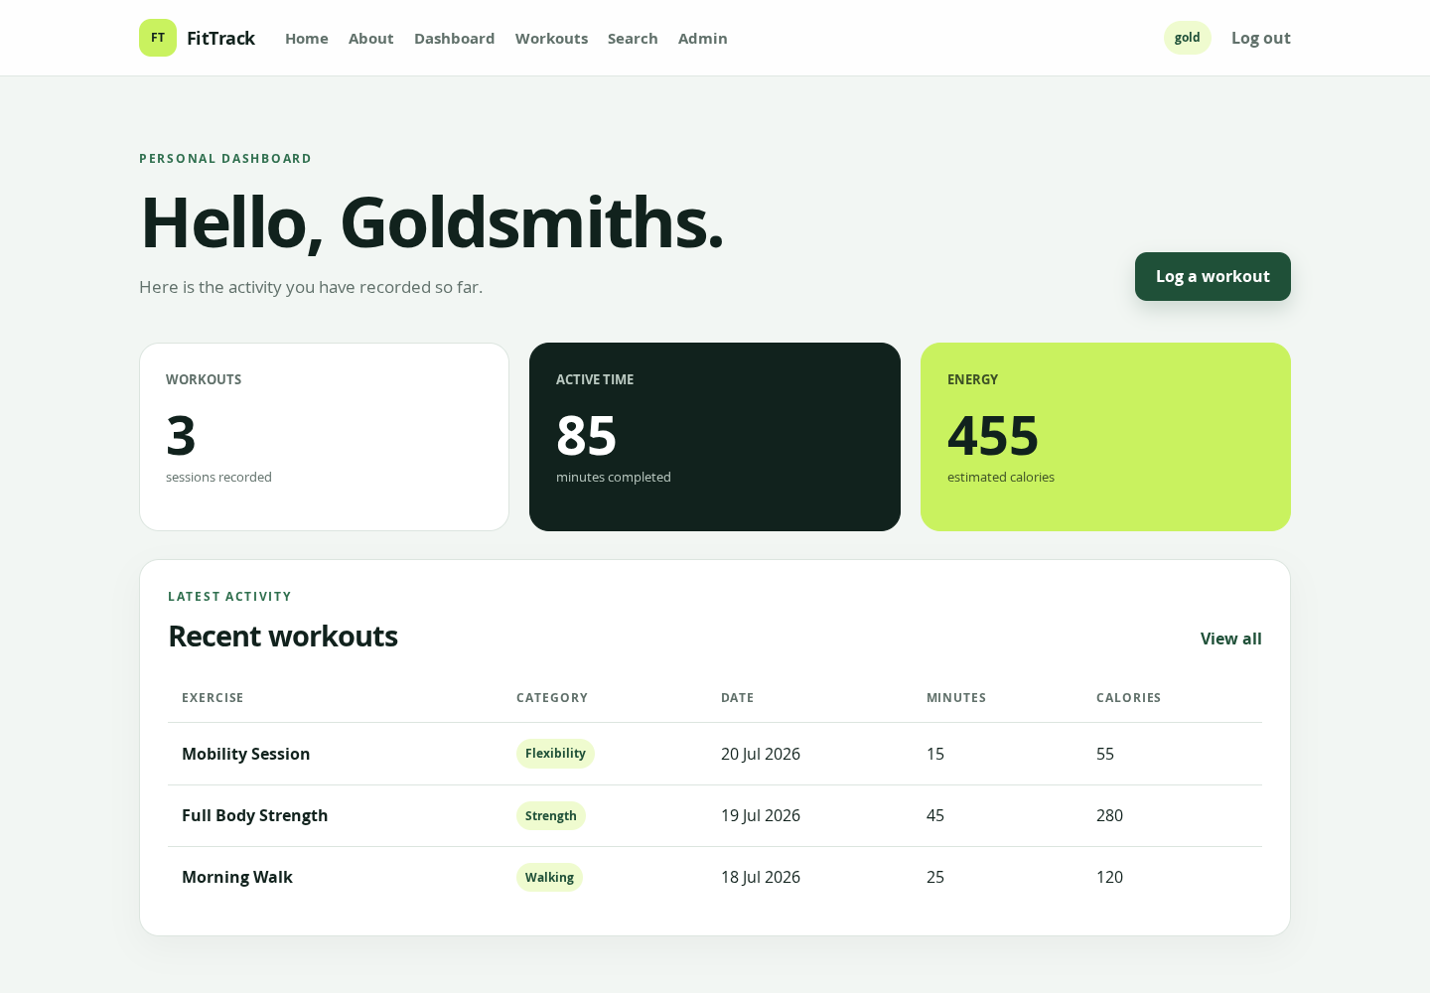
Figures 3–4. Public home page (top) and the signed-in dashboard (bottom).
The dashboard gives an overview of the current user’s records. SQL totals show the number of sessions, active minutes and estimated calories, followed by the five most recent workouts. The workout history lists full details. The add form inserts a record in MySQL, Edit pre-populates the same form, and Delete asks for confirmation. Every select, update and delete includes the logged-in user ID, so one member cannot manage another member’s data.
Quick Workouts uses a filtered query to show sessions lasting 30 minutes or less. Search accepts a keyword and checks exercise name, category and notes in MySQL while restricting results to the current user. Empty states and validation messages explain what to do if there are no records or the input is invalid.

Managing and finding workouts
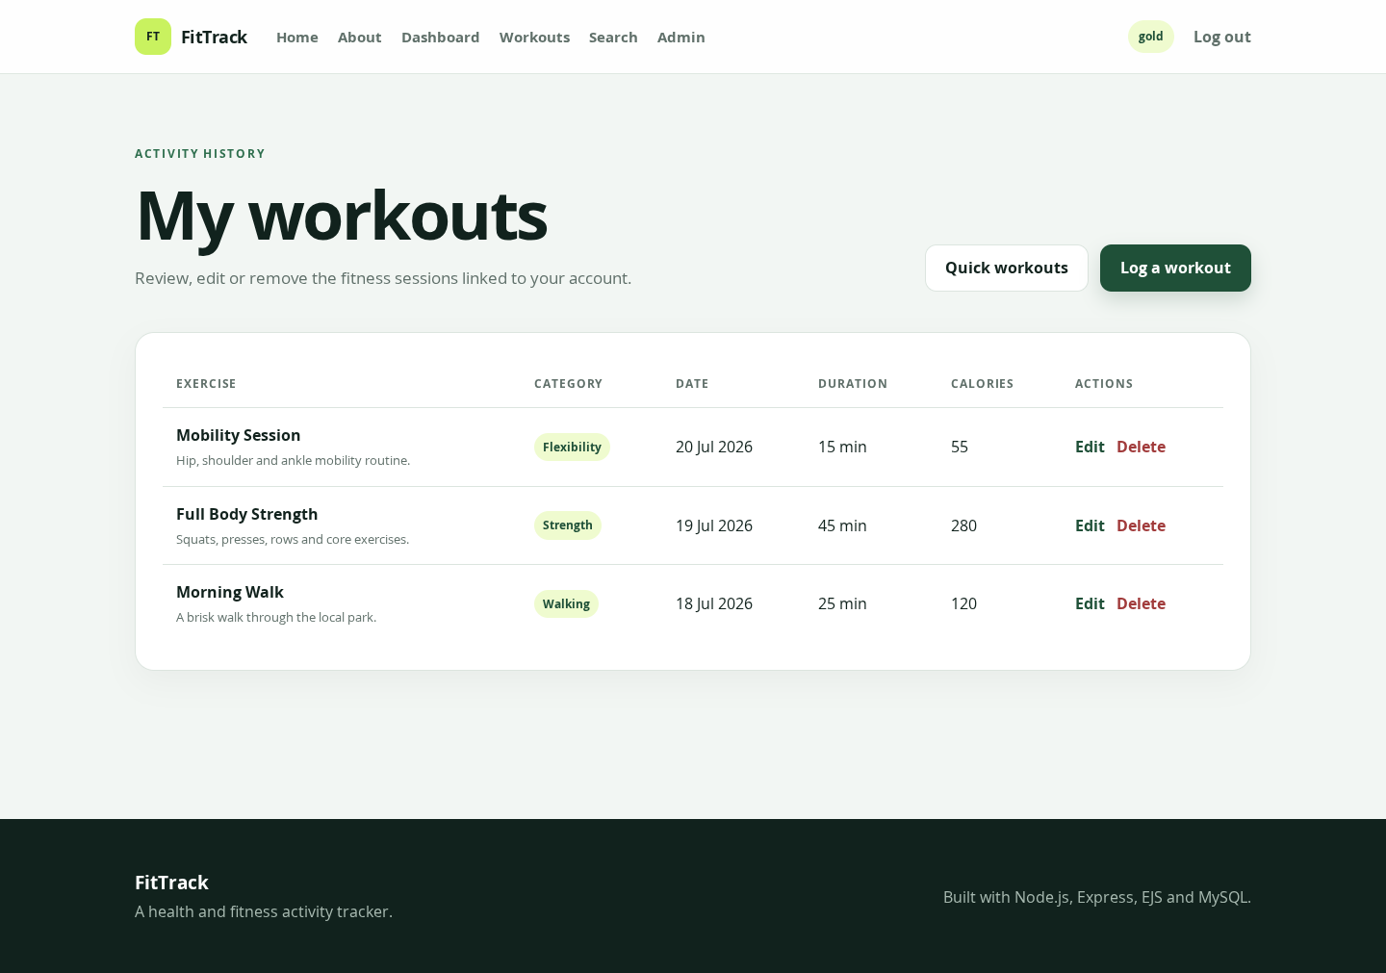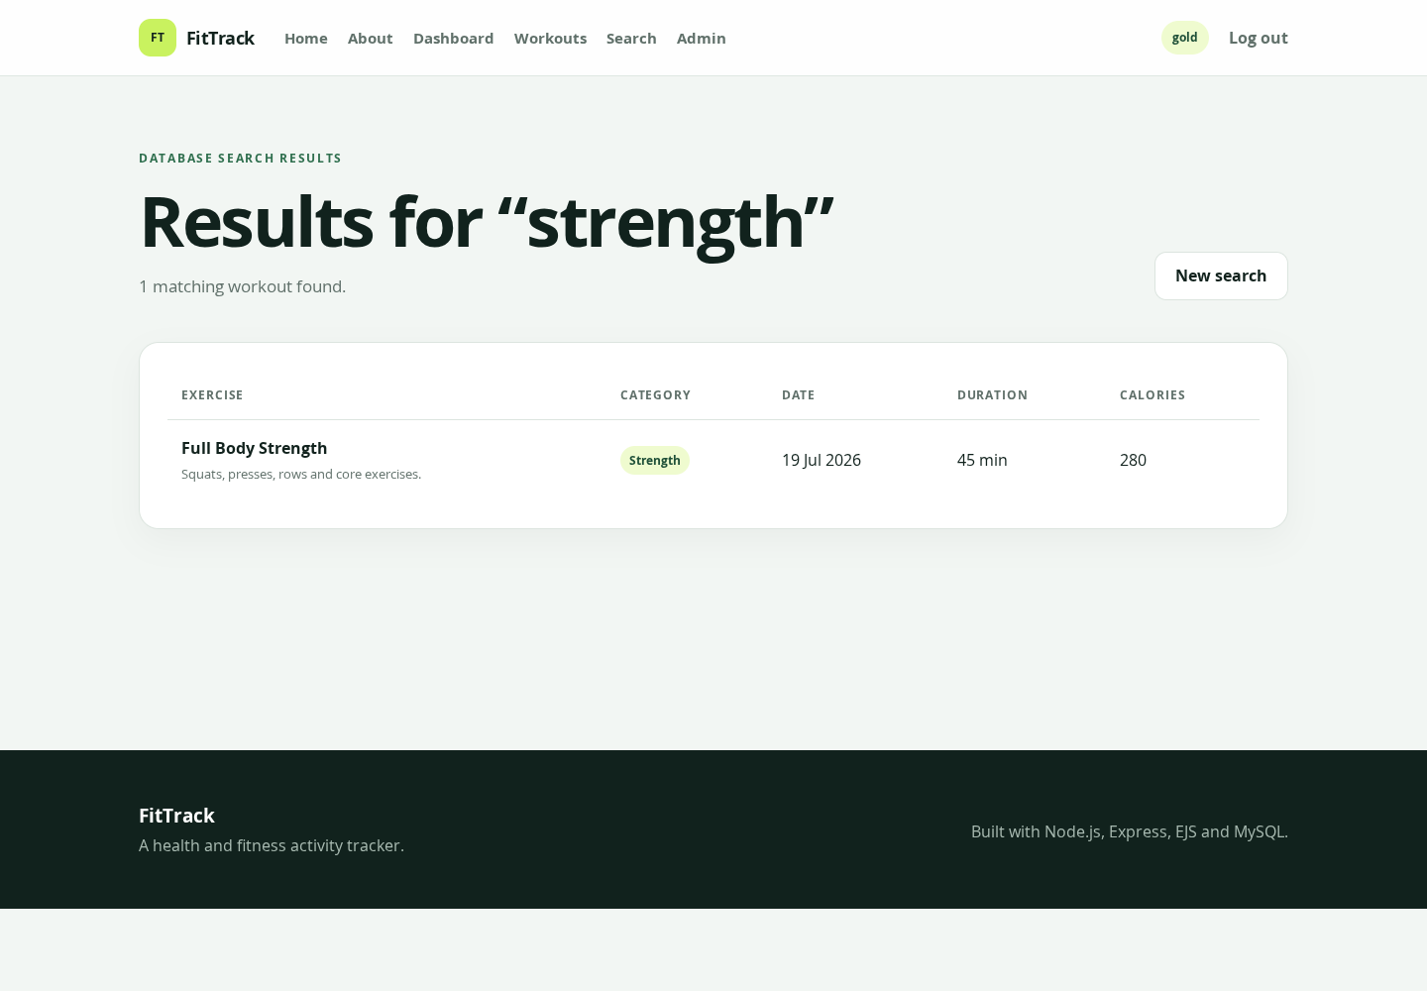
Figures 5–6. Workout management (top) and database search results (bottom).
The administrator pages show registered users and the most recent successful or failed login attempts. Pages that require an account redirect to login, while admin-only pages return an access-denied response to an ordinary member. The layout adapts to smaller screens using CSS, and EJS escapes displayed values by default.

Advanced Techniques

1. Parameterised, account-scoped search
The search uses one LIKE value across three columns and passes every value separately to mysql2. The user ID is included in the same query, so results remain private to the signed-in account (routes/main.js).
const searchValue = `%${req.body.keyword}%`;
WHERE user_id = ?
AND (exercise_name LIKE ? OR category LIKE ? OR notes LIKE ?)
db.query(sql, [req.session.user.id, searchValue, searchValue, searchValue], ...);

2. Ownership checks for CRUD
Update and delete queries match both the record ID and the session user ID. Changing an ID in the URL therefore cannot edit another member’s workout. express-validator also checks workout fields before insert or update (routes/main.js).
UPDATE workouts
SET exercise_name = ?, category = ?, duration_minutes = ?,
calories_burned = ?, workout_date = ?, notes = ?
WHERE id = ? AND user_id = ?

3. Passwords, roles and login audit
Registration hashes passwords with bcrypt. Login compares the submitted password with the stored hash, stores only basic account information in the session, and records the outcome in login_audit. requireLogin and requireAdmin are reused as route guards (routes/main.js).
req.session.user = {
id: user.id,
username: user.username,
firstName: user.first_name,
role: user.role
};

4. Dashboard totals
The dashboard creates useful information from the stored records by using COUNT and SUM with COALESCE. It then runs a second query for the five most recent workouts (routes/main.js).
SELECT COUNT(*) AS workout_count,
COALESCE(SUM(duration_minutes), 0) AS total_minutes,
COALESCE(SUM(calories_burned), 0) AS total_calories
FROM workouts WHERE user_id = ?

AI Declaration
I used ChatGPT to help plan how my existing Bertie’s Books work could be adapted to the health and fitness brief, draft and refactor parts of the routes, EJS templates and CSS, troubleshoot issues, prepare a testing checklist, and structure this report. The starting code and techniques—Express routes, EJS, MySQL, search, sessions, bcrypt, validation, CRUD and login auditing—came from my own completed module labs and previous coursework. I am responsible for checking, understanding and explaining the submitted code.

