New-Indian-Restaurant-Sydney.com

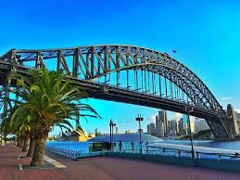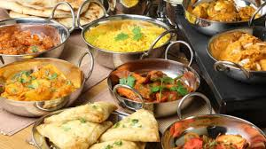

NEW INDIAN RESTAURANT LOCATIONS - SYDNEY

**Recommended suburbs (as of Dec 2018 in order of priority)**

|  |  |
| --- | --- |
| **Eastwood - Gladesville-Ryde-Eastwood**  **Ultimo - Central & Inner Metropolitan**  **Cremorne – North Shore** |  |
| **Hurstville - St George & Sutherland Shire**  **Burwood - Western Suburbs**  **Newtown - Central & Inner Metropolitan**  **Waterloo - Central & Inner Metropolitan**  **Gladesville - Gladesville-Ryde-Eastwood**  **Merrylands - South Western Suburbs**  **Narrabeen - Northern Beaches** |  |

**Based on research these are the factors for opening new Indian Restaurant in Sydney**

**1 Should be in areas with many Asian non-Indian restaurant**

**2 with no or one existing Indian Restaurant**

**3 In medium earning areas (High and low are not suitable)**

**4 With medium/ low crime rates**

**5 High Density population areas (Indian population density should not be a criteria)**

**6 Ample parking spaces**