COLLEGE CODE : 5113

COLLEGE NAME : Kingston Engineering College

DOMAIN : Internet of Things

PROJECT TITLE : Noise Pollution Monitoring System

PROJECT MEMBERS:

D Navin(Leader) 511321104062

D Namdev 511321104060

B Purushoth 511321104076

H Sai Jaswanth 511321104083

T Vamsi Krishna 511321104108

INTRODUCTION:

Monitoring noise pollution with Arduino and sound devices can be a valuable project, helping to collect data for environmental purposes or personal use. Below is a development plan for such a project:

BLOCK DIAGRAM:

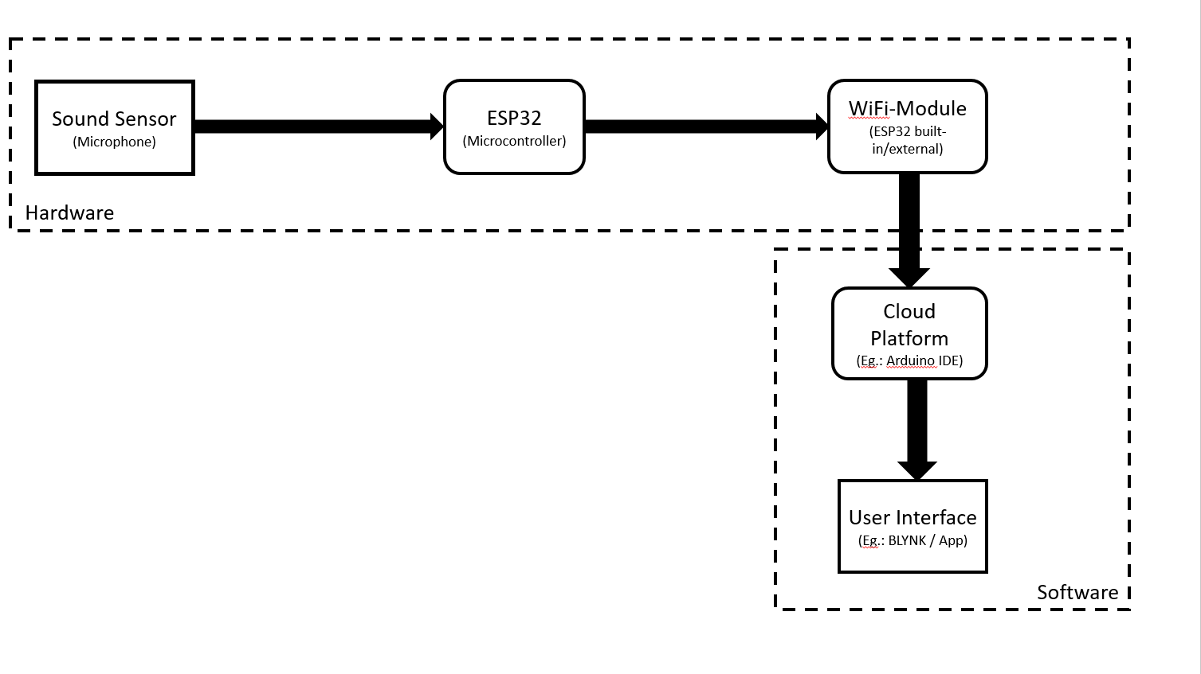

1. Define Project Objectives: -

Clearly state the goals of your noise pollution monitoring system. Consider what you want to achieve and the specific data you wish to collect.

2. Select Hardware and Components: -

Choose the right sound sensor or microphone for your project. Some popular options include electret condenser microphones or sound level sensors.

- You will also need an Arduino board (e.g., Arduino Uno, Arduino Nano) to process data.

- Depending on the project's requirements, consider other components like an SD card module for data storage, an LCD screen for real-time display, and a power source.

3. Software Development: -

Write the Arduino code to interface with the sound sensor/microphone and collect noise data.

- You may need to use libraries for signal processing or noise analysis.

- Implement data logging functions to store noise level data.

4. Data Processing: -

Consider including data preprocessing steps if required. This can include filtering, averaging, or other data manipulation to get more accurate readings.

5. Calibration: -

Calibrate your sound sensor to real-world noise levels to ensure accurate measurements.

6. Data Storage: -

Implement data storage options, such as writing data to an SD card, uploading to a cloud server, or displaying on a local screen.

7. Real-Time Display: -

If you want real-time monitoring, connect an LCD or LED display to show noise levels.

8. Data Analysis: -

Develop software for data analysis to identify patterns and trends in noise pollution data over time.

9. Connectivity: -

Add Wi-Fi or Bluetooth modules to transmit data to a remote server for centralized monitoring and analysis.

10. Power Supply: -

Ensure that you have a reliable power source for your Arduino and sensors. Battery or solar power options can be considered for remote and outdoor deployments.

11. Housing and Weatherproofing: -

If the system will be deployed outdoors, consider weatherproofing and enclosure options to protect the components.

12. Testing and Calibration: -

Test your system in various environments to ensure accurate and reliable noise measurements. - Recalibrate as needed to maintain data accuracy.

13. Data Visualization:-

If desired, create a data visualization dashboard, which could include graphs, maps, or a web-based interface to view the noise pollution data.

14. Maintenance and Monitoring:-

Develop a plan for maintaining and monitoring the system, including periodic calibration and checking for hardware issues.

15. Data Usage:-

Determine how you will use the collected data. Will you share it with the public, local authorities, or for personal analysis?

16. Legal and Ethical Considerations:-

Be aware of any legal and ethical considerations related to collecting noise data, especially in public spaces.

Remember that noise pollution monitoring can serve a range of purposes, from community awareness to scientific research, so adapt your project's complexity and features to the intended application. Additionally, consider using open-source and open-data principles to encourage collaboration and knowledge sharing

PYTHON PROGRAM

import sounddevice as sd

import numpy as np

import csv

import time

# Define the parameters

duration = 3600 # Recording duration in seconds (1 hour)

sample_rate = 44100 # Sampling rate in Hz

channels = 1 # Mono audio

# Create an empty list to store the sound level data

sound_levels = []

# Function to calculate the decibel level

def calculate_decibel_level(audio_data):

rms = np.sqrt(np.mean(audio_data**2))

decibel_level = 20 * np.log10(rms)

return decibel_level

# Callback function for recording audio

def audio_callback(indata, frames, time, status):

if status:

print("Error:", status)

decibel_level = calculate_decibel_level(indata) sound_levels.append(decibel_level)

# Start recording

with sd.InputStream(callback=audio_callback, Channels=channels, samplerate=sample_rate):

print(f"Recording for {duration} seconds...")

sd.sleep(duration * 1000) # Sleep for the recording duration

# Save the recorded data to a CSV file

timestamp = time.strftime("%Y%m%d%H%M%S")

filename = f"sound_levels_{timestamp}.csv"

with open(filename, 'w', newline='') as csvfile:

csv_writer = csv.writer(csvfile)

csv_writer.writerow(['Time', 'Decibel Level (dB)'])

for i, level in enumerate(sound_levels):

csv_writer.writerow([i / sample_rate, level])

print(f"Data saved to {filename}"