# IoT BASED NOISE POLLUTION MONTIORING

# PHASE 2 PROJECT SUBMISSION

INTRODUCTION:

Here in the Phase 2 of our IoT-Based Noise Pollution Monitoring System project focuses on taking the design concepts from Phase 1 and transforming them into innovative solutions for noise pollution monitoring. Here are the detailed steps for this transformation:

BLOCK DIAGRAM:

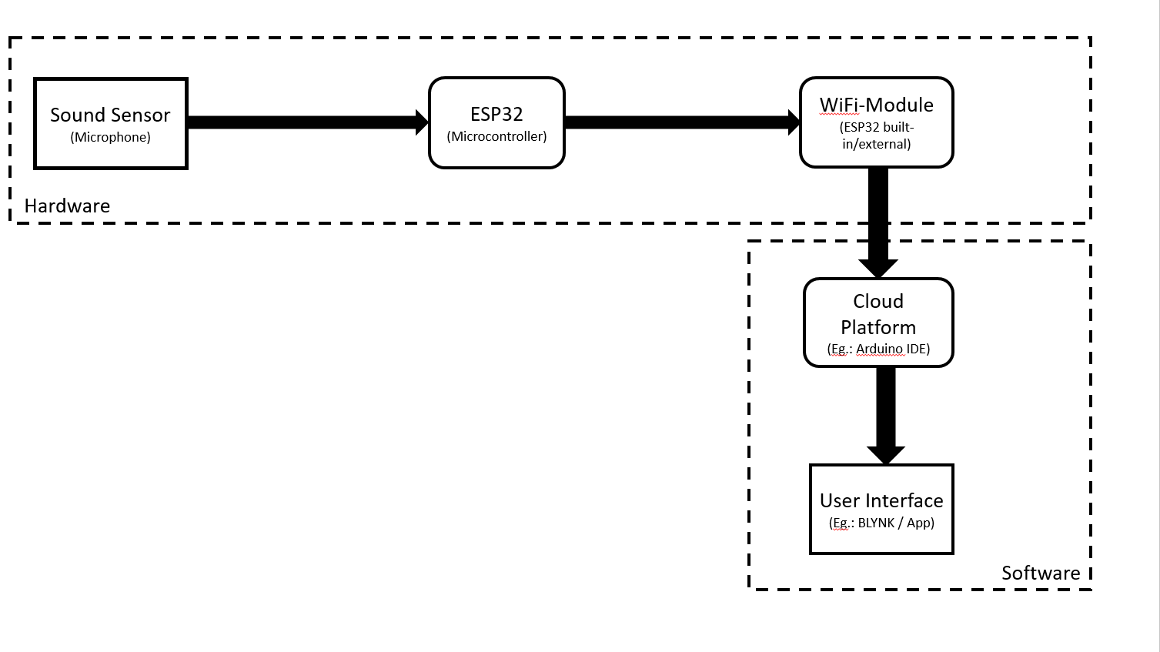

1. Concept Validation:

Before proceeding with the implementation, validate the feasibility and effectiveness of the design concepts developed in Phase 1. This may involve testing the selected IoT sensors, communication protocols, and data processing methods in controlled environments.

2. Prototyping:

Create a prototype of the IoT sensor system, including the selected sensors and communication modules. This allows you to test and refine the hardware components before full-scale deployment.

3. Sensor Network Optimization:

Optimize the design of the sensor network architecture. Ensure that sensors are strategically placed in public areas to capture accurate noise data and minimize interference. Consider factors such as coverage, data transmission range, and power consumption.

sensor, ESP32, Wi-Fi module, and cloud infrastructure components of your IoT-Based Noise Pollution Monitoring System project:

Sensor Selection and Design:

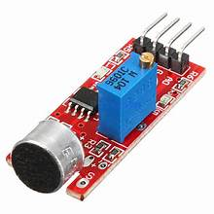

Choose appropriate noise sensors (e.g., microphones or sound level meters) with the necessary sensitivity and accuracy to measure noise pollution effectively.

Consider factors such as frequency range, resolution, and dynamic range to ensure the sensors capture a wide range of noise levels accurately.

Develop a sensor calibration procedure to ensure data accuracy.

ESP32 Microcontroller:

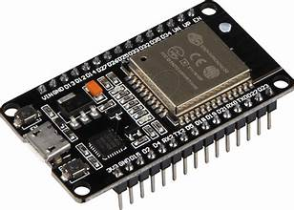

The ESP32 is a versatile and cost-effective microcontroller suitable for IoT applications. It can be used as the central processing unit for your noise pollution monitoring system.

Configure the ESP32 to interface with the noise sensors, collect data from them, and transmit it to the central server.

Implement low-power modes to optimize energy consumption, especially if the system is battery-powered.

Wi-Fi Module:

The Wi-Fi module, typically integrated into the ESP32, is essential for wireless data transmission.

Configure the Wi-Fi module to connect to a local network or cellular data network, depending on the deployment environment.

Implement secure communication protocols such as HTTPS or MQTT over TLS to ensure data security during transmission.

4. Firmware Development:

Develop or customize firmware for the IoT sensors to collect noise data accurately. Implement algorithms for data preprocessing, noise level calculations, and data transmission to the central server.

5. Data Security and Privacy:

Implement robust security measures to protect the collected data from unauthorized access or tampering. Ensure compliance with data privacy regulations, and design mechanisms for user consent and data anonymization if needed.

6. Cloud-Based Server Setup:

Set up a cloud-based server infrastructure to store and process the incoming noise data. Choose a scalable cloud provider like AWS, Azure, or Google Cloud, and configure the necessary databases and storage systems.

7. Real-Time Data Processing:

Enhance the data processing capabilities by leveraging cloud-based services for real-time data analysis and visualization. Use Python-based tools and libraries to process the data efficiently.

8. User-Friendly Interface Refinement:

Continue to develop and refine the user-friendly web-based platform or mobile app. Focus on creating an intuitive and engaging user interface that allows users to access and understand real-time noise pollution data easily.

9. Integration Testing:

Conduct extensive integration testing to ensure that the IoT sensors, data transmission, data processing, and user interface components work seamlessly together. Identify and resolve any compatibility or synchronization issues.

10. Scalability and Redundancy:

Prepare the system for scalability by designing it to handle a growing number of sensors and users. Implement redundancy and failover mechanisms to ensure system reliability and uptime.

11. Performance Optimization:

Optimize the system's performance to minimize latency and ensure timely data updates on the user interface. Monitor and fine-tune the system for optimal resource utilization.

12. User Training and Documentation:

Provide training and documentation for users and administrators to ensure they can effectively use and manage the system. This may include tutorials, user manuals, and troubleshooting guides.

13. Innovation Assessment:

Continuously assess and explore innovative technologies and approaches to improve the system. This could involve exploring machine learning techniques for noise prediction or incorporating new sensor technologies for enhanced data accuracy.

14. Regulatory Compliance:

Ensure that the system complies with all relevant regulatory requirements, including noise pollution monitoring standards and data privacy regulations.

15. Pilot Deployment:

Conduct a pilot deployment in a select area to gather real-world feedback and fine-tune the system based on user experiences and requirements.

16. Documentation and Reporting:

Maintain thorough documentation of the system's design, architecture, and components. Create progress reports to keep stakeholders informed of the project's status.

By following these steps, you can effectively transform your design concepts into an innovative IoT-based noise pollution monitoring system that addresses the problem and provides valuable insights to the public and local authorities. Continuous innovation and refinement will ensure the system's effectiveness and relevance in combating noise pollution.