

Safety Plan Lane Assistance

**Document Version: 1.1**

**Version 1.1, Released on 2018-05-22**



# Document history

|  |  |  |  |
| --- | --- | --- | --- |
| Date | Version | Editor | Description |
| 2018-05-18 | 1.0 | Navin Rawther | First Draft |
| 2018-05-22 | 1.1 | Navin Rawther | Updated DIA |
|  |  |  |  |
|  |  |  |  |
|  |  |  |  |

# Table of Contents

Document history

Table of Contents

Introduction

Purpose of the Safety Plan

Scope of the Project

Deliverables of the Project

Item Definition

Goals and Measures

Goals

Measures

Safety Culture

Safety Lifecycle Tailoring

Roles

Development Interface Agreement

Confirmation Measures

# Introduction

## Purpose of the Safety Plan

The Safety Plan defines the steps that are to be taken to achieve functional safety. It defines the goals and measures and roles and responsibilities to ensure that important safety design steps are not missed.

## Scope of the Project

For the lane assistance project, the following safety lifecycle phases are in scope:

Concept phase

Product Development at the System Level

Product Development at the Software Level

The following phases are out of scope:

Product Development at the Hardware Level

Production and Operation

## Deliverables of the Project

The deliverables of the project are:

Safety Plan

Hazard Analysis and Risk Assessment

Functional Safety Concept

Technical Safety Concept

Software Safety Requirements and Architecture

# Item Definition

The item under consideration for this safety plan is the lane assistance system. This system makes sure that the vehicle stays in the current lane unless the driver has turned the indicator lanes on.

The Lane Assistance system has two functions:

1. Lane Departure Warning – will vibrate the steering wheel when the car drifts towards the edge of the lane
2. Lane keeping assistance – will move the steering wheel so that the wheels turn towards the center of the lane when car drifts away from the center of the lane.

The camera subsystem, the car display subsystem and the steering subsystem are responsible for each of these functions. The camera subsystem identifies the lane lines and warns when the car drifts away from the center of the lane. The car display subsystem shows the warning when this happens. The steering subsystem provides haptic feedback and turns such that the wheels turn towards the center of the lane when this happens.

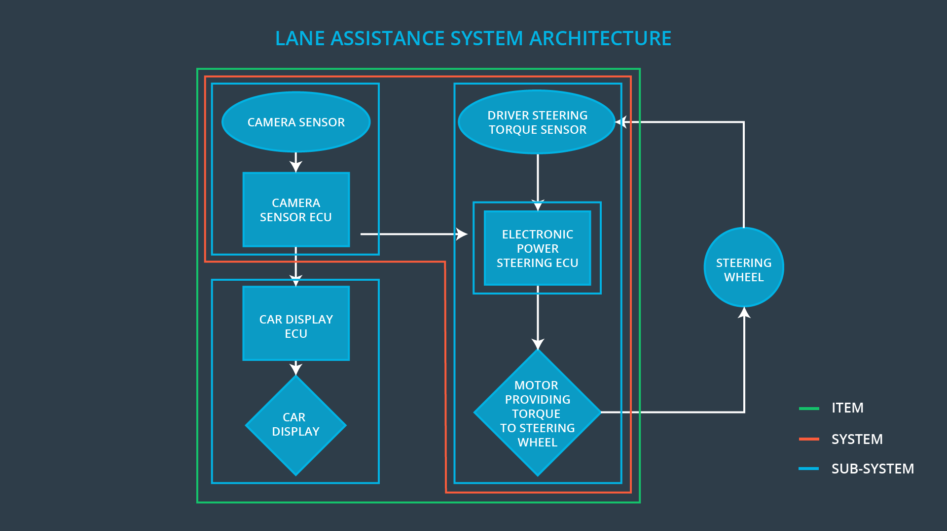

The above image shows the lane assistance item and its systems and subsystems. The main system of the item contains the camera subsystem and the steering subsystem with a display subsystem outside of the system. The steering wheel actually lies outside the item.

# Goals and Measures

## Goals

The Goal of this Safety Plan is to reduce risks to reasonable levels by identifying hazards that could lead to accidents, evaluating the risks associated with each hazard and using systems engineering to lower risks to acceptable levels.

## Measures

|  |  |  |
| --- | --- | --- |
| Measures and Activities | Responsibility | Timeline |
| Follow safety processes | All Team Members | Constantly |
| Create and sustain a safety culture | All Team Members | Constantly |
| Coordinate and document the planned safety activities | Safety Manager | Constantly |
| Allocate resources with adequate functional safety competency | Project Manager | Within 2 weeks of start of project |
| Tailor the safety lifecycle | Safety Manager | Within 4 weeks of start of project |
| Plan the safety activities of the safety lifecycle | Safety Manager | Within 4 weeks of start of project |
| Perform regular functional safety audits | Safety Auditor | Once every 2 months |
| Perform functional safety pre-assessment prior to audit by external functional safety assessor | Safety Manager | 3 months prior to main assessment |
| Perform functional safety assessment | Safety Assessor | Conclusion of functional safety activities |

# Safety Culture

Safety is the highest priority for our company among other constraints such as cost and productivity. We have incorporated the following to ensure this:

* **Accountability** in processes such that design decisions are traceable back to the people and teams who made the decisions
* **Rewards** that motivates and supports the achievement of functional safety
* **Penalties** that penalizes shortcuts that jeopardize safety or quality
* **Independence** betweenteams who design and develop a product and the teams who audit the work
* **Well defined processes** for design and management
* **Resources** in projects by including people with appropriate skills
* **Diversity** integrated into processes as they are highly valued
* **Communication** channels to encourage disclosure of problems

# Safety Lifecycle Tailoring

For the lane assistance project, the following safety lifecycle phases are in scope:

Concept phase

Product Development at the System Level

Product Development at the Software Level

The following phases are out of scope:

Product Development at the Hardware Level

Production and Operation

# Roles

|  |  |
| --- | --- |
| Role | Org |
| Functional Safety Manager- Item Level | OEM |
| Functional Safety Engineer- Item Level | OEM |
| Project Manager - Item Level | OEM |
| Functional Safety Manager- Component Level | Tier-1 |
| Functional Safety Engineer- Component Level | Tier-1 |
| Functional Safety Auditor | OEM or external |
| Functional Safety Assessor | OEM or external |

# Development Interface Agreement

The Development Interface Agreement (DIA) defines the roles and responsibilities between the OEM and the Tier-1 company involved in developing the lane assistance system.

The OEM is responsible for providing a functional lane assistance system. The Functional Safety Manager and Engineer in the OEM will be responsible for providing the same. The Tier-1 company is responsible for analyzing and modifying the sub-systems of the lane assistance system from a functional safety viewpoint. The Tier-1 company will be responsible for finding and fixing the safety problems in the lane assistance system. The Safety Manager in the Tier-1 company will ensure all safety practices are followed. The Safety Engineer in the Tier-1 company will be responsible for each activity in the design and production. An external Functional Safety Auditor and Functional Safety Assessor will be appointed by the OEM to assess and audit the work done by Tier-1.

# Confirmation Measures

The confirmation measures ensure:

* that the functional safety project conforms to ISO 26262, and
* that the project does make the vehicle safer.

The confirmation review ensures that the project compiles with ISO 26262. As the product is designed and developed, an independent person would review the work to make sure ISO 26262 is being followed.

The functional safety audit checks to make sure that the actual implementation of the project conforms to the safety plan.

The functional safety assessment is the process of confirming that plans, designs and developed products actually achieve functional safety.