

Functional Safety Concept Lane Assistance

**Document Version: 1.0**

**Version 1.0, Released on 2018-05-21**



# Document history

|  |  |  |  |
| --- | --- | --- | --- |
| Date | Version | Editor | Description |
| 2018-05-21 | 1.0 | Navin Rawther | Initial Draft |
|  |  |  |  |
|  |  |  |  |
|  |  |  |  |
|  |  |  |  |

# Table of Contents

Document history

Table of Contents

Purpose of the Functional Safety Concept

Inputs to the Functional Safety Analysis

Safety goals from the Hazard Analysis and Risk Assessment

Preliminary Architecture

Description of architecture elements

Functional Safety Concept

Functional Safety Analysis

Functional Safety Requirements

Refinement of the System Architecture

Allocation of Functional Safety Requirements to Architecture Elements

Warning and Degradation Concept

# Purpose of the Functional Safety Concept

The Functional Safety Concept refines the safety goals into functional safety requirements and allocates these safety requirements to the relevant parts of the system diagram. The system architecture is refined to handle the new requirements.

# Inputs to the Functional Safety Concept

## Safety goals from the Hazard Analysis and Risk Assessment

|  |  |
| --- | --- |
| **ID** | **Safety Goal** |
| Safety_Goal_01 | The oscillating steering torque from the lane departure warning function shall be limited |
| Safety_Goal_02 | The lane keeping assistance function shall be time limited and the additional steering torque shall end after a given time interval so that the driver cannot misuse the system for autonomous driving |

## Preliminary Architecture

The following figure shows the lane assistance system architecture.

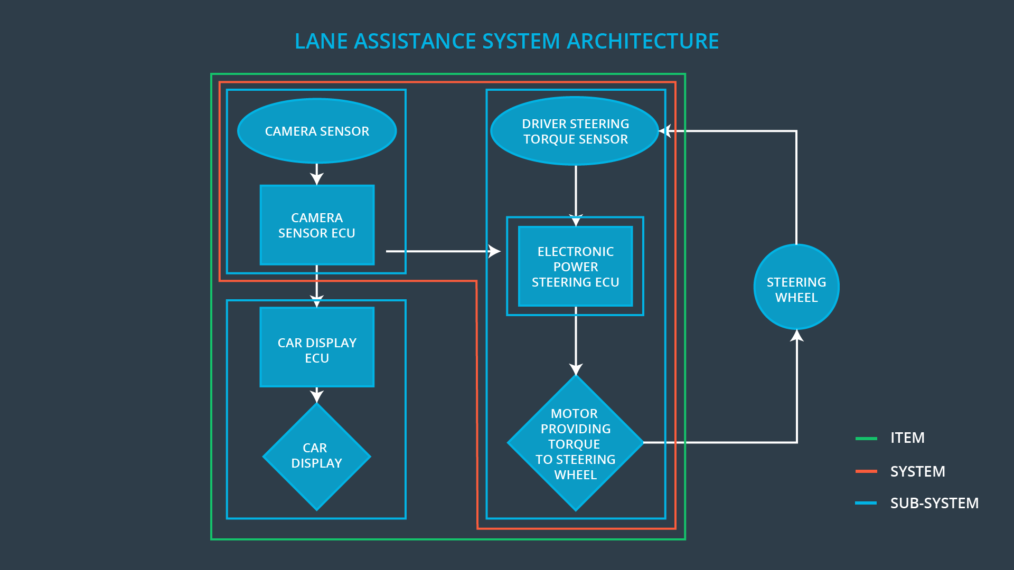

The main system of the item contains the camera subsystem and the steering subsystem with a display subsystem outside of the system. The steering wheel actually lies outside the item.

### Description of architecture elements

|  |  |
| --- | --- |
| **Element** | **Description** |
| Camera Sensor | Captures the images of the road to identify lane lines |
| Camera Sensor ECU | Contain the hardware and software required for deep learning and computer vision techniques used for identification of lane lines and calculation of vehicle’s position in the lane |
| Car Display | Contains the warning light to indicate lane assistance system is active |
| Car Display ECU | Contain the hardware and software to enable the car display and to share information between the camera subsystem and the car display subsystem |
| Driver Steering Torque Sensor | Detects how much the steering wheel is already turned |
| Electronic Power Steering ECU | Contain hardware and software to provide commands to turn and vibrate the steering wheel. It also communicates with the camera subsystem |
| Motor | Provides torque to the steering wheel to obtain the required steering |

# Functional Safety Concept

The functional safety concept consists of:

* Functional safety analysis
* Functional safety requirements
* Functional safety architecture
* Warning and degradation concept

## Functional Safety Analysis

|  |  |  |  |
| --- | --- | --- | --- |
| **Malfunction ID** | **Main Function of the Item Related to Safety Goal Violations** | **Guidewords (NO, WRONG, EARLY, LATE, MORE, LESS)** | **Resulting Malfunction** |
| Malfunction_01 | Lane Departure Warning (LDW) function shall apply an oscillating steering torque to provide the driver a haptic feedback | MORE | The lane departure warning function applies an oscillating torque with very high torque amplitude (above limit) |
| Malfunction_02 | Lane Departure Warning (LDW) function shall apply an oscillating steering torque to provide the driver a haptic feedback | MORE | The lane departure warning function applies an oscillating torque with very high torque frequency (above limit) |
| Malfunction_03 | Lane Keeping Assistance (LKA) function shall apply the steering torque when active in order to stay in ego lane | NO | The lane keeping assistance function is not limited in time duration which leads to misuse as an autonomous driving function |

## Functional Safety Requirements

Lane Departure Warning (LDW) Requirements:

|  |  |  |  |  |
| --- | --- | --- | --- | --- |
| **ID** | **Functional Safety Requirement** | **ASIL** | **Fault Tolerant Time Interval** | **Safe State** |
| Functional  Safety  Requirement  01-01 | The electronic power steering ECU shall ensure that the lane departure warning oscillating torque amplitude is below Max_Torque_Amplitude | C | 50ms | Lane departure warning oscillating amplitude is below Max_Torque_Amplitude |
| Functional  Safety  Requirement  01-02 | The electronic power steering ECU shall ensure that the lane departure warning oscillating torque frequeny is below Max_Torque_Frequency | C | 50ms | Lane departure warning oscillating torque frequency is below Max_Torque_Frequency |

Lane Departure Warning (LDW) Verification and Validation Acceptance Criteria:

|  |  |  |
| --- | --- | --- |
| **ID** | **Validation Acceptance**  **Criteria and Method** | **Verification Acceptance**  **Criteria and Method** |
| Functional  Safety  Requirement  01-01 | A Max_Torque_Amplitude has to be chosen and validated that it is a reasonable value by testing how drivers react to different torque amplitudes and chosing the comfortable one | Verify that lane assistance output is zero within the 50ms fault tolerant time interval for the chosen Max_Torque_Amplitude |
| Functional  Safety  Requirement  01-02 | A Max_Torque_Frequency has to be chosen and validated that it is a reasonable value by testing how drivers react to different torque frequencies and chosing the comfortable one | Verify that lane assistance output is zero within the 50ms fault tolerant time interval for the chosen Max_Torque_Frequency |

Lane Keeping Assistance (LKA) Requirements:

|  |  |  |  |  |
| --- | --- | --- | --- | --- |
| **ID** | **Functional Safety Requirement** | **ASIL** | **Fault Tolerant Time Interval** | **Safe State** |
| Functional  Safety  Requirement  02-01 | The electronic power steering ECU shall ensure that the lane keeping assistance torque is applied for only Max_Duration | B | 500ms | Lane keeping assistance torque is 0 after Max_Duration |

Lane Keeping Assistance (LKA) Verification and Validation Acceptance Criteria:

|  |  |  |
| --- | --- | --- |
| **ID** | **Validation Acceptance**  **Criteria and Method** | **Verification Acceptance**  **Criteria and Method** |
| Functional  Safety  Requirement  02-01 | Test and validate that the Max_Duration chosen dissuades drivers from taking their hands off the wheel | Verify that the Lane Keeping Assistance function turned off every exceeded Max_Duration |

## Refinement of the System Architecture

The figure below shows the refined system architecture with the ASIL values:

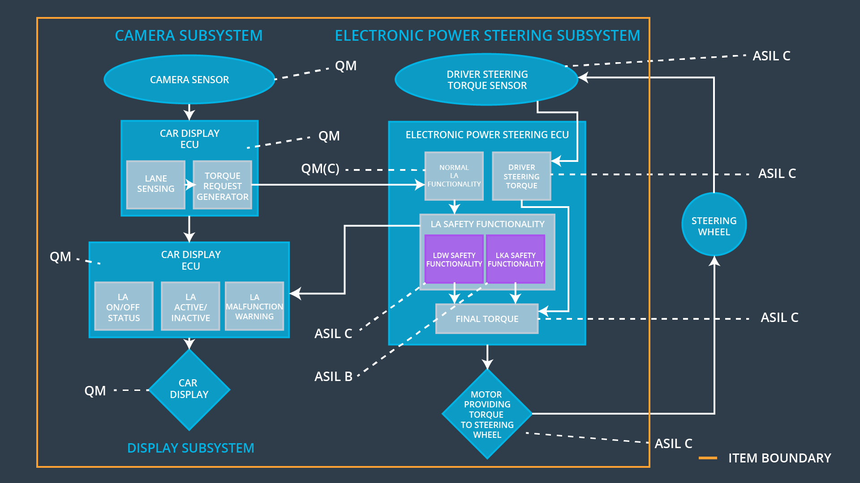

## Allocation of Functional Safety Requirements to Architecture Elements

|  |  |  |  |  |
| --- | --- | --- | --- | --- |
| **ID** | **Functional Safety Requirement** | **Electronic Power Steering ECU** | **Camera ECU** | **Car Display ECU** |
| Functional  Safety  Requirement  01-01 | The electronic power steering ECU shall ensure that the lane departure warning oscillating torque amplitude is below Max_Torque_Amplitude | **X** |  |  |
| Functional  Safety  Requirement  01-02 | The electronic power steering ECU shall ensure that the lane departure warning oscillating torque frequeny is below Max_Torque_Frequency | **X** |  |  |
| Functional  Safety  Requirement  02-01 | The electronic power steering ECU shall ensure that the lane keeping assistance torque is applied for only Max_Duration | **X** |  |  |

## Warning and Degradation Concept

|  |  |  |  |  |
| --- | --- | --- | --- | --- |
| **ID** | **Degradation Mode** | **Trigger for Degradation Mode** | **Safe State invoked?** | **Driver Warning** |
| WDC-01 | Lane Departure Warning functionality is turned off | Malfunction_01, Malfunction_02 | Yes | Lane Assistance Warning light in driver dashboard turned on |
| WDC-02 | Lane Assistance function turned off | Malfunction_03 | Yes | Lane Assistance Warning light in driver dashboard turned on |