

Technical Safety Concept Lane Assistance

**Document Version: 1.0**

**Version 1.0, Released on 2018-05-22**



# Document history

|  |  |  |  |
| --- | --- | --- | --- |
| Date | Version | Editor | Description |
| 2018-05-22 | 1.0 | Navin Rawther | Initial Draft |
|  |  |  |  |
|  |  |  |  |
|  |  |  |  |
|  |  |  |  |

# 

# Table of Contents

Document history

Table of Contents

Purpose of the Technical Safety Concept

Inputs to the Technical Safety Concept

Functional Safety Requirements

Refined System Architecture from Functional Safety Concept

Functional overview of architecture elements

Technical Safety Concept

Technical Safety Requirements

Refinement of the System Architecture

Allocation of Technical Safety Requirements to Architecture Elements

Warning and Degradation Concept

# Purpose of the Technical Safety Concept

A technical Safety Concept defines requirements and allocates them to the system architecture. The new requirements are more concrete and gets into the item’s technology.

# Inputs to the Technical Safety Concept

## Functional Safety Requirements

|  |  |  |  |  |
| --- | --- | --- | --- | --- |
| **ID** | **Functional Safety Requirement** | **ASIL** | **Fault Tolerant Time Interval** | **Safe State** |
| Functional  Safety  Requirement  01-01 | The electronic power steering ECU shall ensure that the lane departure warning oscillating torque amplitude is below Max_Torque_Amplitude | C | 50ms | Lane departure warning oscillating amplitude is below Max_Torque_Amplitude |
| Functional  Safety  Requirement  01-02 | The electronic power steering ECU shall ensure that the lane departure warning oscillating torque frequeny is below Max_Torque_Frequency | C | 50ms | Lane departure warning oscillating torque frequency is below Max_Torque_Frequency |
| Functional  Safety  Requirement  02-01 | The electronic power steering ECU shall ensure that the lane keeping assistance torque is applied for only Max_Duration | B | 500ms | Lane keeping assistance torque is 0 after Max_Duration |

## Refined System Architecture from Functional Safety Concept

The figure below shows the refined system architecture with the ASIL values:

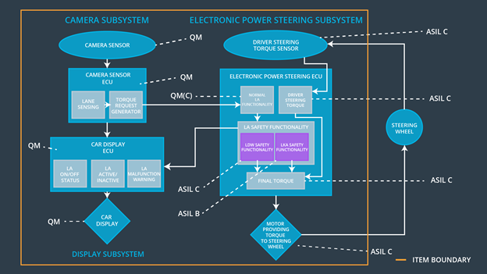

### Functional overview of architecture elements

|  |  |
| --- | --- |
| **Element** | **Description** |
| Camera Sensor | Reads images of the road |
| Camera Sensor ECU - Lane Sensing | Computes and senses where the lane markings are on the road |
| Camera Sensor ECU - Torque request generator | Generates the torque request in case of vehicle reaching edge of a lane and sends it to the Electronic Power Steering Subsystem |
| Car Display | The display that contains the signals of the lane assistance item for the driver |
| Car Display ECU - Lane Assistance On/Off Status | Switches the signal corresponding to Lane Assistance to On/Off |
| Car Display ECU - Lane Assistant Active/Inactive | Decides whether the Lane Assistance system is active or not |
| Car Display ECU - Lane Assistance malfunction warning | Provides warning if the Lane Assistance system is malfunctioning by obtaining input from Electronic Power Steering Subsystem |
| Driver Steering Torque Sensor | Detects how much the steering wheel is already turned |
| Electronic Power Steering (EPS) ECU - Driver Steering Torque | Senses how much the driver is turning the steering wheel |
| EPS ECU - Normal Lane Assistance Functionality | Receives vibrational torque request from camera subsystem and computes the torque required to get back to the lane center |
| EPS ECU - Lane Departure Warning Safety Functionality | Limits the amplitude and frequency torque provided by the Normal Lane Assistance Functionality |
| EPS ECU - Lane Keeping Assistant Safety Functionality | Switches the Lane Keeping Assistance output torque to 0 when exceeds the Max_Duration |
| EPS ECU - Final Torque | Computes the final torque from the Driver Steering Torque subsystem and the Lane Assistance Safety Functionality |
| Motor | Provides torque to the steering wheel to obtain the required steering |

# Technical Safety Concept

## Technical Safety Requirements

**Lane Departure Warning (LDW) Requirements:**

Functional Safety Requirement 01-01 with its associated system elements

(derived in the functional safety concept)

|  |  |  |  |  |
| --- | --- | --- | --- | --- |
| **ID** | **Functional Safety Requirement** | **Electronic Power Steering ECU** | **Camera ECU** | **Car Display ECU** |
| Functional  Safety  Requirement  01-01 | The lane keeping item shall ensure that the lane departure oscillating torque amplitude is below Max_Torque_Amplitude | X |  |  |

Technical Safety Requirements related to Functional Safety Requirement 01-01 are:

|  |  |  |  |  |  |
| --- | --- | --- | --- | --- | --- |
| **ID** | **Technical Safety Requirement** | **ASIL** | **Fault Tolerant Time Interval** | **Architecture Allocation** | **Safe State** |
| Technical  Safety  Requirement  01 | The LDW safety component shall ensure that the amplitude of the LDW_Torque_Request sent to the Final electronic power steering component is below Max_Torque_Amplitude | C | 50ms | LDW safety block | LDW_Torque_Request Amplitude shall be set to zero |
| Technical  Safety  Requirement  02 | The validity and integrity of the data transmission for LDW_Torque_Request signal shall be ensured | C | 50ms | Data Transmission Integrity Check | LDW_Torque_Request Amplitude shall be set to zero |
| Technical  Safety  Requirement  03 | As soon as a failure is detected by the LDW function, it shall deactivate the feature and the LDW_Torque_Request shall be set to zero | C | 50ms | LDW safety block | LDW_Torque_Request Amplitude shall be set to zero |
| Technical  Safety  Requirement  04 | As soon as the LDW function deactivates the LDW feature, the LDW safety feature block shall send a signal to the car display ECU to turn on a warning light | C | 50ms | LDW safety block | LDW_Torque_Request Amplitude shall be set to zero |
| Technical  Safety  Requirement  05 | Memory test shall be conducted at the startup of the EPS ECU to check for any faults in memory | A | ignition cycle | Safety Startup | LDW_Torque_Request Amplitude shall be set to zero |

Functional Safety Requirement 01-2 with its associated system elements

(derived in the functional safety concept)

|  |  |  |  |  |
| --- | --- | --- | --- | --- |
| **ID** | **Functional Safety Requirement** | **Electronic Power Steering ECU** | **Camera ECU** | **Car Display ECU** |
| Functional  Safety  Requirement  01-02 | The lane keeping item shall ensure that the lane departure oscillating torque frequency is below Max_Torque_Frequency | X |  |  |

Technical Safety Requirements related to Functional Safety Requirement 01-02 are:

|  |  |  |  |  |  |
| --- | --- | --- | --- | --- | --- |
| **ID** | **Technical Safety Requirement** | **ASIL** | **Fault Tolerant Time Interval** | **Architecture Allocation** | **Safe State** |
| Technical  Safety  Requirement  01 | The LDW safety component shall ensure that the frequency of the LDW_Torque_Request sent to the Final electronic power steering component is below Max_Torque_Frequency | C | 50ms | LDW safety block | LDW_Torque_Request Frequency shall be set to zero |
| Technical  Safety  Requirement  02 | The validity and integrity of the data transmission for LDW_Torque_Request signal shall be ensured | C | 50ms | Data Transmission Integrity Check | LDW_Torque_Request Frequency shall be set to zero |
| Technical  Safety  Requirement  03 | As soon as a failure is detected by the LDW function, it shall deactivate the feature and the LDW_Torque_Request shall be set to zero | C | 50ms | LDW safety block | LDW_Torque_Request Frequency shall be set to zero |
| Technical  Safety  Requirement  04 | As soon as the LDW function deactivates the LDW feature, the LDW safety feature block shall send a signal to the car display ECU to turn on a warning light | C | 50ms | LDW safety block | LDW_Torque_Request Frequency shall be set to zero |
| Technical  Safety  Requirement  05 | Memory test shall be conducted at the startup of the EPS ECU to check for any faults in memory | A | ignition cycle | Safety Startup | LDW_Torque_Request Frequency shall be set to zero |

**Lane Keeping Assistance (LKA) Requirements:**

Functional Safety Requirement 02-1 with its associated system elements

(derived in the functional safety concept)

|  |  |  |  |  |
| --- | --- | --- | --- | --- |
| **ID** | **Functional Safety Requirement** | **Electronic Power Steering ECU** | **Camera ECU** | **Car Display ECU** |
| Functional  Safety  Requirement  02-01 | The lane keeping item shall ensure that the lane keeping assistance torque is applied for only Max_Duration | X |  |  |

Technical Safety Requirements related to Functional Safety Requirement 02-01 are:

|  |  |  |  |  |  |
| --- | --- | --- | --- | --- | --- |
| **ID** | **Technical Safety Requirement** | **ASIL** | **Fault Tolerant Time Interval** | **Allocation to Architecture** | **Safe State** |
| Technical  Safety  Requirement  01 | The LKA safety component shall ensure that the LKA_Torque_Request is sent to the Final electronic power steering component for only Max_Duration | B | 500ms | LKA safety block | LKA_Torque_Request is 0 after Max_Duration |
| Technical  Safety  Requirement  02 | The validity and integrity of the data transmission for LKA_Torque_Request signal shall be ensured | B | 500ms | Data Transmission Integrity Check | LKA_Torque_Request is 0 after Max_Duration |
| Technical  Safety  Requirement  03 | As soon as a failure is detected by the LKA function, it shall deactivate the feature and the LKA _Torque_Request shall be set to zero | B | 500ms | LKA safety block | LKA_Torque_Request is 0 after Max_Duration |
| Technical  Safety  Requirement  04 | As soon as the LKA function deactivates the LKA feature, the LKA safety feature block shall send a signal to the car display ECU to turn on a warning light | B | 500ms | LKA safety block | LKA_Torque_Request is 0 after Max_Duration |
| Technical  Safety  Requirement  05 | Memory test shall be conducted at the startup of the EPS ECU to check for any faults in memory | A | ignition cycle | Safety Startup | LKA_Torque_Request is 0 after Max_Duration |

## Refinement of the System Architecture

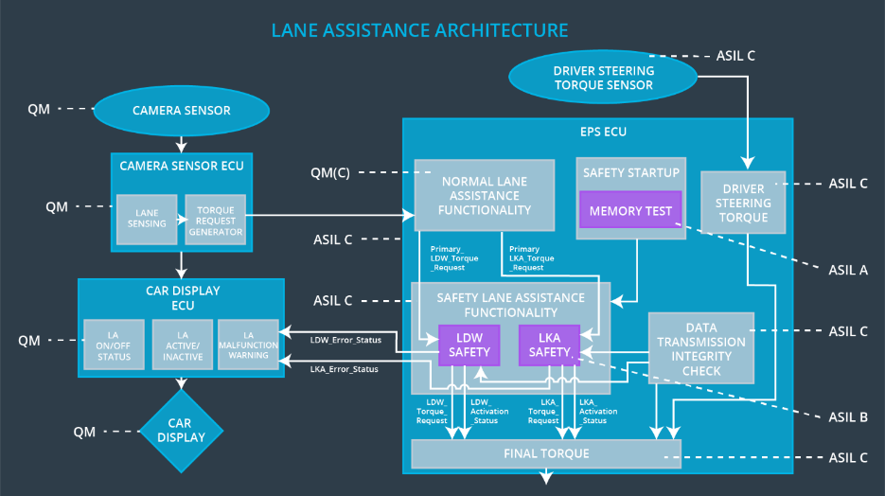

## Allocation of Technical Safety Requirements to Architecture Elements

All technical safety requirements are allocated to the Electronic Power Steering ECU.

## Warning and Degradation Concept

|  |  |  |  |  |
| --- | --- | --- | --- | --- |
| **ID** | **Degradation Mode** | **Trigger for Degradation Mode** | **Safe State invoked?** | **Driver Warning** |
| WDC-01 | Lane Departure Warning functionality is turned off | Malfunction_01, Malfunction_02 | Yes | Lane Assistance Warning light in driver dashboard turned on |
| WDC-02 | Lane Assistance function turned off | Malfunction_03 | Yes | Lane Assistance Warning light in driver dashboard turned on |