PowerBI-RetailAB Project
Meaningful
Reports
In Minutes


Transform Your
Data into…

Facilitator: SUNIL KUMAR | Microsoft Certified Data Analysts | Power BI |Microsoft Certified DA100
1.Source Data (Source Data for Project. SQL Server)

The Source has Nine Tables

Returns
Sales
Date Table
Segment
Regions
Ship Mode
Products
Customers
Address

Facilitator: SUNIL KUMAR | Microsoft Certified Data Analysts | Power BI |Microsoft Certified DA100

Task-1

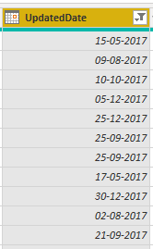
- Connect to the Data Source(SQL SERVER) Bring The Data/Tables From the Database.
- Go to Sales Table Change the Updated Date Column Data-Type to Date Data-Type.
- Create a Parameters Called StartDate.
- Assign This Parameters to Update date Column.
- As Shown in the Below Figures.

Facilitator: SUNIL KUMAR | Microsoft Certified Data Analysts | Power BI |Microsoft Certified DA100

Task-1 (Continuation)

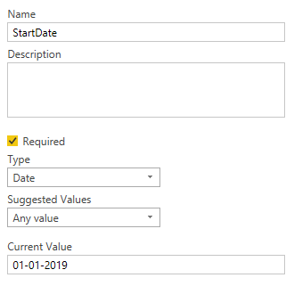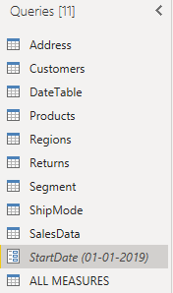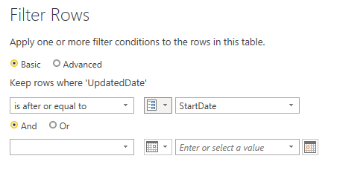
Facilitator: SUNIL KUMAR | Microsoft Certified Data Analysts | Power BI |Microsoft Certified DA100

Task-2

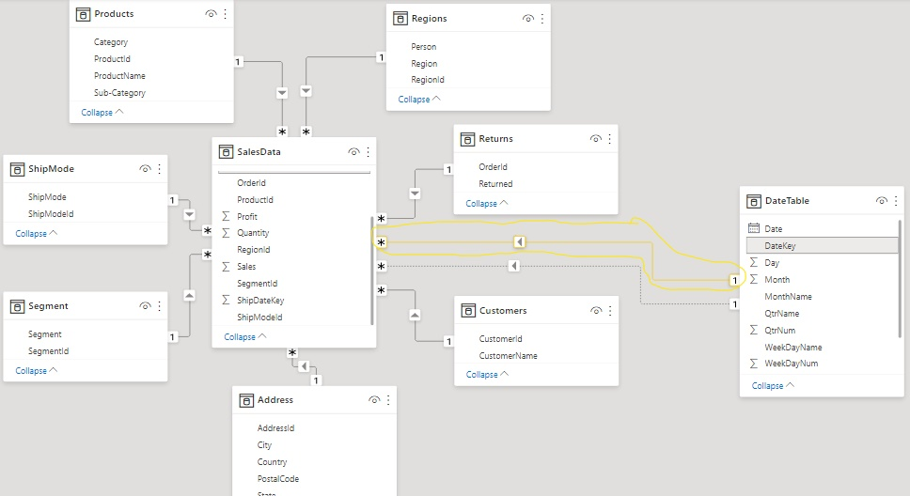
- Load all the Nine Tables Into Power Pivot.
- Ensure that all the tables are properly related to each other through common columns.
- Create the Relationship Between Data Table and Sales Table Using Common Column (Date Key Column) in Date Table, (OrderDatekey & ShipDateKey) in Sales Table.
- Active Relationship Should Be (OrderDateKey & DateKey) as shown in the figure.
- Give The Relationship Between Returns Table and sales Table.
- Finally Prepare the Model as Shown in the Figure
- In Sales Table we have Only the Data from 01/01/2019.

Facilitator: SUNIL KUMAR | Microsoft Certified Data Analysts | Power BI |Microsoft Certified DA100

Task-3

- Create Three Hierarchies.
1) Create a Hierarchy to show Year, Quarter, Month, WeekName, Weekday Wise Data in a Single Visual.
2) Create a Hierarchy to Show Category, Sub-Category, Product Wise Data in a Single Visual.
3) Create a Hierarchy to show Country, State, City Wise data in a single Visual.
- Stop the Default Date Hierarchies.
- Short The Month Name Column Based on the Month Number
Column.

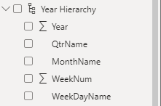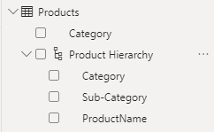
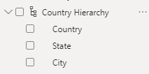

Facilitator: SUNIL KUMAR | Microsoft Certified Data Analysts | Power BI |Microsoft Certified DA100

Task-4

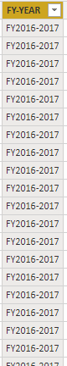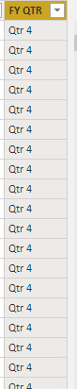
- In Date Table Derive the FY-Year Column (Month Need to Start With “April” and ends with “March”) Using DAX Functions.
- In the same Way Derive The FY-Qtr Column (Qtr1=April-June, Qtr2=July-sept, Qtr3=Oct-Dec, Qtr4 Jan-March) Using DAX Functions.
- You Need to short the Month Name Column by MonthNum Column
- You Need Declare This as date Table
- Finally Relate this DATE Table with Transactions Table.

Facilitator: SUNIL KUMAR | Microsoft Certified Data Analysts | Power BI |Microsoft Certified DA100

Task-5

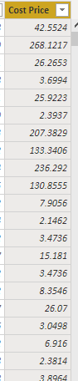
- Derive the Cost Price Column Using Sales, Quantity, Profits Columns as shown in the Figure
Facilitator: SUNIL KUMAR | Microsoft Certified Data Analysts | Power BI |Microsoft Certified DA100

Task-6

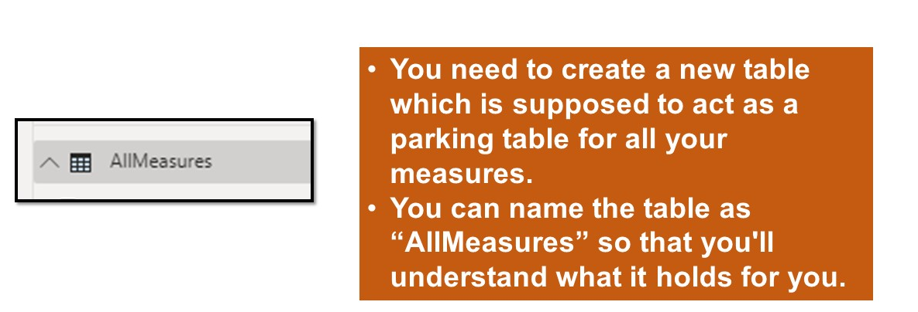

Facilitator: SUNIL KUMAR | Microsoft Certified Data Analysts | Power BI |Microsoft Certified DA100

Task-7

- Create The Measures Using Existing Fact Columns In The Sales Table
- Ex:- Sum Of Sales, Total Quantity, Total Discount, Total Profits.

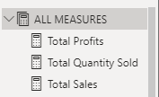

Facilitator: SUNIL KUMAR | Microsoft Certified Data Analysts | Power BI |Microsoft Certified DA100

Task-8

- Create a Workspace in Power BI Service Called RetailAB.
- Publish This Dataset to the RetailAB Workspace.
- Now Download the DATA GATEWAY and Install it in The Server Machine from Where You are Getting the Data.
- Add the Data Source Connections to the Gateway
- Configure This connection to the RetailAB Dataset.
- Now go to Dataset--> Click on 3 Dots --> Settings --> go to Parameters Here Change the Startdate Parameter to Startdate=1/1/2017
- Now Click on Refresh to Get the Entire Data to the Workspace.

Stop the Default Date Hierarchy

Facilitator: SUNIL KUMAR | Microsoft Certified Data Analysts | Power BI |Microsoft Certified DA100

Task-9

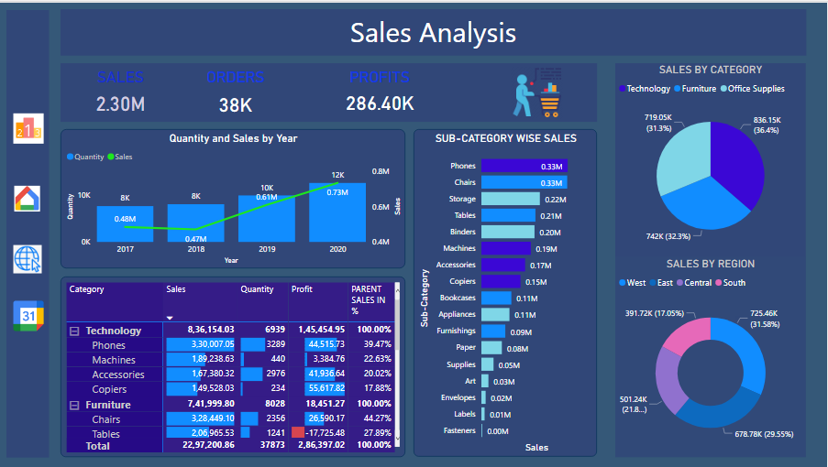
- You Need to Create a Page as per sample. Colors, Fonts, Position Of the Visuals are as for Your Choice.
- Visual You Need to Present: 3 Cards, One Combo Chart (Line and Clustered Column Chart)
- One Stacked Bar Chart to Show Sub-Category wise sales
- One Pie-Chart to Show Category Wise Sales
- One Donut-Chart to Show Region Wise Sales.
- Create a Matrix Visual as shown in the Image Use ALLEXCEPT Dax Function to Get the Parent sales in Percentages.
- Create Drill Through on a Region Column to Regio Wise Analysis Page.

Facilitator: SUNIL KUMAR | Microsoft Certified Data Analysts | Power BI |Microsoft Certified DA100

Task-10

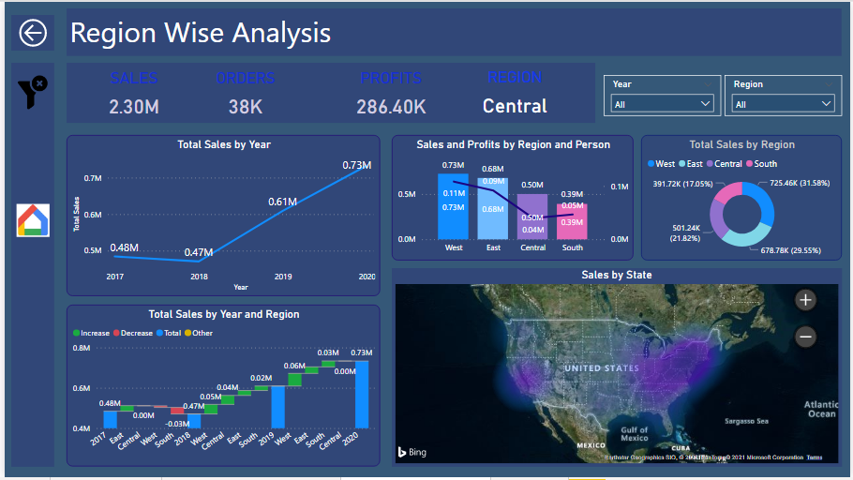
- Create a Report Page called Region Wise Analysis.
- Visuals Need to keep in This Report Page are:
- Four Card Visuals (sales, Orders, Profits, Regions).
- Two Slicers (Year and Region).
- One Line Chart to show Year Wise sales.
- One Combo Chart to Show sales and Profits by Region and Person
- One Donut Chart to Show Region Wise Sales.
- Create a Waterfall Chart to Show Year and Region Wise Sum of Sales.
- Create Map Visual to show State Wise sales. (Map Should be Heat map)
- Create Drill Through on Region Column.

- Create a Bookmark to Clear all the Filters at a Time.
- Create a Page Navigation to Go to Main Page by Clicking on the Home Image.

Facilitator: SUNIL KUMAR | Microsoft Certified Data Analysts | Power BI |Microsoft Certified DA100
- Create a Report Page called Calendar Date Wise sales.
- One Slicer to show the Years
- One Line Chart to Show Month Wise Sales.
- Another One More Line Chart to Show FY-Year Wise Sales.
- One Stacked Column Chart to show QTR Wise sales.
- One Table Visual to Show Year wise Order Date and Ship date sales.
- Show the same Data in Stacked Column Chart.
- Create a Bookmark to Clear all the Filters at a Time.
- Create a Page Navigation to Go to Main Page by Clicking on the Home Image

Task-11

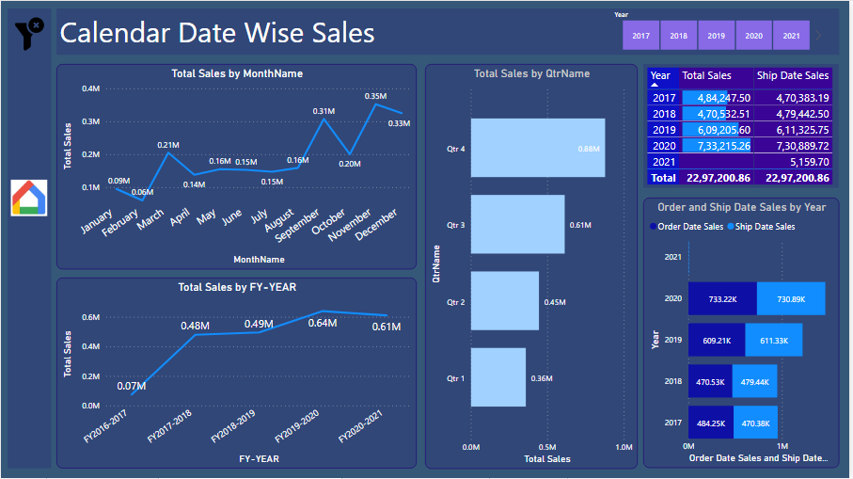

Facilitator: SUNIL KUMAR | Microsoft Certified Data Analysts | Power BI |Microsoft Certified DA100
Facilitator: SUNIL KUMAR | Microsoft Certified Data Analysts | Power BI |Microsoft Certified DA100

Task-12

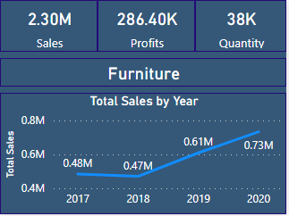
- Create a Custom ToolTip and Show it on the Visual Category Wise Sales.
- As Shown in the Visualization.
- Assign this Tooltip to the Pie Chart visual in the Main page.
- Create the Page Navigations to all the Four Pages.

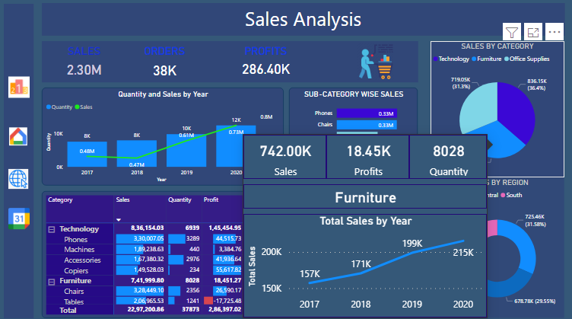

Facilitator: SUNIL KUMAR | Microsoft Certified Data Analysts | Power BI |Microsoft Certified DA100

Conclusion

- Treated The Above Three Pages as One Report and Name This Report as Retail AB Report 1.
- Make Sure That all The Requirements Should be Correct.
- After Developing all the Pages Publish This Report to Retail AB Workspace.

Facilitator: SUNIL KUMAR | Microsoft Certified Data Analysts | Power BI |Microsoft Certified DA100

RetailAB Report 2

Task-1

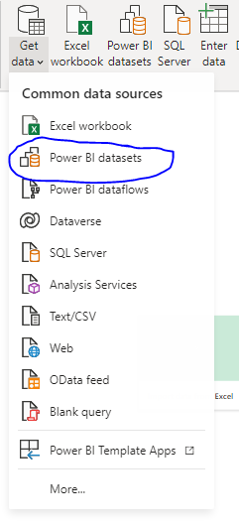
Facilitator: SUNIL KUMAR | Microsoft Certified Data Analysts | Power BI |Microsoft Certified DA100
- Open New Power BI File Click on Get data and Connect to the RetailAB Dataset Which is already there in the Power BI Service.
- After Connecting to the Dataset Create the Report according to the Requirements

Task-2

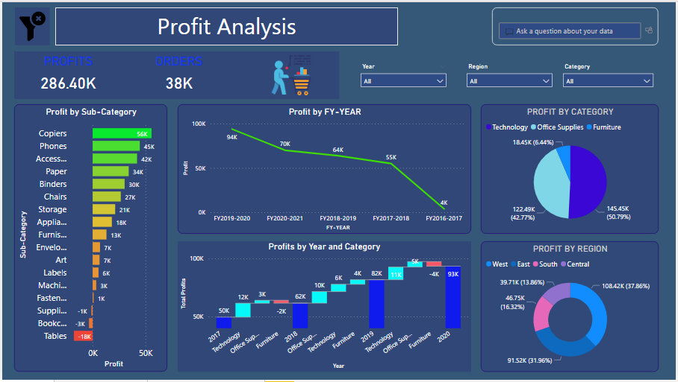
Facilitator: SUNIL KUMAR | Microsoft Certified Data Analysts | Power BI |Microsoft Certified DA100

Task-2 (Requirements)

- Create a Report Page called Profit Analysis.
- Two Card Visuals to Show Profits and Orders.
- Three Slicers Visuals for Year, Region, Category.
- One Stacked Column Chart to Show Sub-Category Wise Profits.
- Line Chart to Show FY-Year Wise Profits.
- One Waterfall Chart to Show Year Wise Category Wise Profits.
- One Pie-Chart to show Category Wise Sales.
- One Donut Chart to show Region Wise Sales.
- Place One Q&A Visual in This Report Page.
- Create a Bookmark to Clear all Slicer Filters
- Assign this Bookmark to the Clear filter Image Which is their on the Top.

Facilitator: SUNIL KUMAR | Microsoft Certified Data Analysts | Power BI |Microsoft Certified DA100

Task-3

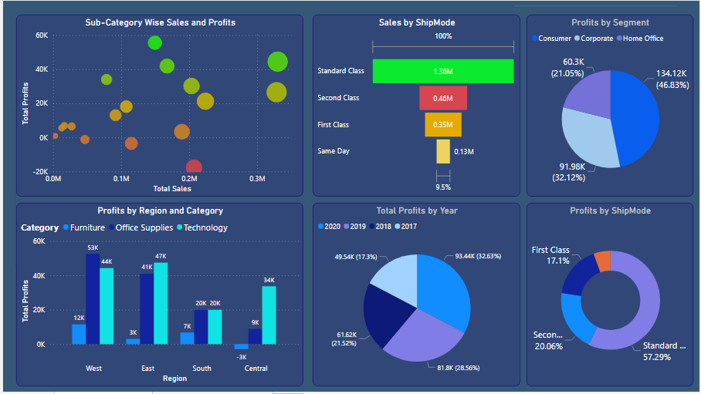
Facilitator: SUNIL KUMAR | Microsoft Certified Data Analysts | Power BI |Microsoft Certified DA100

Task-3 (Requirements)

- Create a Visual to Show Sub-Category Wise Sales and Profits. (To Identify Which Sub-category Is Getting More Sales and More Profits)
- The Purpose Of This Visual is to Compare two Fact Values Based On The Single Dimensional Column.
- One Funnel Chart to Identify Which Mode of Shipments Is Preferred by the Customers.
- Create a Clustered Chart to show Region and Category wise Profits.
- Create a Visual to Show to Show Segment Wise Profits.
- Create a Visual to show Year Wise Profit.
- Create a Visual to show Ship Mode wise Profits in Percentages.

Facilitator: SUNIL KUMAR | Microsoft Certified Data Analysts | Power BI |Microsoft Certified DA100

Task-4
SS

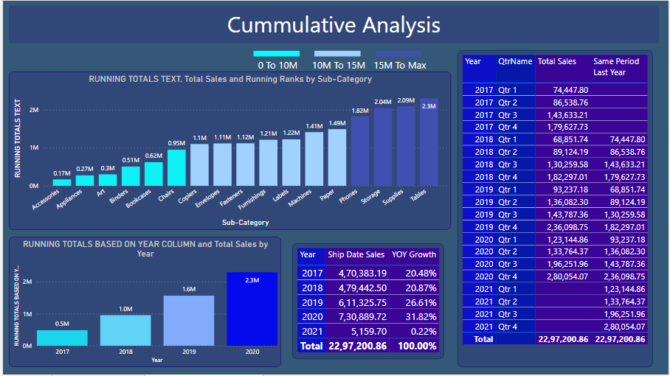
Facilitator: SUNIL KUMAR | Microsoft Certified Data Analysts | Power BI |Microsoft Certified DA100

Task-4 (Requirements)

- Create a visual to Show Running Totals (or) Cumulative Totals
Base on the Sub-Category Column. i.e Text Column and also Give Ranking Based on the Running Totals.
- Create a visual to Show Running Totals (or) Cumulative Totals
Based on the Date Column. i.e Year Column.
- Create a table visual to Show Ship Date wise Sales and their Growth in Percentages.
- Create a Table Visual to Show Qtr Wise Cumulative Totals Use Total QTD Dax Function.

Facilitator: SUNIL KUMAR | Microsoft Certified Data Analysts | Power BI |Microsoft Certified DA100

Task-5

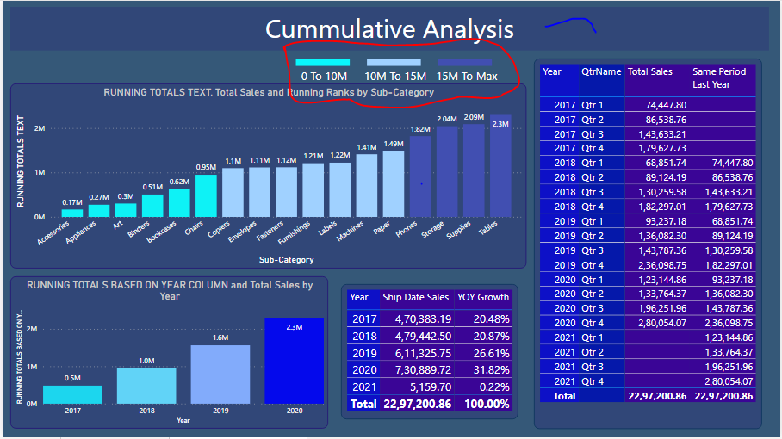
- Create a Custom Legend to Show the Conditional Color Formatting of the Visual.

Facilitator: SUNIL KUMAR | Microsoft Certified Data Analysts | Power BI |Microsoft Certified DA100

THANK YOU
ANALYTICS BENCHMARK

SUNIL KUMAR

