**TCP2201 Project**

**Trimester 1, 2019/2020**

**By <<Zorro>>**

|  |  |  |  |
| --- | --- | --- | --- |
| Name | Student ID | Phone Number | E-mail |
| Boo Ee Kein Ivan (Team Leader) | 1161104032 | 0173070870 | [1161104032@student.mmu.edu.my](mailto:1161104032@student.mmu.edu.my) |
| Low Seh Hong | 1161104400 | 0129008266 | [1161104400@student.mmu.edu.my](mailto:1161104400@student.mmu.edu.my) |
| Seng Weng Hoong | 1161103872 | 0164801488 | [1161103872@student.mmu.edu.my](mailto:1161103872@student.mmu.edu.my) |
| Kuan Wei Ben | 1161104365 | 0102221522 | [1161104365@student.mmu.edu.my](mailto:1161104365@student.mmu.edu.my) |

## Methods to Compile the Program (JDK8 needed)

1. Open Perilanda_Chess and open src
2. In the directory of src file, type in cmd.

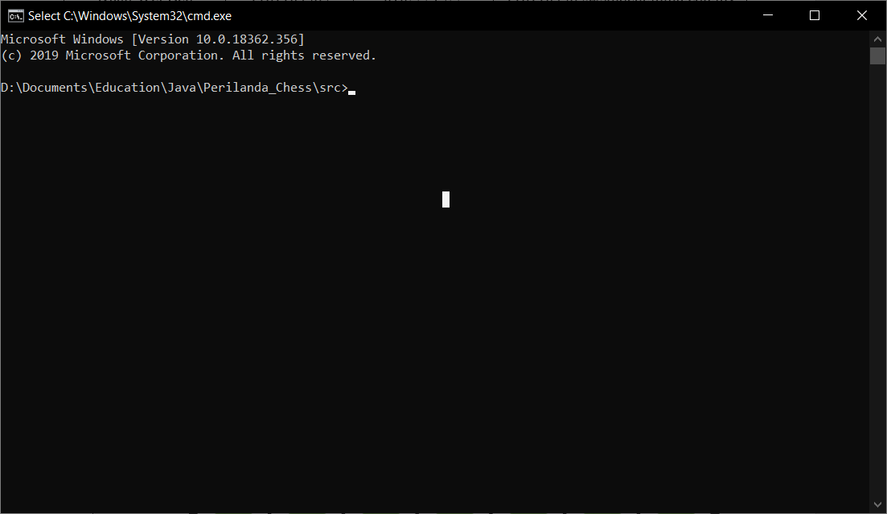

1. 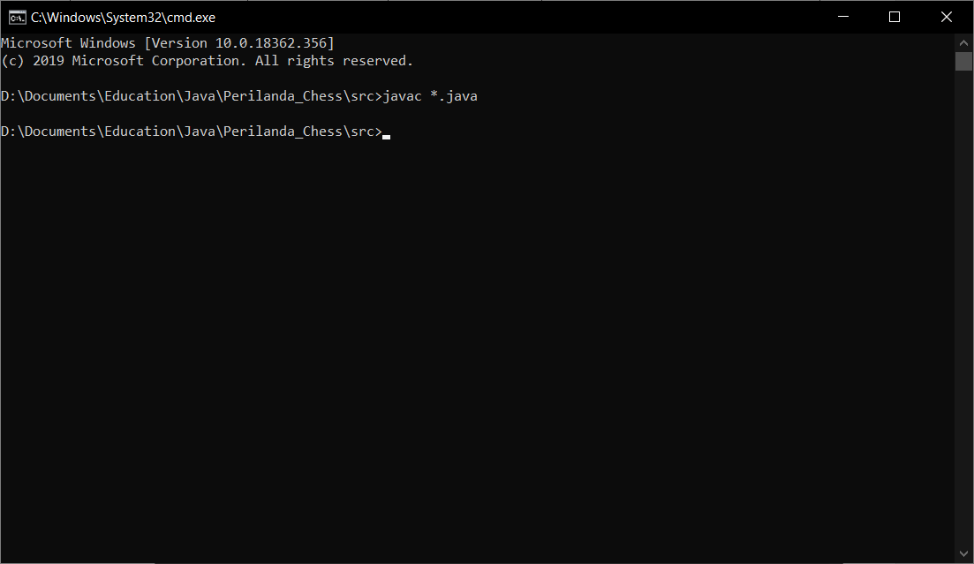
2. Type in javac *.java to compile the java program.
3. Type java JChess to run the program.

Command line: [Directory where you have saved the file]\Perilanda_Chess\src>javac *.java

## Documentation of the program

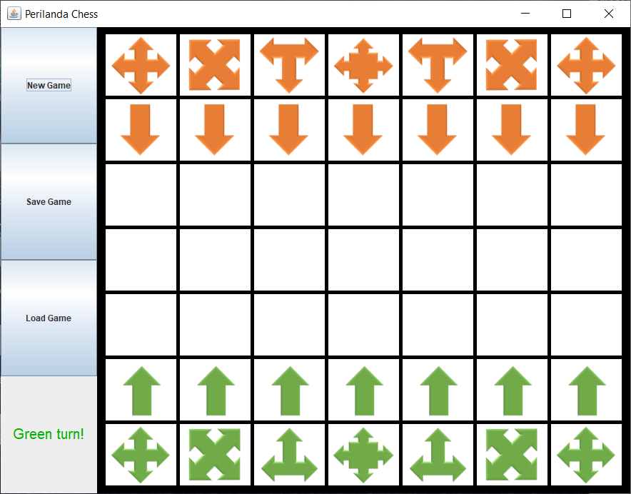

Figure above shows the Perilanda Chess game interface when the program runs. The players are presented with the chessboard, with Green Pieces and Orange Pieces, both represent each player1 and player2. On the left, there are three buttons for initializing a new game, saving a game and loading a previous game from a text file. There is also a text display that indicates current player’s turn.

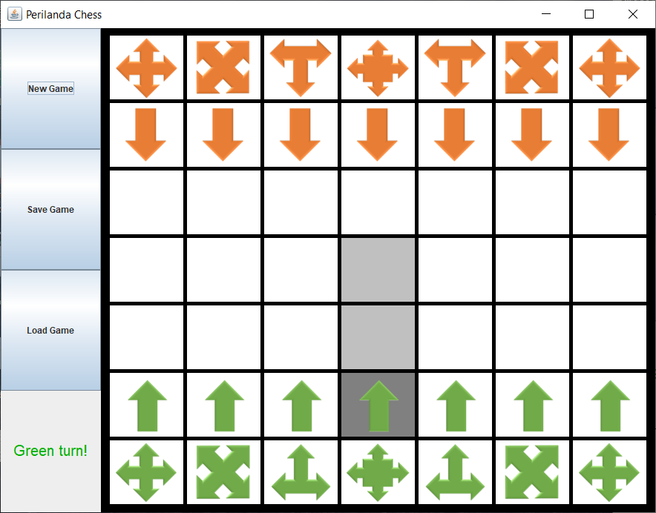

When player clicks on a piece, the selected piece will have a darker highlight and the available moves will be highlighted in a lighter shade. In this case, Player1 which is controlling the green chess piece, selected an Advancer.

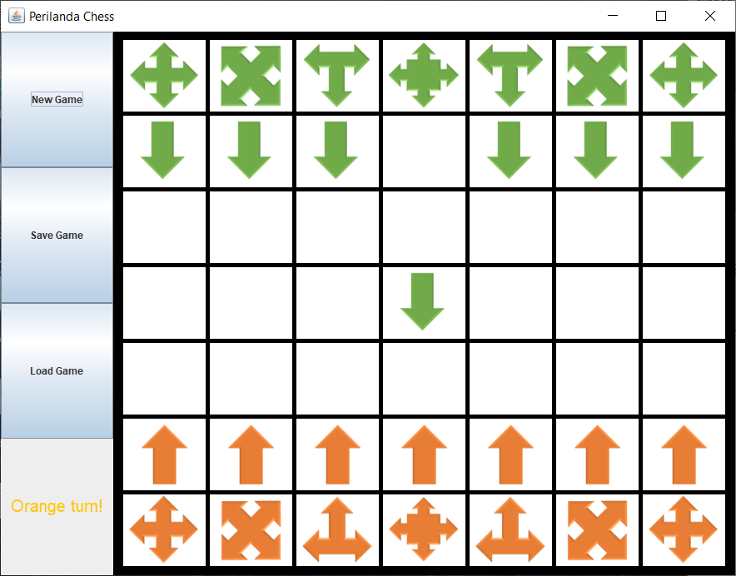

When Player1 has moved, the red-highlighted area displays the current player’s turn, in this case: Player2’s turn. The board will then rotate to have pieces of Player2 at the bottom to ease player’s view.

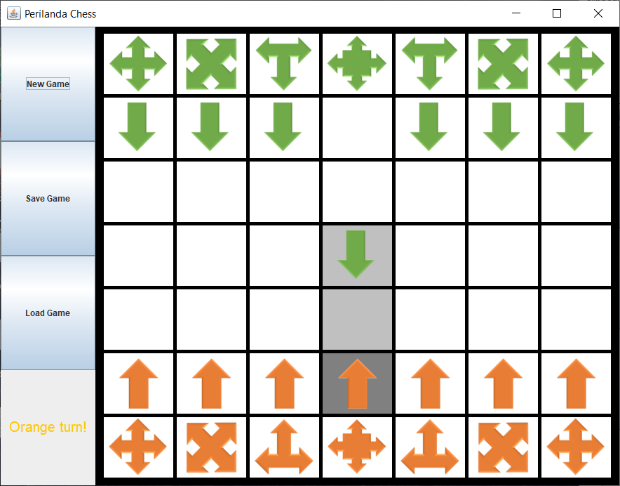

When player2 has selected the piece that he/she wanted to move, the piece will then have highlights showing the chess piece’s available moves, including if the chess piece of Player1 can be captured.

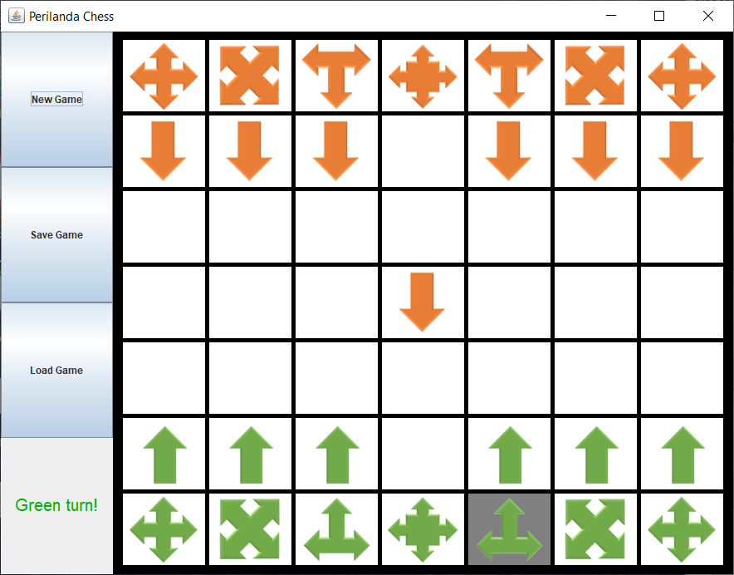

If the chess selected is being blocked by other chess pieces of the same player, it will not show any highlights as it has no available moves.

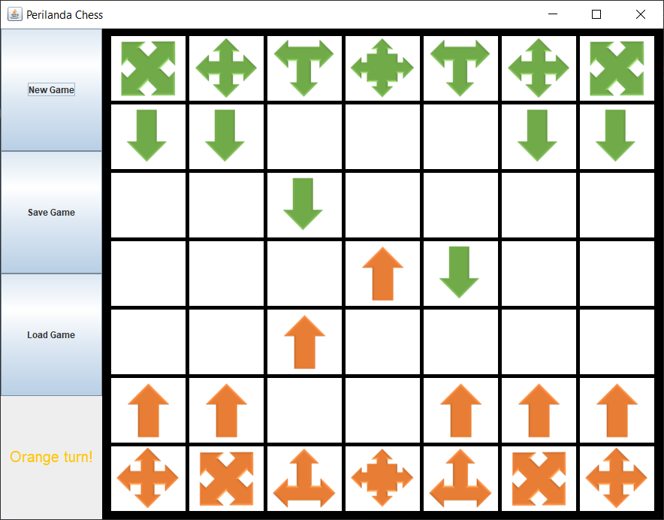

For every 3 turns for Player1, the chess pieces, Excel and Tercel will change their states and the way they move. The pieces in the redbox will be changed.

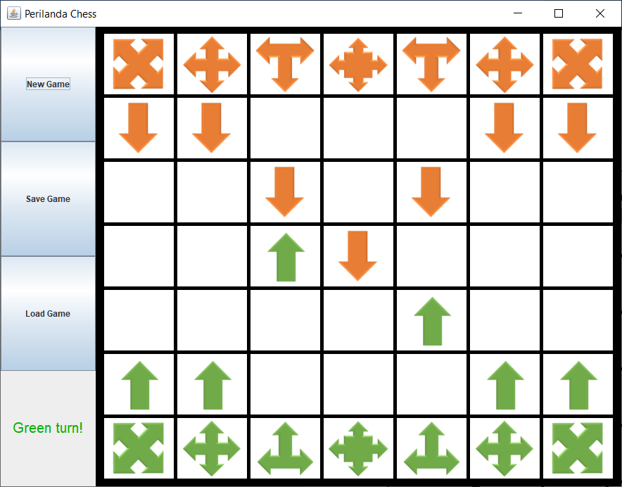

For every 3 turns for Player2, the chess pieces, Excel and Tercel will change their states and the way they move. The pieces in the redbox will be changed.

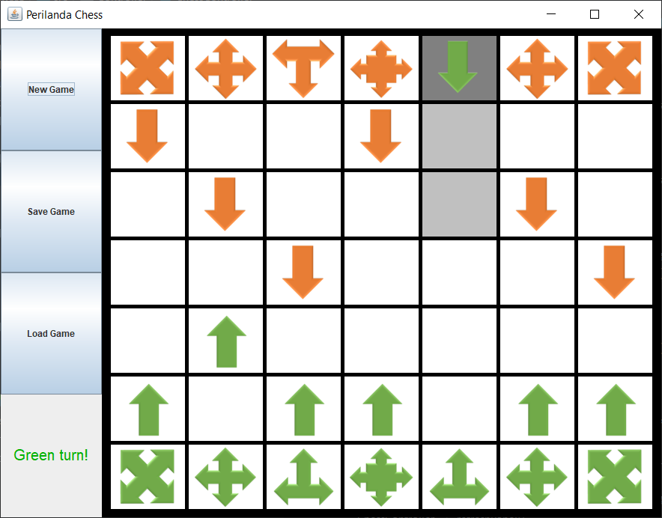

If Advancer reaches the boarder of the board, it will turn around and heads back in the opposite direction.

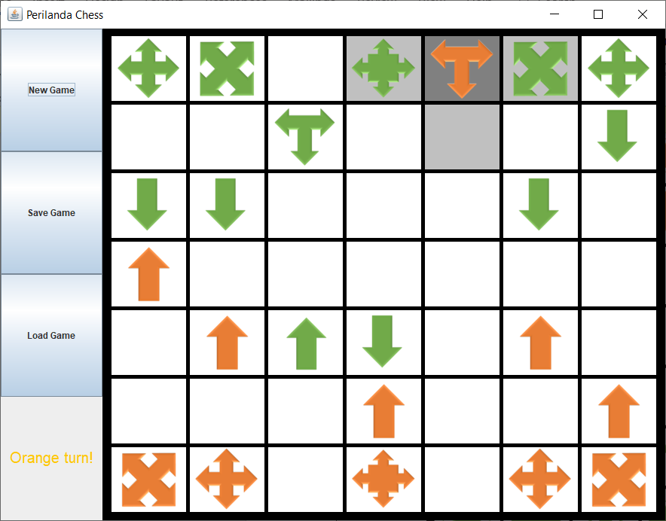

Similarly, if Trident reaches the boarder of the board, it will also turn around and heads back in the opposite direction.

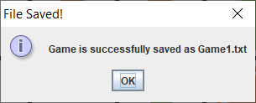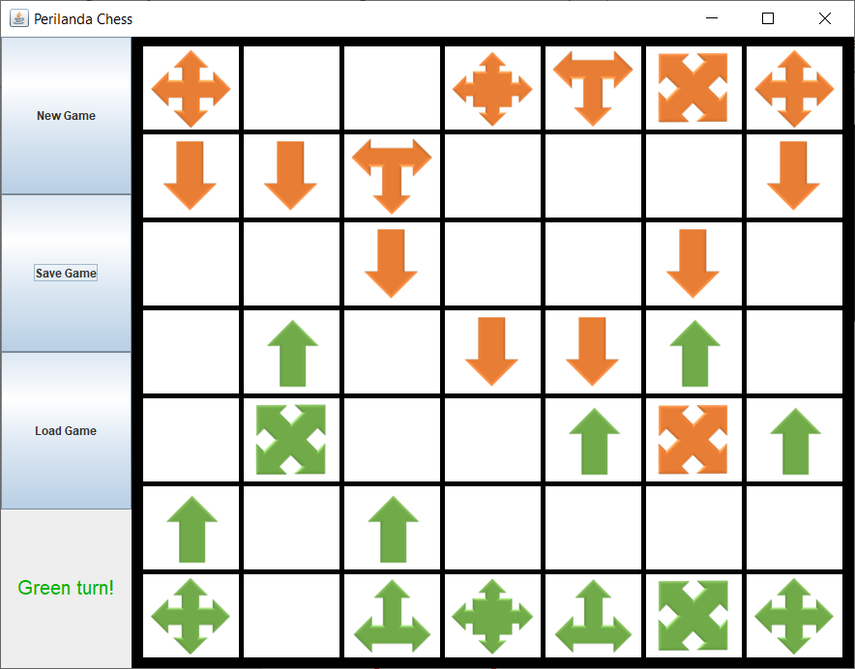

When <Save Game> is clicked, the current state of the chess game will be saved into a text file and stored in a file named “GameFile”. After the game state is saved successfully, a pop up will be prompted.

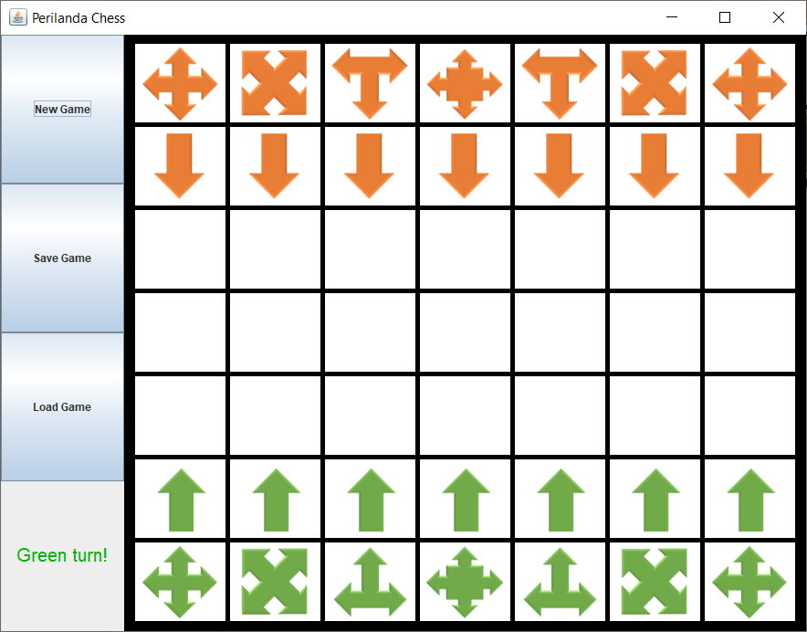

If the <New Game> button is clicked, the board will be initialized and the game will be started over.

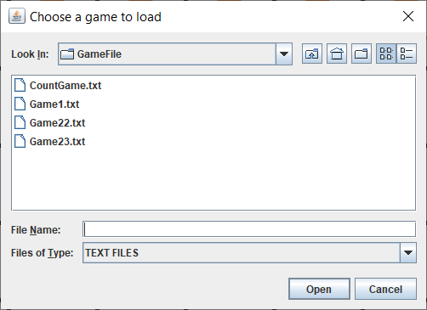

When the <Load Game> button is clicked, the player can choose a game to load from the file “GameFile”.

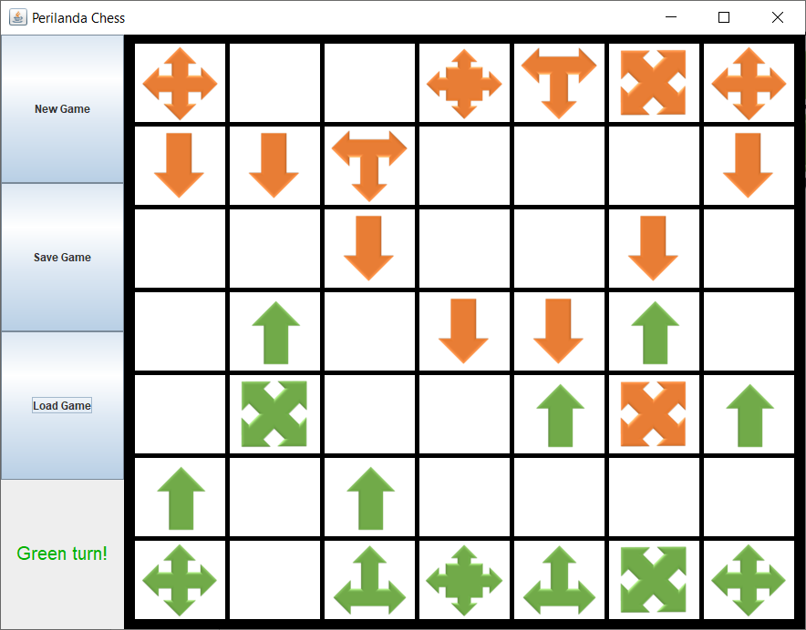

The game will be set to the same as previous.

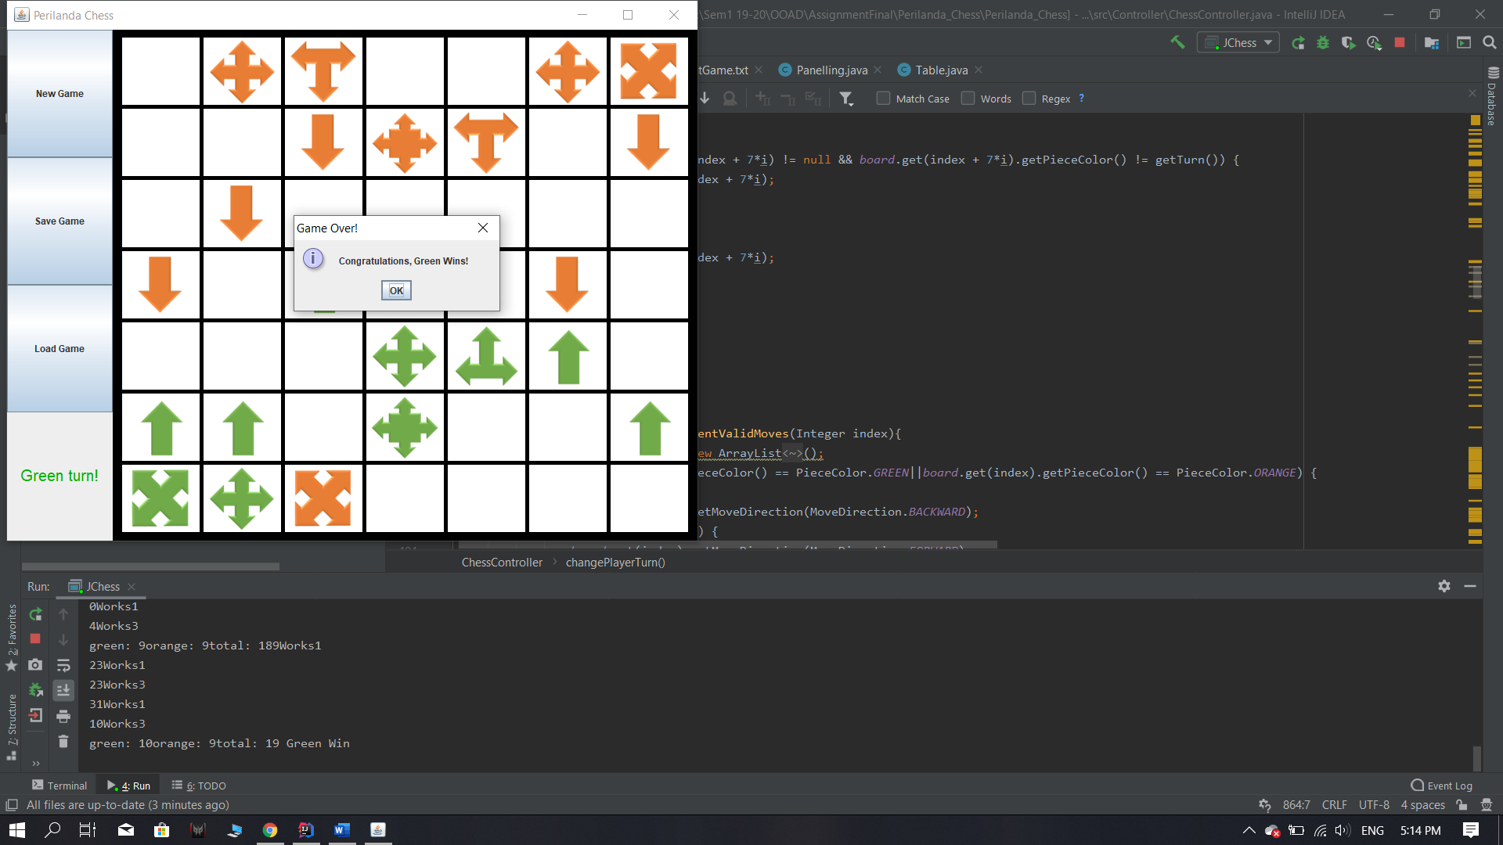

When a Chief is being captured, the opposite player will be declared as a winner through a pop up.

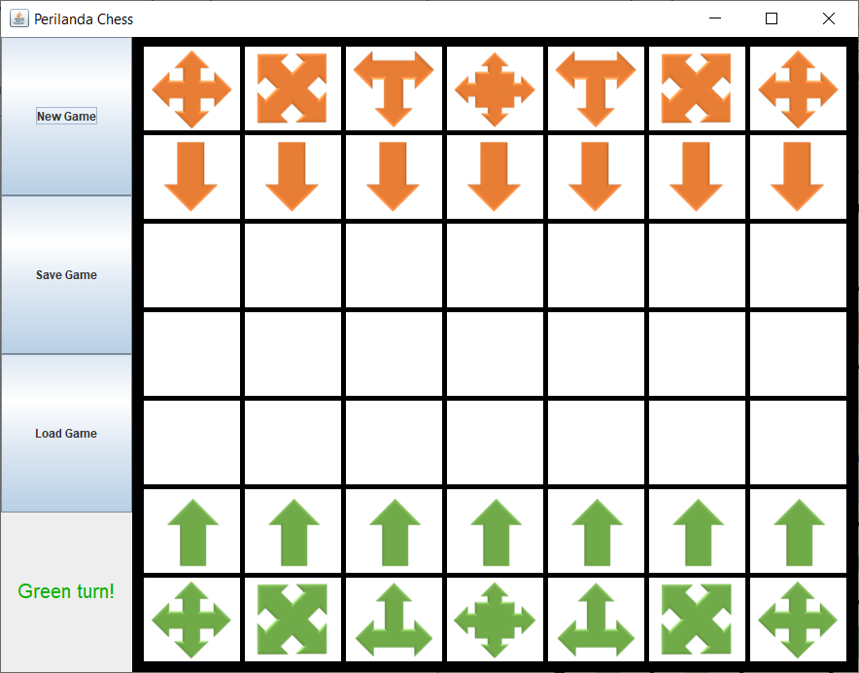

After the winner has been declared, the game will once again be initialized and ready for a new game.

## UML Class Diagram

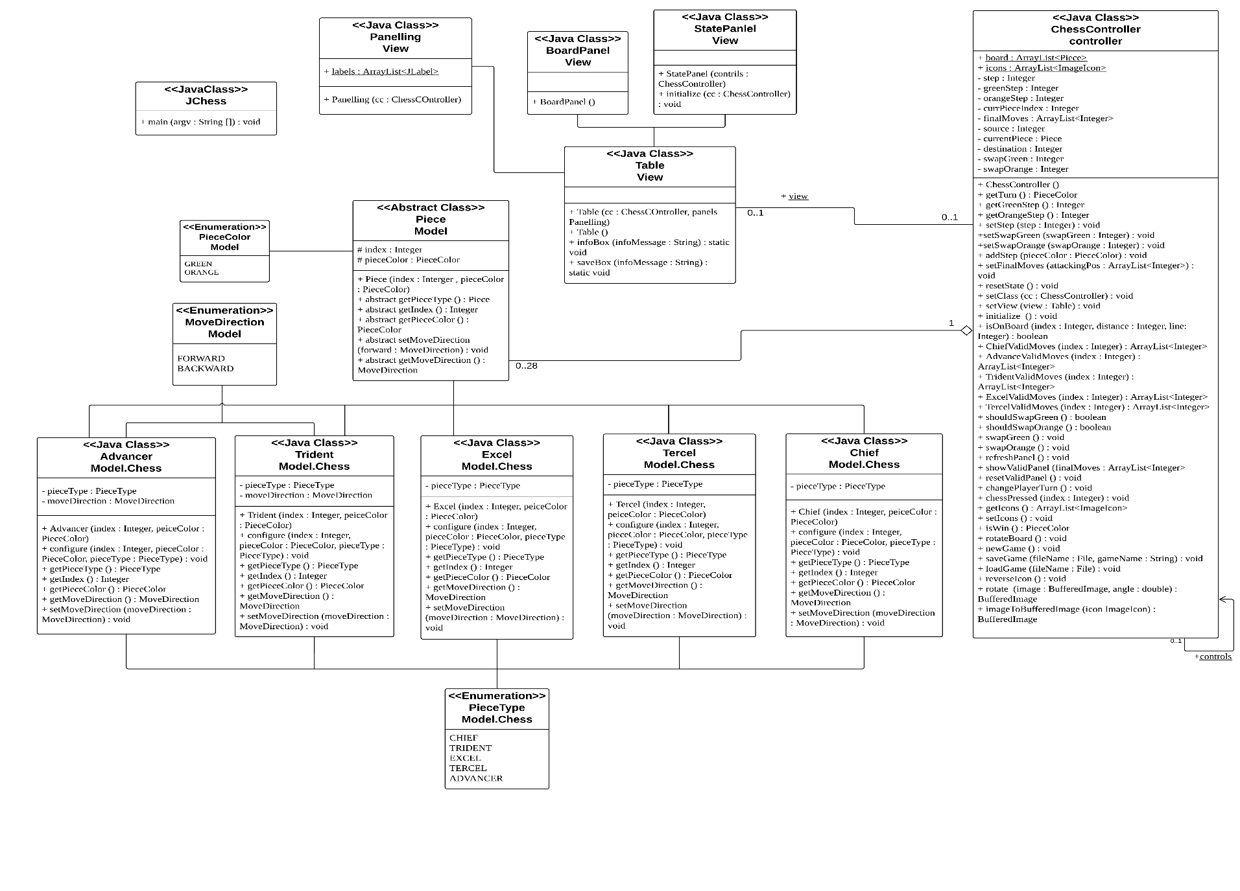

## Use Case Digarm

## Sequential Diagrams

## Save Game

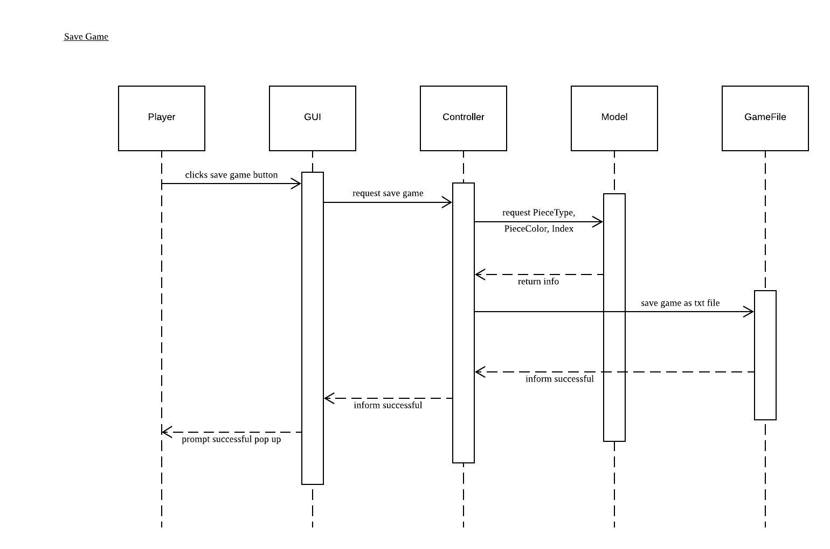

## Load Game

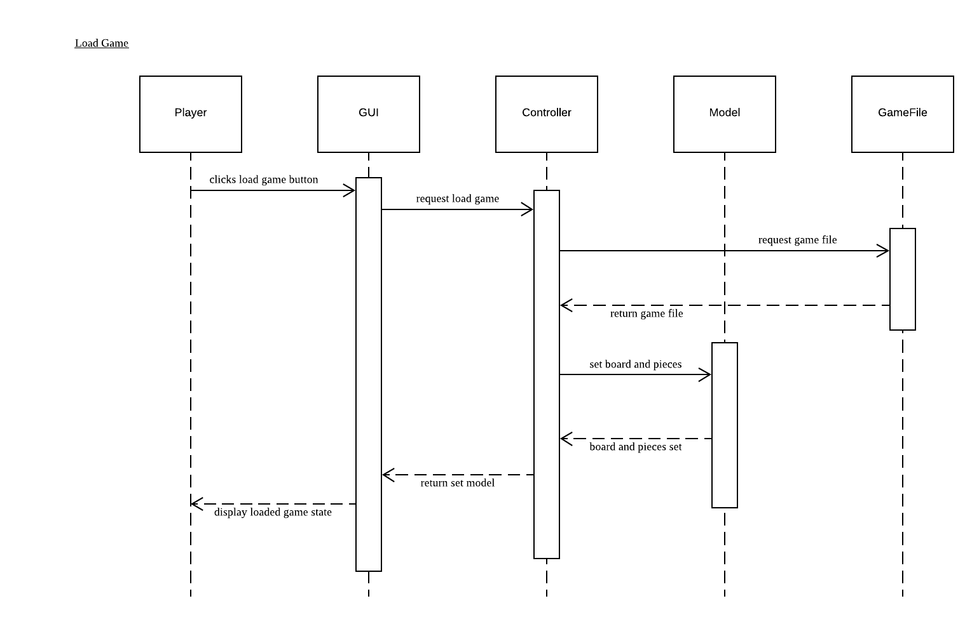

## Move Piece

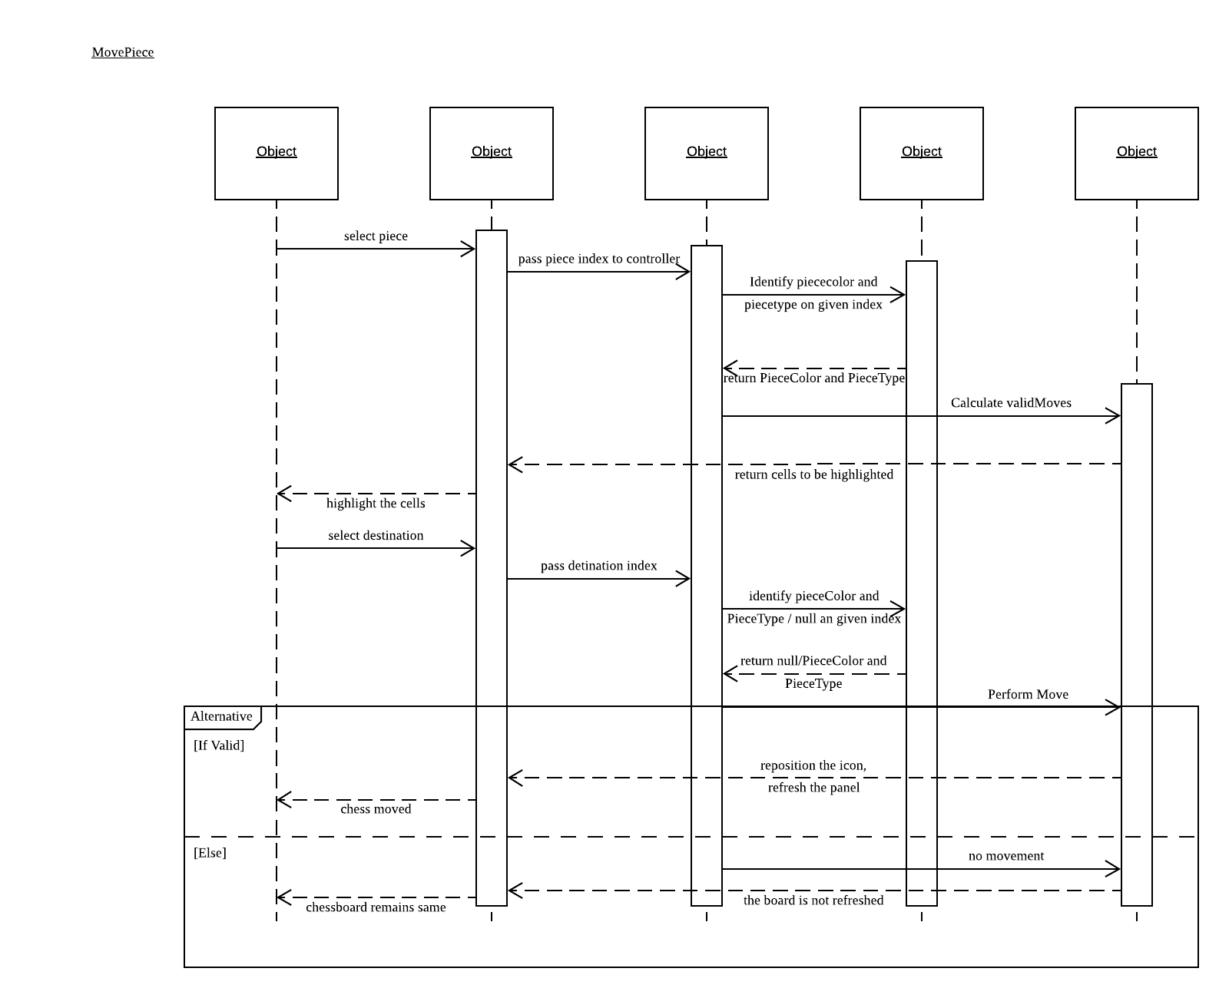

## New Game

