Cloud Server Project and Video Explainer

Name: Naviru Dulneth Kalatuwawa Lekamge Gunawardena  
Student ID: 35289243  
Domain name: [www.naviru.linkpc.net](http://www.naviru.linkpc.net)

IP: 4.200.16.50

Table of Contents

1. Logging in to Microsoft Azure

2. Accessing the Azure Dashboard

3. Starting the Virtual Machine Creation Process

4. Configuring Basic VM Settings

5. Choosing the Operating System and Image

6. Selecting the VM Size

7. Configuring Administrator Account and Authentication

8. Configuring Inbound Port Rules

9. Reviewing and Creating the VM

10. Deployment in Progress

11. Deployment Complete

12. Viewing VM Overview and Public IP

13. SSH Key Management and PuTTY Configuration

14. Installing Apache Web Server

# 1. Logging in to Microsoft Azure

Log in to the Microsoft Azure portal using your university student account. This provides access to Azure’s cloud resources, including the ability to create and manage virtual machines.  
  
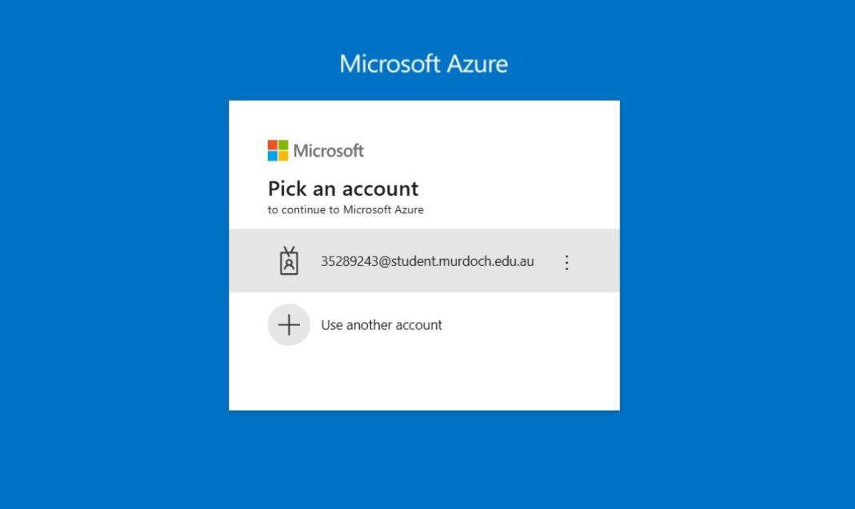

Figure 1: Microsoft Azure login page

# 2. Accessing the Azure Dashboard

After logging in, you are directed to the Azure dashboard. This is the central hub for managing all your Azure resources.

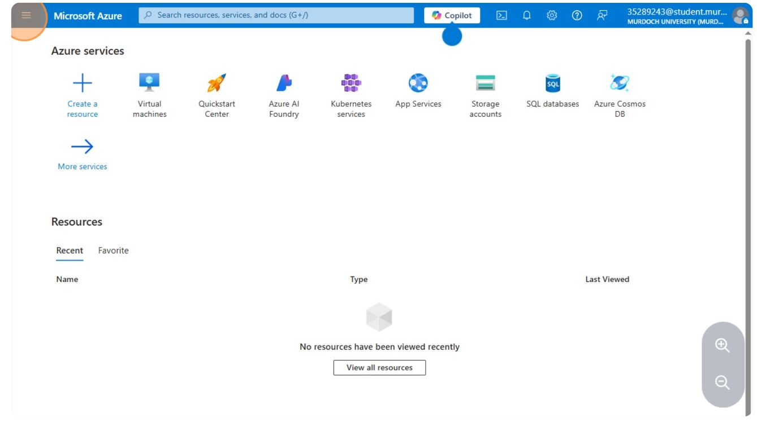

Figure 2: Azure dashboard overview

# 3. Starting the Virtual Machine Creation Process

On the dashboard, select the option to create a new resource. Choose to create a “Virtual Machine” to begin configuring and deploying a new VM in the Azure cloud.

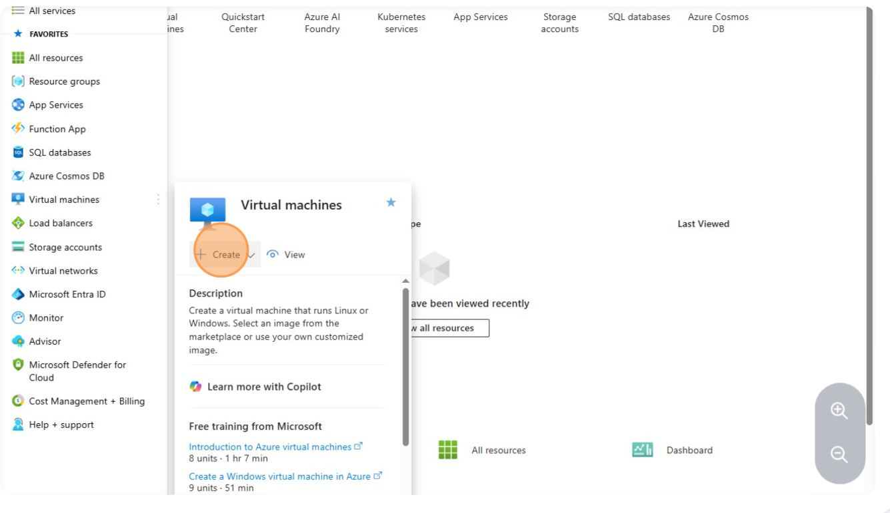

Figure 3: Creating a new virtual machine

# 4. Configuring Basic VM Settings

Fill in the basic details for your VM, such as the subscription, resource group, and virtual machine name. Select the region where your VM will be hosted.

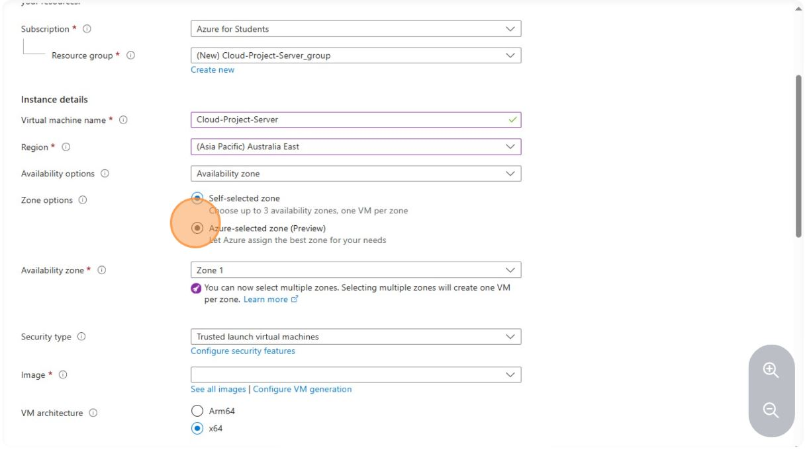

Figure 4: Basic VM configuration

# 5. Choosing the Operating System and Image

Select the operating system image for your VM. In this example, Ubuntu Server 22.04 LTS is chosen.

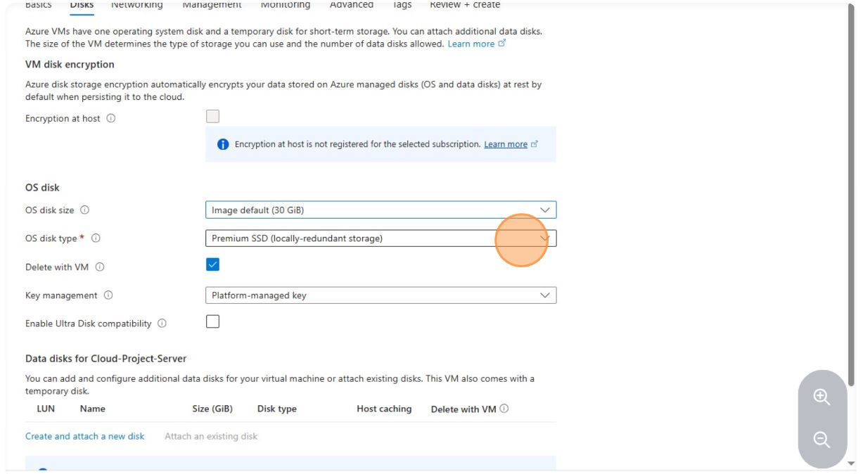

Figure 5: Selecting the OS image

# 6. Selecting the VM Size

Choose the size of your VM, which determines the number of virtual CPUs, memory, and other resources.

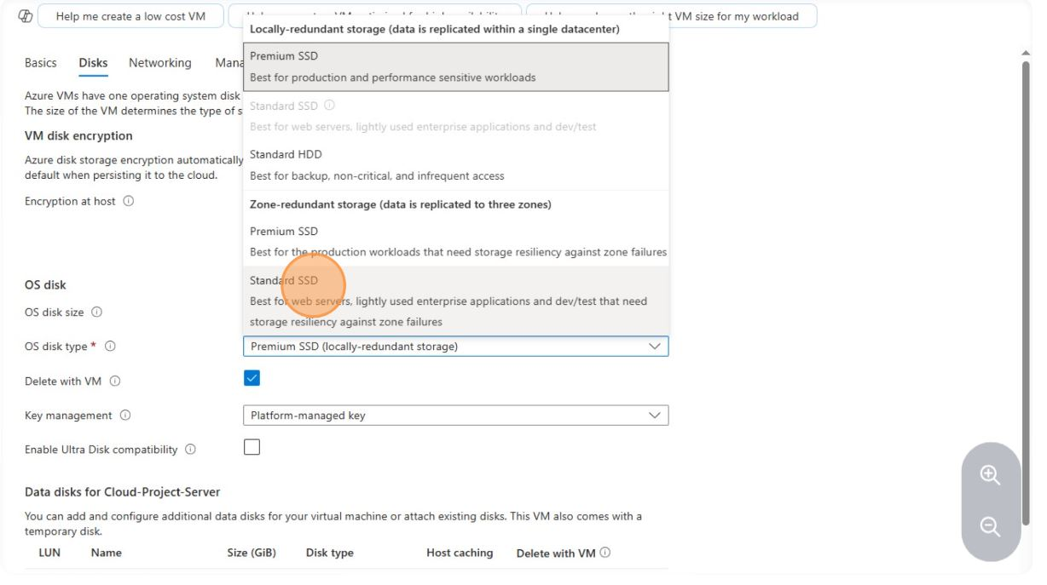

Figure 6: Selecting VM size

# 7. Configuring Administrator Account and Authentication

Set up the administrator account for your VM. Authenticate using an SSH public key for secure remote access.

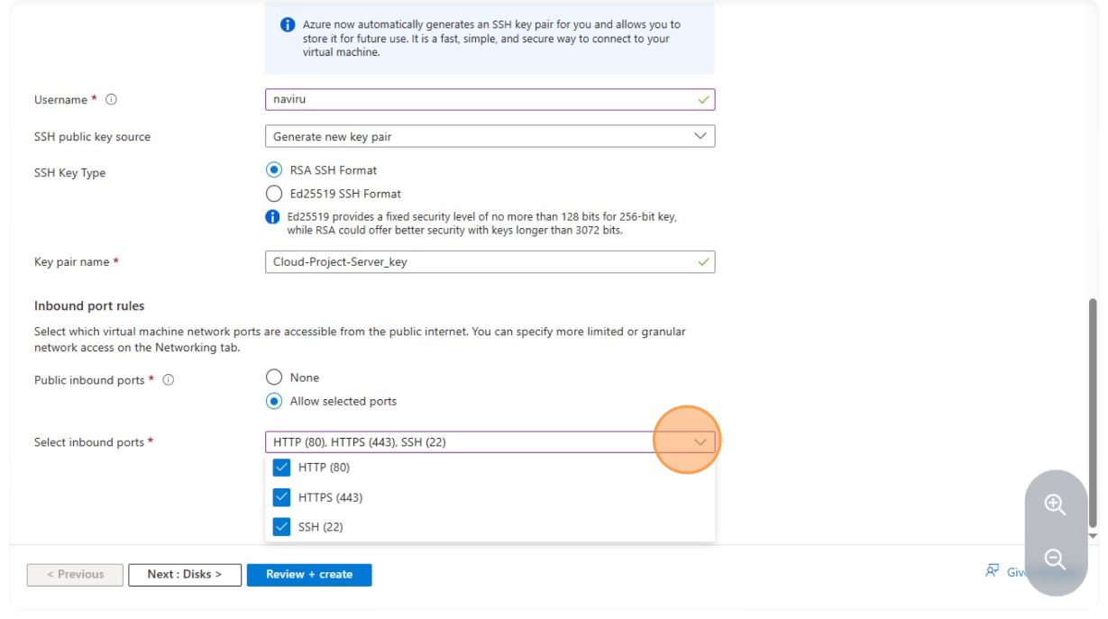

Figure 7: SSH authentication setup

# 8. Configuring Inbound Port Rules

Configure the network security group (NSG) to allow inbound traffic on specific ports. Allow SSH (port 22) for remote connection.

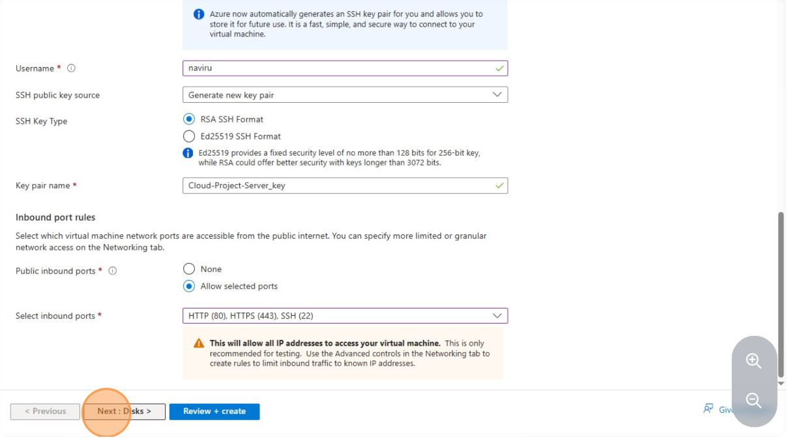

Figure 8: Inbound port rules configuration

# 9. Reviewing and Creating the VM

Review all configuration settings. Click “Create” to deploy the VM.

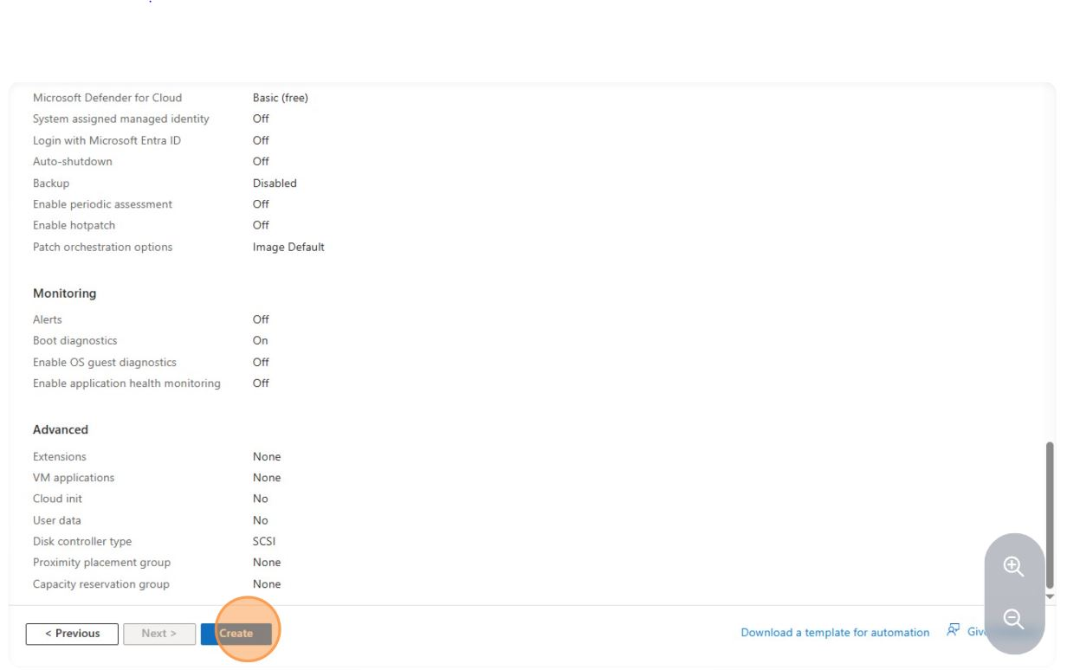

Figure 9: Review and create VM

# 10. Deployment in Progress

Azure displays the deployment progress. This may take a few minutes.

# 11. Deployment Complete

Once deployment is complete, you receive a confirmation message. Your VM is now live and ready for use.

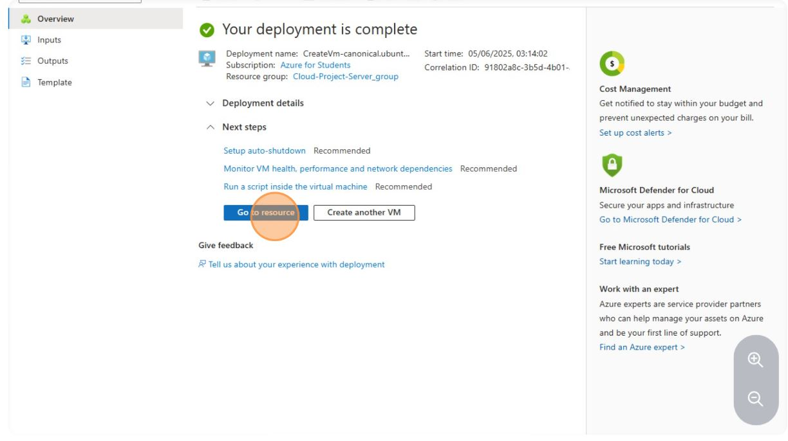

Figure 11: Deployment complete

# 12. Viewing VM Overview and Public IP

Navigate to the VM’s overview page to see details such as the public IP address, status, and resource group.

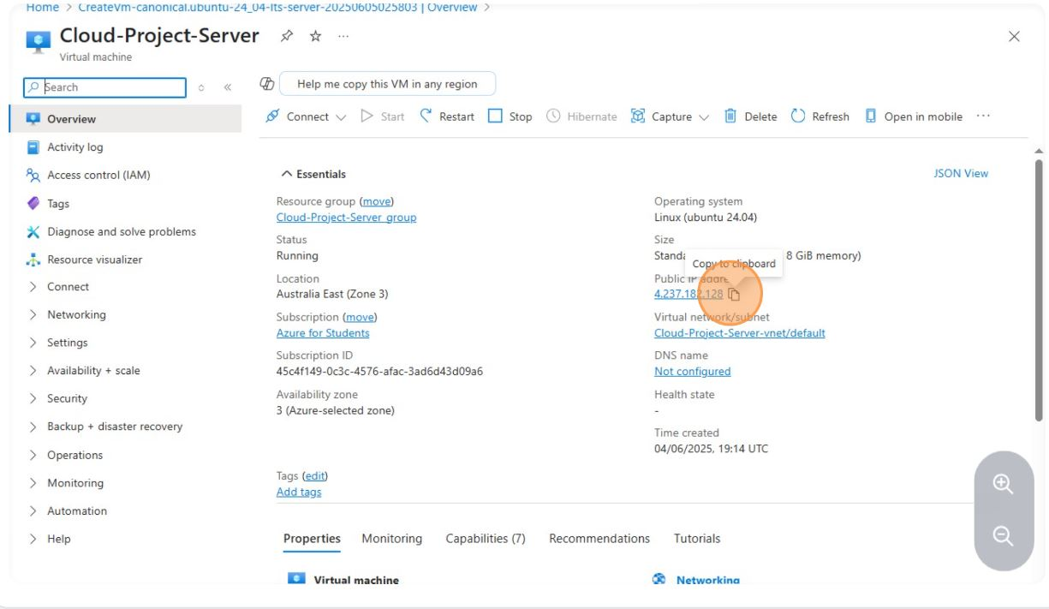

Figure 12: VM overview and public IP

# 13. SSH Key Management and PuTTY Configuration

After deploying your VM, securely connect to it using SSH. The following steps guide you through managing your server key and configuring PuTTY for SSH access:

1. Download the server key (.pem) from Azure.

2. Open PuTTYgen, load the .pem file.

3. Save the private key as .ppk.

4. In PuTTY, enter your VM’s public IP and set SSH as the connection type.

5. Under SSH > Auth, select your .ppk file for authentication.

# 14. Installing Apache Web Server

After connecting to your VM via SSH, install the Apache web server to host web pages and applications.

Step 1: Update System Packages

Run the following command to update your system:

sudo apt update && sudo apt upgrade -y

Step 2: Install Apache

Install Apache with:

sudo apt install apache2 -y

Step 3: Verify Apache Installation

Check the status of Apache:

sudo systemctl status apache2

Step 4: Allow HTTP Traffic Through the Firewall

Allow HTTP traffic:

sudo ufw allow 'Apache'  
sudo ufw enable  
sudo ufw status

Step 5: Test Apache Web Server

Open a web browser and enter your VM’s public IP address. You should see the default Apache2 Ubuntu web page.