**Assignment 6**

Group Members:

HAITAO ZHOU (HAZ59)

YINGZHI YANG(YIY50)

XIN JIN(XIJ21)

**DATA & METHODS**

In this assignment, data is from wikipedia and statista website, which is the same as Franz’s data. The website of our data can be found in *References* . We use R Studio to statistic and analyze the data.

The following picture is the screen shot of the data:

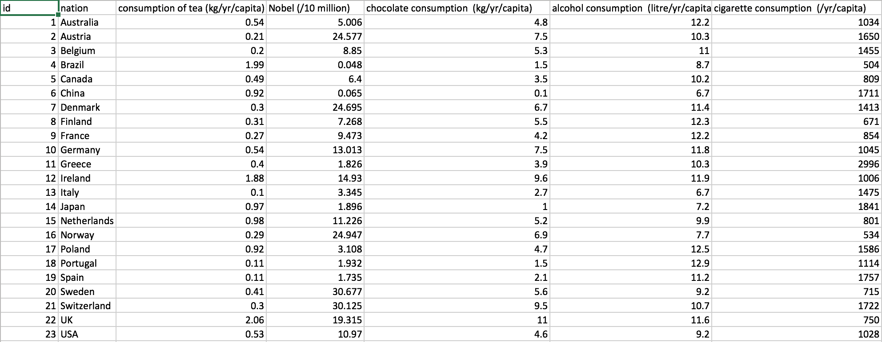

**Analysis**

1.Summary of Data:

First of all, we show some summary information about ‘Nobel.laureates’, ‘consumption of tea’, ‘chocolate consumption’, ‘alcohol’ and ‘cigarette’.

Consumption.of.tea.kg.yr.capita.

Min. :0.1000

1st Qu.:0.2800

Median :0.4100

Mean :0.6448

3rd Qu.:0.9200

Max. :2.0600

Nobel.laureates /10.million

Min. : 0.048

1st Qu.: 2.520

Median : 8.850

Mean :11.106

3rd Qu.:17.122

Max. :30.677

Chocolate.consumption kg/yr/capita.

Min. : 0.100

1st Qu.: 3.100

Median : 4.800

Mean : 4.996

3rd Qu.: 6.800

Max. :11.000

alcohol.consumption...litre.yr.capita.

Min. : 6.70

1st Qu.: 9.20

Median :10.70

Mean :10.34

3rd Qu.:11.85

Max. :12.90

cigarette.consumption....yr.capita.

Min. : 504

1st Qu.: 805

Median :1045

Mean :1238

3rd Qu.:1618

Max. :2996

2.Chart

The following chart is the correlation between ‘Chocolate consumption’ and ‘Nobel laureates’. The result is quite same as Franz’s result.

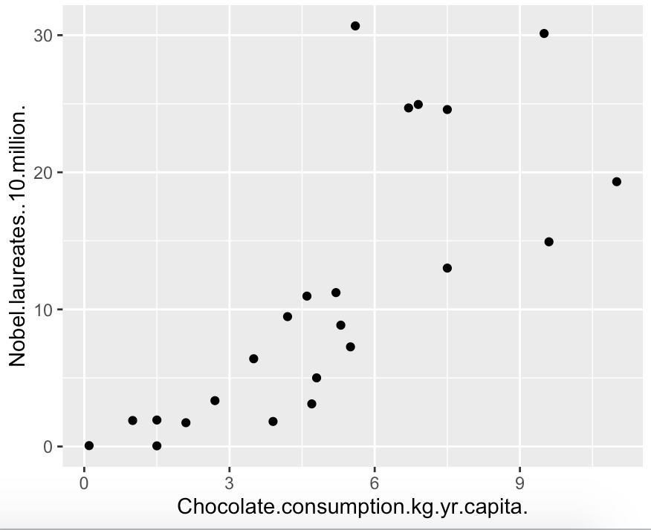

And then, we generate the charts which relate Nobel laureates to Tea consumption, Alcohol consumption and Cigarettes consumption.

X: Tea consumption(kg/yr/capita), Alcohol consumption (litre/yr/capita), Cigarette consumption (/yr/capita)

Y: Nobel laureates(/10 million)

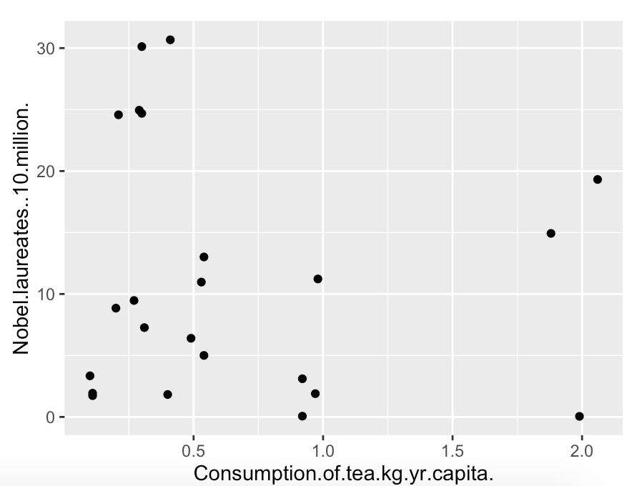

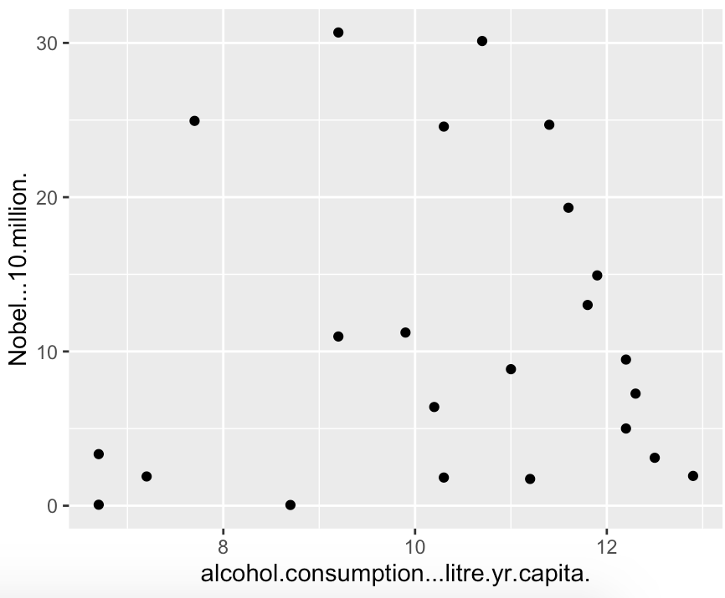

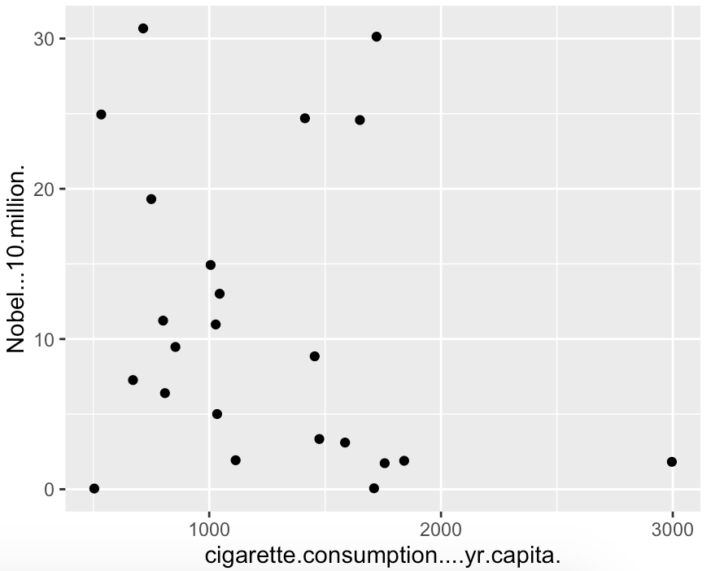

Besides, We use GeNIe to observe the correlation.



Nobel=2.66188*chocolate_consumption+Normal(-2.19229,6.42313)

According to the several charts above, we can make the following conclusions:

1. We can tell that chocolate consumption is correlated to the Nobel Laureates as is shown in the initial report.

2. The correlation between other factors and Nobel laureates is not very obvious. But when we remove several outliers, we can see that Nobel laureates and tea consumption as well as cigarattes are probably negatively related.

**References**

1. Chocolate Consumption: <http://www.statista.com/statistics/262981/amount-of-chocolate-consumed-per-person-by-country/>
2. Nobel: <https://en.wikipedia.org/wiki/List_of_countries_by_Nobel_laureates_per_capita>
3. Tea Consumption <https://en.wikipedia.org/wiki/List_of_countries_by_tea_consumption_per_capita>