1. Azure Data Factory – Successful Data Ingestion
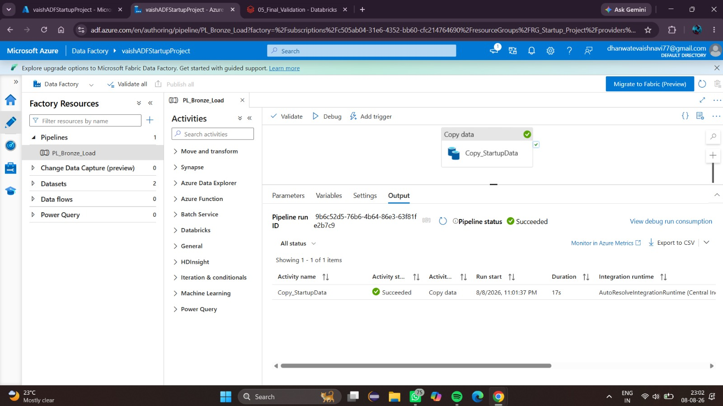
Figure 1: Successful Azure Data Factory Copy Activity
Azure Data Factory was used to ingest the startup funding dataset from Azure Data Lake Storage Gen2. The Copy Data activity successfully transferred 1,100 records from the source to the destination. The execution completed successfully in approximately 11 seconds, confirming that the configured source and sink connections were working correctly.
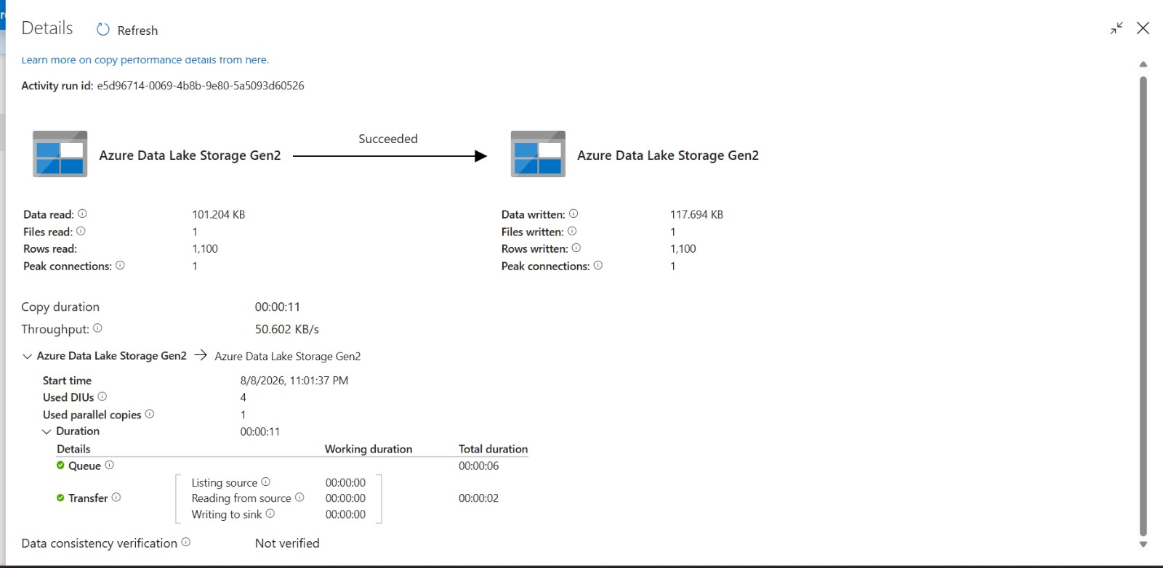

2. Azure Data Lake Storage Gen2
Figure 2: Azure Data Lake Storage Gen2 Container
Azure Data Lake Storage Gen2 is used as the central storage layer for the startup funding data pipeline. The startup-data container stores the raw input data and the processed Bronze, Silver, and Gold datasets generated during the data engineering workflow.
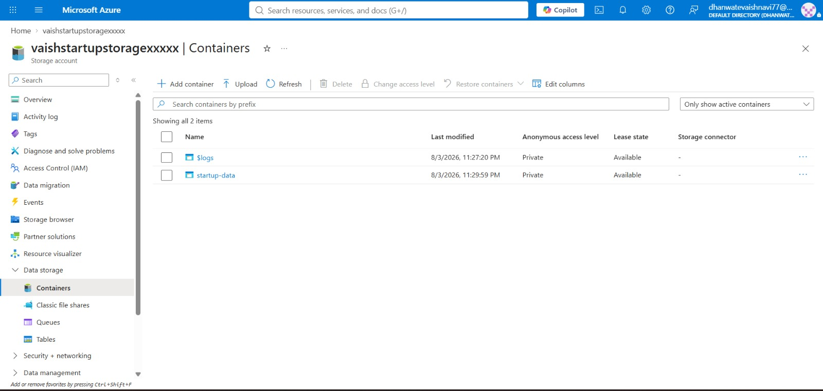
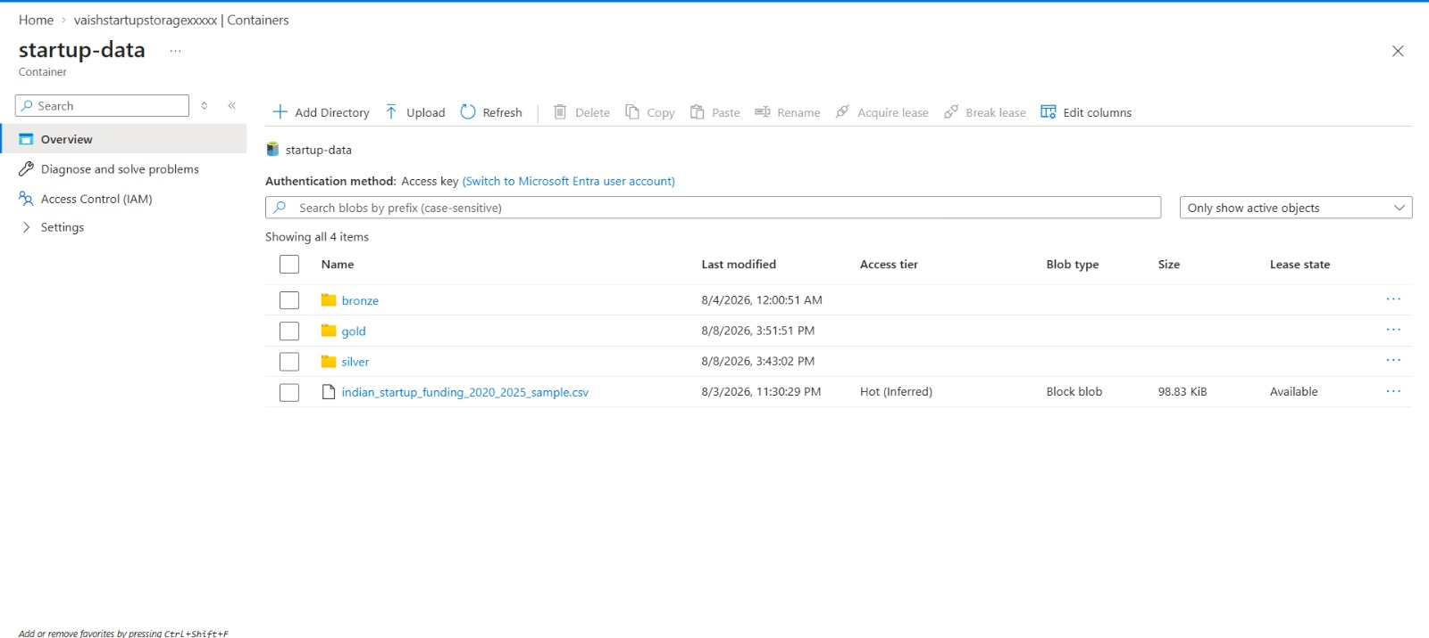

3. Bronze Layer – Raw Data Ingestion
The Bronze layer stores the ingested startup funding dataset in its raw form. Azure Data Lake Storage Gen2 is used as the storage destination, while Databricks is used to read and process the data. The Bronze dataset contains 1,100 records and preserves the original business information before transformation and cleaning.
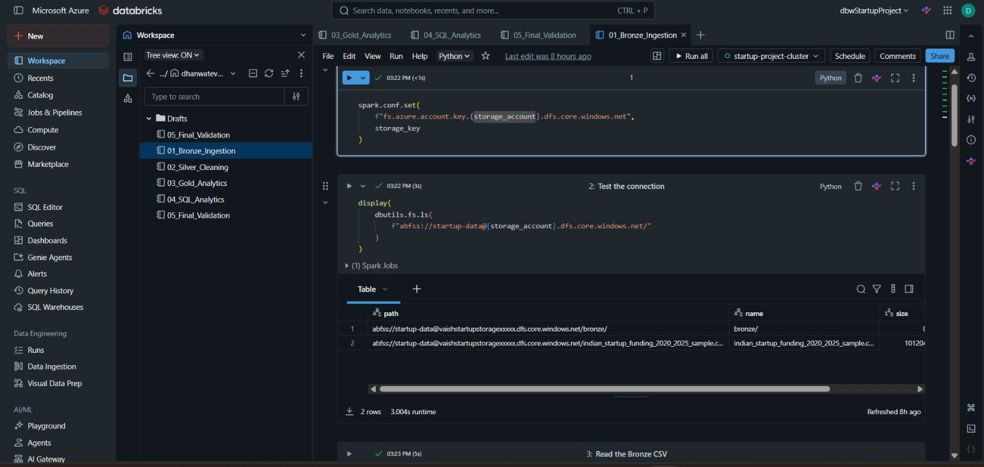

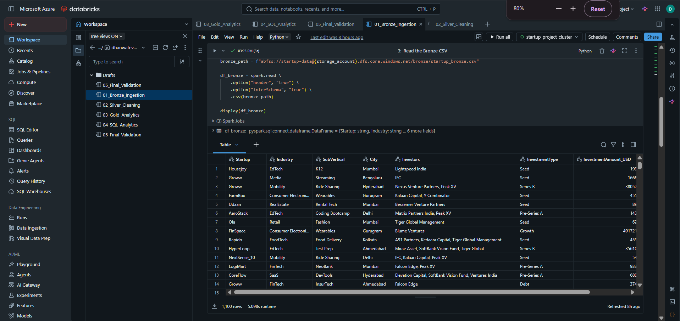

4. Silver Layer – Data Cleaning and Transformation
The Silver layer contains cleaned and transformed startup funding data. Data quality operations such as handling missing values, standardizing fields, removing duplicate records, converting investment amounts into numeric values, and deriving date-related attributes were performed. The resulting dataset contains structured fields such as industry, city, investment type, investment amount, date, year, and month.
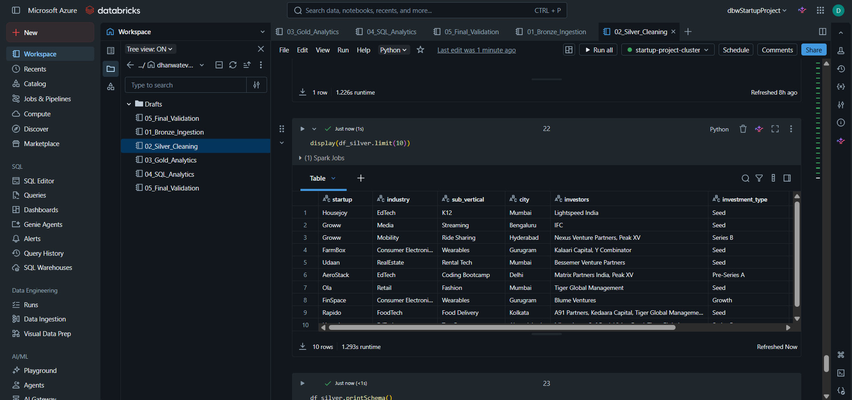

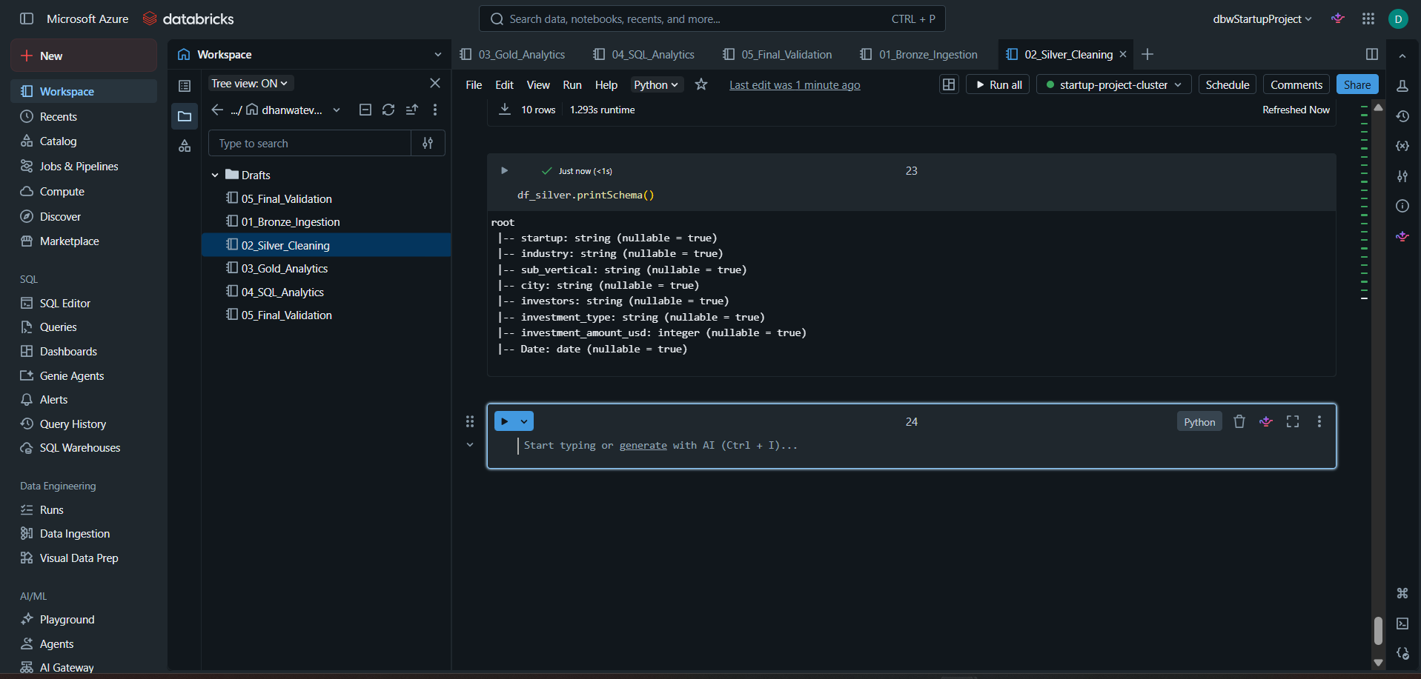

5. Gold Layer – Business Analytics
The Gold layer contains business-ready analytical datasets generated from the Silver layer. Multiple analytical tables were created to support investment analysis, including top funded sectors, city funding rankings, investor deal counts, average deal size by investment stage, sector funding history, and year-over-year sector funding analysis.
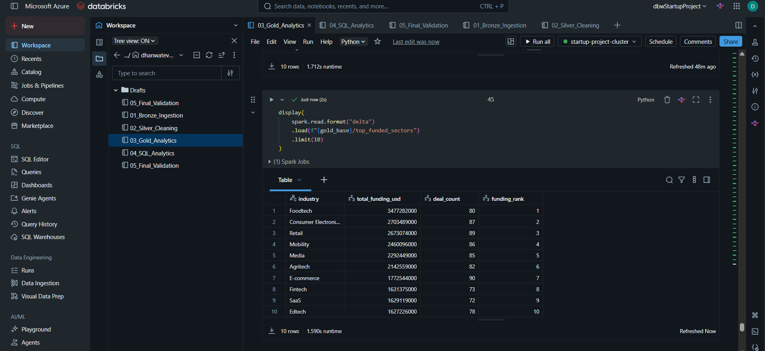
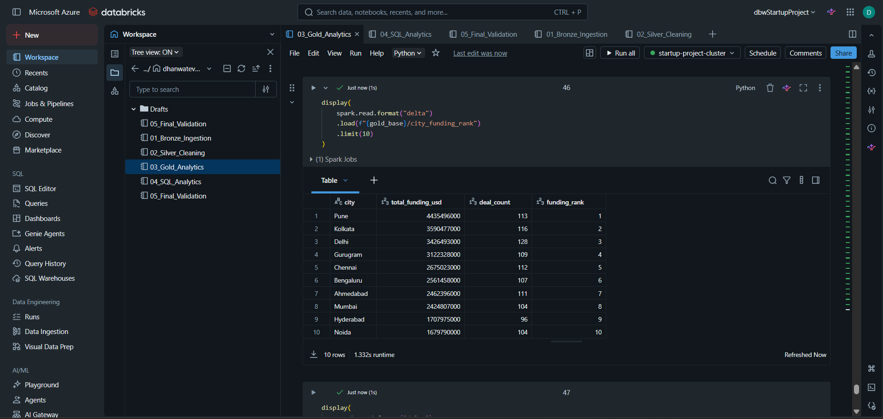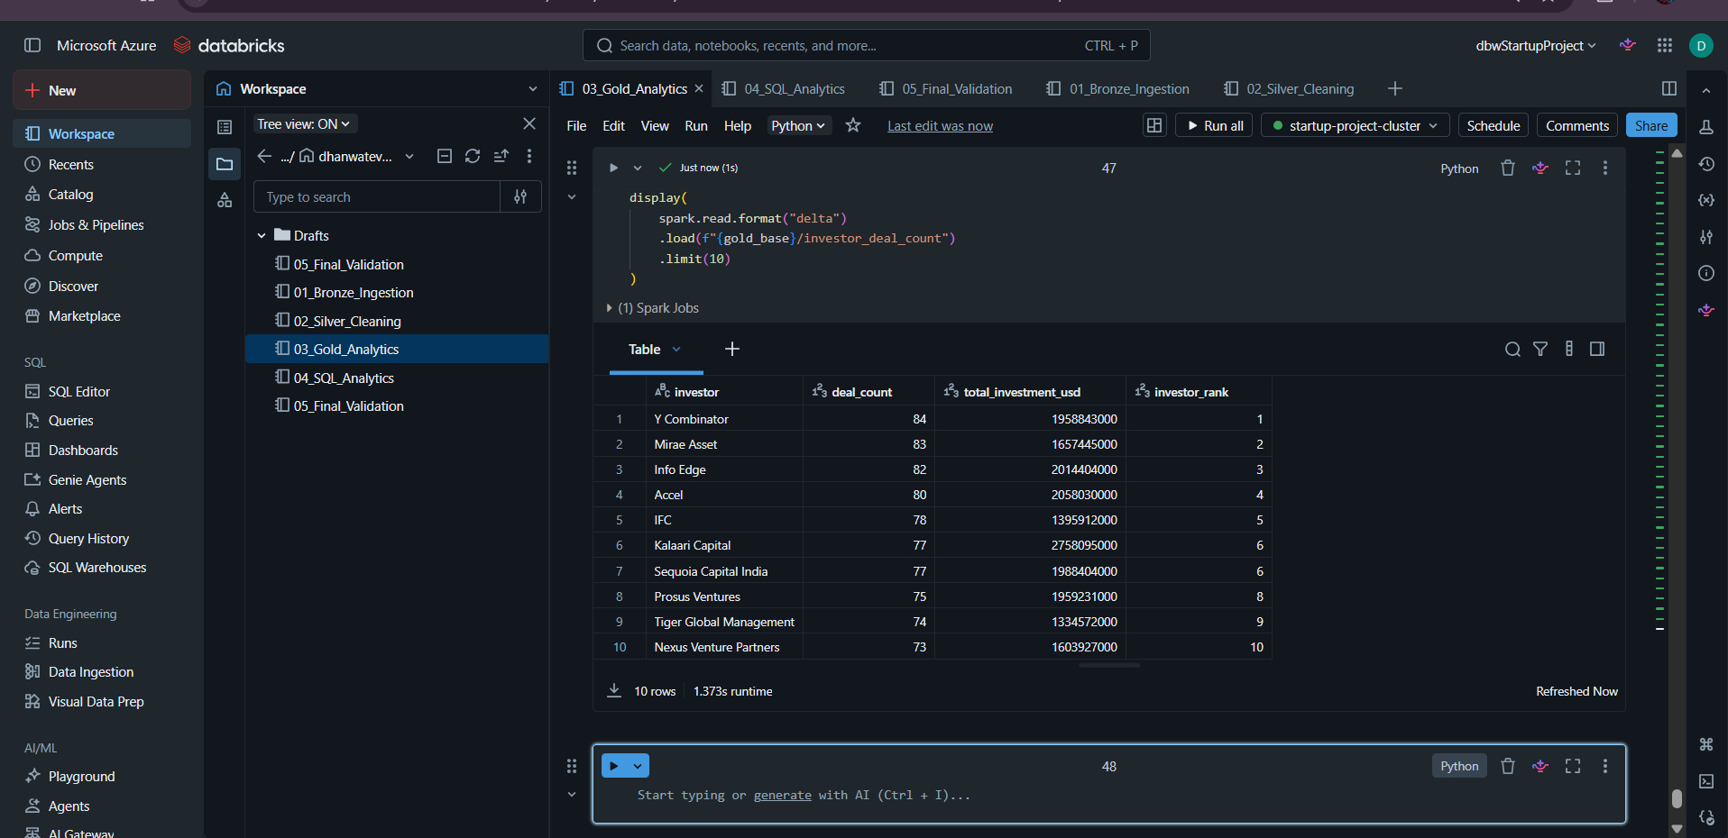
6. Gold Table Validation
The Gold layer was validated by loading each analytical Delta table and checking its row count. The validation confirmed that all six analytical datasets were successfully created and could be read from Azure Data Lake Storage Gen2 using Delta Lake.
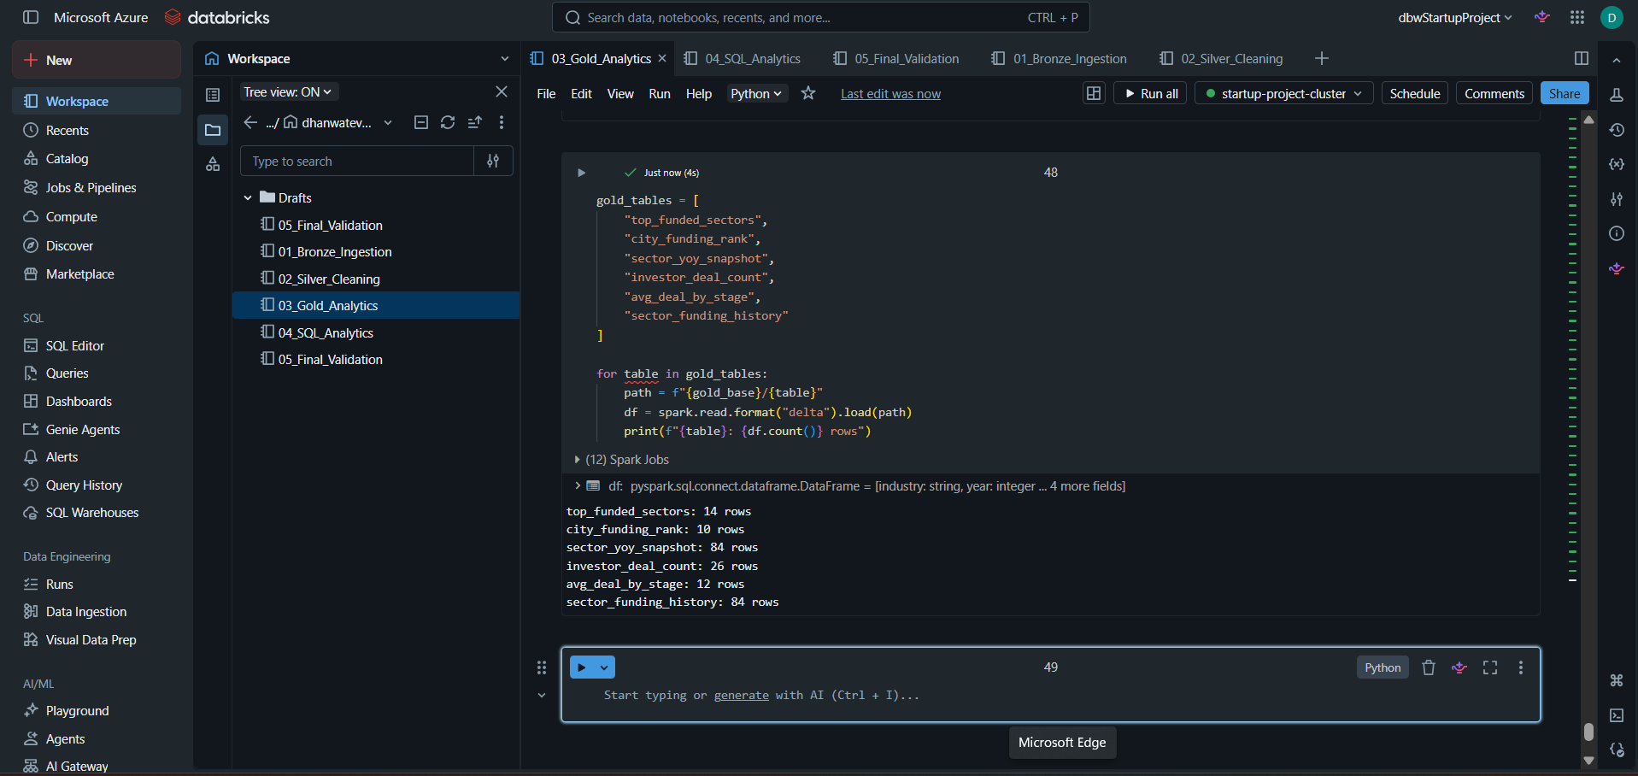

SQL Analytics
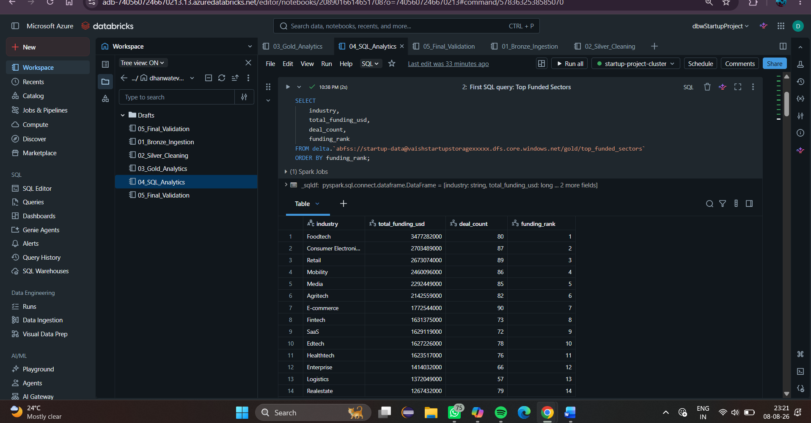

Sector Funding Analysis
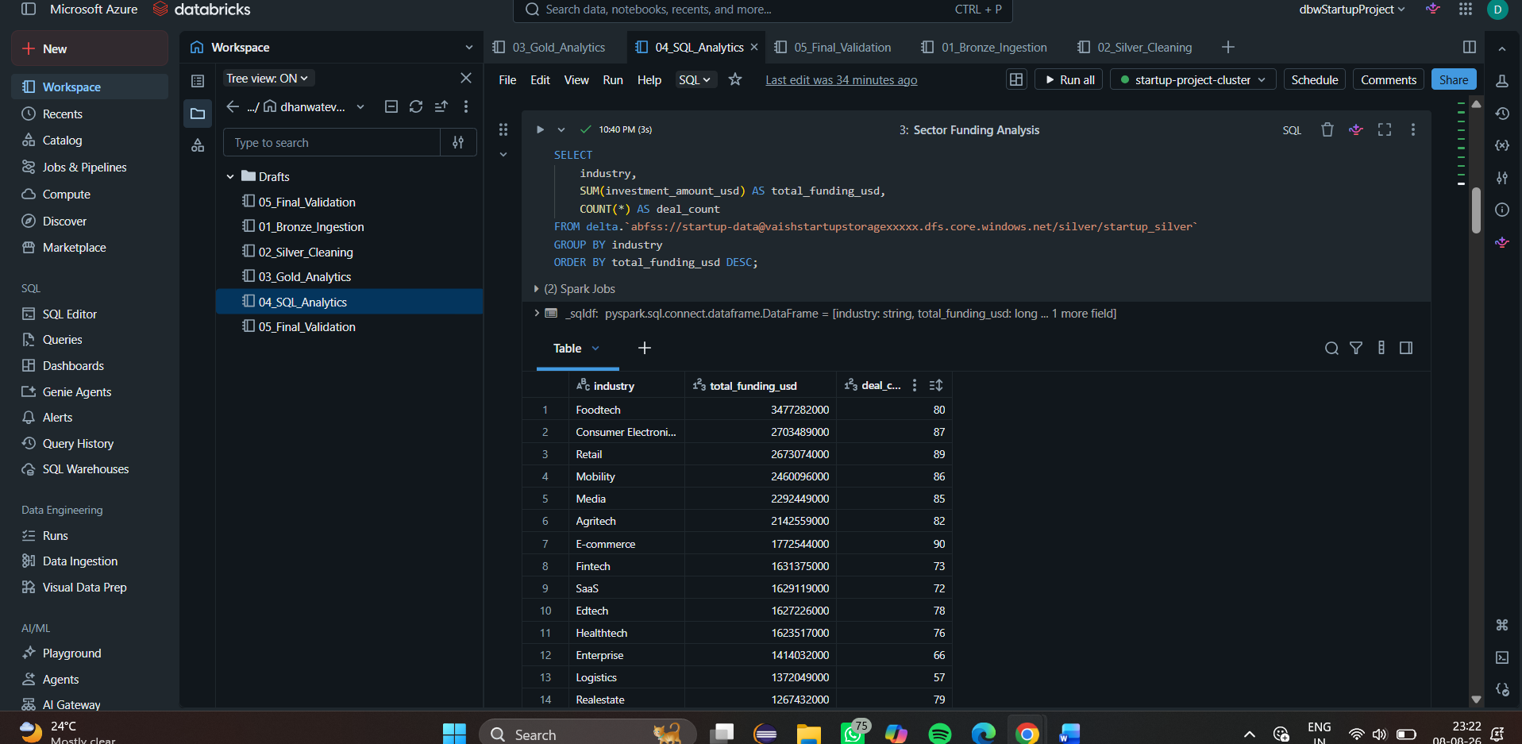

City Funding Ranking
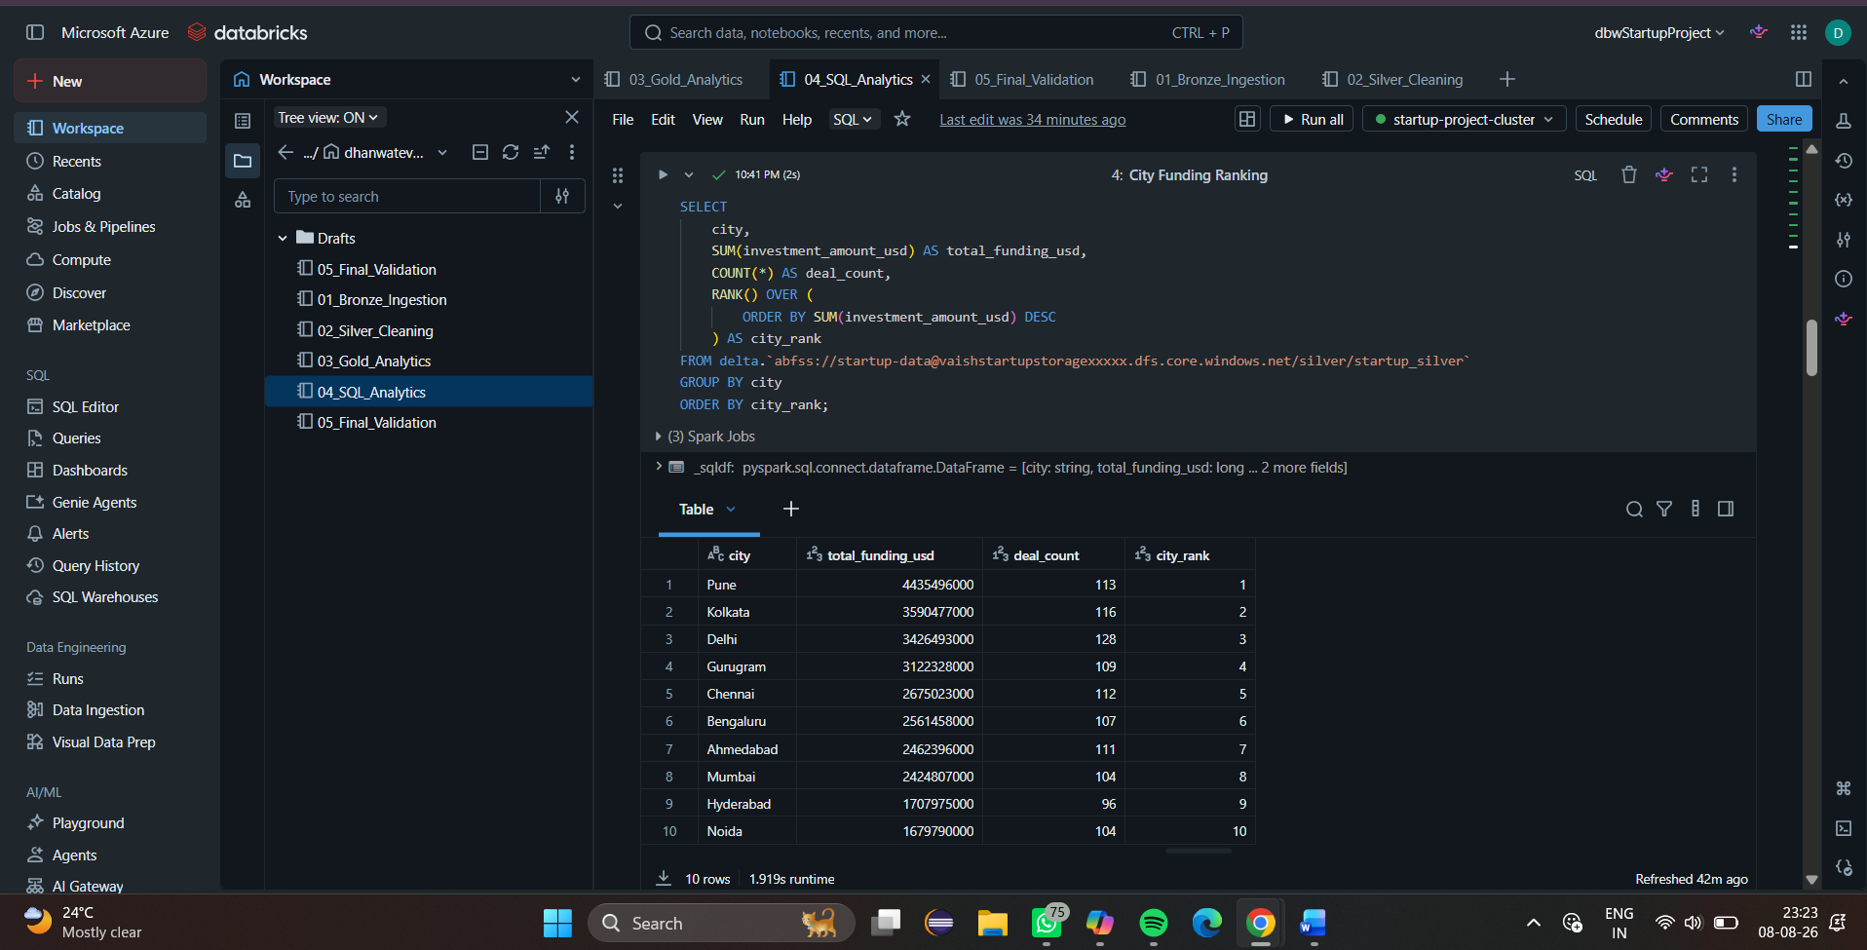

Investor Activity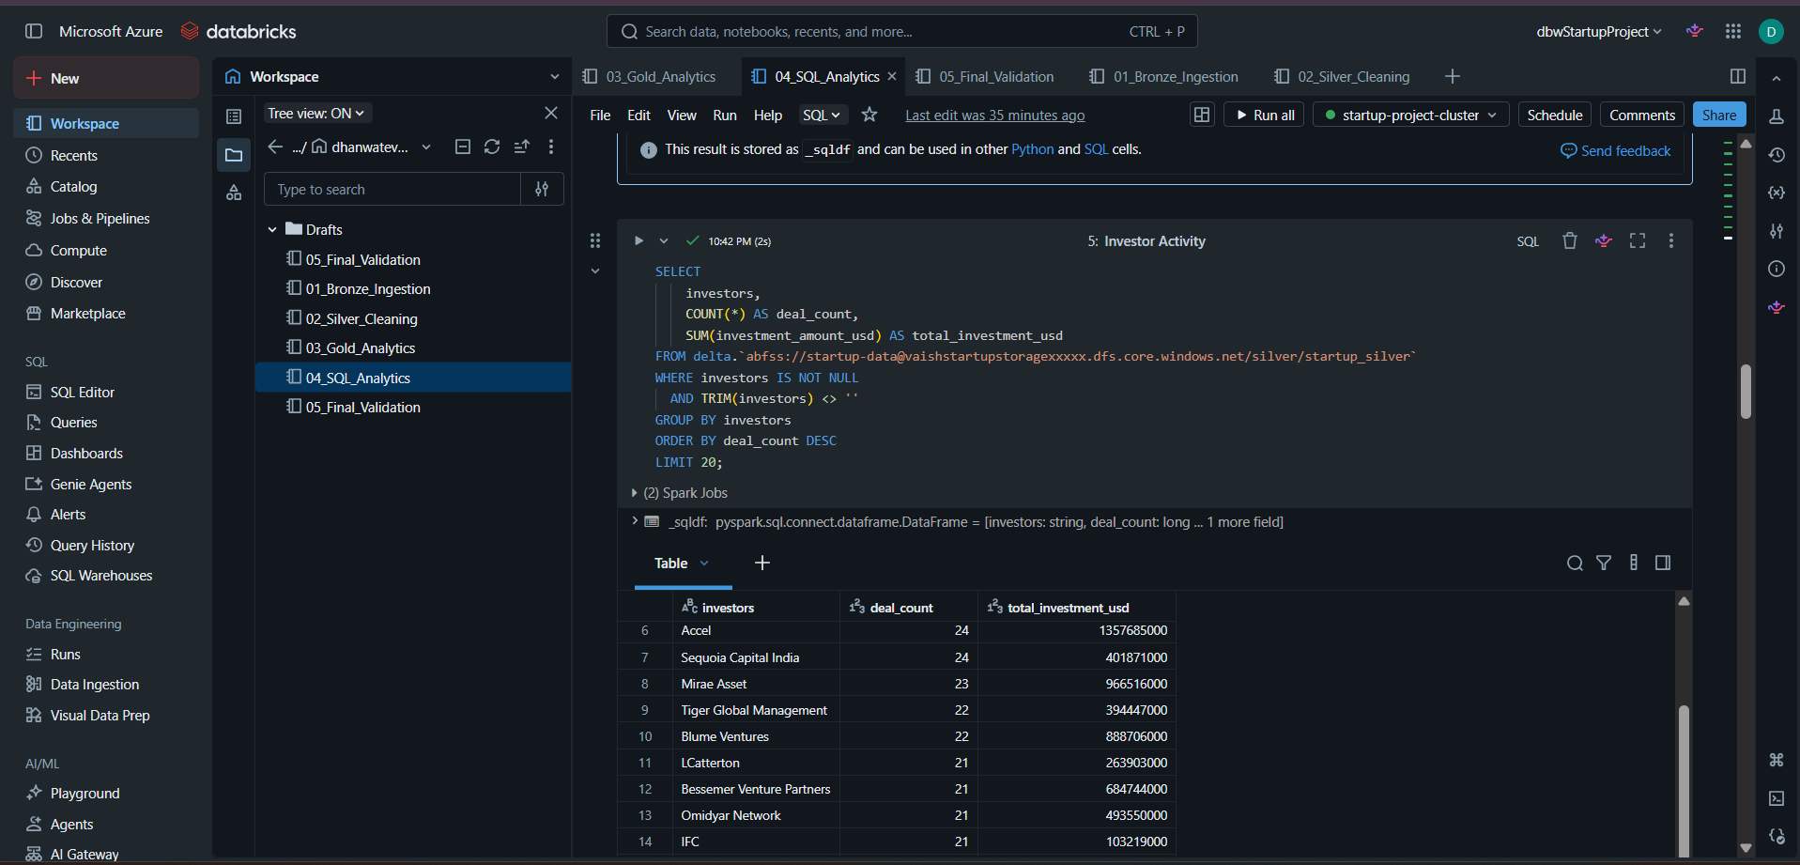
Average Deal by Investment Stage
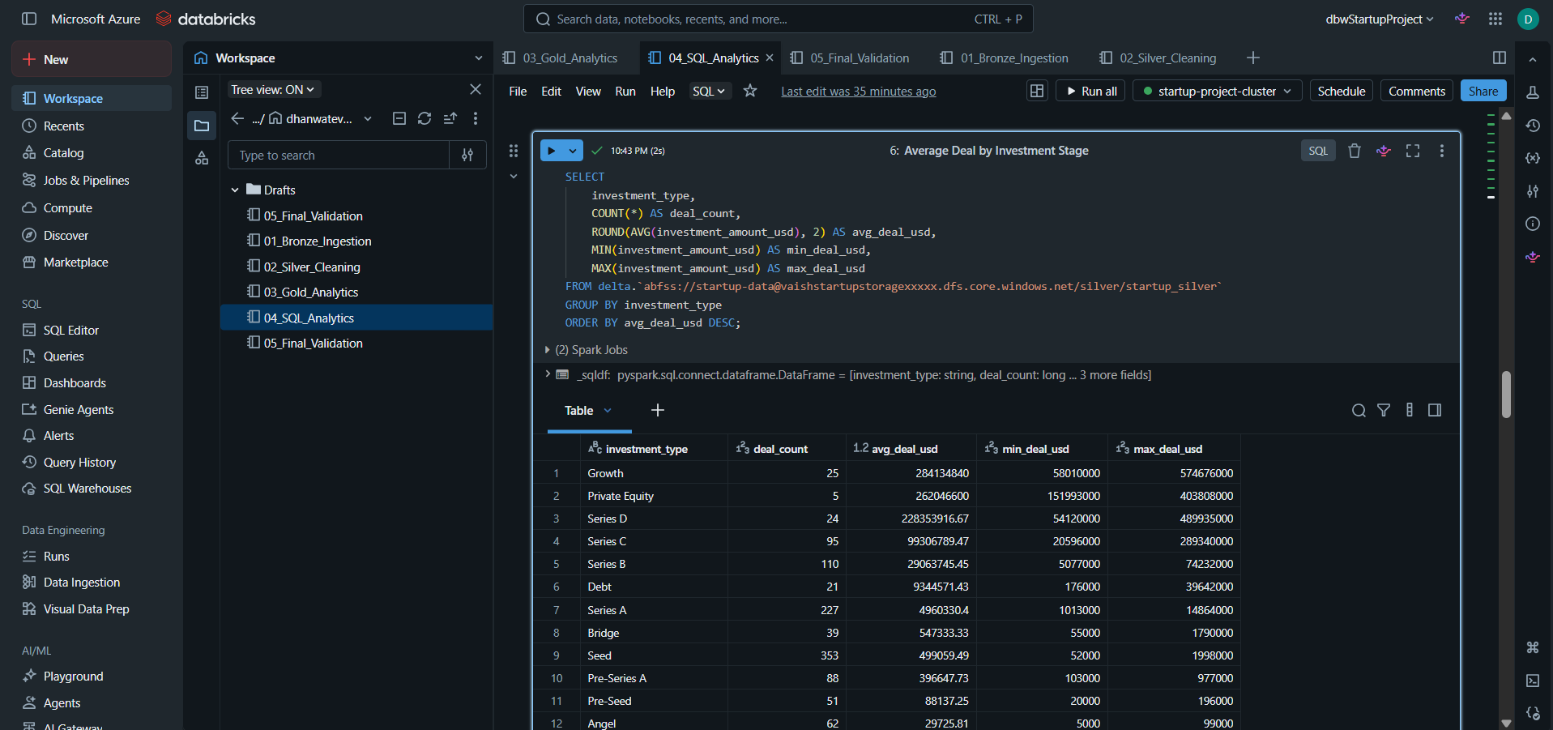

Year-over-Year Funding Analysis
