CREATE TABLE customers (
customer_id INT PRIMARY KEY,
first_name VARCHAR(50) NOT NULL,
last_name VARCHAR(50) NOT NULL,
email VARCHAR(100) UNIQUE NOT NULL,
city VARCHAR(50) NOT NULL,
state VARCHAR(50) NOT NULL,
join_date DATE NOT NULL,
is_premium BOOLEAN DEFAULT FALSE
); -- Index for filtering by city/state
CREATE INDEX idx_customers_city ON customers(city);
CREATE INDEX idx_customers_state ON customers(state);

CREATE TABLE products (
product_id INT PRIMARY KEY,
product_name VARCHAR(100) NOT NULL,
category VARCHAR(50) NOT NULL,
brand VARCHAR(50) NOT NULL,
unit_price DECIMAL(10,2) NOT NULL CHECK (unit_price > 0),
stock_qty INT NOT NULL DEFAULT 0 CHECK (stock_qty >= 0)
); -- Index for filtering by category
CREATE INDEX idx_products_category ON products(category);

CREATE TABLE orders (
order_id INT PRIMARY KEY,
customer_id INT NOT NULL,
order_date DATE NOT NULL,
status VARCHAR(20) NOT NULL DEFAULT 'Pending'
CHECK (status IN ('Pending','Shipped','Delivered','Cancelled')),
total_amount DECIMAL(12,2) NOT NULL CHECK (total_amount >= 0),
FOREIGN KEY (customer_id) REFERENCES customers(customer_id)
); -- Index for date-based filtering and sorting
CREATE INDEX idx_orders_date ON orders(order_date);
CREATE INDEX idx_orders_status ON orders(status);

CREATE TABLE order_items (
item_id INT PRIMARY KEY,
order_id INT NOT NULL,
product_id INT NOT NULL,
quantity INT NOT NULL CHECK (quantity > 0),
unit_price DECIMAL(10,2) NOT NULL CHECK (unit_price > 0),
discount_pct DECIMAL(5,2) DEFAULT 0 CHECK (discount_pct BETWEEN 0 AND 100),
FOREIGN KEY (order_id) REFERENCES orders(order_id),
FOREIGN KEY (product_id) REFERENCES products(product_id)
);

INSERT INTO customers VALUES
(101, 'Aarav', 'Sharma', 'aarav.s@email.com', 'Mumbai', 'Maharashtra', '2024-01-15', TRUE),
(102, 'Priya', 'Patel', 'priya.p@email.com', 'Ahmedabad', 'Gujarat', '2024-02-20', FALSE),
(103, 'Rohan', 'Gupta', 'rohan.g@email.com', 'Delhi', 'Delhi', '2024-03-10', TRUE),
(104, 'Sneha', 'Reddy', 'sneha.r@email.com', 'Hyderabad', 'Telangana', '2024-04-05', FALSE),
(105, 'Vikram', 'Singh', 'vikram.s@email.com', 'Jaipur', 'Rajasthan', '2024-05-12', TRUE),
(106, 'Ananya', 'Iyer', 'ananya.i@email.com', 'Chennai', 'Tamil Nadu', '2024-06-18', FALSE),
(107, 'Karan', 'Mehta', 'karan.m@email.com', 'Pune', 'Maharashtra', '2024-07-22', TRUE),
(108, 'Divya', 'Nair', 'divya.n@email.com', 'Kochi', 'Kerala', '2024-08-30', FALSE);

select * from customers;
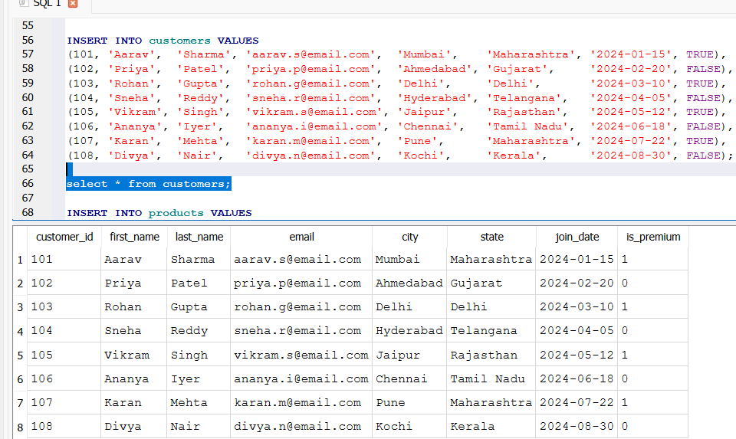

INSERT INTO products VALUES
(201, 'Wireless Earbuds', 'Electronics', 'BoAt', 1499.00, 250),
(202, 'Cotton T-Shirt', 'Clothing', 'Levis', 799.00, 500),
(203, 'Smart Watch', 'Electronics', 'Noise', 2999.00, 150),
(204, 'Running Shoes', 'Clothing', 'Nike', 4599.00, 120),
(205, 'Bluetooth Speaker', 'Electronics', 'JBL', 3499.00, 200),
(206, 'Bedsheet Set', 'Home', 'Spaces', 1299.00, 300),
(207, 'Laptop Stand', 'Electronics', 'AmazonBasics', 899.00, 180),
(208, 'Cushion Covers (Set)', 'Home', 'HomeCenter', 599.00, 400);

select * from products ;
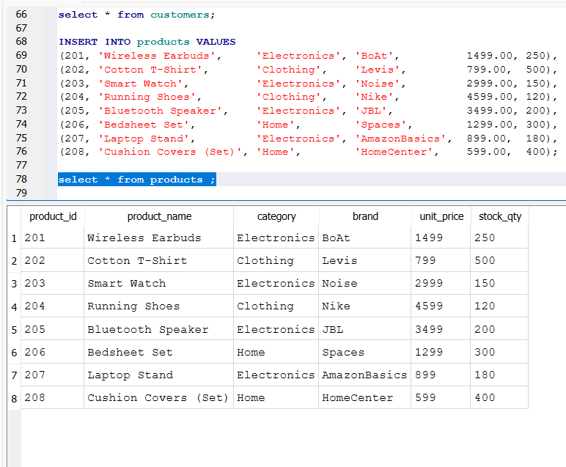

INSERT INTO orders VALUES
(1001, 101, '2024-08-01', 'Delivered', 4498.00),
(1002, 102, '2024-08-03', 'Delivered', 799.00),
(1003, 103, '2024-08-05', 'Shipped', 7498.00),
(1004, 101, '2024-08-10', 'Delivered', 3499.00),
(1005, 104, '2024-08-12', 'Cancelled', 2999.00),
(1006, 105, '2024-08-15', 'Delivered', 5898.00),
(1007, 106, '2024-08-18', 'Pending', 1299.00),
(1008, 103, '2024-08-20', 'Delivered', 899.00),
(1009, 107, '2024-08-25', 'Shipped', 6098.00),
(1010, 108, '2024-08-28', 'Delivered', 1598.00);

select * from orders ;
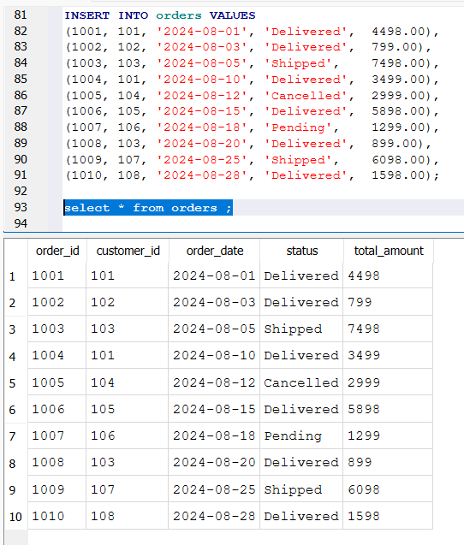
INSERT INTO order_items VALUES
(5001, 1001, 201, 2, 1499.00, 0),
(5002, 1001, 207, 1, 899.00, 10),
(5003, 1002, 202, 1, 799.00, 0),
(5004, 1003, 203, 1, 2999.00, 0),
(5005, 1003, 204, 1, 4599.00, 5),
(5006, 1004, 205, 1, 3499.00, 0),
(5007, 1005, 203, 1, 2999.00, 0),
(5008, 1006, 201, 1, 1499.00, 10),
(5009, 1006, 204, 1, 4599.00, 5),
(5010, 1007, 206, 1, 1299.00, 0),
(5011, 1008, 207, 1, 899.00, 0),
(5012, 1009, 205, 1, 3499.00, 0),
(5013, 1009, 208, 2, 599.00, 15),
(5014, 1010, 206, 1, 1299.00, 0),
(5015, 1010, 208, 1, 599.00, 0);

select * from order_items ;
