- Resource Group Overview Page:
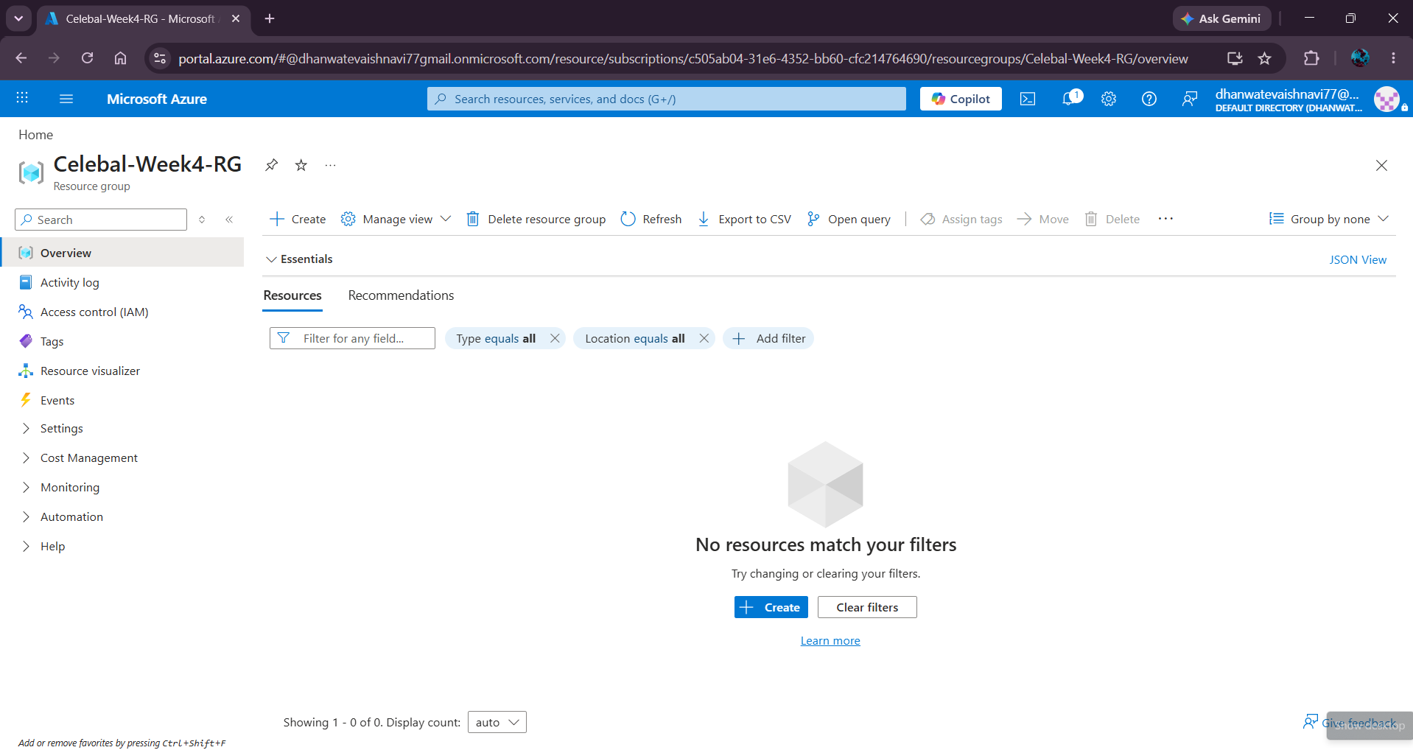

- Storage Account Overview Page :
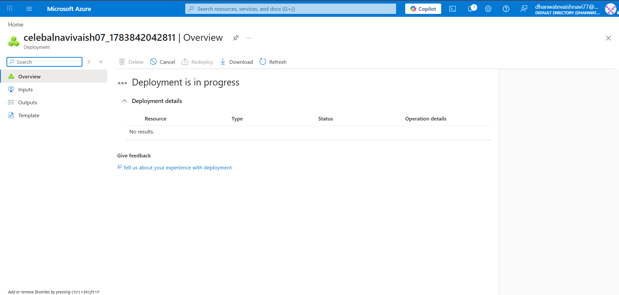
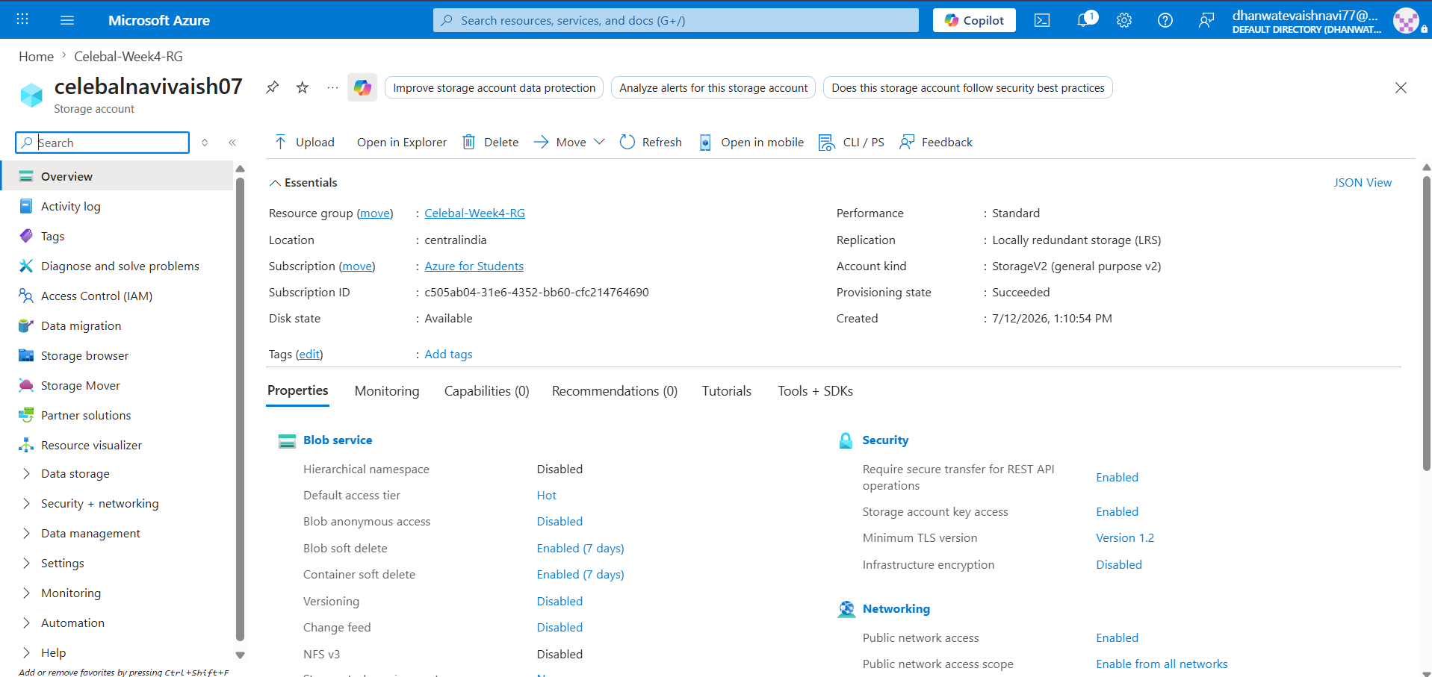

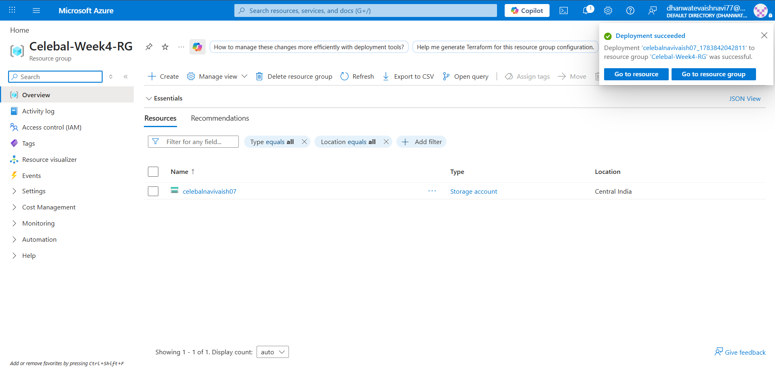

3. Create Blob Containers inside the storage account 1.source-data
2. destination-data :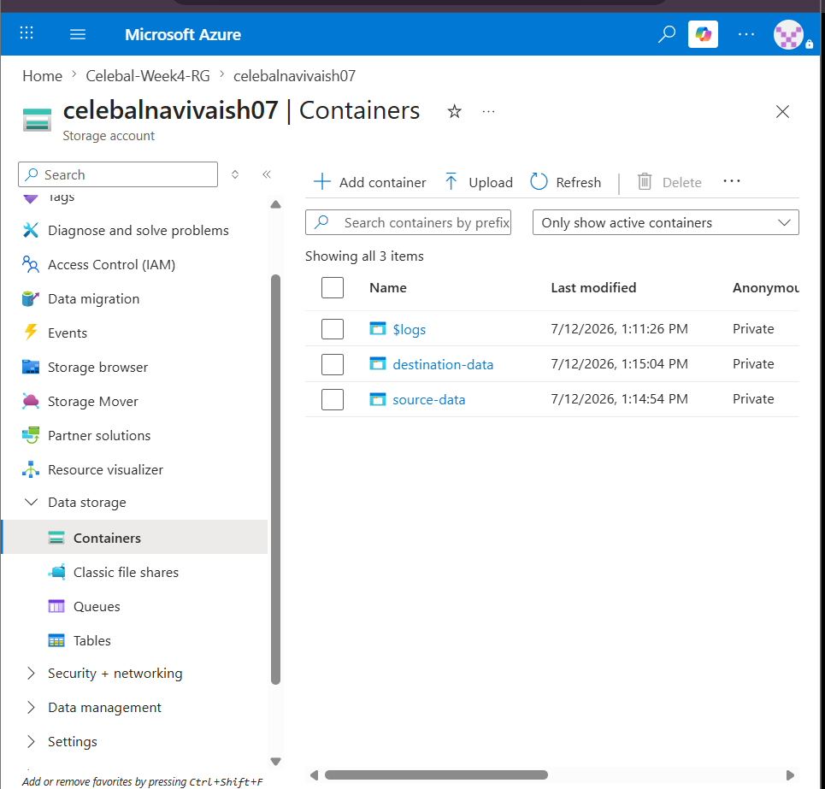

- Upload Your Existing CSV File into the Source-data container:
The Superstore CSV dataset was uploaded to the source-data Blob container in the Azure Storage Account. This file will serve as the source for the Azure Data Factory pipeline.
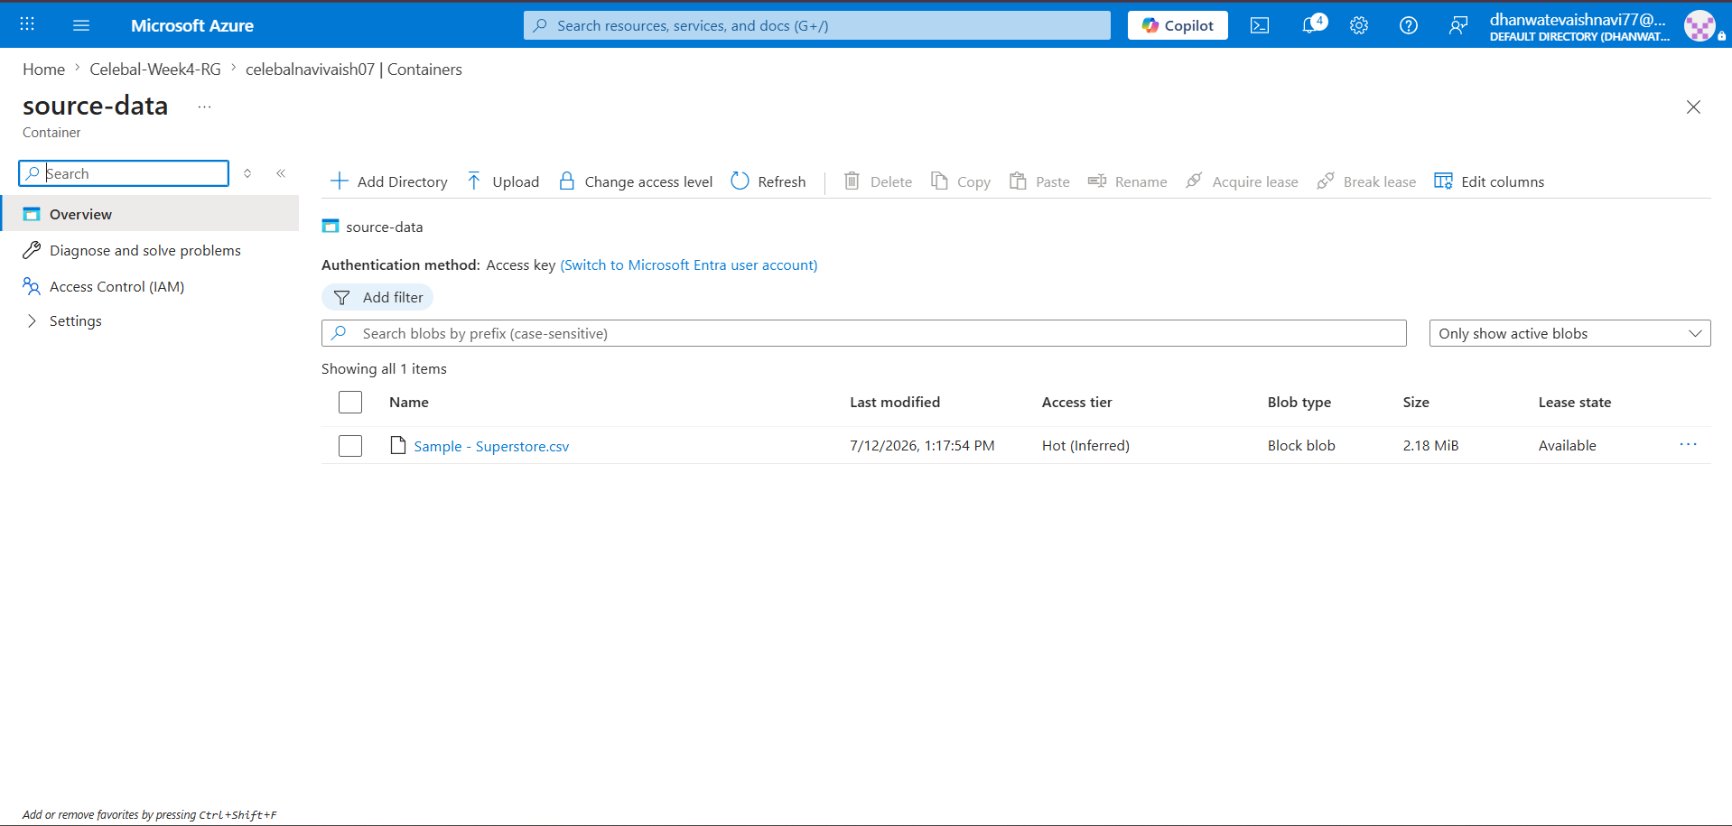
STEP 5: Create Azure Data Factory (ADF)
1.Azure Data Factory Created Successfully
Azure Data Factory was created successfully within the Resource Group. This service will be used to design, execute, and monitor the end-to-end data pipeline.
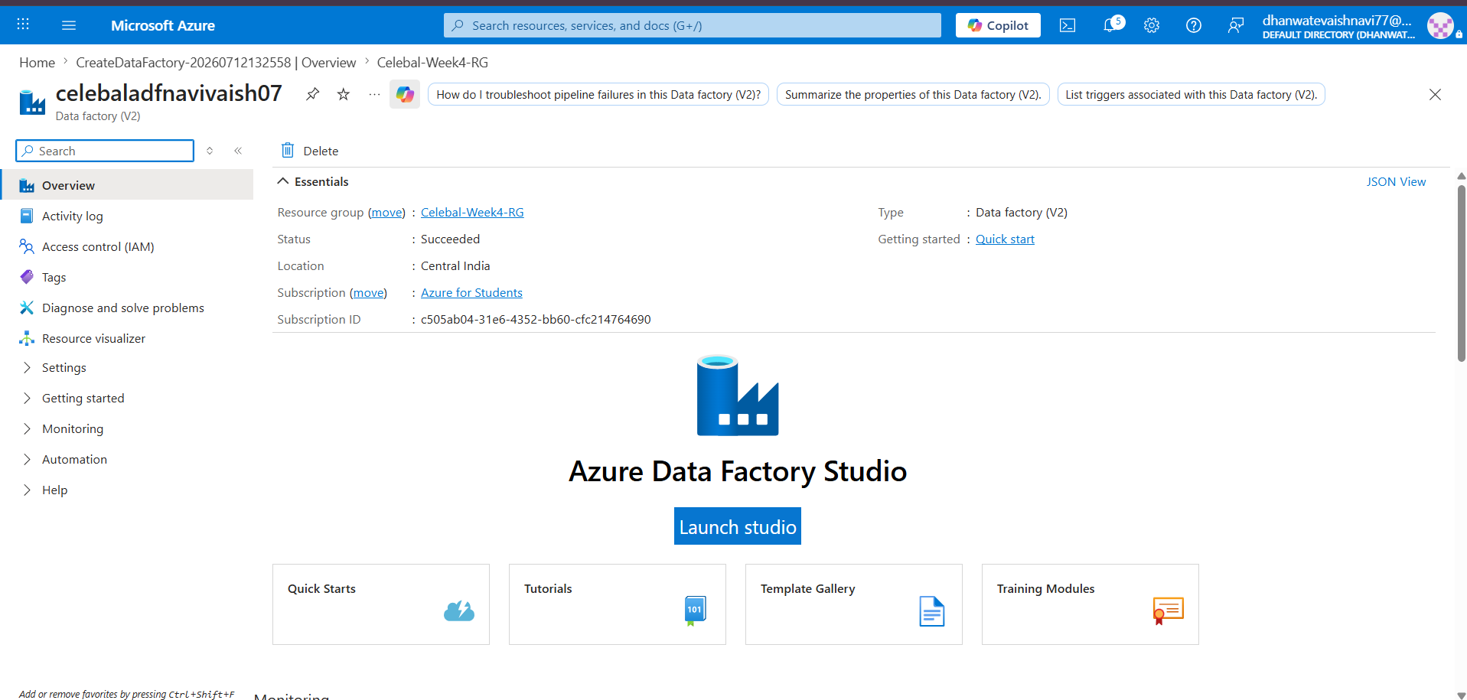
2. Azure Data Factory Studio Home Page
Azure Data Factory Studio provides the workspace for creating pipelines, datasets, linked services, and monitoring data integration activities.
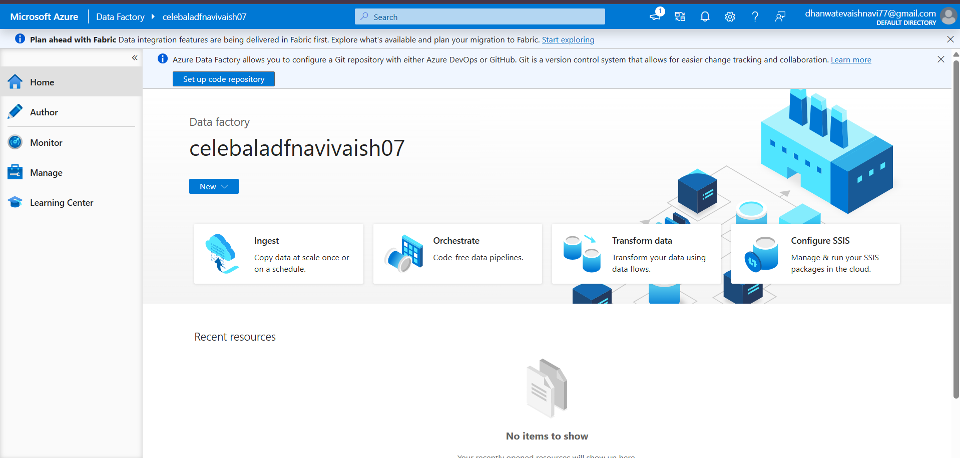

6: Create a Linked Service (Connect ADF to Blob Storage)
A Linked Service was created in Azure Data Factory to establish a secure connection between Azure Data Factory and the Azure Blob Storage account. This connection enables the pipeline to access the source and destination containers.
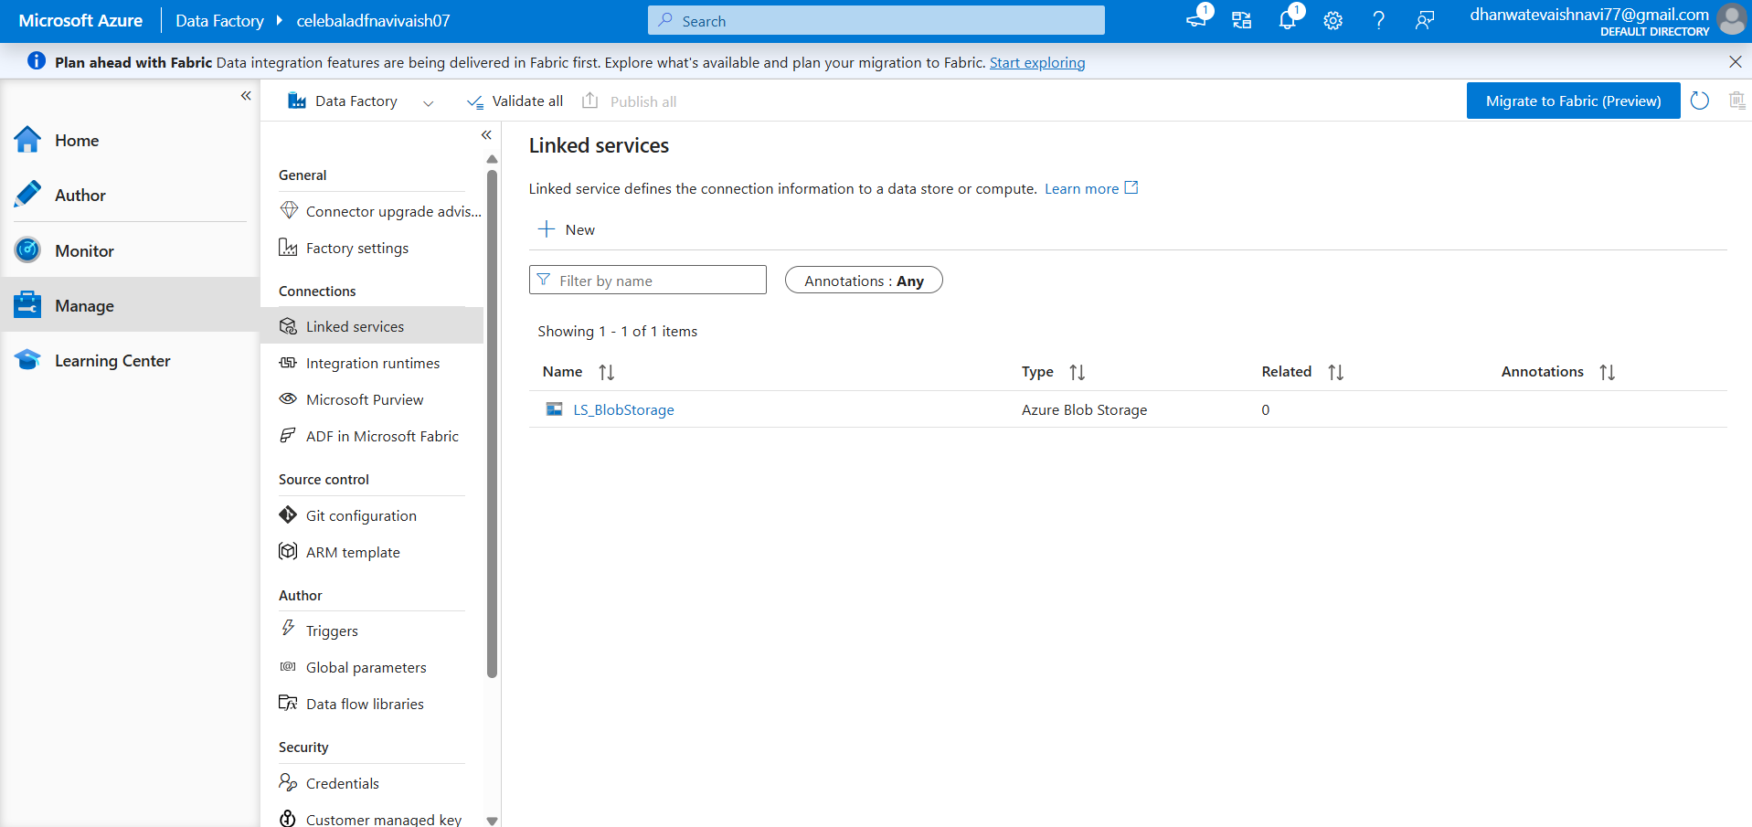

7: Create the Source Dataset
Source Dataset Configuration : A source dataset was created in Azure Data Factory to connect the uploaded Superstore CSV file stored in the source-data Blob container. The dataset defines the structure and location of the source data used by the pipeline.
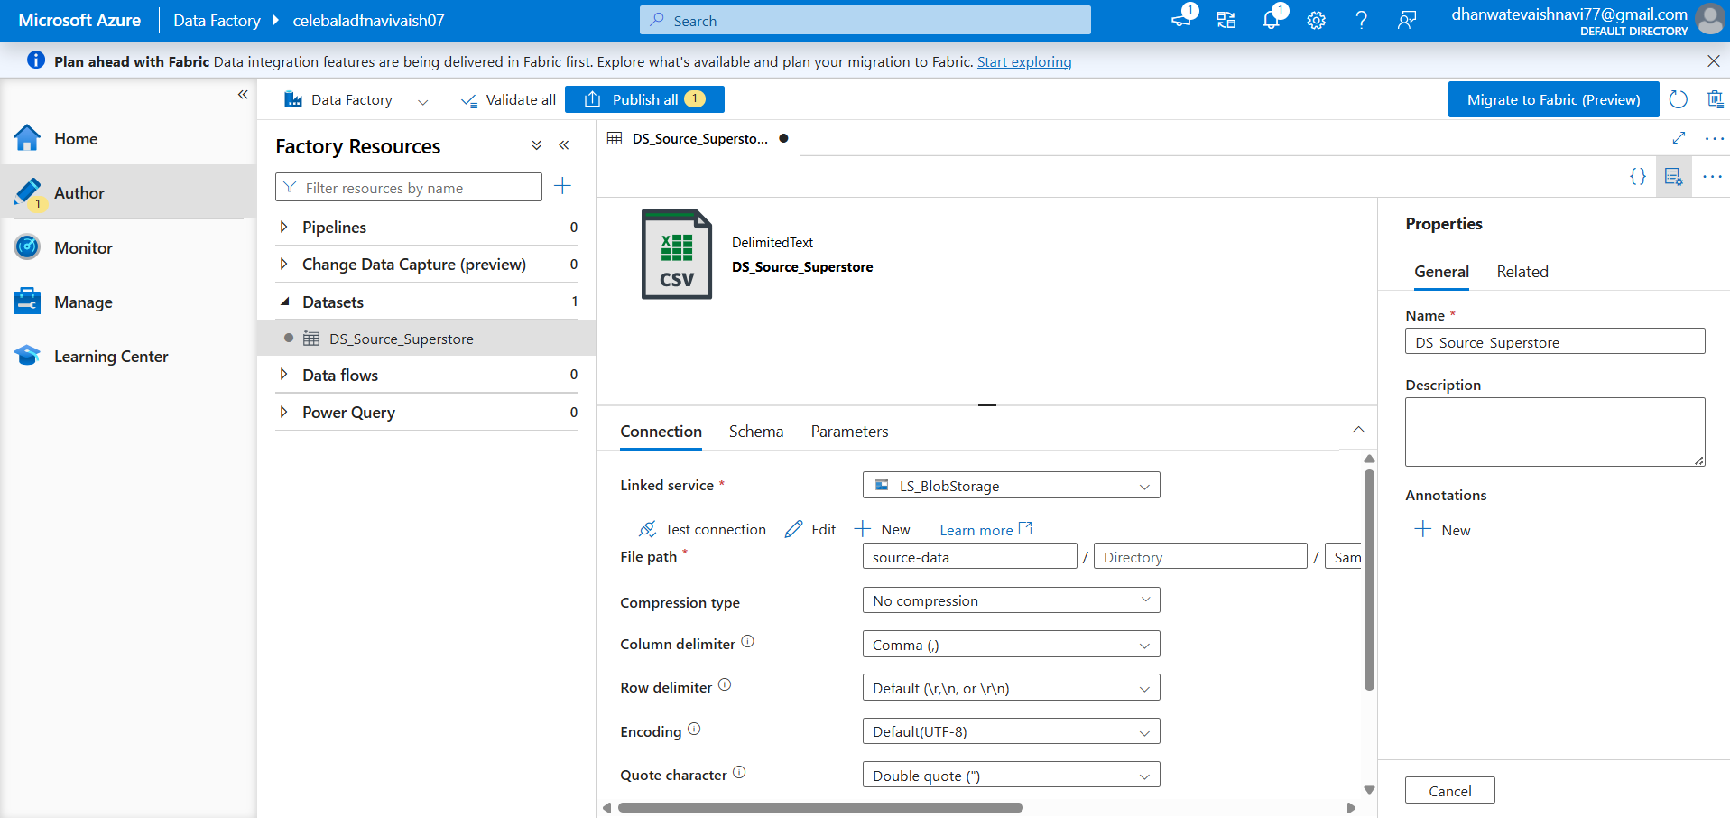

8: Create the Destination Dataset
Destination Dataset Configuration : A destination dataset was created in Azure Data Factory to define the target location where the copied CSV file will be stored after successful pipeline execution.
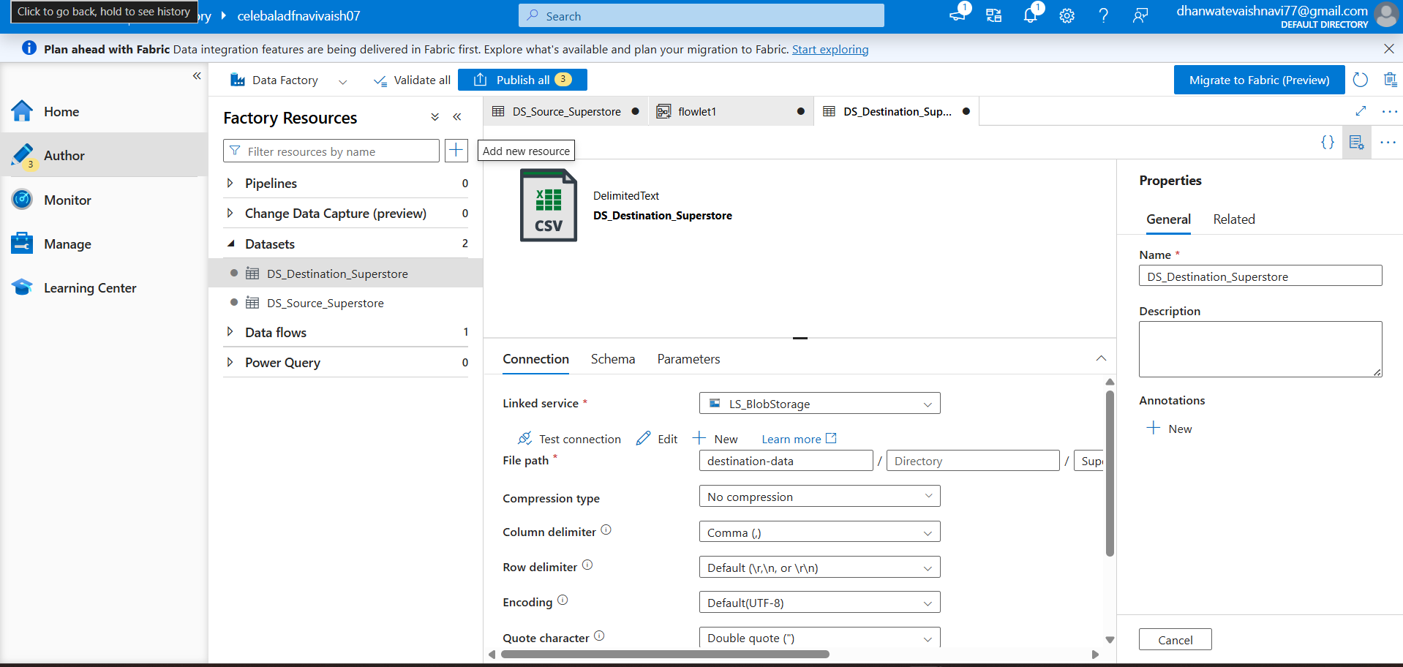

9: Build the Pipeline (Get Metadata + Copy Data)
Azure Data Factory Pipeline Design : An Azure Data Factory pipeline was created containing a Get Metadata activity to validate the source file and a Copy Data activity to transfer the CSV file from the source Blob container to the destination Blob container.
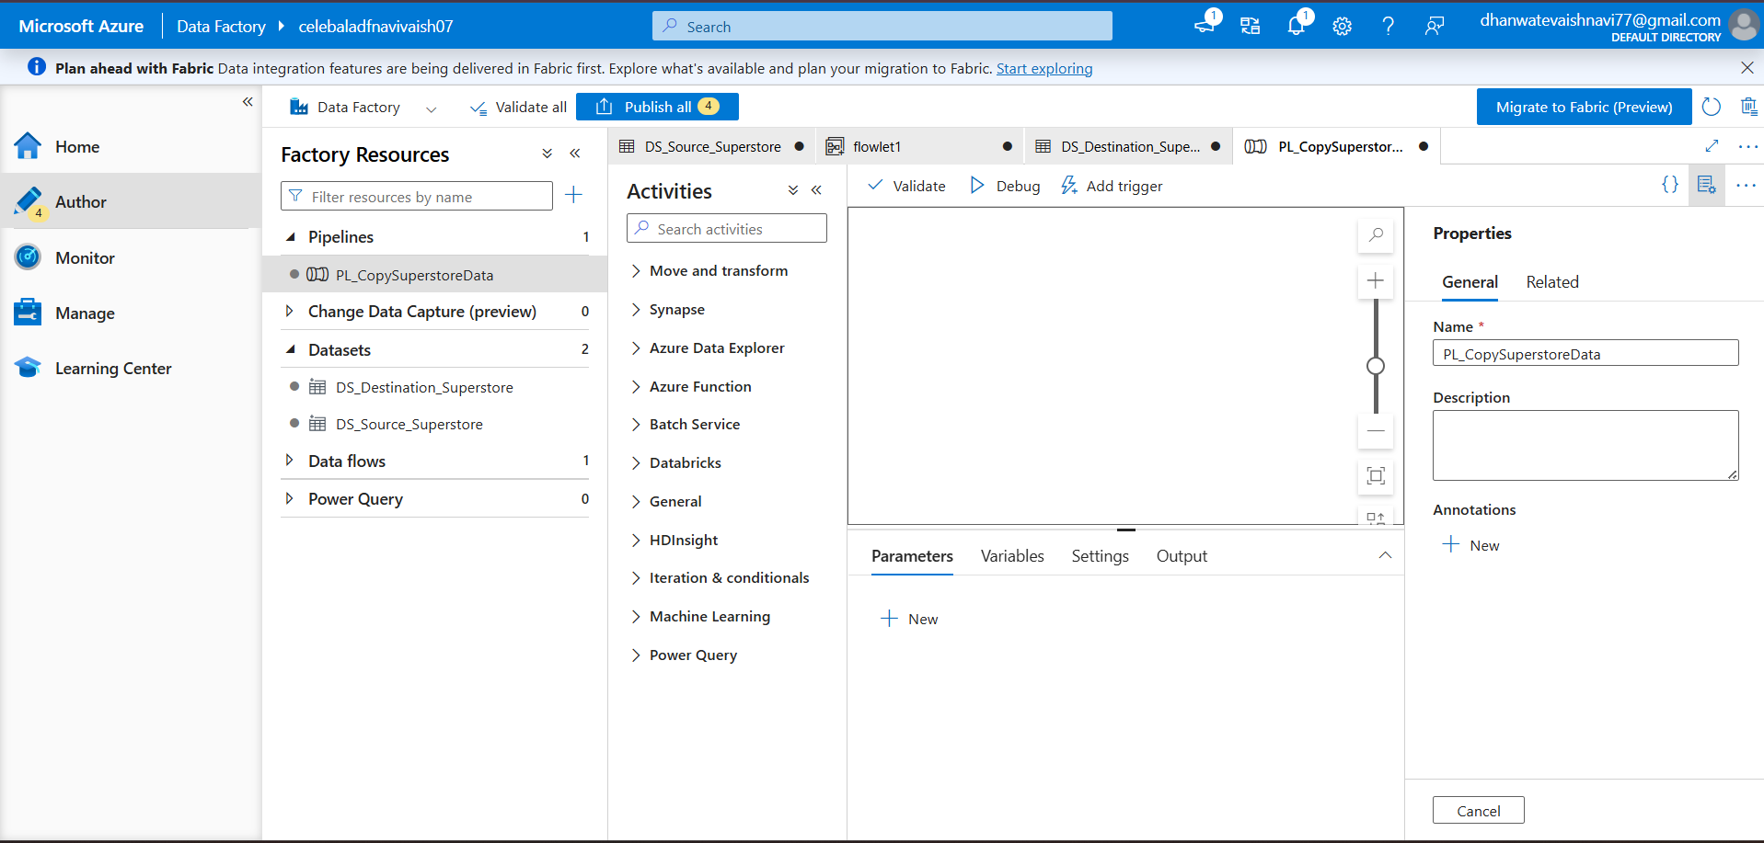
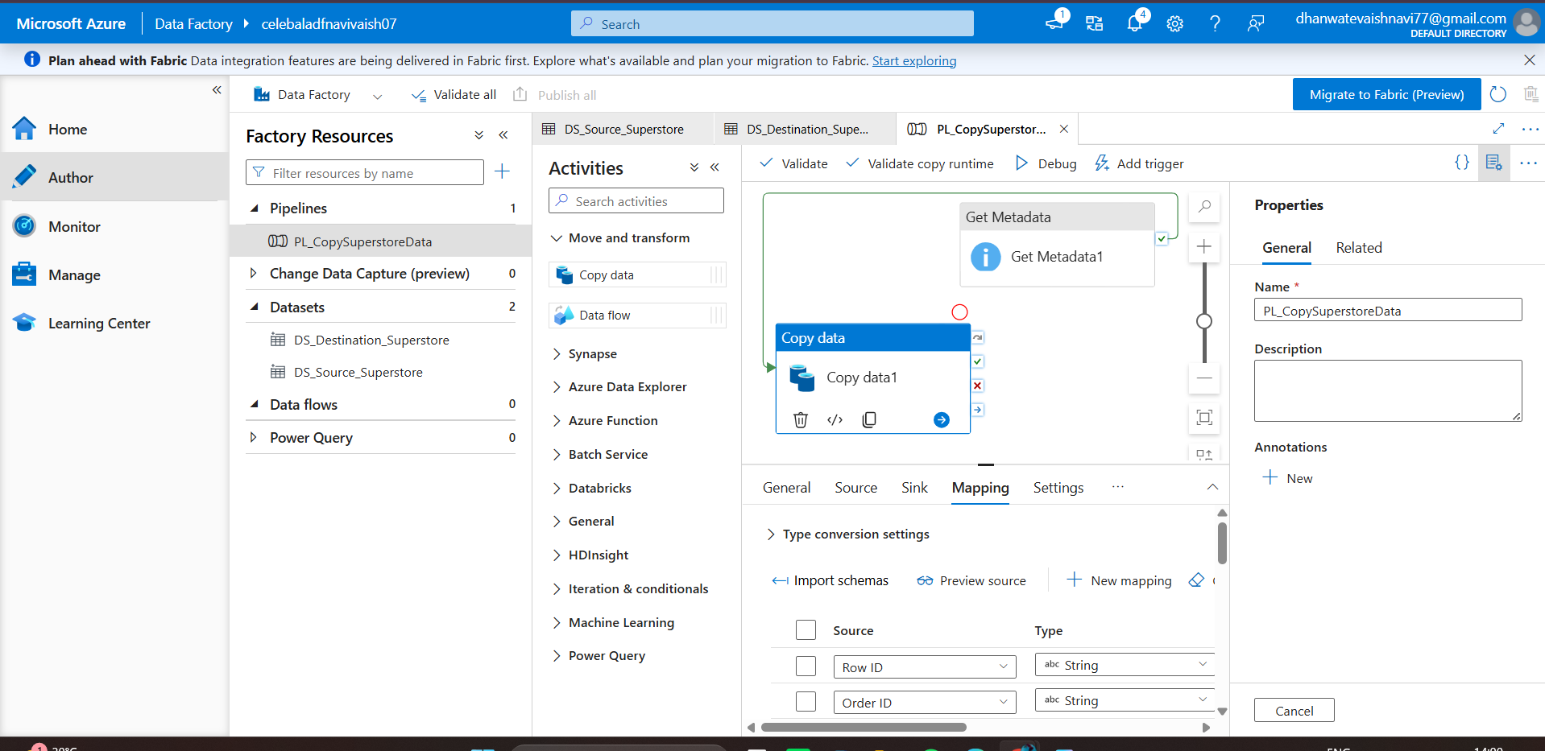

10: Execute the Pipeline
Executed the pipeline using Debug mode. The Get Metadata activity completed successfully. However, the Copy Data activity failed due to a CSV parsing issue (DelimitedTextMoreColumnsThanDefined) caused by inconsistencies in the source dataset format.
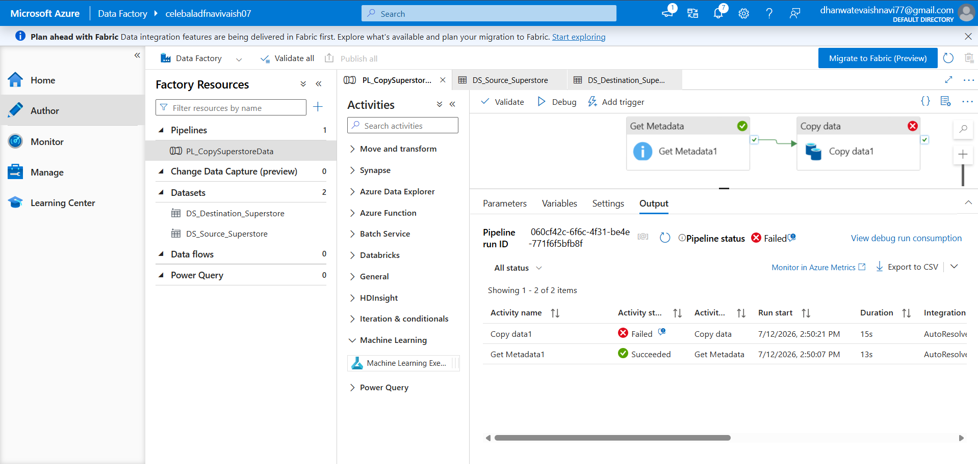

11. IAM Role Assignment
Assigned appropriate Azure IAM roles (Reader and Contributor) to provide Azure Data Factory with access to Azure Blob Storage.
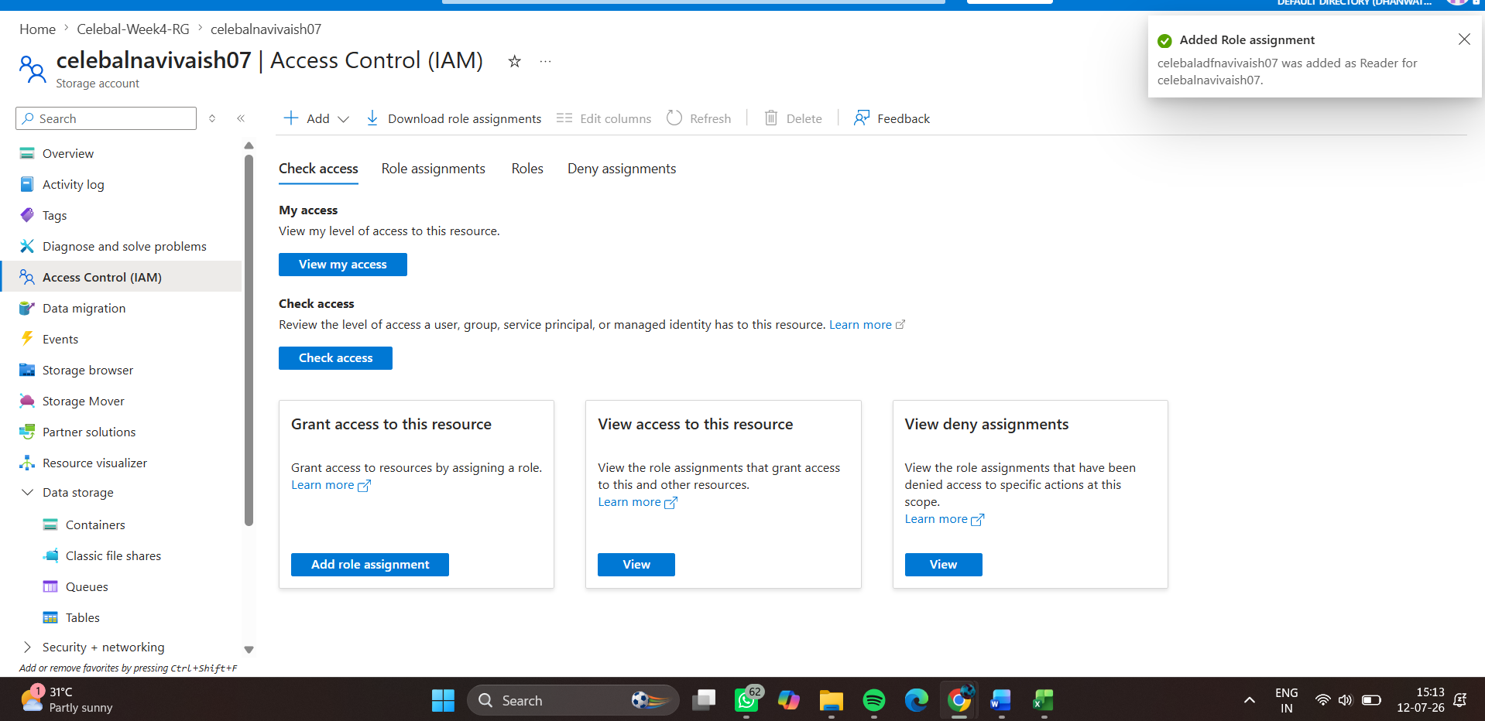

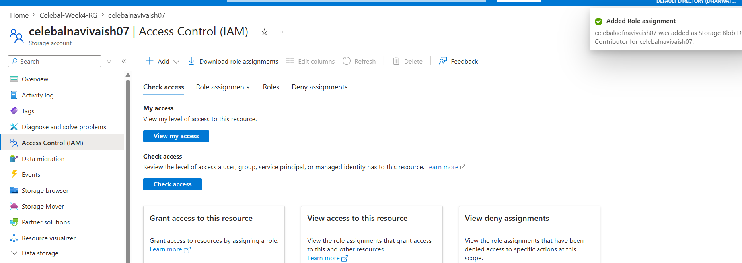
Assigned the Storage Blob Data Contributor role to Azure Data Factory Managed Identity to enable reading from the source container and writing to the destination container.

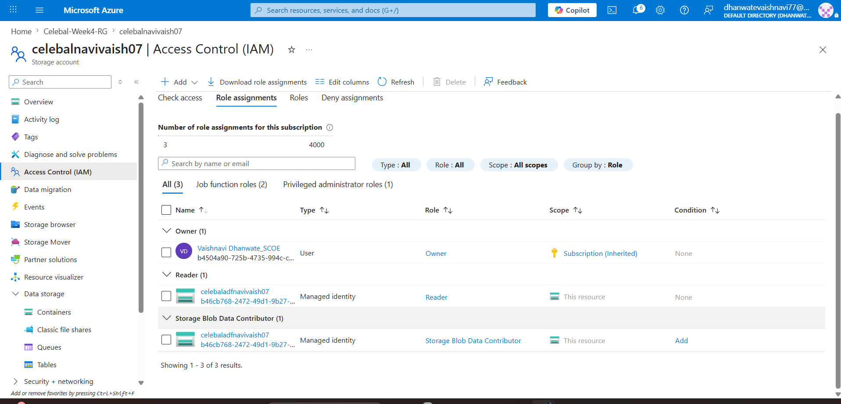
Verified that Azure Data Factory has the required permissions to access Azure Blob Storage through Azure RBAC role assignments.

