Q24. Write a query using CASE to classify products into price tiers:
• 'Budget' → unit_price < 1000
• 'Mid-Range' → unit_price BETWEEN 1000 AND 3000
• 'Premium' → unit_price > 3000
Display: product_name, unit_price, price_tier.
-- Q24: Classify each order based on its total amount using CASE.
-- High Value : total_amount > 5000
-- Medium Value : total_amount between 2000 and 5000
-- Low Value : total_amount < 2000
SELECT
order_id,
total_amount,
CASE
WHEN total_amount > 5000 THEN 'High Value'
WHEN total_amount BETWEEN 2000 AND 5000 THEN 'Medium Value'
ELSE 'Low Value'
END AS order_category
FROM orders;
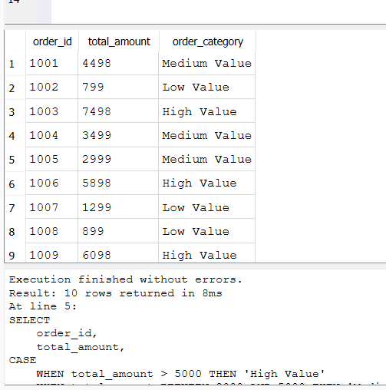

Q25. Using a CASE statement inside an aggregate function, count how many orders are 'Delivered' vs 'Not Delivered' (all other statuses). Display the result in a single row.
-- the query about the Count delivered and non-delivered orders in a single row using CASE
SELECT SUM(CASE
WHEN status = 'Delivered' THEN 1
ELSE 0
END) AS Delivered_Orders,
SUM(CASE
WHEN status <> 'Delivered' THEN 1
ELSE 0
END) AS Not_Delivered_Orders
FROM orders;
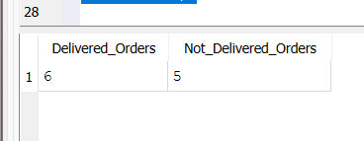

Q26. Explain each letter of ACID:
• A – Atomicity
• C – Consistency
• I – Isolation
• D – Durability
Give a real-world example (e.g., bank transfer) showing why each property is important.
--Explain each letter of ACID with a real - world example

--A Atomicity means Atomicity ensures that a transaction is treated as a single unit.
-- Either all operations are completed successfully, or none are.
--Bank Transfer Example
-- when we tranfer certain amount from account A to account B
--the amount is debited from A and Credited to B
--if credited fails then debited operation also cancelled using ROLLBACK so no partial transaction occurs

-- C - Consistency - it ensures that the database remains valid before
-- and after every transaction by following all constraints and rules.
-- Bank Transfer Example:
-- Before transfer:
-- Account A = Rs 20,000
-- Account B = Rs 10,000
-- Total = Rs 30,000
-- After transferring Rs 5,000:
-- Account A = Rs 15,000
-- Account B = Rs 15,000
-- Total still = Rs 30,000
-- The database remains consistent because no money is lost or created.

-- I - Isolation it ensures that multiple transactions running at the same
-- time do not interfere with each other.
-- Bank Transfer Example: if the Two customers try to transfer money from the same account
-- simultaneously. Isolation ensures that each transaction is
-- processed independently, preventing incorrect balances or conflicts.

-- D Durability guarantees that once a transaction is committed,
-- the changes are permanently stored, even if the system crashes.
-- Bank Transfer Example:
-- After a successful money transfer and COMMIT, if the bank's
-- server crashes or loses power, the transaction remains saved
-- in the database and is not lost.

Q27. Write a SQL transaction that does the following atomically:
1. Insert a new order (order_id=1011, customer_id=102, today's date, 'Pending', 1598.00)
2. Insert two order items for that order
3. Update the stock_qty of the purchased products
4. If any step fails, ROLLBACK the entire transaction. Otherwise, COMMIT.
Write the complete BEGIN...COMMIT/ROLLBACK block.

-- Q27: Perform an order transaction atomically
-- 1. Insert a new order
-- 2. Insert two order items
-- 3. Update the stock quantity of purchased products
-- 4. Commit if successful; otherwise rollback

BEGIN TRANSACTION;

-- Step 1: Insert a new order
INSERT INTO orders
(order_id, customer_id, order_date, status, total_amount)
VALUES
(1011, 102, DATE('now'), 'Pending', 1598.00);

-- Step 2: Insert two order items

INSERT INTO order_items
(item_id, order_id, product_id, quantity, unit_price, discount_pct)
VALUES
(5011, 1011, 201, 1, 799.00, 0);

INSERT INTO order_items
(item_id, order_id, product_id, quantity, unit_price, discount_pct)
VALUES
(5012, 1011, 206, 1, 799.00, 0);

-- Step 3: Update stock quantity

UPDATE products
SET stock_qty = stock_qty - 1
WHERE product_id = 201;

UPDATE products
SET stock_qty = stock_qty - 1
WHERE product_id = 206;

-- Step 4: Save all changes
COMMIT;

-- If any statement above fails before COMMIT,
-- execute the following command instead:
ROLLBACK;

